|  |
| --- |
| **In-House Development Team** |
| **PHUB TECHNICAL SPECIFICATION DOCUMENT** |

**Revision History:**

|  |  |  |  |
| --- | --- | --- | --- |
| **Version No.** | **Date** | **Author** | **Revision Description** |
| 1.0 | 25-Oct-2018 | Rashid Latif | Initial Draft |
| 2.0 | 15-Nov-2018 | Ayesha Laila | Updated the JavaPart |
| 3.0 | 21-Nov-2018 | Pankaj Samadhiya | Updated MIB,RIB & LMS Java Flow |
| 4.0 | 21-Nov-2018 | Rashid Latif | Integration of the document |
| 5.0 | 05-Mar-2020 | Ayesha Laila | Updated ER diagram |

Table of Contents

1. Introduction 6

**1.1.** **Purpose** 6

**1.2.** **Scope** 6

2. System Overview 8

**2.1.** **Architecture Diagram** 11

**2.2** **System Design Approach** 11

**2.3** **Application Flow** 12

**2.3.26** **Appzone Applications Flow** 72

**2.3.27** **Payment Hub Gateway – CPD** 72

**2.3.27.1** **De – Maker / De – Checker And Branch Maker / Branch Checker Profile** 73

2.3.27.2 **Rep–Maker/Rep–Checker/Frd–Maker/Frd–Checker/Salary–Maker/Checker** 110

2.3.27.3 **Upload Maker / Upload Checker Profile** 113

2.3.27.4 **Treasury Maker / Treasury Checker Profiles (CB202/CB2C2)** 116

**2.3.27.5** **Testing** 120

**2.3.27.6** **Remit Maker & Remit Checker Profile (Outward FCY Transactions) – Fast Pay** 120

**2.3.28** **PaymentGateWay-Procash** 126

**2.3.29** **PaymentGateWayReportsDownload** 127

**2.3.30** **PaymentGateWay-SIFCR Extraction** 127

**2.3.31** **Payment Gateway – Salary** 128

**2.3.32** **Utility Bill Settlement System** 163

**2.3.33** **Multi Corridor Remittance System** 163

**2.3.34** **Corporate IB** 163

**2.3.35** **Supplier Management System (ARIBA)** 163

**2.3.36** **Wages Protection System (WPS)** 163

**2.4** **Assumptions & Dependencies** 164

**2.5** **Utilized Third Party Components** 164

**2.6** **Third Party Consumers** 164

3 Data Design 165

**3.1** **ER Diagram** 165

**3.2** **Persistent Static Data – Master Tables** 166

**3.3** **Transient Dynamic Data** 169

**3.3.1** **FCR / FCRSI Tables** 169

**3.3.2** **Pelican** 169

**3.3.3** **Ariba** 169

**3.3.3.1** **Bill Desk** 169

**3.3.3.2** **Mobile Banking / LMS** 169

**3.3.3.3** **Retail IB** 169

**3.3.3.4** **Custom Bulk Upload** 169

**3.3.3.5** **UAEFTS Incoming** 170

**3.3.3.6** **Incoming Financial Messages** 170

**3.3.3.7** **PHUB Procash Response** 170

**3.3.3.8** **Incoming Non Financial Messages** 170

**3.3.3.9** **All Outgoing** 170

**3.3.3.10** **Procash** 171

**3.3.4** **EFD – CB Responses** 171

**3.3.5** **Processing and Repair Tables** 171

**3.3.6** **Corona** 171

**3.3.7** **Salary AI Procedure** 171

**3.3.8** **NAK Repair (Appzone)** 171

**3.3.9** **Paymenthub Core** 171

**3.3.10** **Fast Pay Repair (Appzone)** 171

**3.3.11** **Payment Hub Generec Repair (Appzone)** 172

**3.3.12** **CCM Generation** 172

**3.3.13** **Fast Pay** 172

**3.3.14** **Bill Desk** 172

**3.3.15** **Random Fraud Repair (Appzone)** 172

**3.3.16** **Utility Bill Payment** 172

**3.3.17** **AI Tables** 173

**3.3.18** **Account Title / Account No AI** 173

**3.3.19** **Report Tables** 173

**3.3.20** **Logging Tables** 173

**3.4** **External Interface Data** 174

4 User Interface Design 176

**4.1** **User Interface Design Overview** 176

**4.2** **User Interface Navigation Hierarchy** 223

5 Other Details 223

6 References 223

7 Glossary 223

8 Appendices 224

9 Annexures 224

# Introduction

The Central Bank of the UAE had implemented EFTS (Electronic Funds Transfer System) in the year 2001 to facilitate settlement of AED transactions with other banks through their current account maintained with CBUAE. The UAEFTS was used for the cover purpose and inquiry only and customer transactions were handled through one of the following methods

* Swift (MT 103)
* Hard copy of customer instructions and
* Demand Draft

In March 2009, CB invited all banks to inform them availability of new functionality of Bulk Payment within UAEFTS and related issues. During the course of discussions, many banks raised concerns on the system usage due to non-inclusion of remitter name and required system changes. CBUAE agreed to look into these issues. Initially the system was used for salary transfers by all banks as it had minimal requirements. However a few banks have started using the functionality for commercial payments also.

As commercial banks continue to use Swift for other payments as well as salary, Central Bank called for the meeting of all banks to further discuss the improvement to enable commercial banks to use UAEFTS system for all domestic payments.

The primary objective of implementing UAEFTS is to provide all banks and other financial institutions the following functionality

* Straight through Processing (STP) capabilities using SFTP for currently supported message formats.
* Enhanced message formats for institutional transfer and customer transfers
* Support for SWIFT message formats
  1. **Purpose**

The purpose of this document is to outline the technical approach and details of how payment hub works.

* 1. **Scope**

The scope of the document revolves around the flow of transactions from different channels and how transaction are created, repaired and processed for incoming and outgoing payments along with data flow and validations.

There are three main data sources from where the data is populated and saved along with one used for user authentication and authorization.

. **GoldenGate**

Most of the customer related information is fetched from Golden Gate

. **TIBCO**

The customer/account related information that is not available in Golden Gate is fetched from TIBCO. Along with that, for rates fetching and swift message generation, we also use TIBCO.

**PHUB DB**

All the transactions coming to payment hub are stored in payment hub DB.

**SQL Server**

All authentication and authorization done through SMS

# System Overview

The Payment Hub is the Real Time Gross Settlement (RTGS) system of ADCB.  The system facilitates the transfer of funds between banks and other financial institutions in the UAE via their accounts held with the Central Bank. The objective is to provide a system that enables entities of all sizes to participate, irrespective of their size or nature of business.

There are two main parts in Payment Hub. One is the front end engine (includes windows services and web application written in .Net) used for creating, loading and repairing the transaction and the other is backend payment engine (written in Java) for processing the transactions. We will discuss each part separately and in detail.

Transactions flow from different channels and come into payment hub through MQ’s, windows services or .Net frontend and are processed in java engine.

Below are the type of payments that are processed by payment hub. The list includes

|  |  |  |
| --- | --- | --- |
| **Payment Type** | **Description** | **Code** |
| 1 | Internal Fund Transfer | IFT |
| 2 | External Fund Transfer- Domestic | EFD |
| 3 | External Fund Transfer - International | EFI |
| 4 | Corporate Salary Transfers | CST |
| 5 | Cheque Printing | BCK |
| 6 | RBS Rejected | RBS |
| 9 | Retail IB Transaction | RIB |
| 11 | SI FCR | FCR |
| 12 | Corp IB Individual transaction | CIB |
| 13 | Xpress Money Transfer | XMT |

We will explain the major payment type being used in the system.

**IFT:** Fund transfer done within the bank (both debit and credit accounts are from ADCB).

**EFD:** Transfer of funds between two banks within UAE.

**EFI:** Transfer of funds between two banks, one of which is outside of UAE.

**CST:** Salary transaction done within bank or between two banks in UAE.

**BCK:** Processing of cheque initiated from Procash (CMS) channel.

Below are the list of channels being processed by Payment hub, the type of payment each channel supports and how they are extracted or processed.

|  |  |  |  |
| --- | --- | --- | --- |
| **Channel ID** | **Channel Description** | **Front End / Extraction** | **Payment Type** |
| 1 | CPD | Appzone Front End | IFT, EFD, EFI, CST |
| 2 | Branch | Appzone Front End | IFT, EFD, EFI, CST |
| 12 | CMS | Message Queue | IFT, EFD, EFI |
| 14 | CMS PRIORITY | Message Queue | EFD |
| 15 | Retail IB | PHUB Cron Job | EFD |
| 17 | SI FCR | PHUB Cron Job | IFT, EFD, EFI |
| 19 | Escrow System | Appzone Front End | IFT, EFD, EFI, CST |
| 20 | BANKTRANSFER | Appzone Front End | EFD (only file Gen) |
| 21 | TreasuryFrontEnd | Appzone Front End | EFD (only file Gen) |
| 22 | TreasuryService | Appzone Service | IFT, EFD, EFI, CST, BCK |
| 23 | Mobile Banking | Message Queue | IFT |
| 24 | ARIBA | Appzone Front End & Service | IFT, EFD, EFI, |
| 25 | Customer Bulk upload | Appzone Front End & Service | EFD |
| 26 | Pelican | Appzone Service | EFD, EFI, |
| 27 | CLMS | Message Queue | EFD, EFI, |
| 28 | FCR | PHUB Cron Job | EFD, EFI |
| 29 | UTL_BILL | Appzone Front End | IFT, EFD, EFI, XMT |

In first part, we are going to discuss frontend along with the windows services used for extraction and validation and in second part we are going to discuss the how transactions are processed and posted in java engine. Frontend consist of different applications including

* Payment Gateway - CPD
* Payment Gateway - Branch
* Payment Gateway – Salary
* Utility Bill Settlement System
* Multi Corridor Remittance System
* Corporate IB
* Supplier Management System (ARIBA)
* Wages Protection System

Then there are different windows services written to extract and validate the transactions coming from different channel. Below are the list of services used for extraction.

* Pelican Service
* Custom Bulk Upload Service
* Ariba Processing Service
* Treasury Service
* Salary Validation Service

Initialy we are going to define the functional flow of different types of payment and how they are processed. Then we are going to define more complicated cases for incoming and outgoing payments.

* 1. **Architecture Diagram**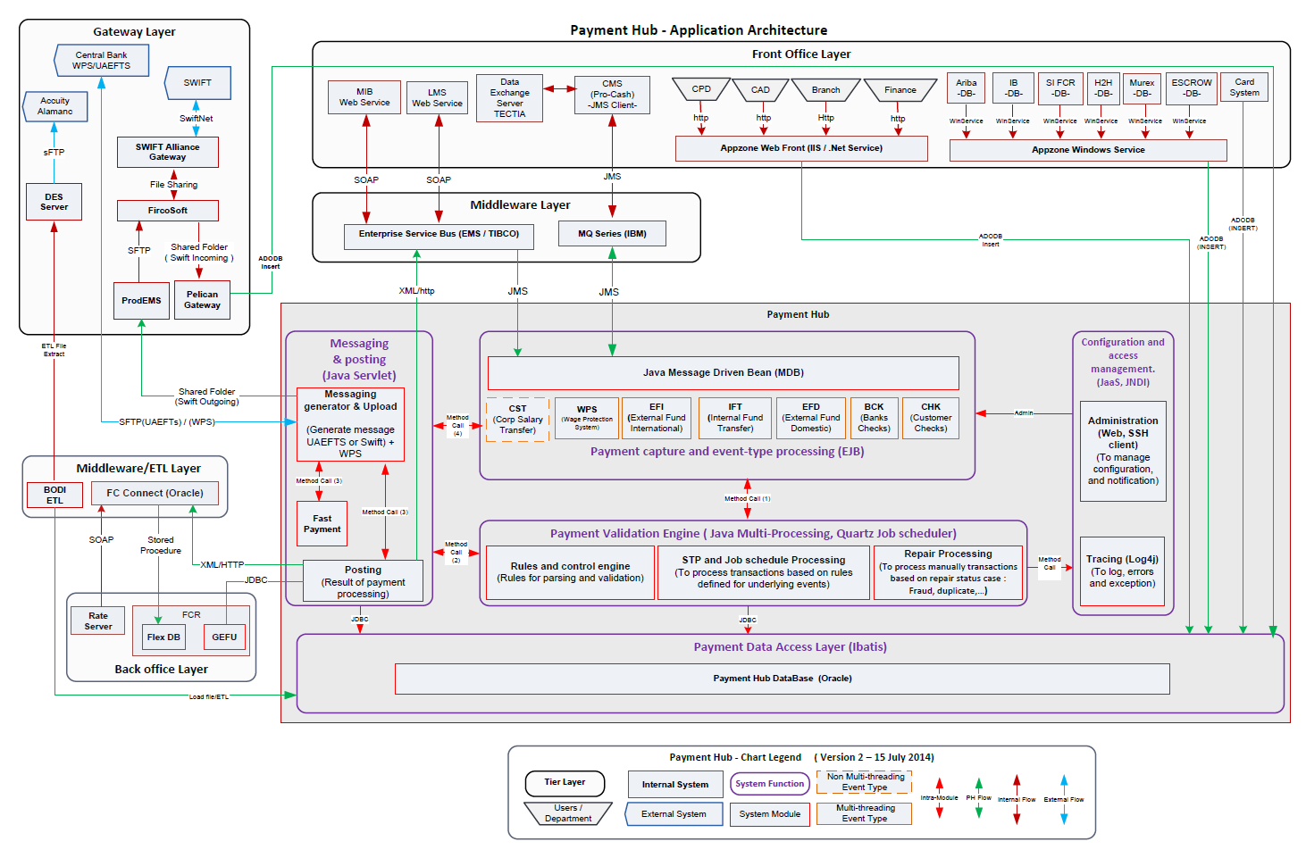
  2. **System Design Approach**

The application is build using core Java,message driven bean,ibatis for Database,ESB services.

* 1. **Application Flow**



The payments or transactions are received either through Incoming Payments (transaction coming from CB / Swift) or Outgoing (transactions going out from ADCB). We will discuss in detail the flow of all incoming and outgoing payments. First we will show the flow diagram generic payment process for all the transaction types (IFT/EFD/CST/EFI).

* + 1. **Generic Payment Processing**



The above diagram shows how each type of payment is validated and posted. For all the payment types, the debit account validation is based on status of account and if the account has balance or not. Beneficiary account validations are different for each payment type as we can see in the diagram. As soon as the transaction comes into Payment hub, the java engine validates the debit account and credit account. If any validation is failed, the transaction then goes to appzone Payment Gateway applicaiotn for the repair. For each validation we have differenct screen in the Payment Gateway application. Once the transaction is repaired and approved from the frontend, the posting and file generation is done based on the payment type. We will describe in detail how each payment type (IFT/EFD/CST/EFI) is processed.

* + 1. **PHUB Core Processing Outgoing**
* Fetch the transactions from the staging tables
  + Uaefts_batch
  + Uaefts_remidtlsckr
  + Uaefts_remitdtls
* Get the cid of the debit account no and check if the consolidation flag is enabled

If yes consolidation flow explained in ConsolidationProcessing

* Call the jerseyChecking for all transactions except below 2 conditions
  + The batch is consolidated
  + IFT from RIB and MIB
* Call the tibco service InqCSAcctIBANInfoClient and check if the transaction is jersey

Log the request and response in uaefts_acct_dtls_req_resp

* Check if the jersey allowed for that channel
* If transaction type is EFD and debit is jersey
  + and channel is mobile banking and retail IB call the validate beneficiary service .If beneficiary is valid the change the transaction type as RIB
  + Channel is procash change the transaction type to EFI
  + Any other channel mark the transaction as failed
* Insert into payment_txn_mt the transactions
* If the transactiontype is CST insert into uaefts_salary_txn_ckr
* Call the payment_process_servlet URL for all the transactiontypes with the bacthID
  + 1. **PHUB Core Processing Incoming**
* Fetch the transactions from the inward staging tables
  + Uaefts_inward_batch
  + Uaefts_inward_batch_record
* If the incoming channel is UAEFTS 3.0 check if it’s a incoming EFI transacton
  + Call proc get_sp_incomingCTD21_103Validation
* If yes change the transaction type as EFI
* Check if its an Incoming jersey transaction
* Insert into payment_txn_mt
* If salary insert into uaefts_salary_txn_ckr
* Call the incoming valueDateProcessor for channels uaeft 30 to check if the transaction came within the uaefts cut off
* Incoming cut off obtained from proc get_sp_fetchThresholdCutoFF
* If before cut off call the processor to process the transaction,if after cut off the park for next business download
  + 1. **IFT Payment Processing**

Below diagram illustrates how IFT transactions are processed.



This module will process adcb payments.There are 2 types

1)IFT Incoming where the debit is CB and credit is ADCB account.Payments coming from CB

2)IFT Outgoing where the debit and credit are ADCB accounts.

**Flow IFT Incoming**

1. Payments will flow from the inward module to payment_txn_mt.
2. As debit is CB account debit account validation is bypassed
3. If the bene Account is IBAN ,validate the algorithm of the IBAN account if success get the CASA by direct query into FCUBS.
4. Get the credit account details by direct query into FCUBS
5. If account does not exist check if it can be enriched.
6. Validate the beneficiary credit account status against the configuration

COD_ACCT_STATUS:-The FCUBS account status

FLAG

* A-STP
* P-Pushed to repair.Can be repaired or rejected from Front end
* R-Pused to repair.Can be only repaired from Front End

|  |  |  |  |
| --- | --- | --- | --- |
| **COD_ACCT_STATUS** | **TXT_ACCT_STATUS** | **FLAG** | **ERROR_CODE** |
| 6 | ACCOUNT OPENED TODAY | A |  |
| 16 | ACCOUNT OPEN - DEBIT WITH OVERRIDE | A |  |
| 8 | ACCOUNT OPEN REGULAR | A |  |
| 3 | ACCOUNT OPEN - NO DEBIT | A |  |
| 4 | ACCOUNT OPEN - NO CREDIT | P | 110 |
| 21 | UNCLAIMED ACCOUNT | P | 119 |
| 10 | ACCOUNT BLOCKED DORMANT | P | 112 |
| 19 | ACCOUNT DORMANT - CREDIT WITH OVERRIDE | P | 117 |
| 18 | ACCOUNT DORMANT - DEBIT WITH OVERRIDE | P | 130 |
| 17 | ACCOUNT OPEN - CREDIT WITH OVERRIDE | P | 116 |
| 12 | ACCOUNT DORMANT - NO CREDIT | P | 113 |
| 11 | ACCOUNT DORMANT - NO DEBIT | P | 128 |
| 20 | ACCOUNT MATURED | P | 118 |
| 7 | ACCOUNT DORMANT | P | 126 |
| 1 | ACCOUNT CLOSED | R | 108 |
| 15 | ACCOUNT INOPERATIVE - NO CREDIT | R | 115 |
| 14 | ACCOUNT INOPERATIVE - NO DEBIT | R | 129 |
| 9 | ACCOUNT INOPERATIVE | R | 127 |
| 2 | ACCOUNT BLOCKED | R | 109 |
| 13 | ACCOUNT INOPERATIVE BLOCKED | R | 114 |
| 5 | ACCOUNT CLOSED TODAY | R | 111 |

1. CTD 05 Incoming validation

* Check if CTD 05 validation enabled
* If the beneAccount is credit card the check if transaction type is allowed for the creditCard ownership code

select count(*) COUNT from uaefts_trasaction_type where IS_ENABLED='Y' and transaction_code=#TXN_CODE#

<dynamic>

<isPropertyAvailable property="OWNERSHIP_BCT_CUSTOMERTYPE"> and BCT_CUSTOMERTYPE like '%'||#OWNERSHIP_BCT_CUSTOMERTYPE#||'%'</isPropertyAvailable>

</dynamic>

* If beneAccount no is CASA if ordering institution is AE,then get then MIS code of account from FCUBS

Get the customerType in the configuration for the MISCODE

select BCT_CUSTOMERTYPE from uaefts_customer_ownership_type where rownum=1 and mis_code=#COD_MIS_COMP_CODE3#

Check the Customer type is allowed for the transaction type.If any failure park as validation failed else STP

* If beneAccount no is CASA if ordering institution is NON AE,check if cross border is enabled for the transaction type

select count(*) COUNT from uaefts_trasaction_type where IS_ENABLED='Y' and transaction_code=#TXN_CODE#

<dynamic>

<isPropertyAvailable property="OWNERSHIP_BCT_CUSTOMERTYPE"> and BCT_CUSTOMERTYPE like '%'||#OWNERSHIP_BCT_CUSTOMERTYPE#||'%'</isPropertyAvailable>

</dynamic>

1. Check if it’s a duplicate transaction

*select BATCH_ID from payment_txn_mt where*

*trunc(status_datetime)>=trunc(sysdate)-7*

*and PYMNT_AMNT = #PYMNT_AMNT#*

*and upper(trim(DEBIT_ACC_NO)) = upper(trim(#DEBIT_ACC_NO#))*

*and upper(trim(BENE_ACC_NO)) = upper(trim(#BENE_ACC_NO#))*

*and upper(trim(PYMNT_CURR)) = upper(trim(#PYMNT_CCY#))*

*and upper(trim(ordering_institution)) = upper(trim(#SENDING_BANK#))*

*and ((status=5 and error_code in ('24','16','5','8')) or status not in (18,5))*

*and batch_id >5276682*

1. Fraud Validation if enabled for the channel

Order of fraud check

* Check if branch code is exempted for the channel
* Check if CID exempted for fraud
* Get the fraud limit for cutomer category ,if not get the default fraud limit.
* If the transaction amount is above the fraud limit check if it’s a recurring transaction.If not push to fraud repair else stp

1. If beneCurrency is NON AED,then fetch rate using the Rate Service
2. RandomFraudCheck.This will pick transaction randomly.A time will be configured,the system will check if the transaction time and the configured time is same,if yes it will be pushed to random repair.

Insert into the table UAEFTS_FRAUD_RANDOM

Random fraud is configured in the table uaefts_fraud_random.

Delete the older entries.

1. For the success transactions check if its an End of Service.Eos is decided by checking the transaction code as EOS or if the remittance info is having any narrative as EOS
2. For all success and EOS success transaction call add funds transfer to do the posting
3. If the bene Account is credit card call the Tibco Service AddCreditCardPaymentCB.

* AddCreditCardPaymentCB service will validate the account
  + If success,the service will do the posting
  + Service will response back to park as retry.These transactions will be retried by Tibco later and will update PHUB accordingly
  + Service will send reponse back to generate 202(return of funds).

1. If the type is EOS ,Call the funds service to hold the amount.

* For the customerCategory and Customer Type if there is charge configured ,then call add funds transfer to do the charge posting

1. For the failed list of transaction check the rejection code is configured for auto 202 generation(Return of funds)
2. Do posting for 202 2 legs of posting,debit CB and credit to cb 202 suspense.Debit 202 suspense to to credit CB.
3. Update the status for all transactions accordingly.

**Flow IFT Outgoing**

1. Fetch the transactions from payment_txn_mt
2. Fetch the debit account details by direct query from FCUBS
3. Validate debit account status against the configuration

COD_ACCT_STATUS:-The FCUBS account status

FLAG

* A-STP
* P-Pushed to repair.Can be repaired or rejected from Front end
* R-Pused to repair.Can be only repaired from Front End

|  |  |  |  |
| --- | --- | --- | --- |
| COD_ACCT_STATUS | TXT_ACCT_STATUS | FLAG | ERROR_CODE |
| 6 | ACCOUNT OPENED TODAY | A |  |
| 17 | ACCOUNT OPEN - CREDIT WITH OVERRIDE | A |  |
| 4 | ACCOUNT OPEN - NO CREDIT | A |  |
| 8 | ACCOUNT OPEN REGULAR | A |  |
| 3 | ACCOUNT OPEN - NO DEBIT | P | 96 |
| 10 | ACCOUNT BLOCKED DORMANT | P | 99 |
| 11 | ACCOUNT DORMANT - NO DEBIT | P | 100 |
| 12 | ACCOUNT DORMANT - NO CREDIT | P | 157 |
| 16 | ACCOUNT OPEN - DEBIT WITH OVERRIDE | P | 104 |
| 18 | ACCOUNT DORMANT - DEBIT WITH OVERRIDE | P | 105 |
| 19 | ACCOUNT DORMANT - CREDIT WITH OVERRIDE | P | 125 |
| 7 | ACCOUNT DORMANT | P | 98 |
| 20 | ACCOUNT MATURED | R | 106 |
| 15 | ACCOUNT INOPERATIVE - NO CREDIT | R | 124 |
| 14 | ACCOUNT INOPERATIVE - NO DEBIT | R | 103 |
| 13 | ACCOUNT INOPERATIVE BLOCKED | R | 102 |
| 9 | ACCOUNT INOPERATIVE | R | 123 |
| 5 | ACCOUNT CLOSED TODAY | R | 97 |
| 21 | UNCLAIMED ACCOUNT | R | 150 |
| 1 | ACCOUNT CLOSED | R | 94 |
| 2 | ACCOUNT BLOCKED | R | 95 |

1. If the bene account no is credit card by calling the proc in the NI CARD

system call card_system.dbo.p_CardValidation(?,?,?,?,?)}.

Insert the card details into SALARY_CARD_DTLS

1. If bene account is CASA validate the beneficiary account.For details Refer point 5 in IFT Flow incoming
2. If account does not exist check it its enriched
3. Validate the account title.Compare the account title of the transaction with the title in FCUBS
4. If title does not match check if the title was enriched.If all fine STP else park the transaction as account title validation failed repair
5. Check if it’s a duplicate payment

select BATCH_ID from payment_txn_mt where

trunc(status_datetime)>=trunc(sysdate)-7

and CASE WHEN (CHARGE_TO_ID in ('2','1')) and (pymnt_amnt=#PYMNT_AMNT#) then 1

WHEN (CHARGE_TO_ID =3) and (nvl(instructed_transaction_amount,0)=#PYMNT_AMNT#) then 1

else 0

end=1

and upper(trim(DEBIT_ACC_NO)) = upper(trim(#DEBIT_ACC_NO#))

and upper(trim(BENE_ACC_NO)) = upper(trim(#BENE_ACC_NO#))

and ((PYMNT_CURR)) = upper(trim(#PYMNT_CCY#))

1. and ((status=5 and error_code in ('24','16','5','8')) or status not in (18,5))
2. Fraud Validation if enabled for the channel

Order of fraud check

* Check if branch code is exempted for the channel
* Check if CID exempted for fraud
* Get the fraud limit for cutomer category ,if not get the default fraud limit.
* If the transaction amount is above the fraud limit check if it’s a recurring transaction.If not push to fraud repair else stp

1. If beneCurrency is NON AED,then fetch rate using the Rate Service
2. RandomFraudCheck.This will pick transaction randomly.A time will be configured,the system will check if the transaction time and the configured time is same,if yes it will be pushed to random repair.

Insert into the table UAEFTS_FRAUD_RANDOM

Random fraud is configured in the table uaefts_fraud_random.

Delete the older entries.

1. Call adds fundsTransfer to do the posting
   * 1. **EFD Payment Processing**

Below diagram illustrates how EFD transactions are processed.



This module will process transaction initiated from ADCB to other domestic banks.All the payments are in currency AED.FTS files are generated and pushed to CB .

Flow

1)Pick the EFD transactions from payment_txn_mt .

2)Fetch charge configuration for the channel

select is_ben_charge_allowed,is_sha_charge_allowed,is_our_charge_allowed from CHANNEL_CHARGES where CHANNEL_ID = #channel_id#

3)If the charge types is BEN and charge allowed for the channels.Fetch CID for the debit account number using direct query from FCUBS

4)Fetch charge using EFD ChargeLook Up

EFD ChargeLookup

Will fetch charge configured in the table uaefts_efd_charge_maintenance.Two types of charge are there.

1)Processing charge:-Debit the customer and credit ADCB commission

2)Correspondance :-Debit the customer and credit CB GL

* Fetch chargeOverride flag
  + *CH_BEN_CHARGE_OVERRRIDE_SELECT*
  + *CH_OUR_CHARGE_OVERRRIDE_SELECT*
  + *CH_SHA_CHARGE_OVERRRIDE_SELECT*
* If override flag is enabled.Call the tibo service to fetch the charge.
* Input parameters for charge fetch
  + CustomerCategory and Customer Type are fetched from MDM database using the CID of the debit account.
  + Transaction Code.If not flowing then pass the default.
* Fetch the charge using Tibco.
* Update charge amout if available.If charge type is ben
  + paymentAmount:-instructedAmount-charge

5)For channels where the PHUB is debiting a CASA account validate the debit account status.

Debit account status configuration is available in table

Uaefts_debit_acct_status

The table configuration will decide whether the transaction debit status can be STP or it should be pushed to repair.

For detail refer **Flow IFT Outgoing** Point no 3

6)CTD05 Validation

* Get the CTD 05 configuration look up

*select IS_CTD05_VALIDATION_ENABLE, IS_CTD05_DEFAULT_ENABLE, CTD05_DEFAULT_VALUE, IS_CTD05_CROSS_BORDER_ENABLE from channel_charges where channel_id=#receivingChannelId#*

* If default enabled ,then update the transaction code with default configured.
* If ordering institution is AE ,check if CTD 05 is enabled for channel if yes then get the MIS code and ownership type of the debit account no by using direct query to MDM goldern get.For the ownership check if the transaction type of the transactions is allowed,if yes proceed else park as validation failed.
* If ordering institution is not AE ,check if cross border is enabled for the channel ,then check if cross border enabled for the transactiontype of transaction,if yes proceed else park as validation failed.
* Validate the Beneficiary IBAN algorithm validation and also if debit IBAN not available fetch the debit IBAN from FCUBS
* Validate if the transaction is duplicate.Logic is as below

*select BATCH_ID from payment_txn_mt where*

*trunc(status_datetime)>=trunc(sysdate)-7*

*and CASE WHEN (CHARGE_TO_ID in ('2','1')) and (pymnt_amnt=#PYMNT_AMNT#) then 1*

*WHEN (CHARGE_TO_ID =3) and (nvl(instructed_transaction_amount,0)=#PYMNT_AMNT#) then 1*

*else 0*

*end=1*

*and upper(trim(DEBIT_ACC_NO)) = upper(trim(#DEBIT_ACC_NO#))*

*and upper(trim(BENE_ACC_NO)) = upper(trim(#BENE_ACC_NO#))*

*and ((PYMNT_CURR)) = upper(trim(#PYMNT_CCY#))*

*and ((status=5 and error_code in ('24','16','5','8')) or status not in (18,5))*

* Fetch Rate for the transaction.
* If customer type is corporate call corporate Rate Server
* If customer type is reatail call Retail Rate Server
* Fraud Validation

Order of fraud check

* Check if branch code is exempted for the channel
* Check if CID exempted for fraud
* Get the fraud limit for cutomer category ,if not get the default fraud limit.
* If the transaction amount is above the fraud limit check if it’s a recurring transaction.If not push to fraud repair else stp
* Check the branch routing code is valid UAE branch Code.Check in the table uaefts_branch
* Validate the account balance including the charges.Get the balance from FCUBS using direct query.
* Post the amount and charges using add Funds Transfer

Sample Tibco Request

Amount

<?xml version="1.0"?>

<soapenv:Envelope xmlns:soapenv="http://schemas.xmlsoap.org/soap/envelope/" xmlns:xsd="http://www.w3.org/2001/XMLSchema" xmlns:xsi="http://www.w3.org/2001/XMLSchema-instance">

<soapenv:Body>

<SRFundTransferReqMsg xmlns="http://www.adcb.com/esb/mnt/NonCard/AddFundTransfer.xsd">

<ns1:header xmlns:ns1="http://www.adcb.com/esb/common/header.xsd">

<ns1:usecaseID>1234</ns1:usecaseID>

<ns1:serviceName>AddFundTransfer</ns1:serviceName>

<ns1:versionNo>2.0</ns1:versionNo>

<ns1:serviceAction>Addition</ns1:serviceAction>

<ns1:sysRefNumber>32244928</ns1:sysRefNumber>

<ns1:senderID>PHUB</ns1:senderID>

<ns1:reqTimeStamp>04/11/2018 15:35:23</ns1:reqTimeStamp>

<ns1:username>10537060</ns1:username>

<ns1:credentials>appuser</ns1:credentials>

</ns1:header>

<SRFundTransferReq>

<FundTransferReq2>

<transactionAmount>7000</transactionAmount>

<transactionCode>PAG</transactionCode>

<transactionCurrencyCode>AED</transactionCurrencyCode>

<orgBranchCode>049</orgBranchCode>

<calculateAmountFlag>Y</calculateAmountFlag>

<repeatFlag>N</repeatFlag>

<serviceChargeFlag>N</serviceChargeFlag>

<forceDebitFlag>N</forceDebitFlag>

<postSuspenseFlag>N</postSuspenseFlag>

<debitAcctNumber>10537060214001</debitAcctNumber>

<debitAcctBrCode>263</debitAcctBrCode>

<debitNarration>O/W TRF 32244928</debitNarration>

<debitAcctCurrCode>AED</debitAcctCurrCode>

<debitAcctCurrTranAmount>7000</debitAcctCurrTranAmount>

<creditAcctNumber>3005004118</creditAcctNumber>

<creditAcctBrCode>049</creditAcctBrCode>

<creditNarration>13573859 32244928</creditNarration>

<creditAcctCurrCode>AED</creditAcctCurrCode>

<creditAcctCurrTranAmount>7000</creditAcctCurrTranAmount>

<docRefNumber>PHUB32244928</docRefNumber>

</FundTransferReq2>

</SRFundTransferReq>

</SRFundTransferReqMsg>

</soapenv:Body>

</soapenv:Envelope>

Charge

<?xml version="1.0"?>

<soapenv:Envelope xmlns:soapenv="http://schemas.xmlsoap.org/soap/envelope/" xmlns:xsd="http://www.w3.org/2001/XMLSchema" xmlns:xsi="http://www.w3.org/2001/XMLSchema-instance">

<soapenv:Body>

<SRFundTransferReqMsg xmlns="http://www.adcb.com/esb/mnt/NonCard/AddFundTransfer.xsd">

<ns1:header xmlns:ns1="http://www.adcb.com/esb/common/header.xsd">

<ns1:usecaseID>1234</ns1:usecaseID>

<ns1:serviceName>AddFundTransfer</ns1:serviceName>

<ns1:versionNo>2.0</ns1:versionNo>

<ns1:serviceAction>Addition</ns1:serviceAction>

<ns1:sysRefNumber>132729</ns1:sysRefNumber>

<ns1:senderID>PHUB</ns1:senderID>

<ns1:reqTimeStamp>04/11/2018 15:35:24</ns1:reqTimeStamp>

<ns1:username>10537060</ns1:username>

<ns1:credentials>appuser</ns1:credentials>

</ns1:header>

<SRFundTransferReq>

<FundTransferReq2>

<transactionAmount>21</transactionAmount>

<transactionCode>PCP</transactionCode>

<transactionCurrencyCode>AED</transactionCurrencyCode>

<convRateTRNtoLCY>1.00</convRateTRNtoLCY>

<orgBranchCode>049</orgBranchCode>

<calculateAmountFlag>N</calculateAmountFlag>

<txnAmountLocalCurr>21</txnAmountLocalCurr>

<repeatFlag>N</repeatFlag>

<serviceChargeFlag>N</serviceChargeFlag>

<forceDebitFlag>N</forceDebitFlag>

<postSuspenseFlag>N</postSuspenseFlag>

<debitAcctNumber>10537060214001</debitAcctNumber>

<debitAcctBrCode>263</debitAcctBrCode>

<debitNarration>O/W PROCESSING CHARGE 32244928</debitNarration>

<debitAcctCurrCode>AED</debitAcctCurrCode>

<debitAcctCurrTranAmount>21.0</debitAcctCurrTranAmount>

<debitConvRateAcctCurrToLCY>1.00</debitConvRateAcctCurrToLCY>

<creditAcctNumber>310008001</creditAcctNumber>

<creditAcctBrCode>049</creditAcctBrCode>

<creditNarration>CHARGES 32244928 13573859</creditNarration>

<creditMisCustId>10537060</creditMisCustId>

<creditAcctCurrCode>AED</creditAcctCurrCode>

<creditAcctCurrTranAmount>21</creditAcctCurrTranAmount>

<creditConvRateAcctCurrToLCY>1.00</creditConvRateAcctCurrToLCY>

<docRefNumber>CHCB32244928</docRefNumber>

</FundTransferReq2>

</SRFundTransferReq>

</SRFundTransferReqMsg>

</soapenv:Body>

</soapenv:Envelope>

* Generate the FTS and SHA file as per the CB format .Next business date in file is fetched using a procedure.Insert filename and content into uaefts_outgoing_file_dtls.

FileContent

CTD,I103N,000001,202620103,MWI,181104,AED,7000.00,7000.00,1100/,AE350030010537060214001,10537060214001AC DESC ADDRESS2 ADDRESS3 ADDRESS4 AE,ADCBAEAA,/AE330260001014556810703,BOA ,/REF/ done,SHA,,,1357385932244928,,,,,,,,,,UAEFTS

CTC,ADCBAEAA,1357385932244928,UAEFTSRB,181104,AED,7000.00,,,,,,,,,,,,,,,,,,,,,,,UAEFTS

*INSERT INTO UAEFTS_OUTGOING_FILE_DTLS*

*(*

*BATCH_ID,*

*FILE_REF_NO,*

*FILENAME,*

*STATUS_DATETIME,*

*STATUS,*

*FTS_FILE_CONTENT*

*)*

*VALUES*

*(*

*#BATCH_ID#,*

*#TXN_REF_NO#,*

*#FTS_FILE_NAME#,*

*SYSDATE,*

*#STATUS#,*

*EMPTY_CLOB()*

*)*

* DES will pick the files from the location
  + 1. **EFI Payment Processing**

Below diagram illustrates how EFI transactions are processed.



**Java Class :-EFI TransactionType Processor**

This module will process all the International payments .Transactions from all transactions except ariba will be pused to the FCYSTP Module

1)Fetch the EFI transactions from payment_txn_mt

2)Find the next business date ,and update the transactions to with nextbusiness date.If the next business date is greater than current date,then park the transcations to be processed on the next business date.

Table:-payment_txn_sys_param

AribaTransactions

Validate the debit account no and duplicate,fraud and park the transction as validation success.tThe corporate AI dot net service will pick and process these transactions

FCY STP Module

The transaction will be pushed to STGG_FCY_OUTWARD table, with 2 entries for each transactions .One each for message type 103 and 202COV

The transactions will having 2 path in this module

->Static RuleFlow

->Dynamic Rule Flow

All the channel level configurations are available in uaefts_fcy_validations

**Dynamic Rule**

1)If the debit account no is a credit card then call the tibco service-InqCCBasicInfo for debit credit card validation.The request response is logged in the table uaefts_creditcard_req_res.If casa then fetch and validate debit account by direct query to FCUBS

2)Fetch the customer type ,profitcenter details from MDM.These fields would be later used for fetching charges and posting.

3)Get the customer country and address details using the InqCustPersonalDtlLocatorService and store the request response of service in the table uaefts_bic_lookup_req_resp

4)Fetch the charge using Tibco if applicable and if the chare Type is ben update the instructed and payment amount accordingly

For charge Type ben payment amount=Instructed amount –Charge

Charge configured in table uaefts_fcy_charge_maintenance

5)If channel is procash and transaction is jersey then populate bank country code and bank country using the bank bic details and table uaefts_country_currency_list

6)Do the nostro Vostro look up using the VostroLookUpService .Request and response is stored in uaetfs_bic_look_up_req_resp.

7)If the payment Date change is enabled fetch and update the paymentDate using the Tibco Service InqVostroLookupLocato

8)Validate the duplicate transaction and beneficiary Id,fraund and insufficient fund and fetch rates if not already fetched

9)Do FCY validations(All the validations will be done if its enabled for the channel)

* Is debit Account watch listed
* Bic Valid
* BankcodeLength Valid
* Iso Code valid

10)Check if any STP rule is applicable by running a select query on the table uaefts_fcy_routing rules.

*SELECT trfccy, countrycode, is_bank_code_available,*

*is_bank_bic_available, is_interme_bic_available,*

*is_interme_bic_lookup, inter_bank_template,*

*benebankcodea_template, benebankcoded_template,*

*benebankname_template, benebankbic_template, is_stp,look_up_success,id*

*FROM UAEFTS_FCY_ROUTING_RULES where trfccy=#trfccy# and countrycode=#countryCode# and*

*is_bank_code_available=#isBankCodeAvailable# and is_bank_bic_available=#isBankBicAvailable#*

*and is_interme_bic_available=#isIntermeBicAvailable# and MESSAGE=#messageType#*

11)If the transaction type is considered to be STP,generate the SWIFTMESSAGEDATAVO objects with the fields required for a 103 message and insert the fields into table uaefts_fcy_txn_adapter

12)Call add fundsTransfer and do the posting

13)Call the tibco service to generate the swiftMessage in the swift Format.Request and response in the table uaefts_swift_message_request and insert the message and details into

Uaefts_fcy_file_gen_data

14)FCY file generation job (Java job) will be running on the interval configured,This job will pick the msg from the table uaefts_fcy_file_gen_data and write the message into a file in the path specified in a properties file.Des will pick these message from this path.

15)FCY File ack download job will also be running in scheduled intervals .Des will put the ack files in the configured location in the PHUB folder.The job will pick the files from this location ,parse it and find the reference no and update the status of the transaction as success using the transaction reference no.

Staticrule

1)Check if matching transaction exist in the AI table using a select query on AI tables

For channels RIB and MIB below is the select query

SELECT

ID,

IS_COVER_PRESENT,

INTERMEDIARY_INSTITUTION,

BANK_CODE_57A,

BANK_CODE_57D,

BENE_BANK_BIC,

BENE_BANK_ADD,

SENDERS_CORR,

RECEIVERS_CORR,

INTERMEDIARY_INSTITUTION_COV,

BANK_CODE_57A_COV,

BANK_CODE_57D_COV,

BENE_BANK_BIC_COV,

BENE_BANK_ADD_COV,

INTER_INST_ADDR,

INTER_INST_PARTY_IDENT,

POPULATE_56D,

SENDERS_CORR_BIC,

SENDERS_CORR_IDENTIFIER,

SENDERS_CORR_NAME_ADD,

POPULATE_SENDERS_CORR,

RECEIVERS_CORR_BIC,

RECEIVERS_CORR_IDENTIFIER,

RECEIVERS_CORR_NAME_ADD,

POPULATE_RECEIVERS_CORR,

INTER_INST_COV_ADDR,

INTER_INST_PARTY_IDENT_COV,

POPULATE_INTER_INST_COV,

RECEIVING_INSTITUTE_IDENTIFIER,

MODIFIED_CURRENCY,

NOSTRO_ACC_NO,

NOSTRO_BIC,

RECEIVING_INSTITUTE_202COV,

SENDING_INSTITUTE_IDENTIFIER,

ROUTE_TO_PELICAN,

SENDER_TO_RECEIVER_INFO,

intermediatryvostroaccount

FROM UAEFTS_FCY_AI_BENEF_DATA

WHERE

MESSAGE_TYPE=#message_type# AND

BENE_ACC_NO=#beneficiaryAccNo# AND

BENEF_ID=#beneficiaryId# AND

ENABLED='Y' AND

REMIT_ACC_NO=#debitAccNo# AND

TRANSFER_CURRENCY=#paymentCurrency# AND

NVL(BENE_BANK_NAME,'X') = NVL(#beneficiaryBankName#,'X') AND

NVL(BENE_BRANCH_NAME,'X') = NVL(#beneficiaryBankAddr1#,'X') AND

NVL(BENE_BRANCH_ADD1,'X') = NVL(#beneficiaryBankAddr2#,'X') AND

NVL(BANK_COUNTRY,'X') = NVL(#bankCountry#,'X') AND

NVL(BANK_CODE,'X')= NVL(#bankCode#,'X') AND

NVL(BANK_BIC,'X') = NVL(#bankBic#,'X') AND

NVL(BENE_NAME,'X')=NVL(#beneficiaryName#,'X')

For channels SI FCR and FCR the query is

SELECT

ID,

IS_COVER_PRESENT,

INTERMEDIARY_INSTITUTION,

BANK_CODE_57A,

BANK_CODE_57D,

BENE_BANK_BIC,

BENE_BANK_ADD,

SENDERS_CORR,

RECEIVERS_CORR,

INTERMEDIARY_INSTITUTION_COV,

BANK_CODE_57A_COV,

BANK_CODE_57D_COV,

BENE_BANK_BIC_COV,

BENE_BANK_ADD_COV,

INTER_INST_ADDR,

INTER_INST_PARTY_IDENT,

POPULATE_56D,

SENDERS_CORR_BIC,

SENDERS_CORR_IDENTIFIER,

SENDERS_CORR_NAME_ADD,

POPULATE_SENDERS_CORR,

RECEIVERS_CORR_BIC,

RECEIVERS_CORR_IDENTIFIER,

RECEIVERS_CORR_NAME_ADD,

POPULATE_RECEIVERS_CORR,

INTER_INST_COV_ADDR,

INTER_INST_PARTY_IDENT_COV,

POPULATE_INTER_INST_COV,

RECEIVING_INSTITUTE_IDENTIFIER,

MODIFIED_CURRENCY,

NOSTRO_ACC_NO,

NOSTRO_BIC,

RECEIVING_INSTITUTE_202COV,

SENDING_INSTITUTE_IDENTIFIER,

ROUTE_TO_PELICAN,

intermediatryvostroaccount

FROM uaefts_fcy_ai_sifcr_data

WHERE

MESSAGE_TYPE=#message_type# AND

BENE_ACC_NO=#beneficiaryAccNo# AND

ENABLED='Y' AND

REMIT_ACC_NO=#debitAccNo# AND

TRANSFER_CURRENCY=#paymentCurrency# AND

NVL(BENE_BANK_NAME,'X') = trim(NVL(#beneficiaryBankName#,'X')) AND

NVL(bene_bank_addr1,'X') = trim(NVL(#beneficiaryBankAddr1#,'X')) AND

NVL(bene_bank_addr2,'X') = trim(NVL(#beneficiaryBankAddr2#,'X')) AND

NVL(BANK_COUNTRY,'X') = trim(NVL(#bankCountry#,'X')) AND

NVL(BANK_BIC,'X') = trim(NVL(#bankBic#,'X')) AND

NVL(BENE_NAME,'X')=trim(NVL(#beneficiaryName#,'X')) AND

NVL(INTERMEDIARY_BANK_NAME,'X')=trim(NVL(#intermediaryBankName#,'X')) AND

NVL(INTERMEDIARY_BANK_ADDRESS_1,'X')=trim(NVL(#intermediaryBankAddr1#,'X')) AND

NVL(INTERMEDIARY_BANK_ADDRESS_2,'X')=trim(NVL(#intermediaryBankAddr2#,'X')) AND

NVL(INTERMEDIARY_BANK_ADDRESS_3,'X')=trim(NVL(#intermediaryBankAddr3#,'X'))

2)If there is any data in look up then transaction can flow as STP.If the transaction is jersey and currency is GBP then do the nostro Vostro look up to find the nostro bic else for all other transactions the nostro bic is obtained from the AI table

3)If there is no AI lookup data then do nostro Vostro fetch .

4) Validate the duplicate transaction and beneficiary Id,fraund and insufficient fund and fetch rates if not already fetched

5)SwiftMessage DataVO is created with fields obtained from AI look up for STP and for NON stp with the details in the transaction and inserted into the uaefts_fcy_txn_adapter table

6)If NON stp end here.If STP do call the tibco service to generate the swiftMessage in the swift Format.Request and response in the table uaefts_swift_message_request and insert the message and details into

Uaefts_fcy_file_gen_data

7)FCY file generation job (Java job) will be running on the interval configured,This job will pick the msg from the table uaefts_fcy_file_gen_data and write the message into a file in the path specified in a properties file.Des will pick these message from this path.

8)FCY File ack download job will also be running in scheduled intervals .Des will put the ack files in the configured location in the PHUB folder.The job will pick the files from this location ,parse it and find the reference no and update the status of the transaction as success using the transaction reference no.

* + 1. **Consolidation Processor**

This module handles consolidated debit to the customer.

Cid’s and channels configured for consolidated debit will moved to consolidation debit

This configuration is available in the table uaefts_cid_consolidation.

Consolidation is allowed only if the batch is having

* Transactions with transaction type IFT ,EFD or combination of both
* Single Payment currency within a batch
* PaymentCurrency should be AED

In all other cases the batch is rejected.

Process

1)Find the distinct transaction types in the batch

2)Create an arraylist of transaction group by the transaction type

3)Each transaction type will undergo its on validation (IFT and EFD flow validations mentioned in other sections)

4)All the transactions should in the consolidated batch should be ready for the batch to move to the next step

->Either validation success

->If any transaction has to gone to repair then it should be repaired or rejected.

5)For EFD transactions fetch the charge Amount using the tibco service.

6)Fetch the total consolidated amount including the charges if any and do the blance check on the debit account.Current Balance of the debit account is found using a direct query to FCUBS .if balance suffiend the proceed else push the transaction to repair.

6)Call addsfundstransfer and do the consolidated posted.Consolidated debit to the customer account and credit the same amount in suspense account.Log the posting entires in uaetfs_Consolidation_posting

7)Second leg of posting is individual for each transactions,debit the suspense account and credit the corresponding bene account .

* + 1. **Report Processing**

This module will process only 2 reports from CB FTSDD56 and FTSDD57

1. Des will be downloading the file and pushing to the location in PHUB server.
2. Des will be sending message to MQ with file Name and file Type
3. Insert file details into

UAEFTS_INCOMING_FILE_AUDIT with file name and downloaded time

1. Parse the file and store into uaefts_uncnfrmed_credit_rep for FTSDD56
2. Parse the file and store into uaefts_cnfrmed_credit_rep for FTSDD57
   * 1. **CST Payment Processing**

Below diagram illustrates how CST transactions are processed.



**CST Incoming Transaction Processing**.

This job is handling CST transactions,that came from CB.The scheduler java job will be running in the configured time interval.

It will the pick CST batches which are ready for posting.Validations of the CST transactions is done by procedure.

Process Flow

1)Fetch the CST batches which are ready

2)Insert the batch into the table UAEFTS_CST_PROCESSED_BATCH to avoid duplicate processing.If batch already avaibale it will throw error and process will exit for the batch

3)For each CST batch ,get the list of transactions.

4)For transactions whose beneCurrency is non AED fetch rate using the retail Rate Server

5)Insert into gitu table and update the batch as gefu Upload.

Gitu is mupltiple credit and a consolidated single debit on the CB acount

6)Dot Net AI service will check if Gitu is processed in FCUBS and update the status back in payment HUB

**CST Outgoing Transaction Processing**.

This module will process CST transactions from channels other than CB.It can handle transactions whose beneficiary is ADCB as well as Non ADCB. The scheduler java job will be running in the configured time interval.

1. Fetch the CST batches which are ready
2. Insert the batch into the table UAEFTS_CST_PROCESSED_BATCH to avoid duplicate processing.If batch already available it will throw error and process will exit for the batch
3. For each CST batch ,get the list of transactions.
4. Get the list of ADCB and NON adcb transactions in a batch.
   1. Bene_bank_name=ADCB
   2. Bene_bank_name !=ADCB
5. Get the consolidated amount of the transaction
6. Get debit currency and balance from FCUBS by direct query
7. If Currency is NON AED then fetch rate
8. Check if balance is available in fcubs.

If not push to repair else stp

1. Call adds funds transfer tibco service to debit the customer and push the amount in a suspense account
2. If the transations as NON ADCB account,get the consolidate non adcb amount, debit the suspense and credit the CB GL account
3. For each transactions generate the EFD central bank file in the same format as 103.
4. For the list of IFT ,non AED benecurrency fetch rate to find the equivalent AED amount
5. Call Gitu for processing.Gitu configuration data is in the below query

select PROCESS_ID, MAST_INTERFACE_CODE, MAST_EXTERNAL_SYSTEM, MAST_FUNCTION_ID, MAST_PROCESS_NO,

MAST_ACTION, MAST_BRANCH_CODE, MAST_FLD8_USER_ID, MAST_FLD9_AUTH_ID, DTL_INTERFACE_CODE,

DTL_EXTERNAL_SYSTEM, DTL_FUNCTION_ID, DTL_PROCESS_NO, DTL_ACTION, DTL_FLD2_TYP_TXN_DEBIT,

DTL_FLD2_TYP_TXN_CREDIT, DTL_FLD4_COD_CC_BRN_DEBIT, DTL_FLD4_COD_CC_BRN_CREDIT, DTL_FLD7_COD_DRCR_DEBIT,

DTL_FLD7_COD_DRCR_CREDIT, DTL_FLD196 from gefu_mb_config where process_id=#process_id#

1. Update the status accordingly

**CST charge Processing Job**

This module will process charges applicable to CST Transactions. Charge posting happens eod.

1. Get the batches eligible for chargePosting. Once picked update the status of the batch as charge posting initiated.
2. For each batch get the transactions grouped by bene_bank,chargeType and transaction code.This is done to avoid duplicate charge lookup for the same type.
3. Update start time

*update uaefts_cst_chrg_post_dtls SET posting_start_datetime = sysdate, posting_end_datetime=null, batch_count=null*

1. Check if the charge is allowed for the channel
2. Get the CID of the debit account no by direct query from fcubs
3. Get the profit center code,product code customer category and type by quering from the golden gate database
4. Call the charge Lookup Tibco to get the charges for each transaction

CST EFD charges are stored uaefts_cst_efd_charge_maint

CST IFT charges are stored in uaefts_cst_ift_charge_maint

Charge request and response are stored in the table uaefts_bic_lookup_req_resp.

Update the charges in PAYMENT_TXN_MT

1. Get the total charg amount for the batch by running select query on the batch.
2. Call add funds transfer to post the charges,debit customer account and credit CST

charge commission account(configured in properties).

Insert charge posting details into payment_txn_chrg_tb

1. If charge posting did not happen insert the same as failure in payment_txn_chrg_tb.
2. Update end time

*update uaefts_cst_chrg_post_dtls SET posting_end_datetime = sysdate, batch_count=#BATCH_COUNT#*

**MIB Message Processing:**

ESB Listener is configured in PHUB to process transaction received from MIB.

When Message is sent to QUEUE, PHUB ESB listener pick the message and execute the steps as following.

**MDBListenertName**: ESBPaymentReceiverMDB

1. ESBPaymentReceiverMDB onMessage method is invoked as soon as message is received in queue.
2. Message is handed over to ESBRequestProcessor by invoking processPayment method to process further

esbFileProcessor.processPayment(textMessage.getText());

1. Request message Batch data is inserted into table **ESB_PAYMENT_REQUEST** as CLOB using below query.

INSERT INTO ESB_PAYMENT_REQUEST (ID, STATUS_DATETIME,REQUEST_XML) VALUES (#seqID#,SYSDATE,EMPTY_CLOB())

1. Parse the request and construct the **ESBPaymentDataVo**
2. Parse and validate the **header** of request and populate to ESBPaymentDataVo
3. Parse and validate the Body of request and populate to ESBPaymentDataVo.

* If for any filed is not valid then create ESBValidationFailureVo object and set validation error Like below.

ESBValidationFailureVo esbValidationFailureVo = new ESBValidationFailureVo(esbPaymentDataVo.getId(), ESBPaymentConstants.HEADER, ESBPaymentConstants.MANDATORY_FIELD_MISSING + SBPaymentConstants.CHANNEL_ID,ESBPaymentConstants.REQ_FORMAT);

esbPaymentDataDao.auditEvent(esbValidationFailureVo);

esbPaymentDataVo.setChannel(ESBPaymentConstants.EMPTY_STRING);

esbPaymentDataVo.addListOfValidationFailureReasons(esbValidationFailureVo);

* At the end of parsing it length of ValidationFailureReason is >0 then return with ErrorDescription Request xml parsing failed.

if(eSBPaymentDataVo.getListOfValidationFailureReasons().size()>0) {

eSBPaymentDataVo.setStatus(ESBPaymentConstants.ESB_PARSING_VALIDATION_FAIL);

eSBPaymentDataVo.setErrorCode(ESBPaymentConstants.ESB_PARSING_VALIDATION_FAIL);

eSBPaymentDataVo.setErrorDescription("Request xml parsing failed.");

esbPaymentDao.updateStagBatchStatus(eSBPaymentDataVo);

eSBPaymentDataVo.getListOfValidationFailureReasons().clear(); eSBPaymentDataVo=null;

esbPaymentDao=null;

return;

}

1. If Parsing is completed successfully then ESB request batch data and txn data are inserted into following tables

esbPaymentDao.insertESBBatchDataToStagging(eSBPaymentDataVo)- This method insert request batch data into **stgg_esb_payment_batch**

esbPaymentDao.insertESBTxnDataToStagging(eSBPaymentDataVo.getEsbPaymentDetailList())- This method insert request txn data into stgg_esb_payment_txn_dtls

1. **Validate Transaction Data –** Txns data are validated by invoking iESBDataHandler.validateTransactionData(esbPaymentDao,eSBPaymentDataVo)– It basically check mandatory fields have values in txn data by checking not Null and length property.
2. If all mandatory fields do not have value then **ESBValidationFailureVo** will be populated with missing field name and error description Request transaction data validation failed. Also update the status to validation failed that is 5 –

esbPaymentDao.updateStagBatchStatus(eSBPaymentDataVo);

1. If Validation is passed against all mandatory field then update status to validation success with status code 4.

esbPaymentDao.updateStagBatchStatus(eSBPaymentDataVo);

1. **Validate request xml against XSD.**

Request xml is validated against xsd by invoking - iESBDataHandler.validateAgainstXsd(paymentRequest, esbPaymentDao, eSBPaymentDataVo)

Schema is retrieved from **UAEFTS_ADAPTER_DATA using below query.**

SELECT TXN_XSD FROM UAEFTS_ADAPTER_DATA WHERE ADAPTER_ID='ESB' AND VERSION_NO ='1'

1. **Process the Transaction**

Below method is invoked to process the transaction

iESBDataHandler.processTransaction(esbPaymentDao,eSBPaymentDataVo);

1. If RequestType is **Payment**

This method will internally invoke esbPaymentDao.insertToUAEFTSBatch(esbDataMap) to insert the rec UAEFTSFileUtil.auditEvent(UAEFTSFileConstants.PHUB_MODULE_ESB, "Error ", "Error", "Error occurred while pushing ESB data to UAEFTS "+e.getMessage());ord into below tables.

sqlMap.insert("CMS_BATCH_TO_UAEFTS_INSERT", esbDataMap) - UAEFTS_BATCH

sqlMap.insert("ESB_TXNS_TO_UAEFTS_INSERT", paymentTxnVo) -UAEFTS_REMITDTLSCKR

sqlMap.insert("ESB_TXNS_TO_REMITDTLS_INSERT", paymentTxnVo) - UAEFTS_REMITDTLS

1. If request Type is **Beneficiary Update**
2. Fetch the transaction using below query

SELECT

esb_ref_no,

esb_txn_identifier,

request_id,

customer_id,

beneficiary_id,

txn_status,

new_request_id,

new_esb_ref_no,

new_esb_txn_identifier,

approval_status,

authorization_type

FROM stgg_esb_payment_txn_dtls

WHERE beneficiary_id=#beneficiaryId# and customer_id=#customerId#

and authorization_type in('N','M') and approval_status in('N','M')

and txn_status=9 and receiving_channel_id='MIB' for update of approval_status

Update the status of transaction to 10 (Beneficiary Update Successful) for fetched transaction.\

1. If no record found from above query the insert audit record for error.

UAEFTSFileUtil.auditEvent(UAEFTSFileConstants.PHUB_MODULE_ESB, "ESB beneficiary update", "Not found ", "No un-authorized transaction found for beneficary id " + ((ESBPaymentDetailVo) esbPaymentDataVo.getEsbPaymentDetailList().get(i)).getBeneficiaryId());

1. For All approved transaction Update the status into Pyament_txn_mt. Based on transaction type respective processor will be invoked.

for (int record = 0; record < approvedBatches.size(); record++) {

HashMap map = (HashMap) approvedBatches.get(record);

if (((String) map.get(ESBPaymentConstants.TRANSAC_TYPE)).equals(PaymentTxnDataConstants.PYMNT_TYPE_INTERNAL)) {

InternalFundTransferTxnTypeProcessor iftProcessor = new InternalFundTransferTxnTypeProcessor();

iftProcessor.processTransactionType((String) map.get(ESBPaymentConstants.BATCHID), (String) map.get(ESBPaymentConstants.TXNREF));

} else if (((String) map.get(ESBPaymentConstants.TRANSAC_TYPE)).equals(PaymentTxnDataConstants.PYMNT_TYPE_DOMESTIC)) {

ExternalDomesticTxnTypeProcessor eftProcessor = new ExternalDomesticTxnTypeProcessor();

eftProcessor.processTransactionType((String) map.get(ESBPaymentConstants.BATCHID), (String) map.get(ESBPaymentConstants.TXNREF));

} else if (((String) map.get(ESBPaymentConstants.TRANSAC_TYPE)).equals(PaymentTxnDataConstants.PYMNT_TYPE_INTERNATIONAL)) {

ExternalInternationalTxnTypeProcessor efiProcessor = new ExternalInternationalTxnTypeProcessor();

efiProcessor.processTransactionType((String) map.get(ESBPaymentConstants.BATCHID), (String) map.get(ESBPaymentConstants.TXNREF));

}

}

1. If all transaction complete successfully then update the **status to 9** that is PUSH to PHUB SUCCESSFULLY.
2. Finally It will invoke generic method to process outgoing transaction message paymentProcess.processOutgoingTxnMessage(esbData.getBatchId()) –
3. If any exception occurred while processing the above mentioned steps It insert record into AUDIT table **- PAYMENT_TXN_AUDIT_TRIAL** by invoking below method.

UAEFTSFileUtil.auditEvent(UAEFTSFileConstants.PHUB_MODULE_ESB, "Error ", "Error", "Error occurred while pushing ESB data to UAEFTS "+e.getMessage());

**RIB Message Processing:**

1. ESB Listener is configured in PHUB to process transaction received from RIB.
2. When Message is sent to QUEUE, PHUB ESB listener pick the message and execute the steps as following.
3. **MDBListenertName**: ESBPaymentReceiverMDB
4. ESBPaymentReceiverMDB onMessage method is invoked as soon as message is received in queue.
5. Message is handed over to ESBRequestProcessor by invoking processPayment method to process further
   * 1. esbFileProcessor.processPayment(textMessage.getText());
6. Request message Batch data is inserted into table **ESB_PAYMENT_REQUEST** as CLOB using below query.
   * 1. INSERT INTO ESB_PAYMENT_REQUEST (ID, STATUS_DATETIME,REQUEST_XML) VALUES (#seqID#,SYSDATE,EMPTY_CLOB())
7. Parse the request and construct the **ESBPaymentDataVo**
8. Parse and validate the **header** of request and populate to ESBPaymentDataVo
9. Parse and validate the Body of request and populate to ESBPaymentDataVo.
10. If for any filed is not valid then create ESBValidationFailureVo object and set validation error Like below.

ESBValidationFailureVo esbValidationFailureVo = new ESBValidationFailureVo(esbPaymentDataVo.getId(), ESBPaymentConstants.HEADER, ESBPaymentConstants.MANDATORY_FIELD_MISSING + SBPaymentConstants.CHANNEL_ID,ESBPaymentConstants.REQ_FORMAT);

esbPaymentDataDao.auditEvent(esbValidationFailureVo);

esbPaymentDataVo.setChannel(ESBPaymentConstants.EMPTY_STRING);

esbPaymentDataVo.addListOfValidationFailureReasons(esbValidationFailureVo);

1. At the end of parsing it length of ValidationFailureReason is >0 then return with ErrorDescription Request xml parsing failed.
   * + 1. if(eSBPaymentDataVo.getListOfValidationFailureReasons().size()>0) {
          1. eSBPaymentDataVo.setStatus(ESBPaymentConstants.ESB_PARSING_VALIDATION_FAIL);
          2. eSBPaymentDataVo.setErrorCode(ESBPaymentConstants.ESB_PARSING_VALIDATION_FAIL);
          3. eSBPaymentDataVo.setErrorDescription("Request xml parsing failed.");
          4. esbPaymentDao.updateStagBatchStatus(eSBPaymentDataVo);
          5. eSBPaymentDataVo.getListOfValidationFailureReasons().clear(); eSBPaymentDataVo=null;
          6. esbPaymentDao=null;
          7. return;

}

1. If Parsing is completed successfully then ESB request batch data and txn data are inserted into following tables
   * 1. esbPaymentDao.insertESBBatchDataToStagging(eSBPaymentDataVo)- This method insert request batch data into **stgg_esb_payment_batch**
     2. esbPaymentDao.insertESBTxnDataToStagging(eSBPaymentDataVo.getEsbPaymentDetailList())- This method insert request txn data into stgg_esb_payment_txn_dtls
2. **Validate Transaction Data –** Txns data are validated by invoking iESBDataHandler.validateTransactionData(esbPaymentDao,eSBPaymentDataVo)– It basically check mandatory fields have values in txn data by checking not Null and length property.
3. If all mandatory fields do not have value then **ESBValidationFailureVo** will be populated with missing field name and error description Request transaction data validation failed. Also update the status to validation failed that is 5 –
   1. esbPaymentDao.updateStagBatchStatus(eSBPaymentDataVo);
4. If Validation is passed against all mandatory field then update status to validation success with status code 4.
   1. esbPaymentDao.updateStagBatchStatus(eSBPaymentDataVo);
5. **Validate request xml against XSD.**
   1. Request xml is validated against xsd by invoking - iESBDataHandler.validateAgainstXsd(paymentRequest, esbPaymentDao, eSBPaymentDataVo)
   2. Schema is retrieved from **UAEFTS_ADAPTER_DATA** using below query.

SELECT TXN_XSD FROM UAEFTS_ADAPTER_DATA WHERE ADAPTER_ID='ESB' AND VERSION_NO ='1'

1. **Process the Transaction**

Below method is invoked to process the transaction iESBDataHandler.processTransaction(esbPaymentDao,eSBPaymentDataVo);

1. If RequestType is **Payment**
   1. This method will internally invoke esbPaymentDao.insertToUAEFTSBatch(esbDataMap) to insert the rec UAEFTSFileUtil.auditEvent(UAEFTSFileConstants.PHUB_MODULE_ESB, "Error ", "Error", "Error occurred while pushing ESB data to UAEFTS "+e.getMessage());ord into below tables**.**
   2. sqlMap.insert("CMS_BATCH_TO_UAEFTS_INSERT", esbDataMap) - UAEFTS_BATCH
   3. sqlMap.insert("ESB_TXNS_TO_UAEFTS_INSERT", paymentTxnVo) -UAEFTS_REMITDTLSCKR
   4. sqlMap.insert("ESB_TXNS_TO_REMITDTLS_INSERT", paymentTxnVo) - UAEFTS_REMITDTLS
2. If request Type is **Beneficiary Update**
3. Fetch the transaction using below query
   1. SELECT
      * 1. esb_ref_no,
        2. esb_txn_identifier,
        3. request_id,
        4. customer_id,
      1. beneficiary_id,
      2. txn_status,
      3. new_request_id,
      4. new_esb_ref_no,
      5. new_esb_txn_identifier,
      6. approval_status,
      7. authorization_type
      8. FROM stgg_esb_payment_txn_dtls
      9. WHERE beneficiary_id=#beneficiaryId# and customer_id=#customerId#
      10. and authorization_type in('N','M') and approval_status in('N','M')
      11. and txn_status=9 and receiving_channel_id='MIB' for update of approval_status
   2. Update the status of transaction to 10 (Beneficiary Update Successful) for fetched transaction.\
4. If no record found from above query the insert audit record for error.
   * 1. UAEFTSFileUtil.auditEvent(UAEFTSFileConstants.PHUB_MODULE_ESB, "ESB beneficiary update", "Not found ", "No un-authorized transaction found for beneficary id " + ((ESBPaymentDetailVo) esbPaymentDataVo.getEsbPaymentDetailList().get(i)).getBeneficiaryId());
5. For All approved transaction Update the status into Pyament_txn_mt. Based on transaction type respective processor will be invoked.

for (int record = 0; record < approvedBatches.size(); record++) {

HashMap map = (HashMap) approvedBatches.get(record);

if (((String) map.get(ESBPaymentConstants.TRANSAC_TYPE)).equals(PaymentTxnDataConstants.PYMNT_TYPE_INTERNAL)) {

InternalFundTransferTxnTypeProcessor iftProcessor = new InternalFundTransferTxnTypeProcessor();

iftProcessor.processTransactionType((String) map.get(ESBPaymentConstants.BATCHID), (String) map.get(ESBPaymentConstants.TXNREF));

} else if (((String) map.get(ESBPaymentConstants.TRANSAC_TYPE)).equals(PaymentTxnDataConstants.PYMNT_TYPE_DOMESTIC)) {

ExternalDomesticTxnTypeProcessor eftProcessor = new ExternalDomesticTxnTypeProcessor();

eftProcessor.processTransactionType((String) map.get(ESBPaymentConstants.BATCHID), (String) map.get(ESBPaymentConstants.TXNREF));

} else if (((String) map.get(ESBPaymentConstants.TRANSAC_TYPE)).equals(PaymentTxnDataConstants.PYMNT_TYPE_INTERNATIONAL)) {

ExternalInternationalTxnTypeProcessor efiProcessor = new ExternalInternationalTxnTypeProcessor();

efiProcessor.processTransactionType((String) map.get(ESBPaymentConstants.BATCHID), (String) map.get(ESBPaymentConstants.TXNREF));

}

}

1. If all transaction complete successfully then update the **status to 9** that is PUSH to PHUB SUCCESSFULLY.
2. Finally It will invoke generic method to process outgoing transaction message paymentProcess.processOutgoingTxnMessage(esbData.getBatchId()) –
3. If any exception occurred while processing the above mentioned steps It insert record into AUDIT table **- PAYMENT_TXN_AUDIT_TRIAL** by invoking below method.
   1. UAEFTSFileUtil.auditEvent(UAEFTSFileConstants.PHUB_MODULE_ESB, "Error ", "Error", "Error occurred while pushing ESB data to UAEFTS "+e.getMessage());

**LMS Message Processing:**

ESB Listener is configured in PHUB to process transaction received from LMS.

LMSRequestHandler is the main class for validating and processing message and that implement the base interface.

When Message is sent to QUEUE, PHUB ESB listener pick the message and execute the steps as following.

1. **MDBListenertName**: ESBPaymentReceiverMDB
2. ESBPaymentReceiverMDB onMessage method is invoked as soon as message is received in queue.
3. Message is handed over to ESBRequestProcessor by invoking processPayment method to process further
   * 1. esbFileProcessor.processPayment(textMessage.getText());
4. Request message Batch data is inserted into table **ESB_PAYMENT_REQUEST** as CLOB using below query.
   * 1. INSERT INTO ESB_PAYMENT_REQUEST (ID, STATUS_DATETIME,REQUEST_XML) VALUES (#seqID#,SYSDATE,EMPTY_CLOB())
5. Parse the request and construct the **ESBPaymentDataVo**
6. Parse and validate the **header** of request and populate to ESBPaymentDataVo
7. Parse and validate the Body of request and populate to ESBPaymentDataVo.
8. If for any filed is not valid then create ESBValidationFailureVo object and set validation error Like below.

ESBValidationFailureVo esbValidationFailureVo = new ESBValidationFailureVo(esbPaymentDataVo.getId(), ESBPaymentConstants.HEADER, ESBPaymentConstants.MANDATORY_FIELD_MISSING + SBPaymentConstants.CHANNEL_ID,ESBPaymentConstants.REQ_FORMAT);

esbPaymentDataDao.auditEvent(esbValidationFailureVo);

esbPaymentDataVo.setChannel(ESBPaymentConstants.EMPTY_STRING);

esbPaymentDataVo.addListOfValidationFailureReasons(esbValidationFailureVo);

1. At the end of parsing it length of ValidationFailureReason is >0 then return with ErrorDescription Request xml parsing failed.
   * + 1. if(eSBPaymentDataVo.getListOfValidationFailureReasons().size()>0) {

eSBPaymentDataVo.setStatus(ESBPaymentConstants.ESB_PARSING_VALIDATION_FAIL);

eSBPaymentDataVo.setErrorCode(ESBPaymentConstants.ESB_PARSING_VALIDATION_FAIL);

eSBPaymentDataVo.setErrorDescription("Request xml parsing failed.");

esbPaymentDao.updateStagBatchStatus(eSBPaymentDataVo);

eSBPaymentDataVo.getListOfValidationFailureReasons().clear(); eSBPaymentDataVo=null;

esbPaymentDao=null;

return;

}

1. If Parsing is completed successfully then ESB request batch data and txn data are inserted into following tables
   * 1. esbPaymentDao.insertESBBatchDataToStagging(eSBPaymentDataVo)- This method insert request batch data into **stgg_esb_payment_batch**
     2. esbPaymentDao.insertESBTxnDataToStagging(eSBPaymentDataVo.getEsbPaymentDetailList())- This method insert request txn data into stgg_esb_payment_txn_dtls
2. **Validate Transaction Data –** Txns data are validated by invoking iESBDataHandler.validateTransactionData(esbPaymentDao,eSBPaymentDataVo)– It basically check mandatory fields have values in txn data by checking not Null and length property.
3. If all mandatory fields do not have value then **ESBValidationFailureVo** will be populated with missing field name and error description with Request transaction data validation failed. Also update the status to validation failed that is 5 –

esbPaymentDao.updateStagBatchStatus(eSBPaymentDataVo);

1. If Validation is passed against all mandatory field then update status to validation success with status code 4.
   1. esbPaymentDao.updateStagBatchStatus(eSBPaymentDataVo);
2. **Validate request xml against XSD.**
   1. Request xml is validated against xsd by invoking - iESBDataHandler.validateAgainstXsd(paymentRequest, esbPaymentDao, eSBPaymentDataVo)
   2. Schema is retrieved from **UAEFTS_ADAPTER_DATA using below query.**
   3. SELECT TXN_XSD FROM UAEFTS_ADAPTER_DATA WHERE ADAPTER_ID='ESB' AND VERSION_NO ='1'
3. **Process the Transaction**
   1. Below method is invoked to process the transaction
   2. iESBDataHandler.processTransaction(esbPaymentDao,eSBPaymentDataVo);
4. If Request Type is Payment .
   1. This method will internally invoke esbPaymentDao.insertToUAEFTSBatch(esbDataMap) to insert the rec UAEFTSFileUtil.auditEvent(UAEFTSFileConstants.PHUB_MODULE_ESB, "Error ", "Error", "Error occurred while pushing ESB data to UAEFTS "+e.getMessage());into below tables.
   2. sqlMap.insert("CMS_BATCH_TO_UAEFTS_INSERT", esbDataMap) - UAEFTS_BATCH
   3. sqlMap.insert("ESB_TXNS_TO_UAEFTS_INSERT", paymentTxnVo) -UAEFTS_REMITDTLSCKR
   4. sqlMap.insert("ESB_TXNS_TO_REMITDTLS_INSERT", paymentTxnVo) - UAEFTS_REMITDTLS
5. If all transaction complete successfully then update the **status to 9** that is PUSH to PHUB SUCCESSFULLY.
6. Finally It will invoke generic method to process outgoing transaction message paymentProcess.processOutgoingTxnMessage(esbData.getBatchId()) –
7. If any exception occurred while processing the above mentioned steps It insert record into AUDIT table **- PAYMENT_TXN_AUDIT_TRIAL** by invoking below method.

UAEFTSFileUtil.auditEvent(UAEFTSFileConstants.PHUB_MODULE_ESB, "Error ", "Error", "Error occurred while pushing ESB data to UAEFTS "+e.getMessage());

* + 1. **Incoming – Financial Message Process**

Financial Messages

* Des will send MQ message as filename and FileType.
* The message will be stored in the table STGG_DES_MDB_DTLS
* Log file name and type in UAEFTS_INCOMING_FILE_AUDIT
* Get bank code from file Name and check if it’s a blocked bank.

Blocked bank configuration is done in the table UAEFTS_BLOCKED_BRANCHES

* Parse the file into Java Objects
* If any file validation failure then insert into UAEFTS_EXCEPTIONS
* Insert the file details into UAEFTS_FM_BATCH_TB and UAEFTS_FM_TXN_DTLS
* Do the SHA checksum validation
* Do the file XSD validation.XSD for the file is stored in table UAEFTS_ADAPTER_DATA
* Do the transaction level validation for the message types

Message Type:-103/102 validation

->Check if it’s a valid transaction type.Valid transactions are configured in properties file

Message Type:-203/202 validation

->Check if transaction type exists

->Validate the transaction type

|  |  |  |  |
| --- | --- | --- | --- |
| ITD 11 ADCB | ITD 22 ADCB | ITD 22 Non ADCB | Result |
| False | NA | NA | Invalid Account Failure |
| true | false | true |  |
| true | false | false | Failure |
| true | true | NA | Success if valid transaction type else failure |

Message Type:-2C2 validation

->Check if the account with institution is ADCB

If all the validations are fine insert into Incoming staging tables and call the Core Processor for Incoming

* + Uaefts_batch
  + Uaefts_inward_batch
  + Uaefts_inward_batch_record
    1. **Incoming – Non Financial Message Process**

NonFinancial Messages

* Des will send MQ message as filename and FileType.
* The message will be stored in the table STGG_DES_MDB_DTLS
* Log file name and type in UAEFTS_INCOMING_FILE_AUDIT
* Parse the files
* Messages handled by the system are
  + 192
  + 195
  + 196
  + 199
  + 191
* Parse and store the messages in the respective tables
* Checksum validation
* XSD Validation
* For message 196/199/191 /95 send email alert to the configured CPD team members
* For 192 check if the original transaction was posted,Orignal transaction batch id and transaction reference no will be coming in the 192.If posted then send mail alert saying the same to CPD team and if not posted then cancel the original transaction
  + 1. **Incoming – AED Payments Favoring Jersey Account from Local Bank (UAEFTS) (Jersey)**



* + 1. **Incoming – AED Payments Favoring Jersey Account from Swift (Jersey)**



* + 1. **Incoming - FCY Swift Payments favoring Jersey Account for GBP Currency Received through ADCB Jersey BIC (Jersey)**



* + 1. **Incoming – FCY Swift Payments favoring Jersey Account for FCY Currency Received through ADCB UAE BIC (Jersey)**



* + 1. **Incoming - FCY Swift Payments favoring Jersey Account for FCY Currency Received through ADCB Jersey BIC (Jersey)**



* + 1. **Outgoing – Payments UAEFTS Payment Flow EFD**



* + 1. **Outgoing - Payments Foreign Currency Transaction (EFI) Non Jersey**



* + 1. **Outgoing – AED Payments Debiting Jersey Account Favoring Local Bank (Jersey)**



* + 1. **Outgoing – AED Payments Debiting Jersey Account Favoring Foreign Bank (Cross Border)**



* + 1. **Outgoing - AED Payments Initiated from FCR and Retail Internet Banking (Jersey)**



* + 1. **Outgoing – FCY Swift Payments Initiated from UAEFTS (Appzone) Frontends (Jersey)**



* + 1. **Outgoing – FCY Swift Payments Initiated from Retail and Mobile Internet Banking (Jersey)**



* + 1. **Outgoing – FCY Swift Payments Initiated from FCR (Jersey)**



* + 1. **Outgoing - AED payments favoring Foreign Bank (Cross Border) (Jersey)**



**Incoming UAEFTS (FTS file processing)**

* System validates Incoming UAEFTS file reference to CTD-14
  + If CTD-14 is a valid UAE IBAN then transaction is processed as per existing functionality
  + If CTD-14 is an invalid UAE IBAN then transaction to validate CTD-21
* System validates Incoming UAEFTS file for CTD-21 post CTD-14 validation
  + CTD-21 read as blank to proceed as normal process assuming the transfer is direct incoming payment or for external operational work around
  + CTD-21 read as non-blank to route transaction as EFI towards Fast Pay application for Nostro / Vostro lookup
  + Non-matched information from Nostro / Vostro routes the transaction to Fast Pay repair queue for the following actions :
    - Reprocess on Vostro repair (Sending Bank Field)
    - Transaction rejection in Fast pay repair for operational work around
  + On successful match from Nostro / Vostro table, system applies sending bank BIC towards the construction of incoming MT103 for Fircosoft and Pelican consumption (refer to **Annexure D** for the mapping table) ; Including posting of accounting entries where accounts to be derived against Nostro / Vostro table (Refer to **Annexure E** entry A for accounting entries)
* System is capable of constructing a swift message that should indicate details for an incoming swift MT103 towards ADCBAEAA (refer to **Annexure D** for the mapping table)
* System has functionality to push constructed swift file towards an “in” location prior to Fircosoft and Pelican system
* Fast pay application routs valid Swift message towards Swift Incoming location

**Outgoing AED Payments for Local and Foreign Beneficiaries**

* Payment hub identifies if the debit account is jersey or not, If jersey then the system tags the payment as jersey. While ***Fast Pay*** (appzone and java module for FCY payments) application is understood to be an outward module for releasing outgoing swift messages, for the jersey payments, Fast pay work as a medium for obtaining inward message for Pelican consumption ; The following points are referred by Fast pay to proceed with the enhanced route of transactions for Pelican consumption
  + Payment Type EFI
  + Transfer Currency is AED
* System processes the payments STP based on applied routing rule table where AED transfers are to be included
  + Non-compliance with STP rules will route the transaction to Fast Pay repair screen for required modification
* System applies existing lookup logic for obtaining Field 56 details through the maintained almanac database (SSI database) ; Failed look up proceed as per normal flow on referring back to routing rule table for STP or Non-STP decision
* For jersey payment, Fast pay allows the Sending Bank Field to be modified in case of required amendment
  + Sending bank default value is populated with Sending Bank BIC obtained from the Nostro / Vostro table against debit or credit account
    - Validate against Debit account for transactions intended for Outgoing transfers
    - Validate against Credit account for transactions intended for Incoming transfers
  + Validation for accounting entries is obtained from the Nostro / Vostro table
  + System does not proceed with the processing if the entered BIC is not available in the Nostro / Vostro table

System has an option to download AED Jersey tagged payments post cut off to support operational flexibility and control from “Manage Cutoff” screen in Remit Checker profile

* + 1. **Appzone Applications Flow**

We will start explaining the frontend application **Payment Gateway** first, then we will move to windows service and at the end we will describe the back engine java flow. There are 8 main applications for payment hub processing.

* Payment Gateway - CPD
* Payment Gateway - Branch
* Payment Gateway – Salary
* Utility Bill Settlement System
* Multi Corridor Remittance System
* Corporate IB
* Supplier Management System (ARIBA)
* Wages Protection System

We will discuss each one in detail starging with Payment Gateway – CPD.

* + 1. **Payment Hub Gateway – CPD**

“Payment Hub Gateway – CPD” is used by central processing department where they can initiate and repair the transactions. Below are the profiles for CPD

* De-Maker
* De-Checker
* Rep - Maker
* Rep – Checker
* FRD – Maker
* FRD – Checker
* Remit – Maker
* Remit – Checker
* Treasury Maker
* Treasury Checker
* Upload –Maker
* Upload – Checker
* Parameter – Maker
* Parameter – Checker
* Consolidated Debit Rep – Maker
* Consolidated Debit Rep – Checker
* Enquiry CPD
  + - 1. **De – Maker / De – Checker And Branch Maker / Branch Checker Profile**

Batch is created against a debit account number with one or more transactions. Batch Id and transaction reference no are always unique. Debit account should be with active status with sufficient balance for creating the transasction. User can create the different payment types (IFT, EFD, EFI, CST) based on the debit account customer type. To create a batch, user has to go to “Create Batch” screen and provide valid debit account no. The customer and account details are fetched from MDM GoldenGate and TIBCO and shown to the screen where user can provide the batch description along the the number of transaction to be created. Below screenshot illustrates the process.

Branch profile users can only create IFT and EFD transactions except for those branches where we specifially put the entry for EFI and CST.

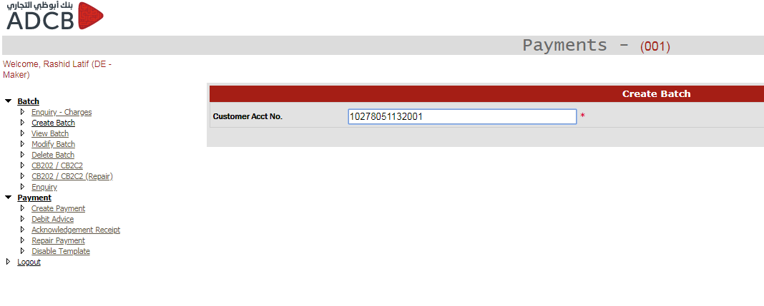

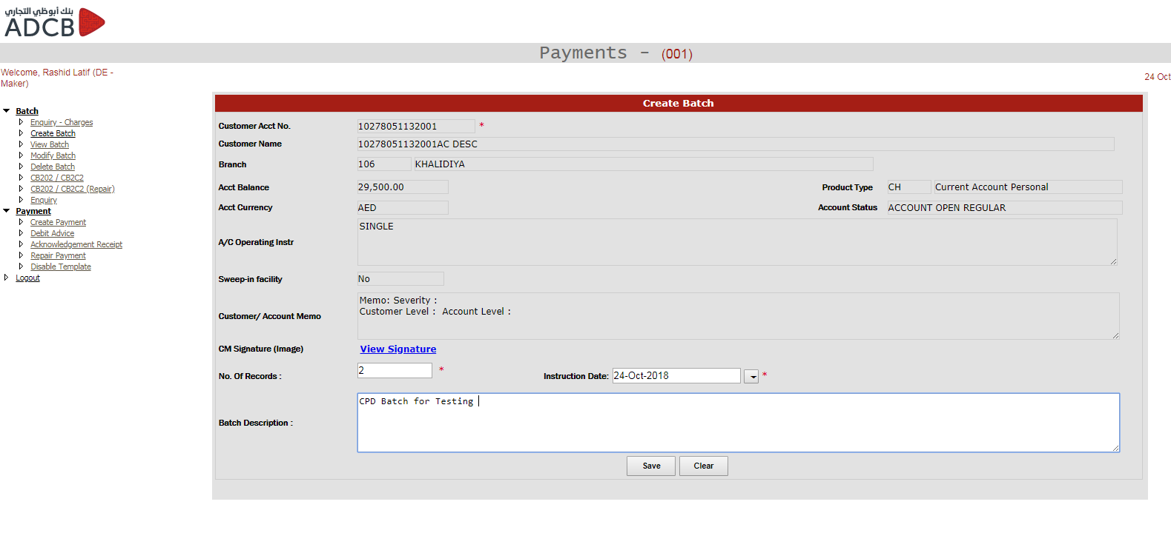

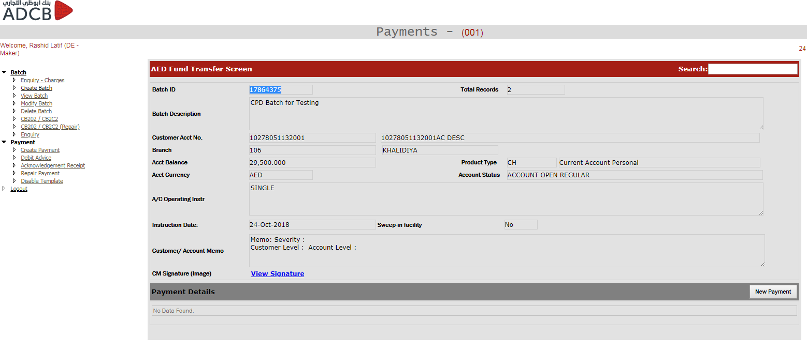

Below is the qeury used for fetching customer information from GoldenGate while mode of operations is fetched from TIBCO service named InqCSAcctIBANInfo

SELECT MCD.COMP_MIS_1 mis_code, SCCC.customer_type flg_typ_class, SCA.iban_ac_no cod_acct_iban, SC.customer_category flg_cust_typ, SCA.ac_desc title, SCA.cust_ac_no acctno, SCA.cust_no custid, fn_fcr_account_stat(SCA.cust_ac_no,SCA.branch_Code,'C') AS acctstatuscode, fn_fcr_account_stat(SCA.cust_ac_no,SCA.branch_Code,'D') AS acctstatusdesc, NVL((NVL(sca.acy_avl_bal,'0') + NVL((SELECT dsp_eff_line_amount FROM getm_facility a, getm_liab_cust b, Sttm_facility_Lmcust c Where line_code||line_serial = linked_ref_no And c.cust_ac_no = sca.cust_ac_no And c.branch_code =sca.branch_code And c.CUSTOMER_NO = b.customer_no And b.liab_id = a.liab_id ), '0') - NVL (sca.min_reqd_bal, '0') - NVL (( Select Nvl(Sum(Amount_Due - Amount_Available-amount_paid), 0) From Cstb_Auto_Settle_Block Where Account_No = sca.cust_ac_no And Account_Br = sca.branch_code ),0)), '0') bal, (TRIM (sc.address_line2) || ' ' || TRIM (sc.address_line3) || ' ' || TRIM (sc.address_line4) || ' ' || TRIM (sc.country)) CustomerAdd, (TRIM (sca.address2) || ' ' || TRIM (sca.address3) || ' ' || TRIM (sca.address4) || ' ' || TRIM (sca.country_code)) address, SCA.account_class productcode, SCA.ccy currencycode, SCA.ccy currencydesc, ' ' instr, 'CH' productdesc, SAC.DESCRIPTION acproddesc, (select case when count(1) > 0 Then 'Y' Else 'N' end from sttm_sweep_details where cust_account = SCA.cust_ac_no) sweepin, 'Customer Level : ' || (SELECT cid.user_message FROM cstm_inst_master cim, cstm_inst_detail cid WHERE cid.memo_id = cim.memo_id AND cim.category = 'C' AND cim.record_stat = 'O' AND cim.auth_stat = 'A' AND cid.customer_no = sc.customer_no AND inst_id = (SELECT MAX(inst_id) FROM cstm_inst_master cim, cstm_inst_detail cid WHERE cid.memo_id = cim.memo_id AND cim.category = 'C' AND cim.record_stat = 'O' AND cim.auth_stat = 'A' AND cid.customer_no = sc.customer_no)) || ' Account Level : ' || (SELECT cid.user_message FROM cstm_inst_master cim, cstm_inst_detail cid WHERE cid.memo_id = cim.memo_id AND cim.category = 'A' AND cim.record_stat = 'O' AND cim.auth_stat = 'A' AND cid.customer_no = sca.cust_ac_no AND inst_id = (SELECT MAX(inst_id) FROM cstm_inst_master cim, cstm_inst_detail cid WHERE cid.memo_id = cim.memo_id AND cim.category = 'C' AND cim.record_stat = 'O' AND cim.auth_stat = 'A' AND cid.customer_no = sca.cust_ac_no)) custmemo, (SELECT cid.display_type FROM cstm_inst_master cim, cstm_inst_detail cid WHERE cid.memo_id = cim.memo_id AND cim.category = 'C' AND cim.record_stat = 'O' AND cim.auth_stat = 'A' AND cid.customer_no = sc.customer_no AND inst_id = (SELECT MAX(inst_id) FROM cstm_inst_master cim, cstm_inst_detail cid WHERE cid.memo_id = cim.memo_id AND cim.category = 'C' AND cim.record_stat = 'O' AND cim.auth_stat = 'A' AND cid.customer_no = sca.cust_ac_no)) memoseverity, SCA.branch_code BRANCH_CODE, (SELECT branch_name FROM sttm_branch sb WHERE sb.branch_code = sca.branch_code) BRANCH_DESC, (SELECT COMP_MIS_3 FROM MITM_CUSTOMER_DEFAULT INNER JOIN STTM_CUST_ACCOUNT ON MITM_CUSTOMER_DEFAULT.Customer = STTM_CUST_ACCOUNT.CUST_NO WHERE CUST_AC_NO = '10503791020005') mis_code_1, 'N' is_virtual_acct FROM sttm_cust_account SCA INNER JOIN sttm_customer SC ON sca.cust_no = sc.customer_no INNER JOIN sttm_customer_cat SCC ON SCC.cust_cat = sc.customer_category INNER JOIN sttm_cust_cat_custom SCCC ON SCC.cust_cat = SCCC.cust_cat INNER JOIN STTM_ACCOUNT_CLASS SAC ON SCA.ACCOUNT_CLASS = SAC.ACCOUNT_CLASS LEFT OUTER JOIN MITM_CUSTOMER_DEFAULT MCD ON SCA.CUST_NO = MCD.CUSTOMER LEFT OUTER JOIN SVTM_ADD_ACC_MSG_CUSTOM SAAMC ON SCA.CUST_AC_NO = SAAMC.ACC_NO AND SCA.BRANCH_CODE = SAAMC.BRANCH LEFT OUTER JOIN sttm_cust_Acc_custom scac ON SCA.CUST_AC_NO = scac.CUST_AC_NO AND SCA.branch_code = scac.branch_code WHERE (SCA.iban_ac_no ='10503791020005' OR SCA.cust_ac_no='10503791020005')

UNION ALL

SELECT DISTINCT '' mis_code ,'' flg_typ_class,'' cod_acct_iban,'' flg_cust_typ, sva.vir_acc_name title,sva.vir_acc_no acctno,sa.cust_no custid, DECODE (sva.record_stat,'C', '1',fn_fcr_account_stat (sa.cust_ac_no, sa.branch_code, 'C')) AS acctstatuscode, DECODE (sva.record_stat,'C', 'ACCOUNT CLOSED',fn_fcr_account_stat (sa.cust_ac_no, sa.branch_code, 'D')) AS acctstatusdesc, NVL ((NVL (sa.acy_avl_bal, '0') + NVL ((SELECT dsp_eff_line_amount FROM getm_facility a, getm_liab_cust b, sttm_facility_lmcust c WHERE line_code || line_serial = linked_ref_no AND c.cust_ac_no = sa.cust_ac_no AND c.branch_code = sa.branch_code AND c.customer_no = b.customer_no AND b.liab_id = a.liab_id), '0') - NVL (sa.min_reqd_bal, '0') - NVL ( (SELECT NVL ( SUM( amount_due - amount_available - amount_paid), 0) FROM cstb_auto_settle_block WHERE account_no = sa.cust_ac_no AND account_br = sa.branch_code), 0)), '0') bal, '' CustomerAdd, TRIM((sc.address_line2) || ' ' || TRIM (sc.address_line3) || ' ' || TRIM (sc.address_line4) || ' ' || TRIM (sc.country)) address, sa.account_class productcode, sva.ccy currencycode, sva.ccy currencydesc, '' instr1,'CH' productdesc,'' acproddesc, '' sweepin,'' custmemo,'' memoseverity,'' BRANCH_CODE,'' BRANCH_DESC, '' mis_code_1, 'Y' is_virtual_acct FROM sttm_cust_account sa, sttm_virtual_accounts sva, sttm_customer sc WHERE sva.phy_acc = sa.cust_ac_no AND sva.phy_brn = sa.branch_code AND sa.cust_no = sc.customer_no AND sva.vir_acc_no = (SELECT vir_acc_no FROM sttm_virtual_accounts_custom WHERE IBAN ='10503791020005' OR vir_acc_no ='10503791020005')

Since every field is not present in golden gate, we are also using TIBCO to fetch some other information including Customer Account Memo, Account Mode of operation etc.

After clicking the Save button, the page is redirected to “Add Fund Transfer Screen” and batch is created in table “UAEFTS_Batch” where one can find the details in payment hub db with below query.

**select** * **From** uaefts_batch **where** batchid = 17864375

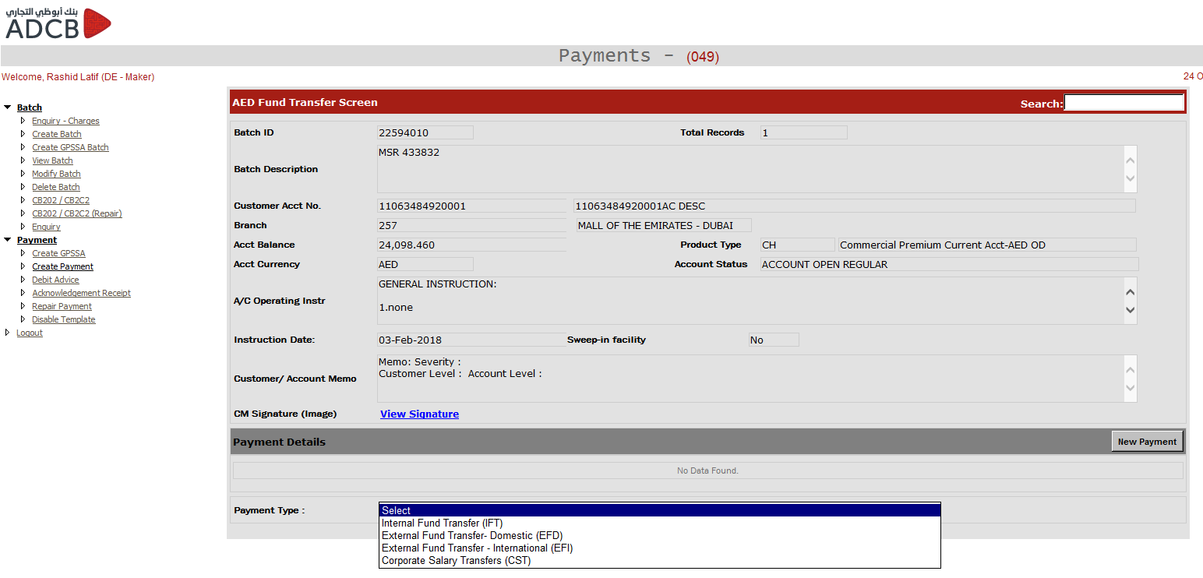

After clicking on the new payments, user can select IFT, EFD, EFI or CST payment and based on the payment type, the number of sections will be visible to the USER.

**IFT Screen:**

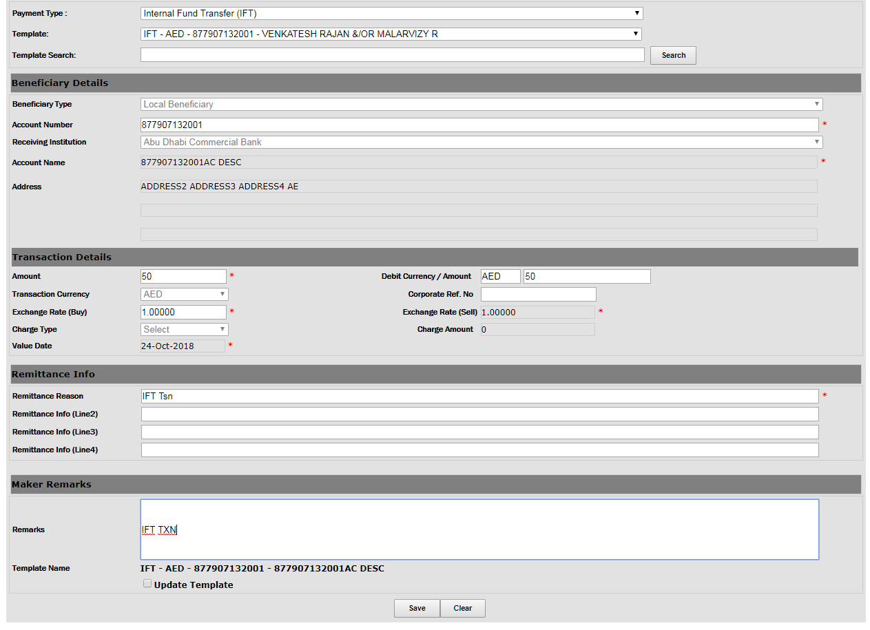

**EFD Screen:**

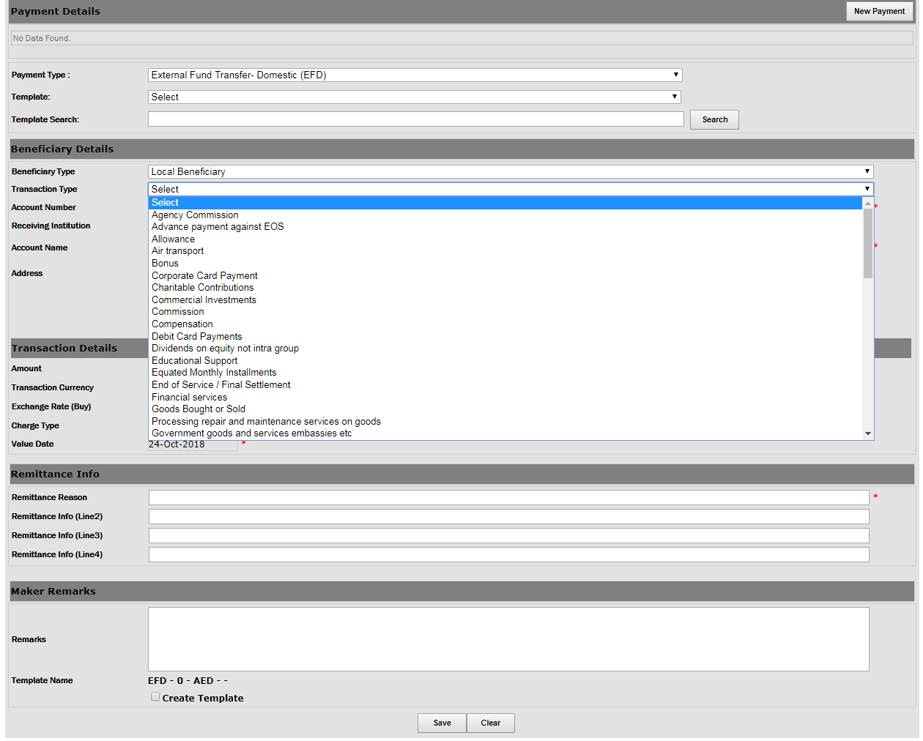

**EFI Screen:**

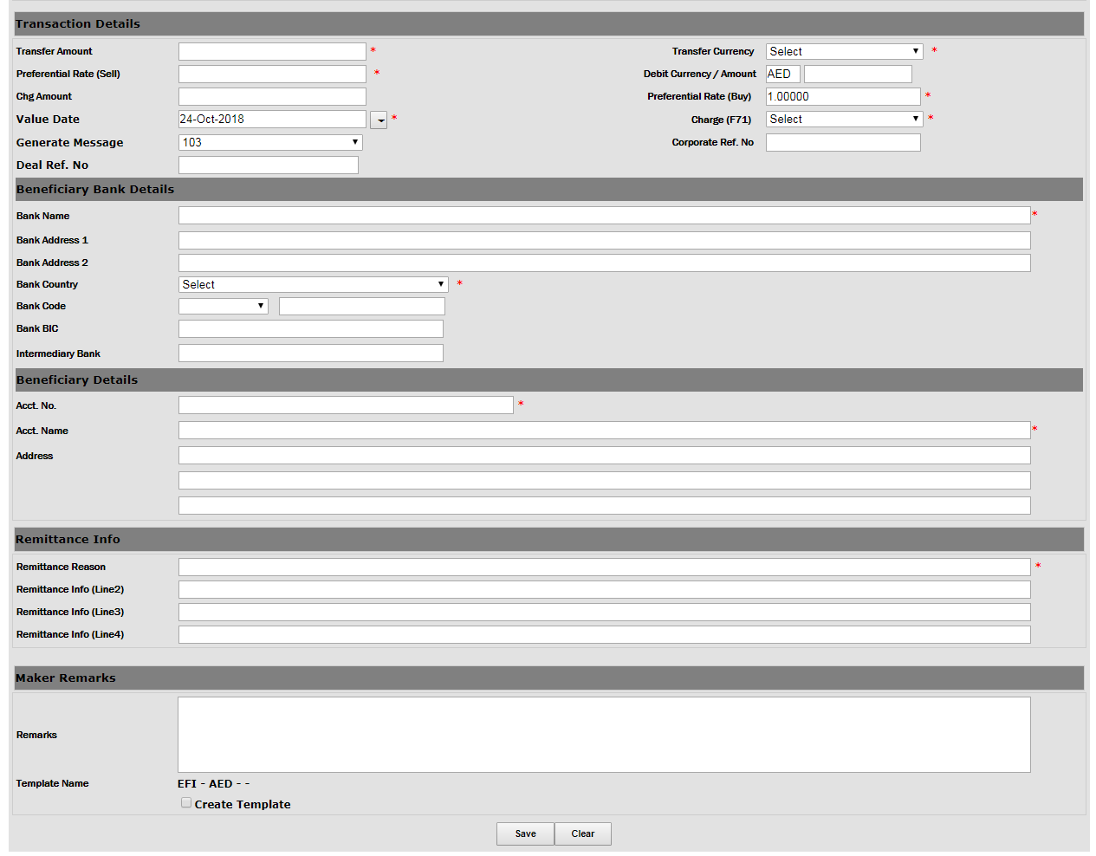

Once the we click on the save button, the transaction is store in table “UAEFTS_REMITDTLSCKR” where one can search the detail with below query.

**SELECT** * **from** uaefts_remitdtlsckr **where** batchid = 22514280 **and** checkerrowid = 59415549

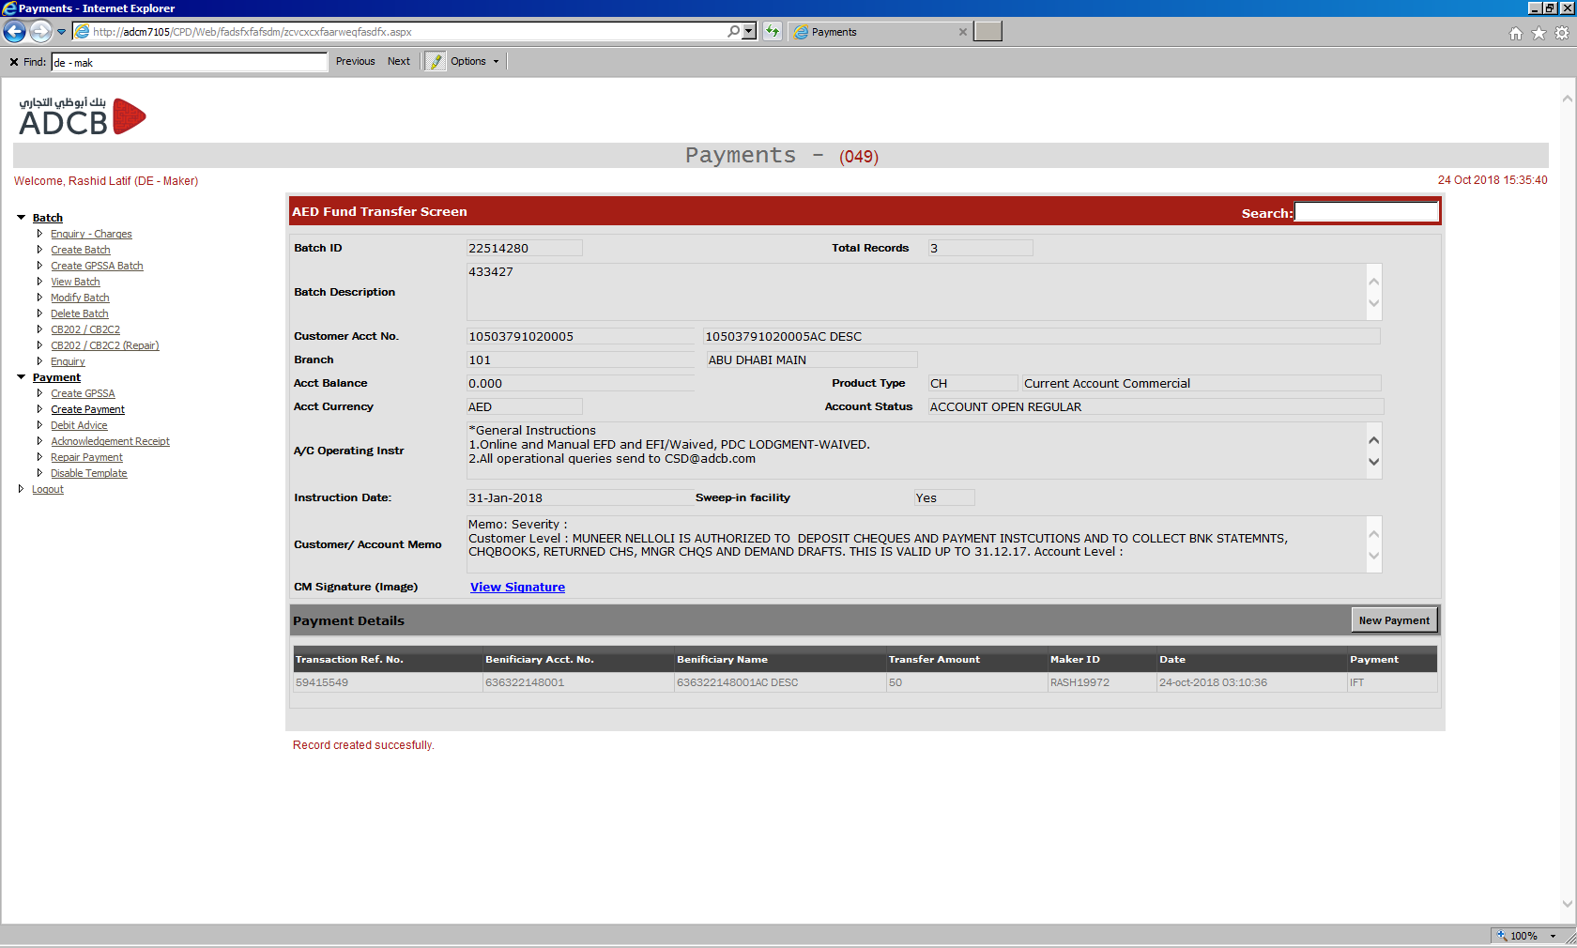

Once all the transactions are created for the batch, one can see the close batch button. Oncly after closing the batch, the transactions will go to checker screen.

If one wants to see all the batches that are created and not sent to checker, user can click on the “Create Payment” link to see all the batches that are not closed.

Below query is used for fetching the pending batches on Create Payment screen.

SELECT batchid "Batch ID", batchdesc "Batch Desc.", totrecords "Total Rec.", acctno "Acct. No.", openby "Created By", to_char(openon,'dd-Mon-yyyy hh:mm:ss') "Created At", to_char(instr_dt,'dd-Mon-yyyy') "Instruction Date" FROM UAEFTS_BATCH WHERE closeby IS NULL AND closeon IS NULL AND authorizedby IS NULL AND nvl(CMS_BATCH_ID,' ')<>'PEN' AND authorizedon IS NULL AND dept='CPD' AND BATCHID >13105150 ORDER BY batchid DESC

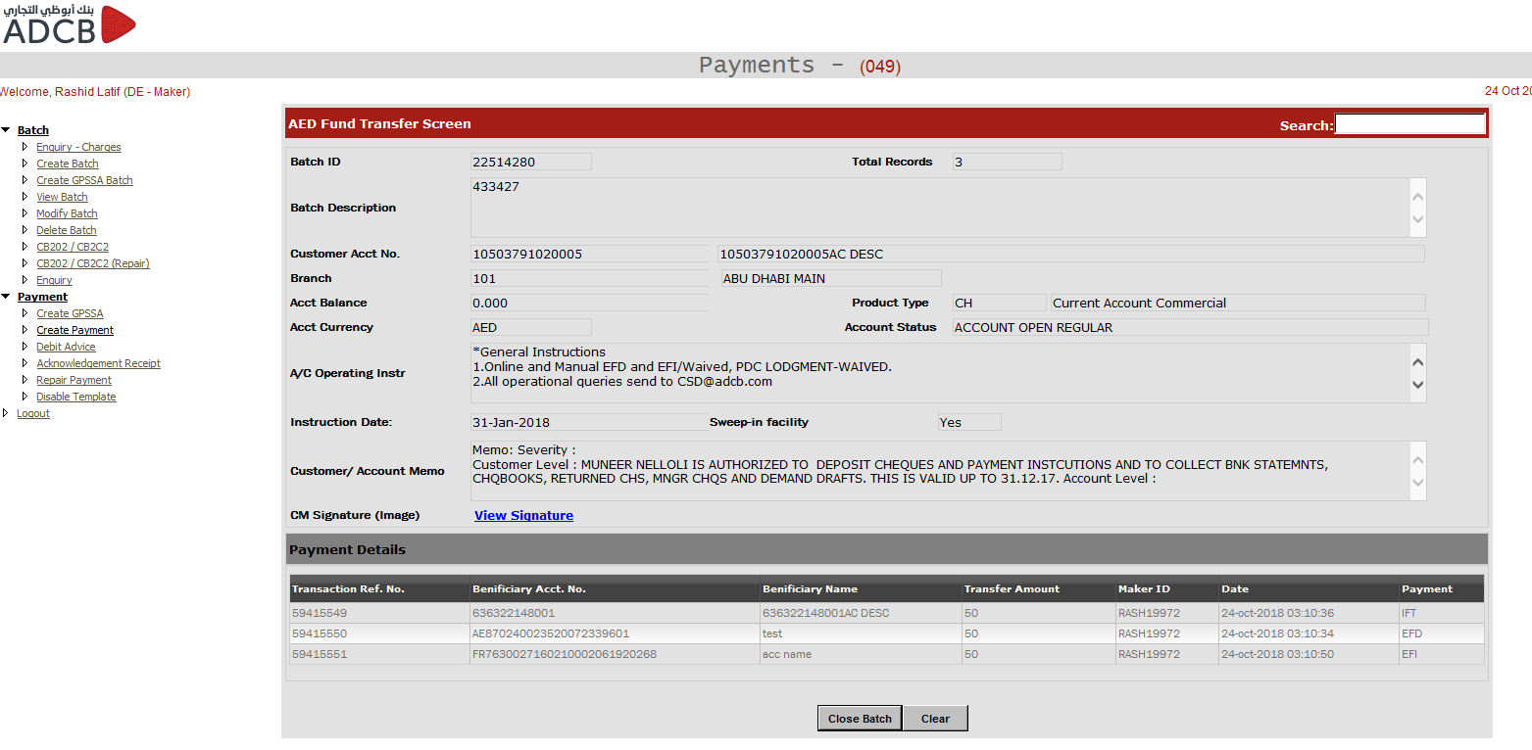

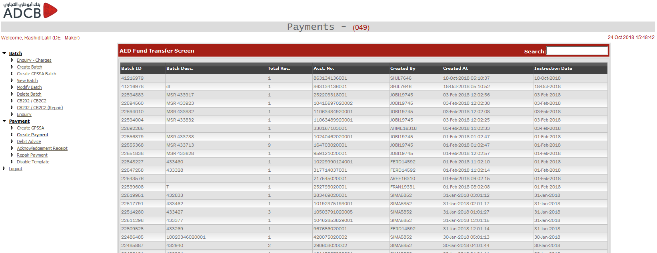

Once the batch is closed, it goes to checker where checker can either approve it or reject it. The complete batch is only processed once all the transactions are approve. If rejected (any transaction), the batch will not be processed and the rejected transaction will go the maker where the transaction can be repaired under “Repair Payment” screen.

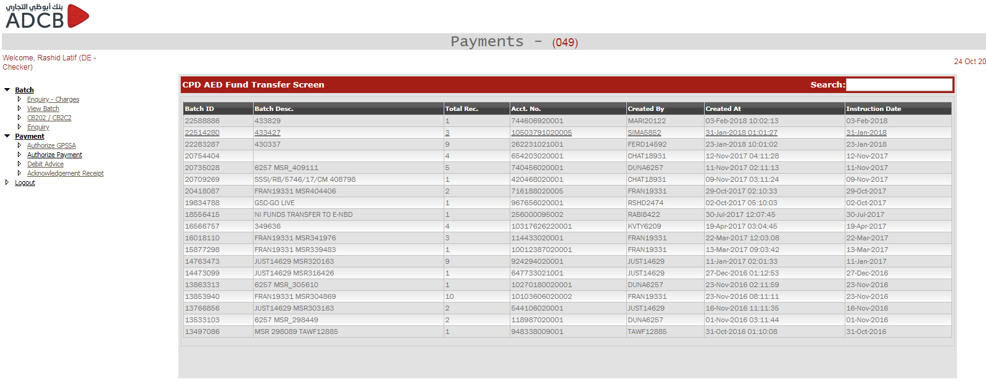

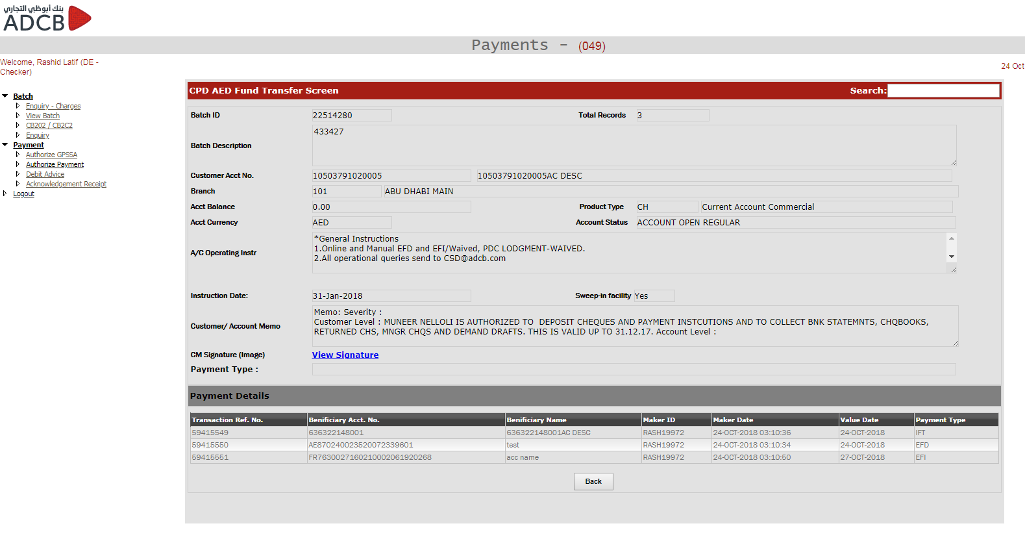

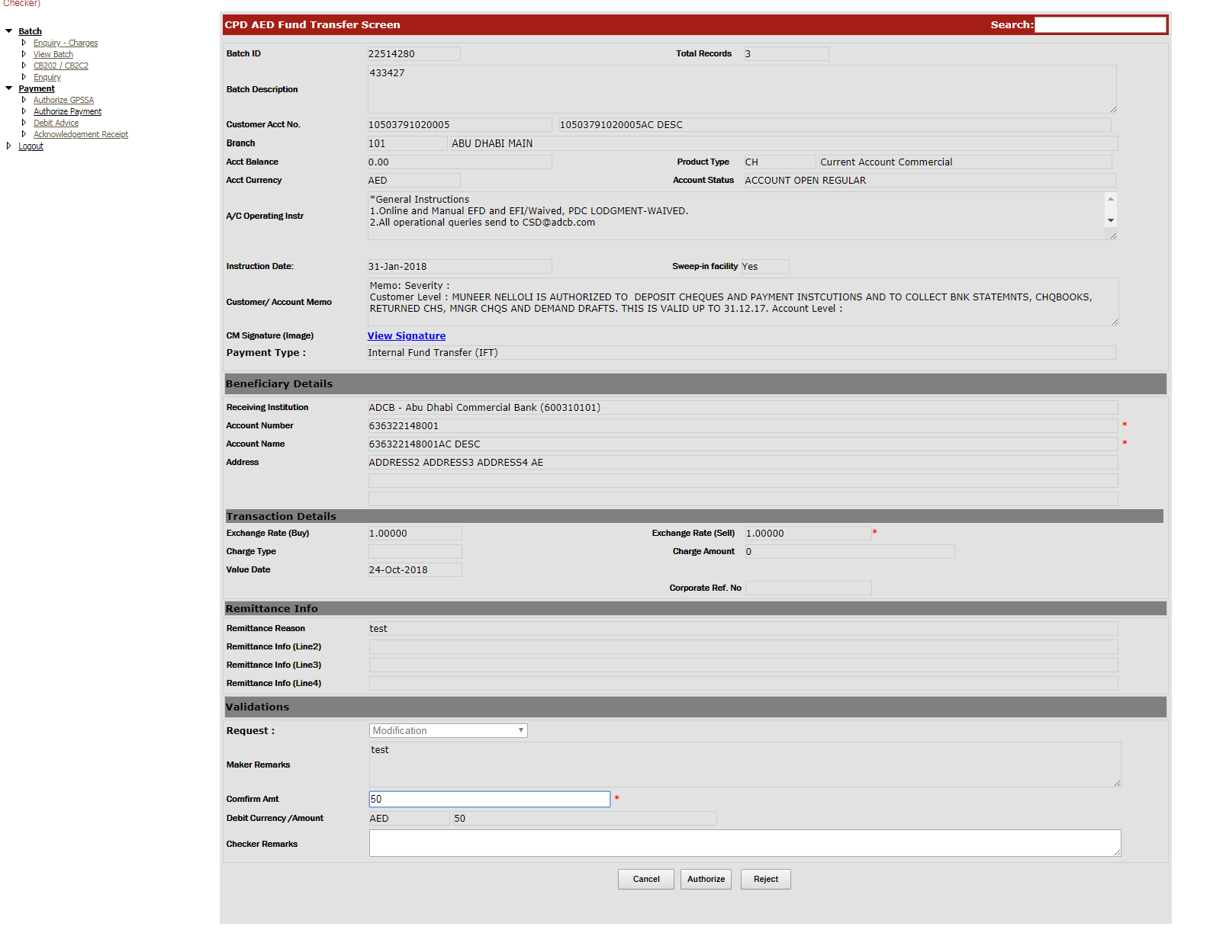

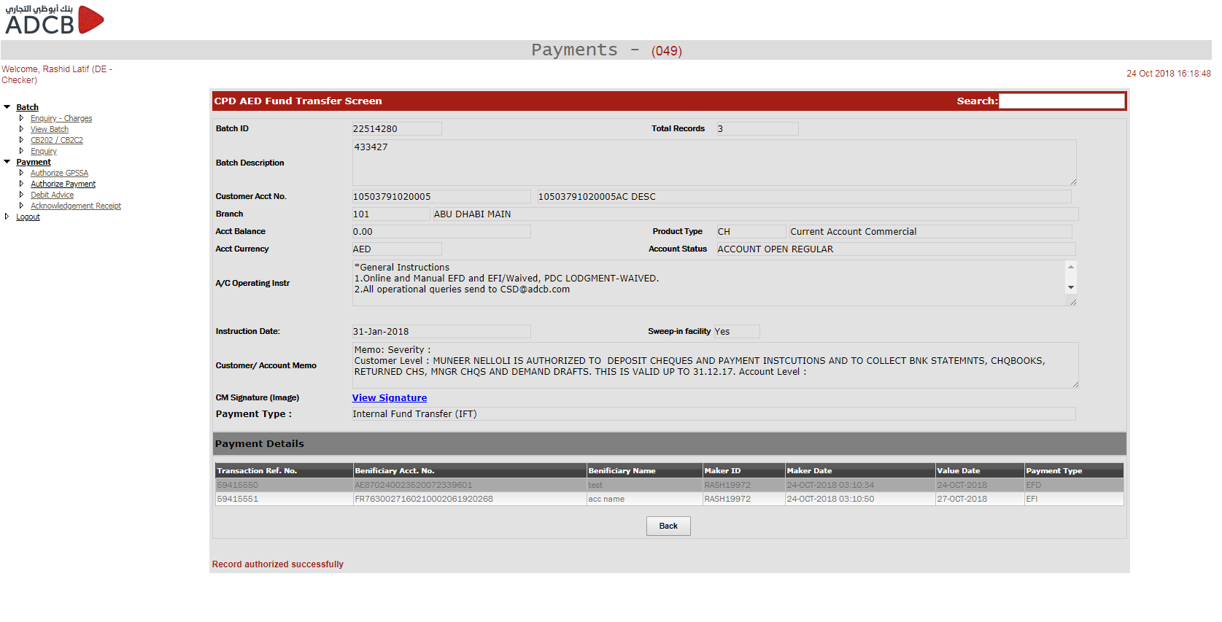

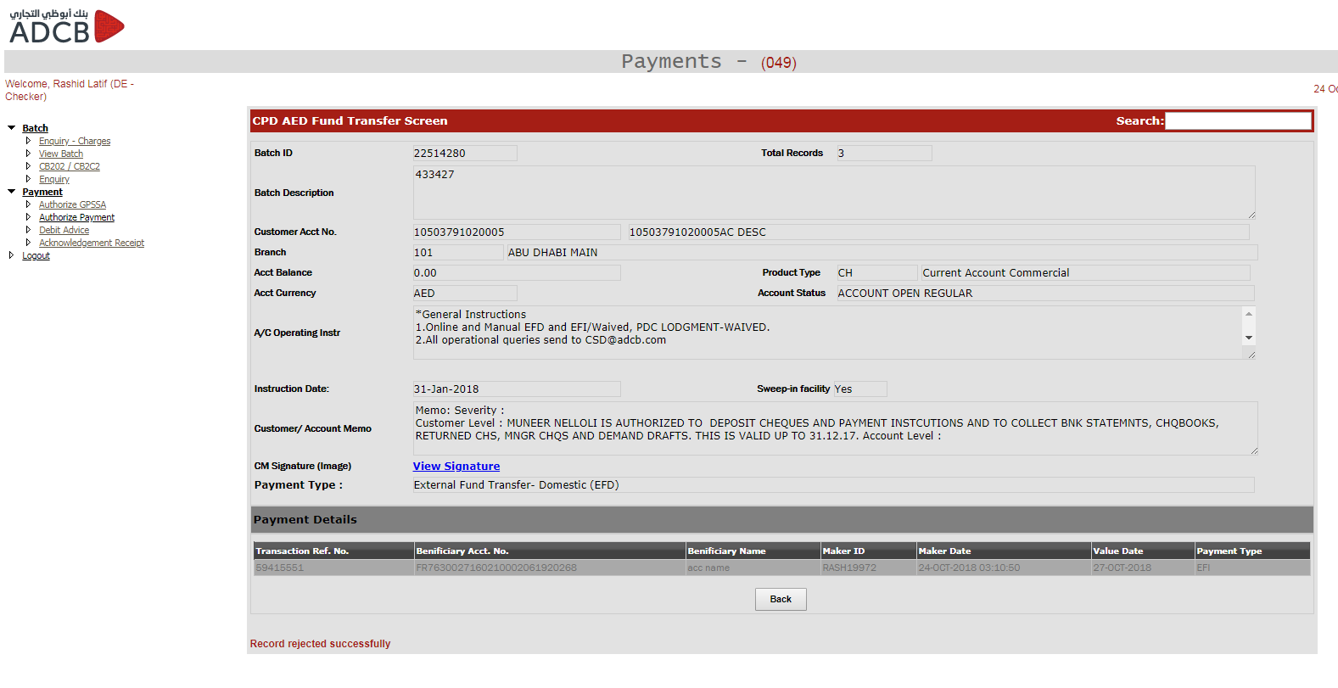

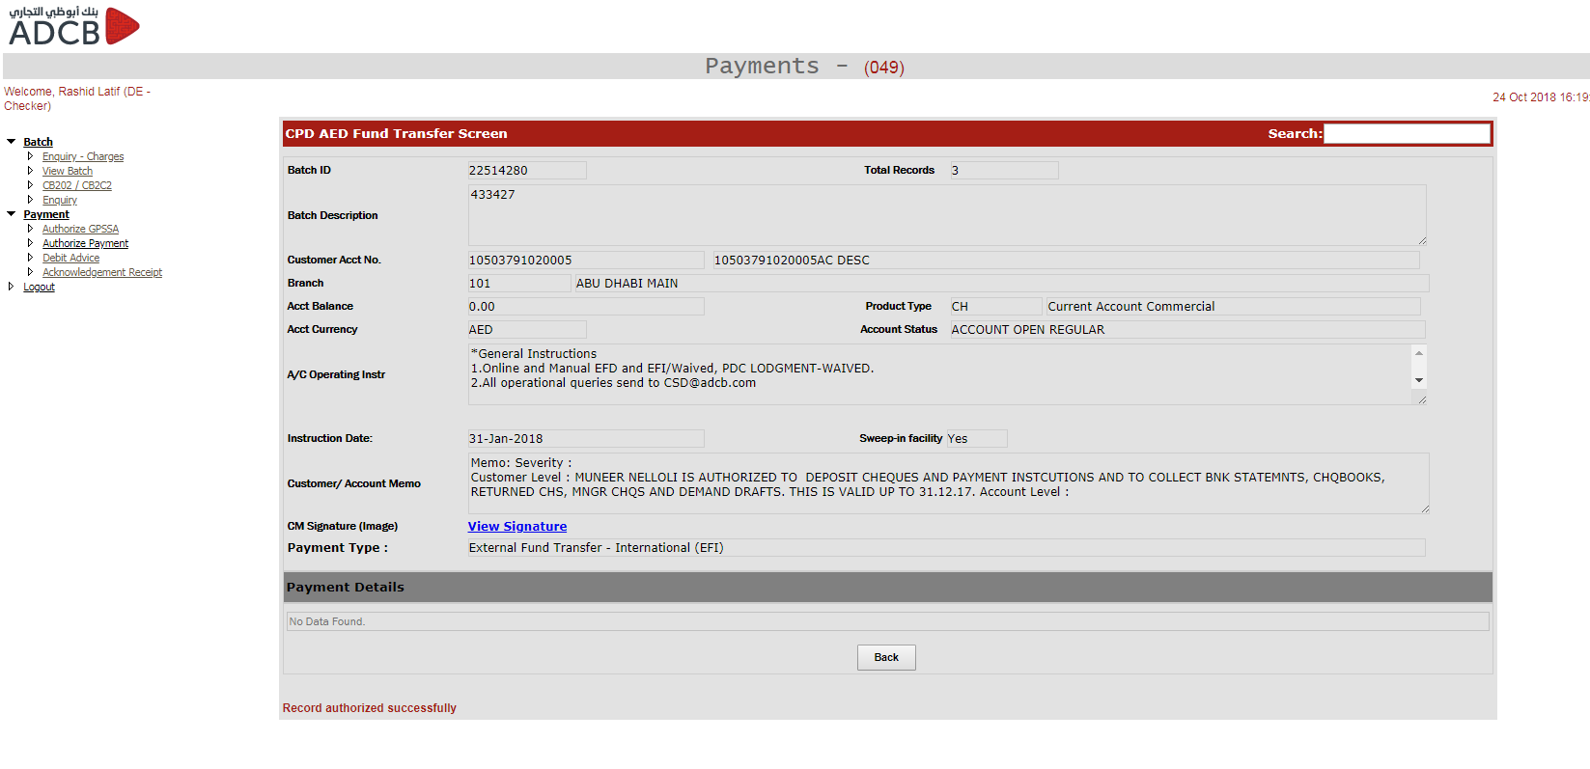

The batch will not be processed untill all the transactions are either approved or delted. The rejected transasction has to be repaired or deleted from “Repair Payment” screen. Once the trasnaction is repaired or deleted, it will again go to checker where checker can approve it.

Below query is used to fetch the rejected transaction.

SELECT batchid "Batch ID", batchdesc "Batch Desc.", totrecords "Total Rec.", acctno "Acct. No.", openby "Created By", to_char(openon,'dd-Mon-yyyy hh:mm:ss') "Created At", to_char(instr_dt,'dd-Mon-yyyy hh:mm:ss') "Instruction Date" FROM UAEFTS_BATCH WHERE closeby IS NOT NULL AND closeon IS NOT NULL AND authorizedby IS NULL AND authorizedon IS NULL AND dept='CPD' AND nvl(cms_batch_id,' ')<>' PEN' AND BATCHID IN ( SELECT UAEFTS_REMITDTLSCKR.batchid FROM UAEFTS_REMITDTLSCKR INNER JOIN UAEFTS_PAYMENT p on p.paymenttype = UAEFTS_REMITDTLSCKR.paymenttype INNER JOIN UAEFTS_BATCH ON UAEFTS_BATCH.batchid = UAEFTS_REMITDTLSCKR.batchid AND NVL(UAEFTS_BATCH.CMS_BATCH_ID, ' ') <> 'PEN' WHERE RECSTATUS = 'R') AND batchid > 13105150 ORDER BY batchid DESC

After the approval, the checker needs to authorize the batch. The transaction will not be processed untill the batch is not authorized. This can be checked from DB with the below query and checking the column “AuthorizedBy”.

select * from UAEFTS_batch where batchid = '22514280'

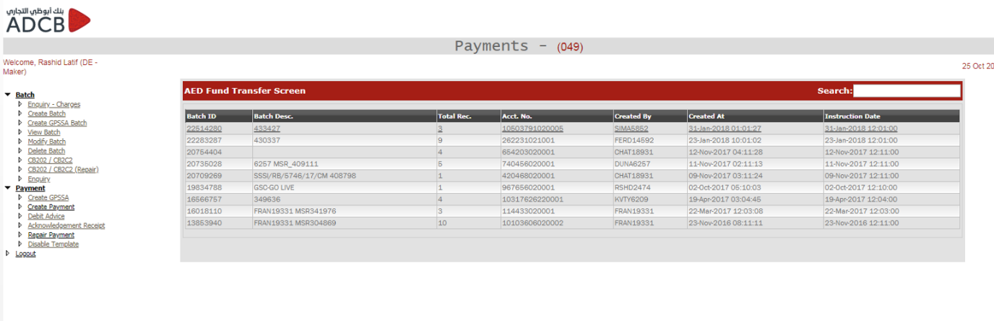

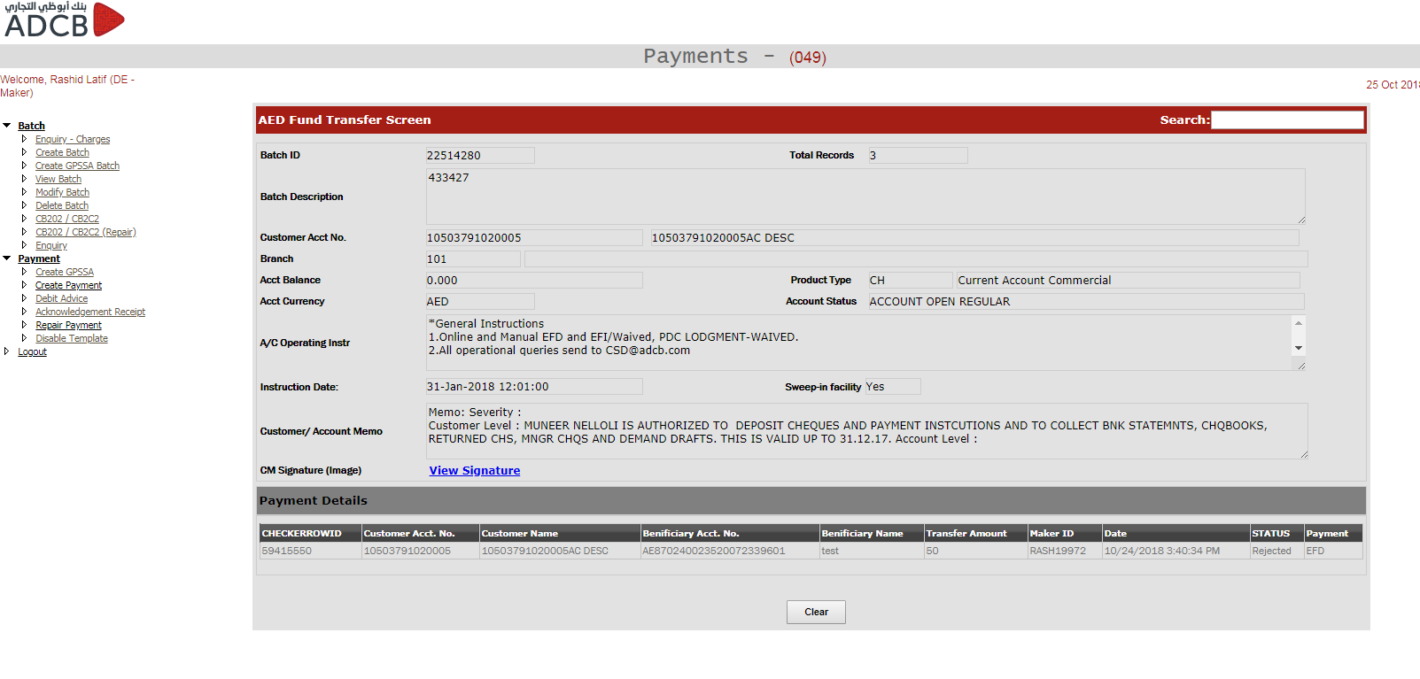

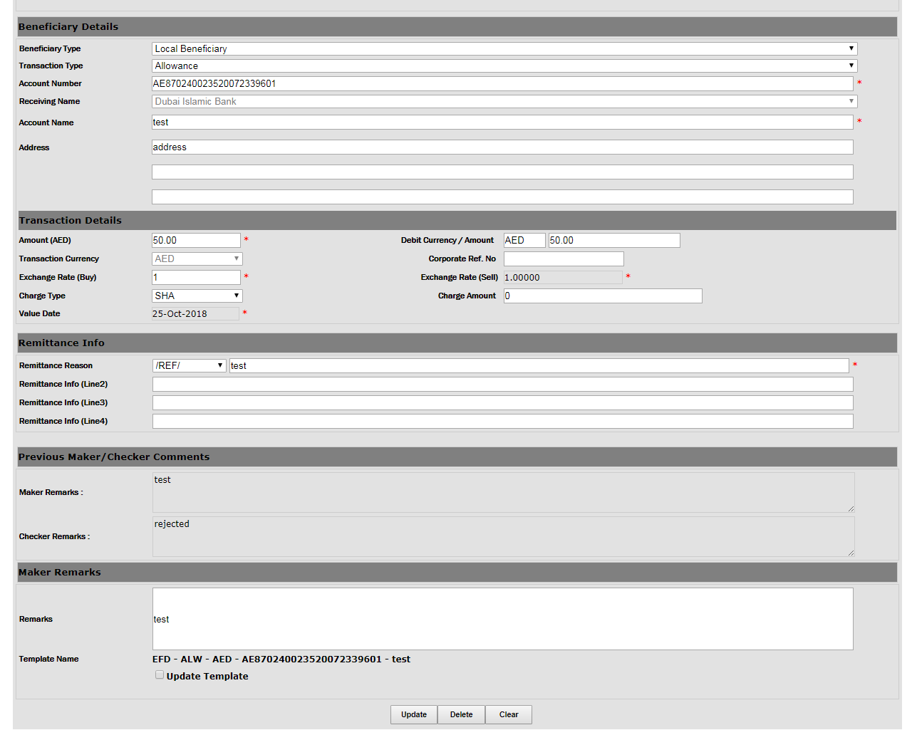

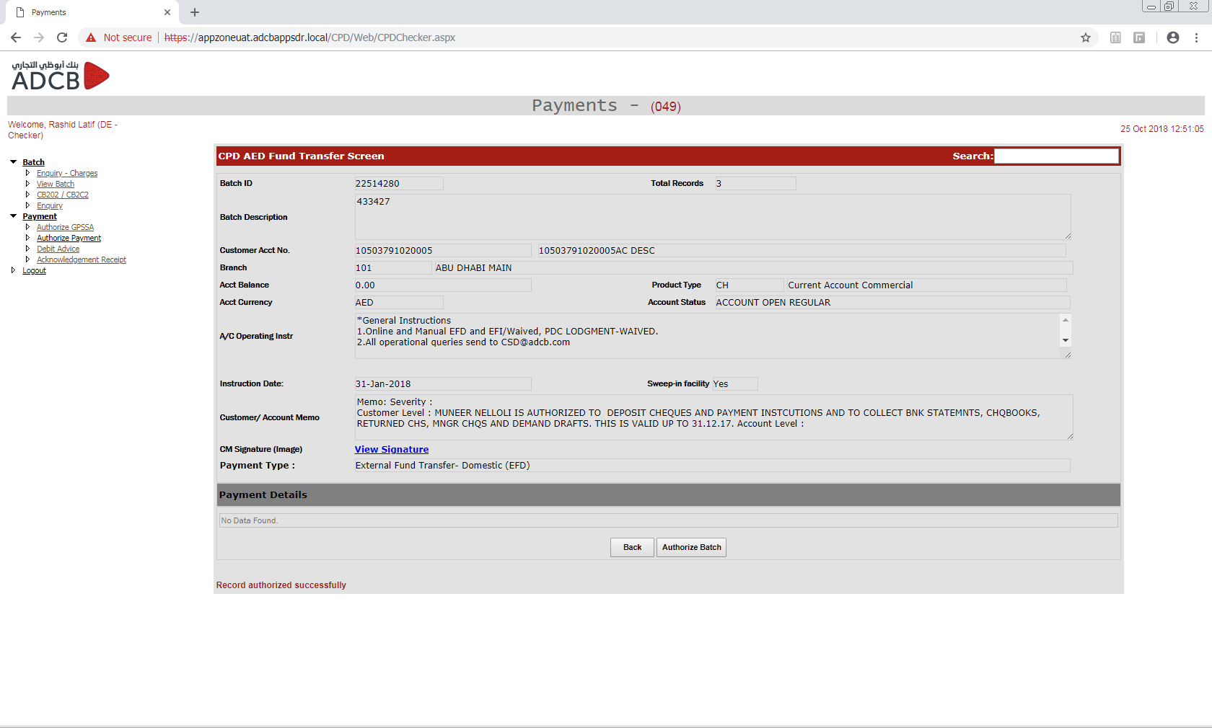

Once the batch is authorized, a URL is being called which invokes the java servlet. The servlet performs different validations (duplicate transaction, invalid account title, invalid account, fraud check, insufficient fund etc.) and once the validations are successful, the transactions are executed.

We can check if the URL is being invoked or not by checking if the batch entry is there in “payment_txn_mt” table. Also there is an entry in the log file by which we can confirm whether the URL for the batch was called or not. Sample log entry is attached below.

EVENT :[5/16/2018 2:57:41 PM] E Calling URL : http://10.146.166.248:9080/paymenthubws/PaymentProcessServlet?batchId=13516254&txnRefNo=32003757&txn_type=FCY&messageType=103

select * from payment_txn_mt where batch_id = '22514280'

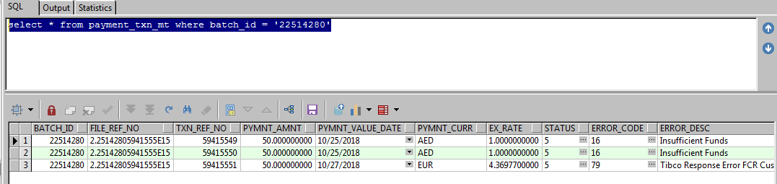

If the batch transactions are processed successfully, the status would become “10” but if some validations are failed then we can check the error_code column in DB to check the error. Frontend user can check the error using “View Batch” screen and entering batch id. Complete history of the transaction can be seen there.

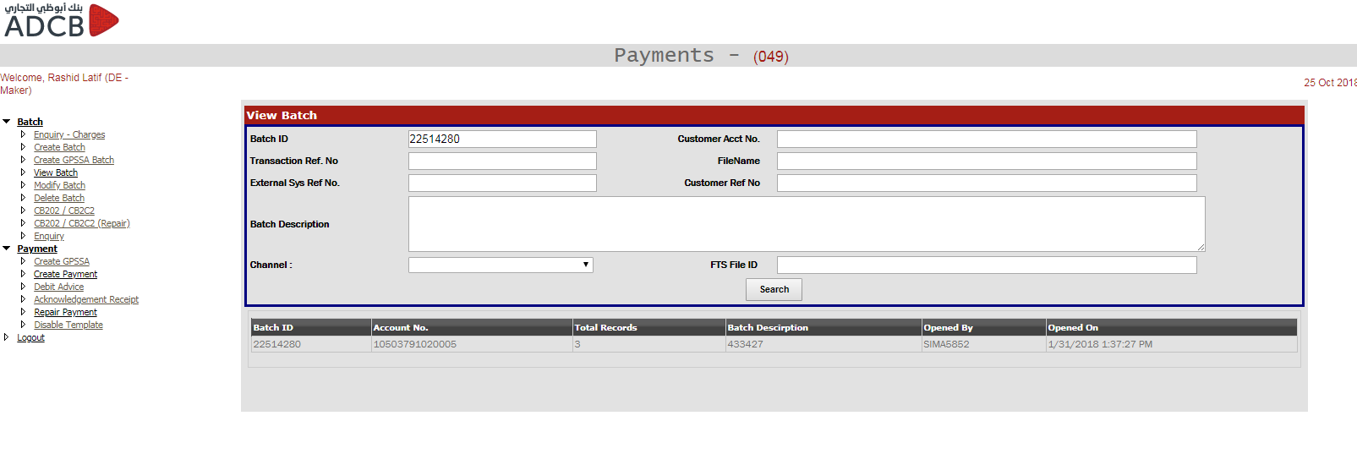

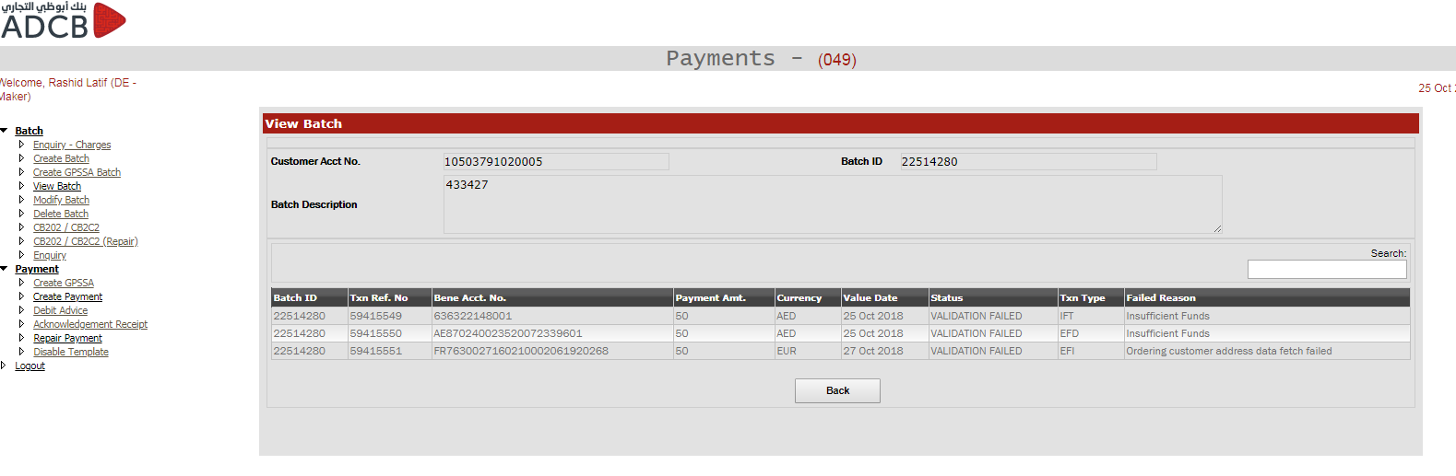

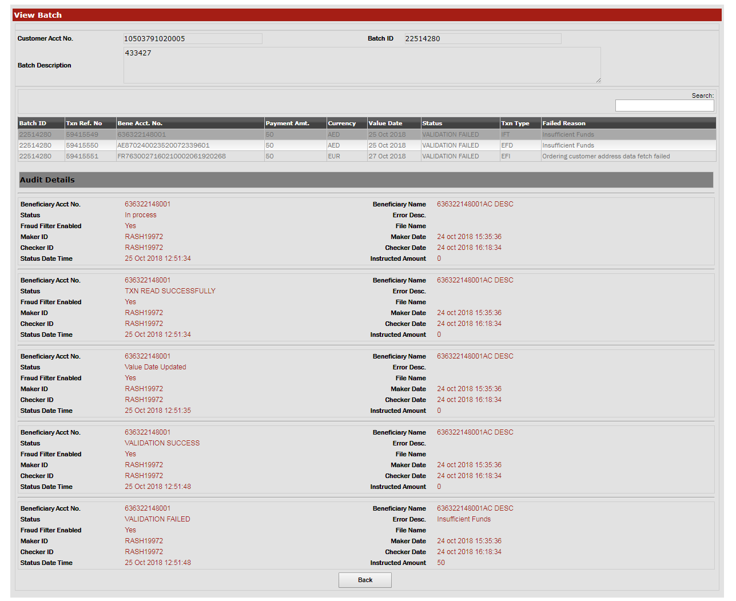

If any of the transaction in a batch is failed then the user has to log in to repair profiles based on the error code. If it failed due to fraud then user has to log in to Frd-Maker profiles else Rep – Maker profile is to be signed in.

Once the repair is done, the transaction again goes through the validation and if it fails again for some other issue, it will again go to the repair queue.

**De – Maker/Checker: GPSSA (General Pension and Social Security Authority)**

GPSSA is an initiative where monthly pension contributions of public and private sector employers are sent to GPSSA using UAEFTS. There are two ways to process GPSSA transaction. One is through custom bulk upload and the other one is through frontend payment hub application. There are certain validations that are done both in frontend and java engine to process these transaction. Below are the codes used for GPSSA pension module.

* + GPSSA
  + ADJST - Adjustment
  + First Time Contribution - GPNEW
  + End Of Service Contribution – GPEOS
  + Retro Payment – GPRET
  + Temporary Stoppage Contribution – GPTSP
  + Resumption Of Previously Stopped Contribution - GPRSM

These validation are defined below.

1. **Validation for GPSSA**

Please check Annexure G for all the CTD fields mapping.

* If value on CTD-04 (Beneficiary Institution Identifier) is 985110101, then value of CTD-05 must always be “PEN”. Further, system skips IBAN validation on CTD-14.
* If value on CTD-04 = 985110101, then date format on CTD-16 must be MMYYY
* If value on CTD-04 (Beneficiary Institution Identifier) is 985110101, then system to validate string 10-24 on CTD-14 (Beneficiary AC with Receiving Participant) against string 19-33 on CTD-16.
* If match, then we proceed with processing.If not, then we reject outright the transaction. No repair is required. Amount debited from customer is the total of all transactions validated successfully, excluding the reject.
* If value on CTD-04 = 985110101 and Remit Info (CTD-16) contains /REF/ADJST, then Special Instructions for Beneficiary field (CTD-19) is mandatory and equal to 174. The following sequential values are to be provided for as field 15 on Customer Bulk upload file and mapped to the field in FTS file.
* /E=0000000.00 where E = employee contribution
* /C=0000000.00 where C = employer contribution
* /B=DDMMYY where B = new Basic effective date
* /H=DDMMYY where H = new Housing effective date
* /S=DDMMYY where S = new Social Allowance effective date
* /C=DDMMYY where C = new Child Allowance effective date
* /L=DDMMYY where L = new Cost of Living Allowance effective date
* /O=DDMMYY where O = new Other allowance effective date
* /HP=000DDMMYY where HP = Sick Leave Half Pay
* /ZP=000DDMMYY where ZP = Sick Leave Zero Pay
* /LT=000DDMMYY where LP = unpaid long term leave
* /SL=000DDMMYY where SL = unpaid study leave
* /UA=000DDMMYY where UA = Unauthorized leave
* /ST=000DDMMYY where ST = unpaid short term leave
* /LP=000000000.00 where LP = unpaid leave payment; Must be left padded with 0’s to equate 12 characters
* If value on CTD-04 - 985110101, then only the following allowable CB strings prefixes are used on CTD-16/19 (E/C/S/B/H/S/C/L/O/T/HP/ZP/LT/SL/UA/ST/LP)
* Individual posting is done against each single record (individual debit and individual credit)
* “PEN” is hardcoded as transaction type CTD-05 field of FTS file.
* System validates strings 10-24 on Beneficiary AC with Receiving Participant (CTD-14) against strings 19-33 on remit info (CTD-16).
* If match, then user is able to close/send the batch for checker processing.
* If not then system to alert user
* Where pension contribution is = ADJST, then CTD-19 (Spl Instruction to Ben field) is mandatory. Further, system validates additional mandatory inputs for Spl Instruction to Ben field (CTD-19).

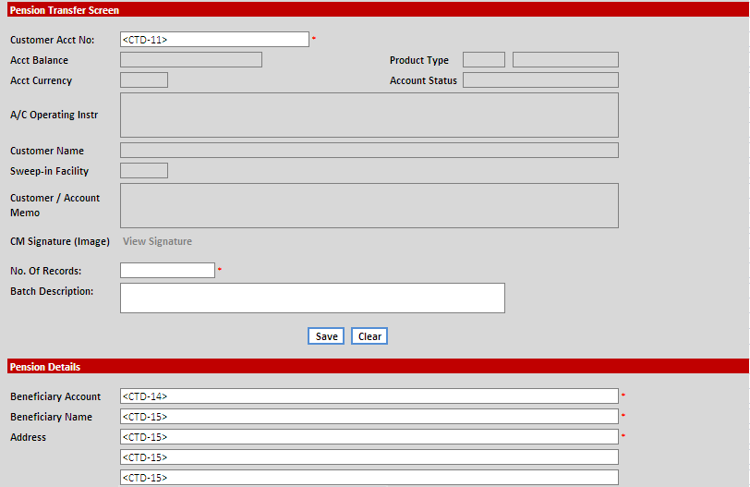

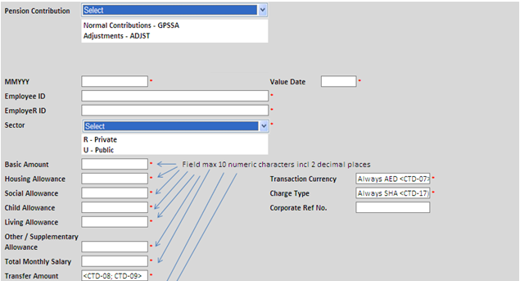

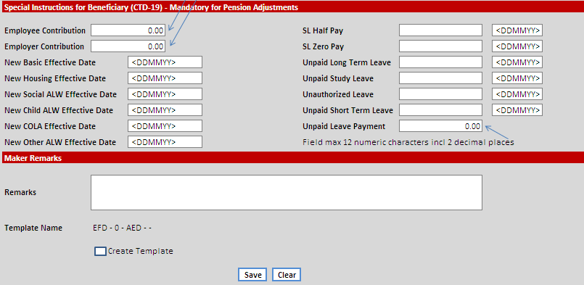

* Once the user inputs all the values for CTD-16, the application auto populates the designated strings on CTD-16. Refer to the appended mapping table for specific details.



**

**

**

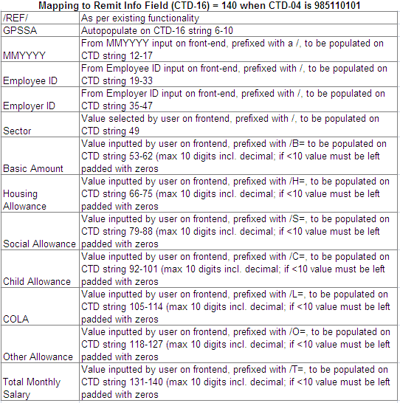

Note: If values on Remit info is > or < 140, then the maker is not be able to close/send the batch to Checker for authorization.

* System to further validate strings 10-24 on Beneficiary AC with Receiving Participant (CTD-14) against strings 19-33 on remit info (CTD-16).
* If match, then user to be able to close/send the batch for checker processing.
* If non match, then system to alert user.

**

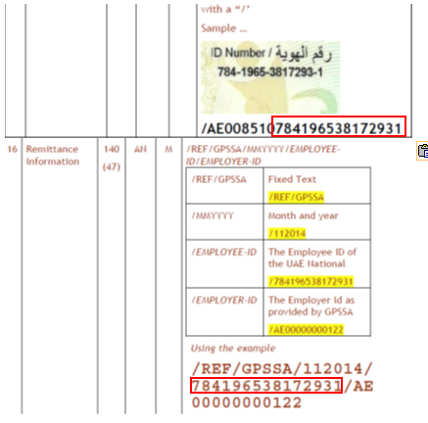

1. **Validation for ADJST (Adjustments)**

* Where pension contribution is = ADJST, system validates additional mandatory front-end inputs for Spl Instruction to Ben field (CTD-19) and populate the value to the FTS file to be generated.

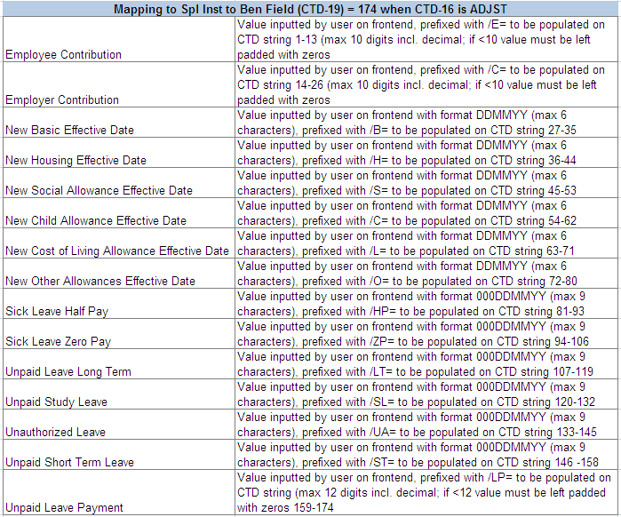

**  
**

**

The following are valid Pension Contribution processes: GPSSA or ADJST and are catered on CTD 16 Remit info field.

* If value on CTD-04 (Beneficiary Institution Identifier) is 985110101
* Value of CTD-05 must be PEN.
* System to skip IBAN validation on CTD-14.
* Format on CTD-16 is MMYYYY.
* System to validate strings 10-24 on CTD-14 (Beneficiary AC with Receiving Participant) against strings 19-33 on CTD-16.
* If match, then proceed with processing.
* If non match, then reject outright the transaction. No repair required. Amount to be debited from customer is the total of all transactions validated successfully, excluding the reject. This is as per current functionality.

**

* If value on CTD-04 = 985110101 and Remit Info (CTD-16) contains /REF/ADJST, then Special Instructions for Beneficiary field (CTD-19) is mandatory and equal to 174 length.

1. **Validation for GPNEW-For new employees**

* GPNEW-For new employees CTD-16

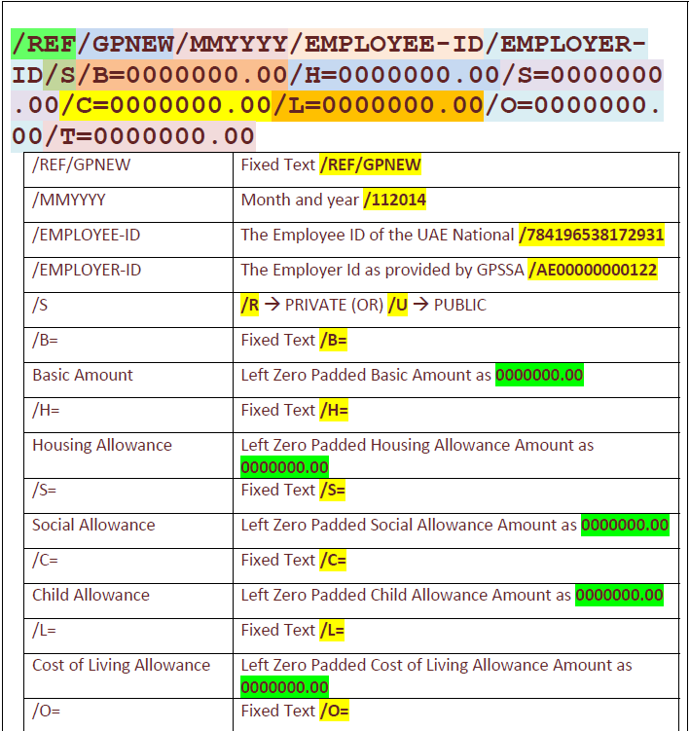

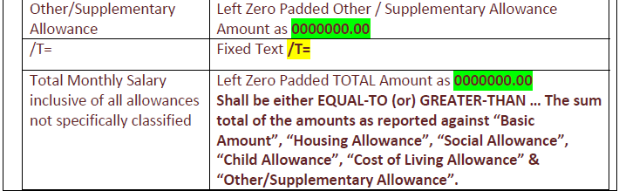

**Note:** If values on Remit info is > or < 140, then the maker is not able to close/send the batch to Checker for authorization. During file generation at the back-end, pHub is auto-populating /REF/ on the first 5 fields of CTD-16.

* GPNEW-For new employees CTD-19
* The length of the data in this field is 36.
* Employee (4th-13th string) and employer (17th-26th string) contribution is left padded with zeros to equate to 10 characters

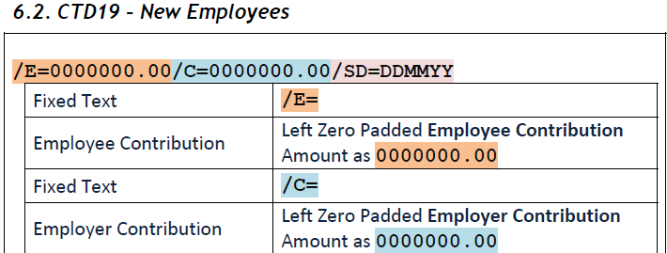

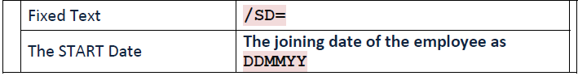

1. **GPEOS- Last contribution for existing employee**

* GPEOS- Last contribution for existing employee CTD-16

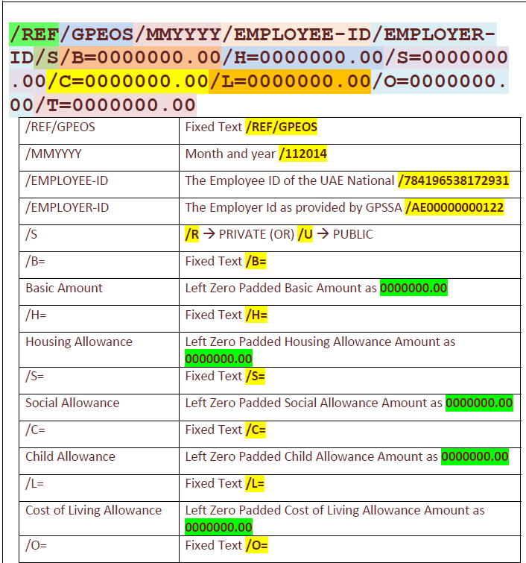

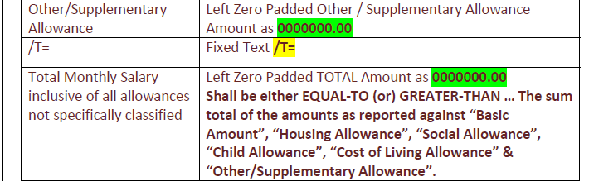

**Note:** If values on Remit info is > or < 140, then the maker is not be able to close/send the batch to Checker for authorization. During file generation at the back-end, pHub is auto-populating /REF/ on the first 5 fields of CTD-16.This functionality must remain..

If pension contribution = New Employee first contribution-GPNEW, then only the following fields are enabled for user input.The remaining fields are not required and are disabled.

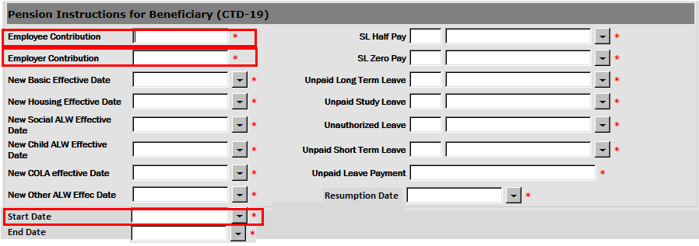

* The CTD-19 field on FTS message is propagated with the following components;
* /E= in strings 1 to 3,
* Amount of employee contribution on 4th to 13th string should be left padded with Zero to equate to 10 characters.
* /C= in string 14th to 16th
* Amount of Employer contribution should be propagated in 17th to 26th string left padded with Zero to equate to 10 characters.
* /SD= string 27th to 30th
* Start date value in 31st to 36th string.



* If values on CTD-19 > or < 36, then the maker is not able to close/send the batch to Checker for authorization.

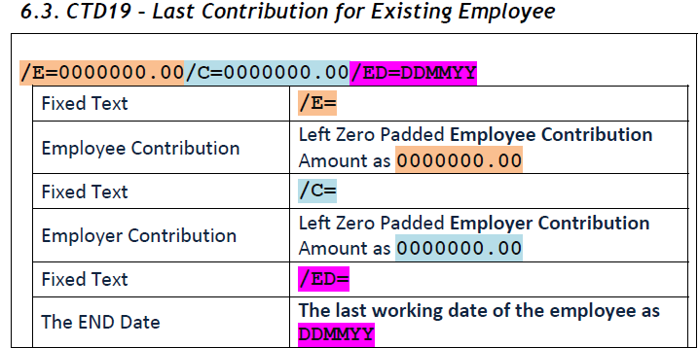

1. **GPRET-Retro Payments for existing Employees CTD-16**

* GPRET-Retro Payments for existing Employees CTD-16

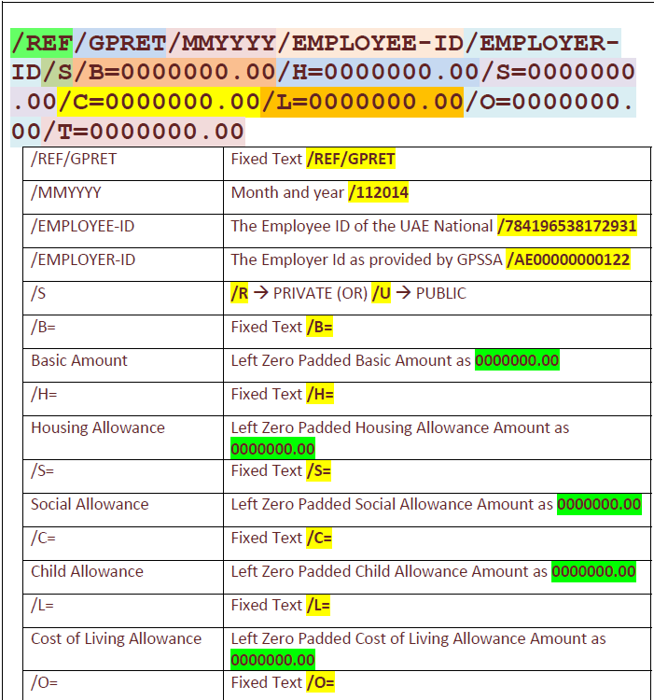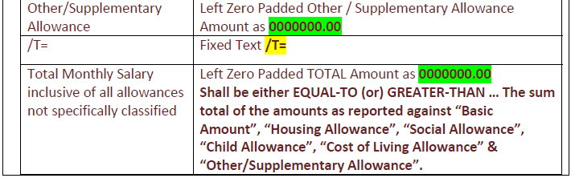

**Note**: If values on Remit info is > or < 140, then the maker is not able to close/send the batch to Checker for authorization. During file generation at the back-end, pHub is auto-populating /REF/ on the first 5 fields of CTD-16.

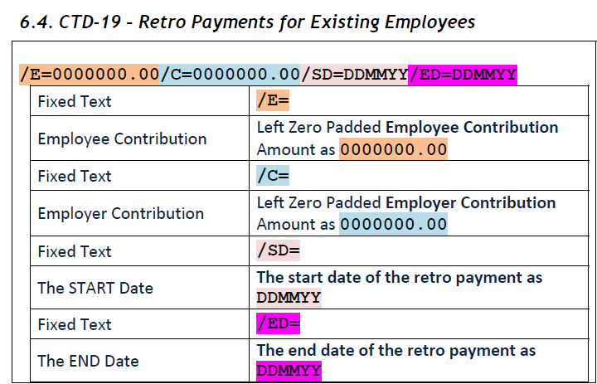

If pension contribution = Retro- GPRET, then only the following fields are enabled for user input.The remaining fields are not required and are disabled

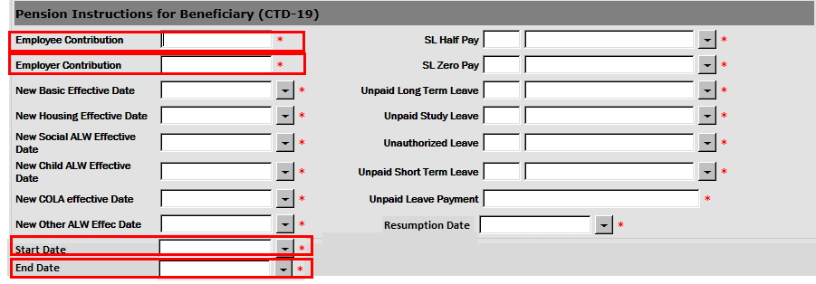

* The CTD-19 field on FTS message is propagated with the following components;
* /E= in strings 1 to 3
* Amount of employee contribution on 4th to 13th string should be left padded with Zero to equate to 10 characters.
* /C= in string 14th to 16th
* Amount of Employer contribution should be propagated in 17th to 26th string left padded with Zero to equate to 10 characters.
* /SD= string 27th to 30th
* Start date 31st to 36th string
* /ED=37st to 40th string
* End date value in 41th to 46th string.



* If values on CTD-19 > or < 46, then the maker is not able to close/send the batch to Checker for authorization.

1. **GPTSP-For temporary suspension**

* GPTSP-For temporary suspension CTD-16

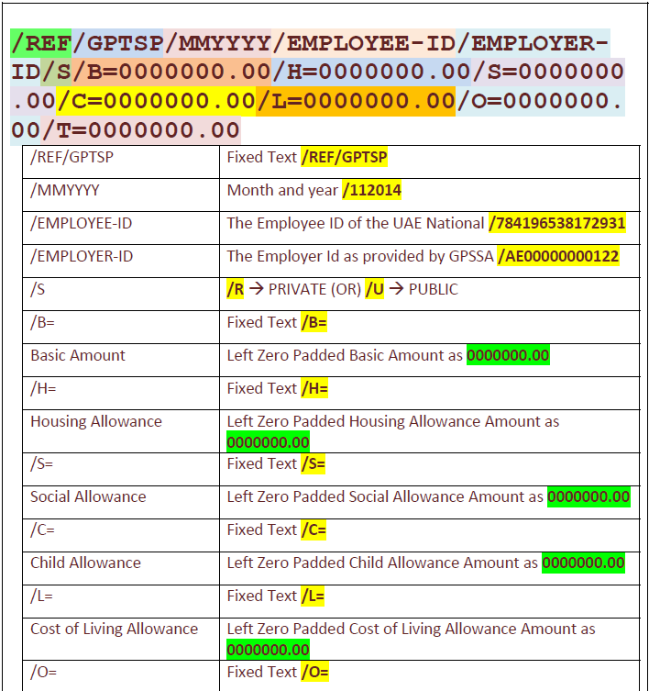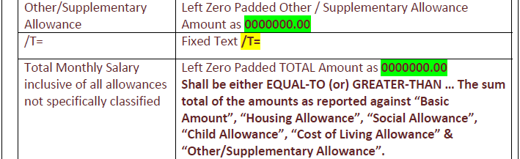

**Note**: If values on Remit info is > or < 140, then the maker is not be able to close/send the batch to Checker for authorization. During file generation at the back-end, pHub is auto-populating /REF/ on the first 5 fields of CTD-16.

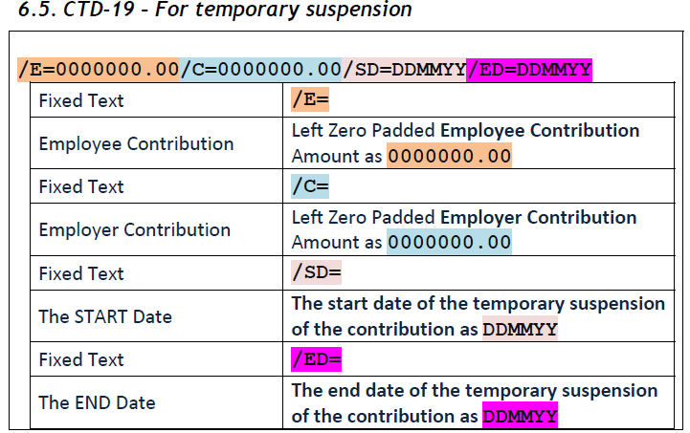

If pension contribution = Temporary Suspension- GPTSP, then only the following fields should be enabled for user input.The remaining fields are not required and should be disabled

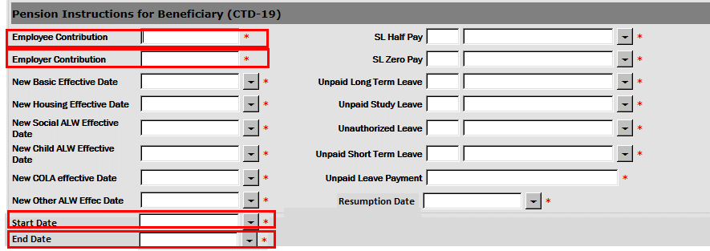

* The CTD-19 field on FTS message is propagated with the following components;
* /E= in strings 1 to 3
* Amount of employee contribution on 4th to 13th string should be left padded with Zero to equate to 10 characters.
* /C= in string 14th to 16th
* Amount of Employer contribution should be propagated in 17th to 26th string left padded with Zero to equate to 10 characters.
* /SD= string 27th to 30th
* Start date 31st to 36th string
* /ED=37st to 40th string
* End date value in 41th to 46th string.



* If values on CTD-19 > or < 46, then the maker is not able to close/send the batch to Checker for authorization.

1. **GPRSM- Resumption Post Temporary Suspension**

* GPRSM- Resumption Post Temporary Suspension-CTD-16

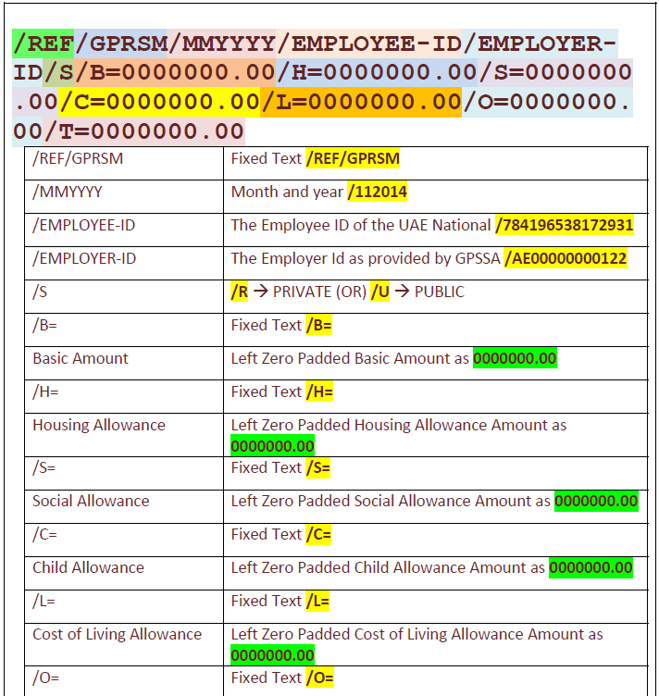 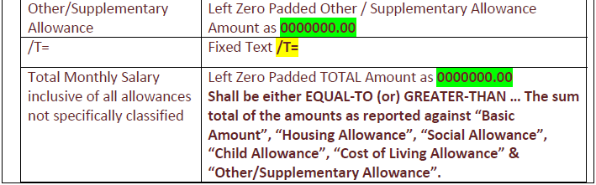

Note: If values on Remit info is > or < 140, then the maker is not able to close/send the batch to Checker for authorization. During file generation at the back-end, pHub is auto-populating /REF/ on the first 5 fields of CTD-16.

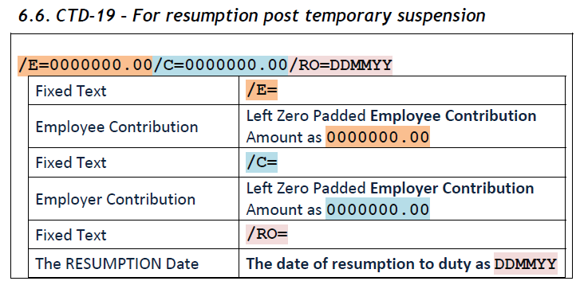

1. If pension contribution = Resumption post temporary suspension - GPRSM, then only the following fields are enabled for user input.The remaining fields are not required and are disabled.

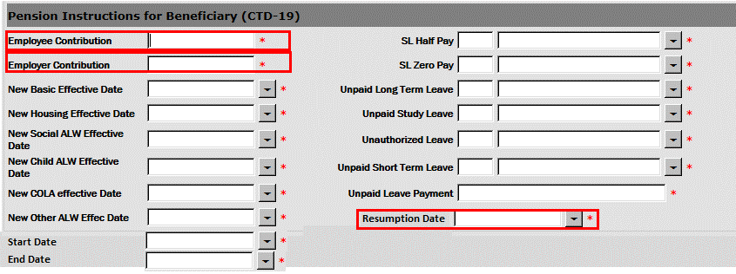

* The CTD-19 field on FTS message is propagated with the following components;

/E= in strings 1 to 3,

* Amount of employee contribution on 4th to 13th string should be left padded with Zero to equate to 10 characters.
* /C= in string 14th to 16th
* Amount of Employer contribution should be propagated in 17th to 26th string left padded with Zero to equate to 10 characters.
* /RO= string 27th to 30th
* Resumption date value in 31st to 36th string.



* If values on CTD-19 > or < 46, then the maker is not sable to close/send the batch to Checker for authorization.
  + - 1. **Rep–Maker/Rep–Checker/Frd–Maker/Frd–Checker/Salary–Maker/Checker**

When any transaction comes into payment hub java engine, certain validations are done on that particular transacition (Insufficient balance check, invalid account check, fraud check, invalid account title check etc.) and if any of the validion is failed, the transaction comes to repair query where either user can reprocess the transaction or delete the transaction based on the error code.

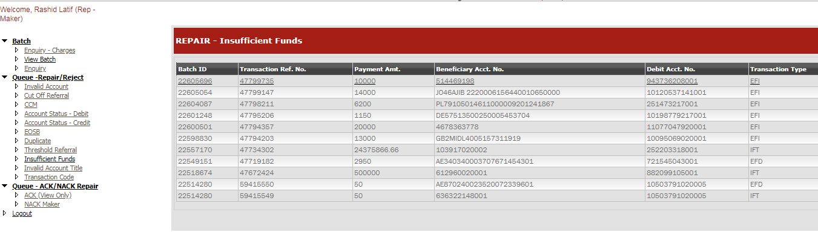

Once the user selects the transaction, it can either be reprocessed or deleted.

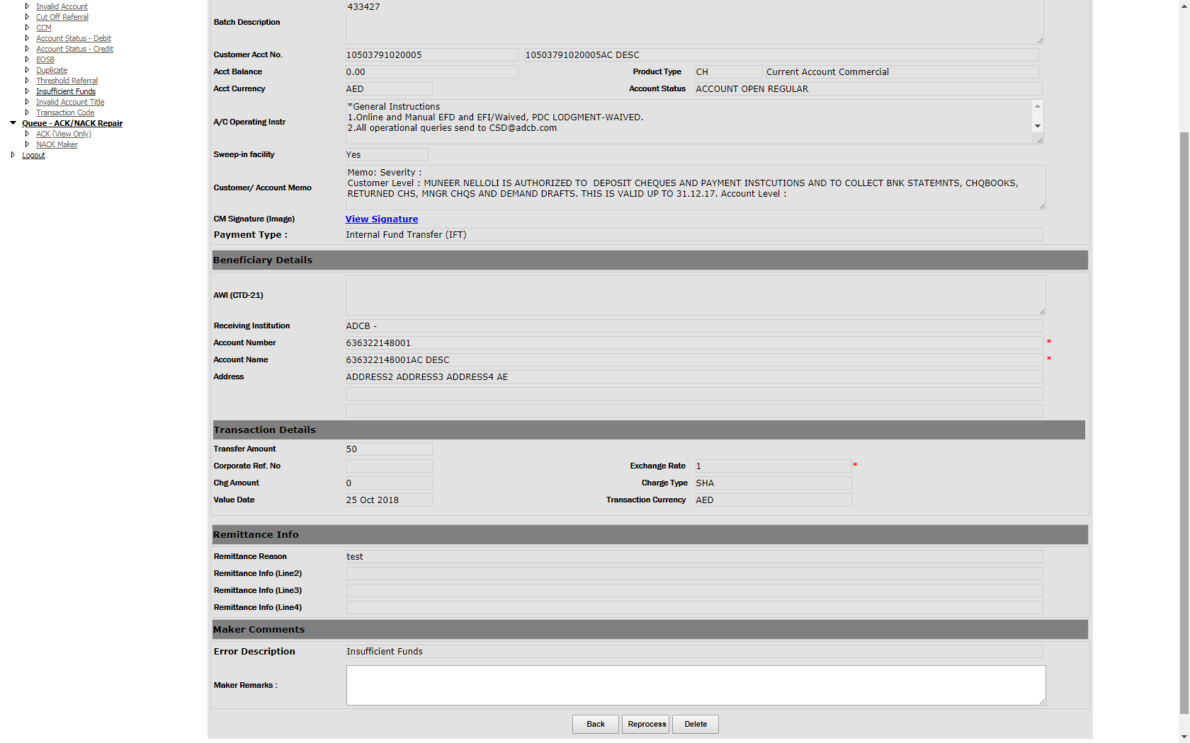

For each repair scenario, the query to fetch the transaction is same except for the error code. Below is the query for maker profile.

SELECT batch_id "Batch ID", txn_ref_no "Transaction Ref. No.", pymnt_amnt "Payment Amt.", '' "Value Date", ERROR_CODE "Error Code", rejection_desc "Error Desc.", bene_acc_no "Beneficiary Acct. No.", bene_name "Beneficiary Name", debit_acc_no "Debit Acct. No.", transaction_type "Transaction Type", CASE mt.record_type WHEN '1' THEN (SELECT filename FROM uaefts_inward_batch WHERE uaefts_inward_batch.batchid = mt.batch_id) WHEN '2' THEN (SELECT batchdesc FROM uaefts_batch WHERE batchid = mt.batch_id) END "Batch Description", record_type, order_cust_name "Debit Acct Name", pymnt_curr "Payment Curr" , status_datetime "Date & Time" FROM payment_txn_mt mt INNER JOIN uaefts_rejection ct ON mt.ERROR_CODE = ct.rejection_code WHERE status_datetime < SYSTIMESTAMP - (5/1440) AND transaction_type <> 'CST' AND mt.receiving_channel_id not in ('12','14') AND ( status = '5' AND ERROR_CODE in ('16') ) and ((receiving_branch_code,mt.error_code) not in ( SELECT distinct branch_code,error_code from uaefts_repair_screen_cntrl where enabled = 'A') OR receiving_branch_code is NULL) AND mt.TXN_CONSOLIDATION_FLG = 'N' ORDER BY batch_id DESC

And the checker query

SELECT mt.checkerrowid, mt.batch_id "Batch ID", mt.txn_ref_no "Transaction Ref. No.", mt.pymnt_amnt "Payment Amt.", TO_CHAR (mt.pymnt_value_date, 'DD-Mon-YYYY') "Value Date", mt.ERROR_CODE "Error Code", rejection_desc "Error Desc.", mt.bene_acc_no "Beneficiary Acct. No.", mt.bene_name "Beneficiary Name", mt.debit_acc_no "Debit Acct. No.", mt.transaction_type "Transaction Type", CASE mt.record_type WHEN '1' THEN (SELECT filename FROM uaefts_inward_batch WHERE uaefts_inward_batch.batchid = mt.batch_id) WHEN '2' THEN (SELECT batchdesc FROM uaefts_batch WHERE batchid = mt.batch_id) END "Batch Description", mt.record_type, mt.pymnt_curr "Payment Curr", mt.order_cust_name "Debit Acct Name", mt.mdate "Date & Time" FROM payment_txn_mt mst INNER JOIN payment_txn_mt_repairckr mt ON mst.batch_id = mt.batch_id and mst.txn_ref_no=mt.txn_Ref_no INNER JOIN uaefts_rejection ct ON mt.ERROR_CODE = ct.rejection_code WHERE mt.STATUS = '5' AND (mt.recstatus IS NULL AND mt.receiving_channel_id not in ('12','14') AND mt.ERROR_CODE IN ('16') ) and ((receiving_branch_code,mt.error_code) not in ( SELECT distinct branch_code,error_code from uaefts_repair_screen_cntrl where enabled = 'A') OR receiving_branch_code is NULL) AND mt.TXN_CONSOLIDATION_FLG = 'N' ORDER BY checkerrowid DESC

|  |  |  |
| --- | --- | --- |
| **Repair Queue** | **Error Code** | **Reprocessing Possible** |
| **Account Status Credit Repair** | '108','109','110','111','112','113','114','115','116','117','118','119','126','127','128','129','130' | **select COD_Acct_status from uaefts_debit_acct_status where flag='P' and error_code=@error_Code** |
| **Account Status Debit Repair** | '95','96','98','99','100','15','7','102','103','104','105','106','150','94','97','106','123','124','125' | **select COD_Acct_status from uaefts_credit_acct_status where flag='P' and error_code=@error_code** |
| **Invalid Account Repair** | '6','13' | **N** |
| **Insufficient Funds Repair** | '16' | **Y** |
| **Account Title Repair** | '5' | **Y** |
| **Duplicate Repair** | '24' | **Y** |
| **Fraud Repair** | '8','132' | **Y** |
| **Transaction Code Repair** | '209','210' | **Y** |
| **Consolidated Debit Repair** | '16' and TXN_CONSOLIDATION_FLG = 'Y' (For Consolidation repair, the query is different) | **Y** |

Once the repair is done, the record is inserted in to payment_txn_mt_repairckr table and goes to checker. After approval of checker, the record again goes through validation and if all the validations are succeeded, the record is sent for file generation or posting based on its payment type.

**Consolidated Repair Queue Maker Query**

SELECT BATCHID, DEPT, BATCHDESC, TOTRECORDS,ACCTNO, OPENBY, OPENON FROM UAEFTS_BATCH

WHERE BATCHID IN

(SELECT batch_id FROM payment_txn_mt mt

INNER JOIN

uaefts_rejection ct

ON mt.ERROR_CODE = ct.rejection_code

WHERE status_datetime < SYSTIMESTAMP - (5/1440) AND transaction_type <> 'CST' AND ( status = '5' AND ERROR_CODE in ('16') )

AND TXN_CONSOLIDATION_FLG = 'Y' AND mt.receiving_channel_id not in ('12','14')

AND batch_id > @maxBatchID)

**Consolidated Repair Queue Checker Query**

SELECT BATCHID, DEPT, BATCHDESC, TOTRECORDS,ACCTNO, OPENBY, OPENON FROM UAEFTS_BATCH

WHERE BATCHID IN AND TXN_CONSOLIDATION_FLG = 'Y' AND mt.receiving_channel_id not in ('12','14')

(SELECT batch_id FROM payment_txn_mt_repairckr mt AND batch_id > @maxBatchID

INNER JOIN )

uaefts_rejection ct

ON mt.ERROR_CODE = ct.rejection_code

WHERE (recstatus IS NULL " + cmsEx + " AND ERROR_CODE IN ('16') )

AND TXN_CONSOLIDATION_FLG = 'Y' AND mt.receiving_channel_id not in ('12','14')

AND batch_id > @maxBatchID)

Transactions can either be repaired or deleted. Once all transactions are repaired, the transaction goes through the validation again and then posting is done for IFT and EFD (if EFD is incoming then posting is done otherwise EFD will go for file generation). For outgoing EFD’s, Central bank will either sent ACK or NACK. If it is NACK from Central Bank then the transaction will go to NACK screen for NACK repair.

For EFI transaction, it the transaction rule is defined, it will go through STP otherwise it will go to EFI repair queue (Remit – Maker/Checker).

For CST transaction, the repair is done in separate application called “Payment Gateway – Salary”

Repair or deletion of the transaction is based on the error codes (Error_Code column).

* + - 1. **Upload Maker / Upload Checker Profile**

In this profile the custom bulk upload files are uploaded by maker and approved by checker. Once the checker approves it, the file is placed on a particular location defined in webconfig file. There is one service called UAEFTS_DES which will pick these files and perform the validations and upload each transaction in payment hub using URL calls.

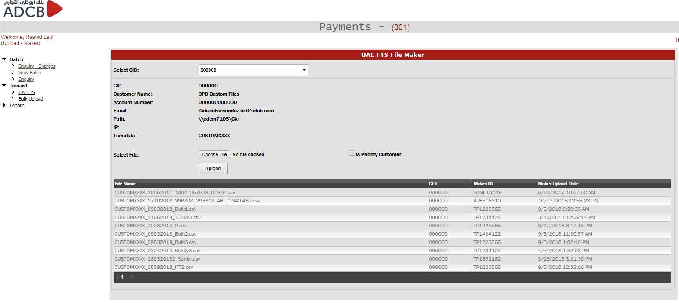

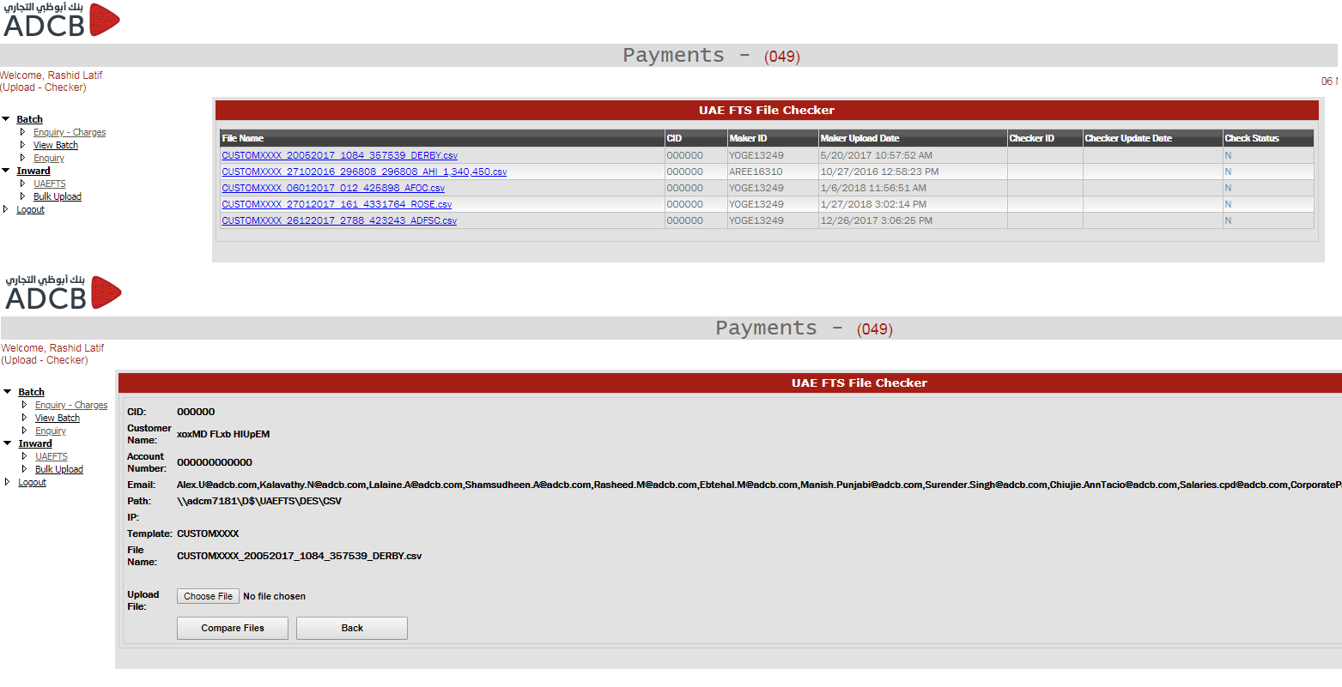

The service will pick the file path from below table.

select * from uaefts_des_filedtls where file_id = 9 or Template =’CUSTOMXXXX’

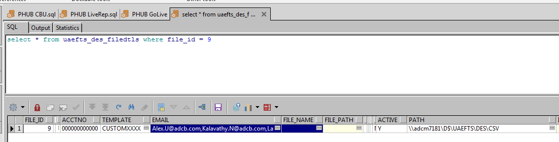

No of fields available are defined in below table.

select * from uaefts_des_filemapping order by 1

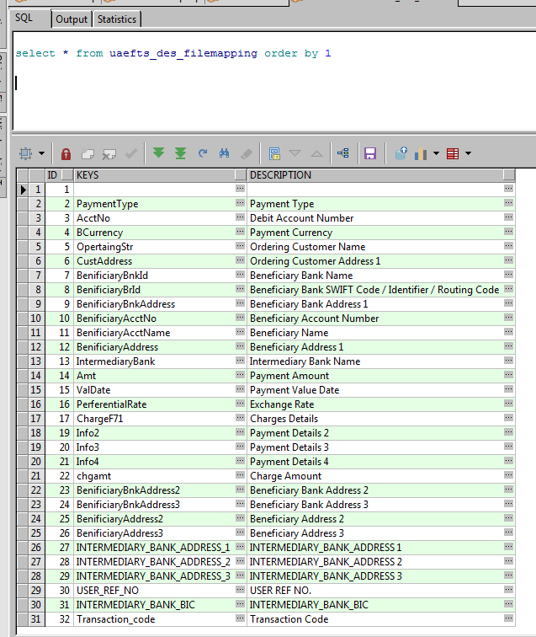

Mapping for custom bulk file fields is defined in below table. If any new field is to be added for custom bulk file, two tables are required to be updated. One is uaefts_des_filemappinggdtls and the other one is uaefts_des_filemapping. We will discuss in detail about Custom Bulk Upload in UAEFTS_DES service module.

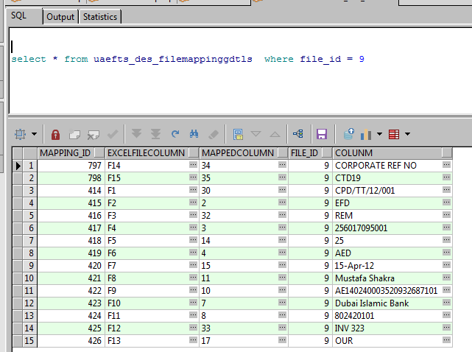

Below is the structure of custom bulk upload file.

|  |  |  |
| --- | --- | --- |
| **Excel Cell** | **Column Name** | **Example** |
| F1 | USER_REF_NO | CPD/TT/12/001 |
| F2 | PaymentType | EFD |
| F3 | Transaction_code | REM |
| F4 | AcctNo | 256017095001 |
| F5 | Amt | 25 |
| F6 | BCurrency | AED |
| F7 | ValDate | 30-Oct-18 |
| F8 | BenificiaryAcctName | Rashid Latif |
| F9 | BenificiaryAcctNo | AE140240003520932687101 |
| F10 | BenificiaryBnkId | Dubai Islamic Bank |
| F11 | BenificiaryBrId | 802420101 |
| F12 | Info1 | INV 323 |
| F13 | ChargeF71 | OUR |
| F14 | CORPORATE_REF_NO | CORPORATE REF NO |
| F15 | special_inst_for_bene_bank | CTD19 |

* + - 1. **Treasury Maker / Treasury Checker Profiles (CB202/CB2C2)**

CB202/203 are financial institutional transfers usually to fund the account of self or to a vostro bank.

The page can be accessed by clicking CB202/CB2C2 link on the menu where user enters the self or Vostro bank account number, selects the message type from dropdown and enters the details and process it. Once the transaction is authorized, payment hub backend processes it after performing the set of validations.

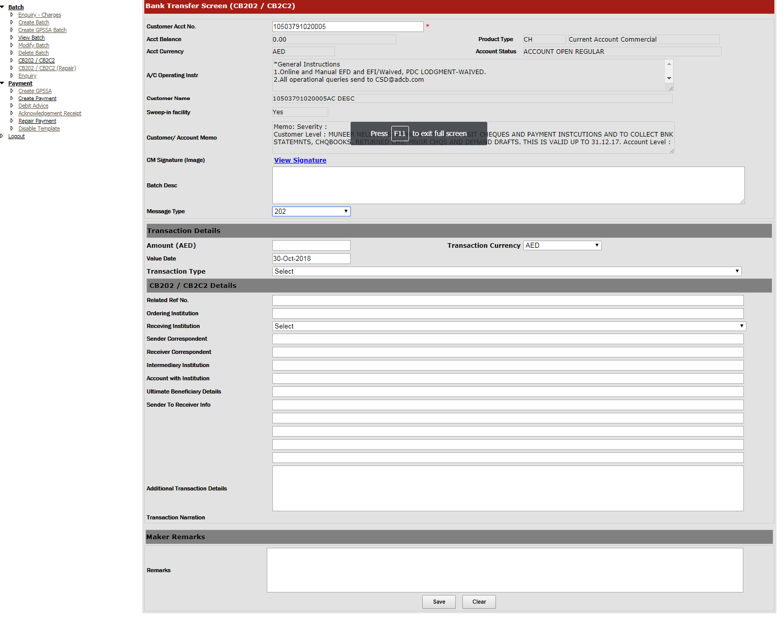

**CB202/203**

* System validates account with institution in ITD-11.
* If it contains ADCB/ADCB BIC/ADCB routing code or blank, further validation to happen in the ultimate beneficiary field (ITD-22) .
* If the value in ITD-22 is ADCB value or blank, system to validate ITD-13.
* If the value is 092,103,102.192,104,105.292,293,294 & 295, then status will show as validation failed with reject reason as return of funds.
* All other values to update as validation failed with reject reason as ‘Routed to CB2XX TRY QUEUE’.
* If the value of ITD-22 is a non-ADCB value, system will validate against vostro list.

- If it’s invalid, system to treat it as validation failed with reject reason as ‘Invalid Vostro BIC.

- If the BIC is a vostro below validation to proceed.

* PHUB system will validate the number of accounts maintained against the vostro BIC contained in ITD-22 .
* If it is a single account against the BIC, system to validate the BIC and process STP to mapped FCR account, account no. need not to be validated.
* if more than 1 accounts exists for the vostro BIC, further validation to happen on the account, IBAN or CASA.

1. If account no. is available and valid, system to process STP in the FCR account.
2. If, account no. is not available processing should not proceed.( treat as validation failed), reject reason to be ‘Account required, BIC has more than one account’
3. If account no./IBAN is available but incorrect, system to treat as validation failed with reject reason ‘Invalid IBAN/Account’

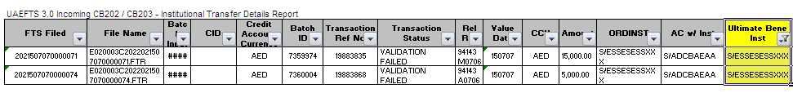

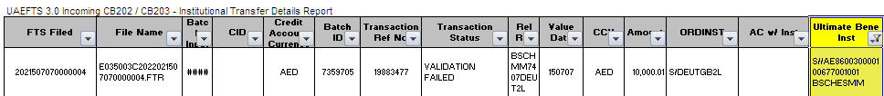

* If the value in ITD-11 is a non-ADCB value no further validation is required (expected validation failed to be handled manually). Rejection reason to update as ‘Invalid account with institution’
* For CB202/203, if ITD-13 contains transaction code 256 system to validate additional transaction related details in ITD-14. If it contains a valid IBAN, payment to be processed STP.

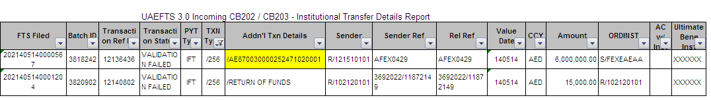

* Accounting entries to proceed as below for STP processed payments,

Dr - Central bank narration to capture FTSID

Cr – vostro/customer narration to capture Related reference in ITD-05

Status to be updated in the status column

**CB2C2**

* System to validate account with institution in CID-11.
* If it contains ADCB/ADCB BIC/ADCB routing code or blank, further validation to happen in the ultimate beneficiary field (CID-15) .
* PHUB system to validate ultimate beneficiary details in CID-15.

- If it’s not a vostro BIC, system to treat it as validation failed with reason ‘Invalid Vostro BIC’

- If it’s a vostro BIC. Further validation to happen in CID- 23 for account with institution.

- If CID -23 differs from CID -15, system to treat it as validation failed with reject reason ‘Invalid Acc with Institution’

- If CID-23 is blank or the value is same as CID-15, validation to proceed as below

* PHUB system to validate the number of accounts maintained against the vostro BIC

- If is a single account, system to validate the BIC and process STP to mapped FCR account, account validation not required.

- If more than 1 accounts exists for the vostro BIC, further validation to happen on the account, IBAN or CASA.

1) If account no. is available and valid, system to process STP in the FCR account.

2) If account is not available, processing should not proceed (validation failed) reject reason to be ‘Account required, BIC has more than one account’

3) If account no/IBAN is available but incorrect, system to treat as validation failed with reject reason ‘Invalid IBAN/Account’

* If the value in CID-11 is a non-ADCB value no further validation is required, system to treat it as validation failed with reject reason ‘Invalid Account With Institution’

* Status to be updated in the status column
* Additional column, ‘reject reason ‘ to be added in UAEFTS 3.0 Incoming CB2C2 - Cover Instruction Details Report

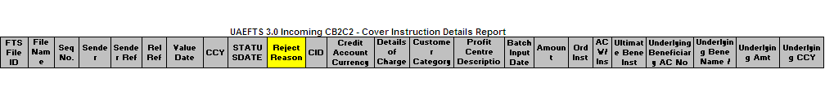

* Accounting entries to proceed as below for STP processed payments,

Dr - Central bank - narration to capture FTSID

Cr - vostro narration to capture Related reference in CID-05

* + - 1. **Testing**
      2. **Remit Maker & Remit Checker Profile (Outward FCY Transactions) – Fast Pay**

Outward transactions processed bank wide in ADCB are initiated through multiple channels which include branches, internet retail banking and internet corporate banking, where 100% of the output of these transactions are transmitted through Swift.

CPD being the backend processing hub for the mentioned channels ensures transactions are in the standard format acceptable in swift for complete end to end processing. There are STP rules defined as well based on certain conditions (defined below) for MIB, RIB, FCR and SIFCR channels.

Below is the flow diagram for outward FCY payment processing.



**Channels supported for EFI**

Below are the payments from different channels that are automated for foreign currencies in Fast Pay module.

|  |  |  |  |  |  |
| --- | --- | --- | --- | --- | --- |
| **Channel ID** | **Channel Description** | **Support For STP** | **AI Rules** | **Message Type** | **Processing System** |
| 1 | CPD | **Y** | Routing Rules | 103, 202 Cov | Fast Pay |
| 2 | Branch | **Y** | Routing Rules | 103, 202 Cov | Fast Pay |
| 19 | Escrow System | **N** |  | 103, 202 Cov | Corporate IB Middleware (Appzone) |
| 24 | ARIBA | **N** |  | 103, 202 Cov | Corporate IB Middleware (Appzone) |
| 12 | CMS | **N** |  | 103, 202 Cov | Fast Pay |
| 23 | Mobile Banking | **Y** | Replicate previously repaired | 103, 202 Cov | Fast Pay |
| 15 | Retail IB | **Y** | Replicate previously repaired | 103, 202 Cov | Fast Pay |
| 17 | SI FCR | **Y** | Replicate previously repaired | 103, 202, 202 Cov | Fast Pay |
| 28 | FCR | **Y** | Replicate previously repaired | 103, 202Cov, 202 Cov | Fast Pay |

We have a fast pay module (Remit Maker and Remit Checker) in payment hub frontend where all non-stp transactions are landed and repaired. We have support for STP for the channels mentioned in above table. Once the users login to remit maker module, they can see the list of transactions to be repaired on process remittance screen as described below from all the channels for all the message types (103, 202Cov, 202).

Below is the query for fetching all repair transactions.

SELECT batch_id, txn_ref_no, order_cust_name,

TO_CHAR (status_datetime, 'DD-MON-YYYY') AS status_date,

TO_CHAR (status_datetime, 'HH:MM:SS') status_time,

TO_CHAR (TRUNC (pymnt_value_date)) AS pymnt_value_date,

pymnt_curr, pymnt_amnt, MESSAGE_TYPE, channel_desc,

receiving_channel_id, status,

DECODE (status, 5, 'Repair', 126,'Checker Rejected')

AS status_desc,

senders_ref, debit_acc_no, bene_bank_name

FROM (stgg_fcy_outward) a

INNER JOIN

payment_txn_in_ch_master

ON channel_id = receiving_channel_id

WHERE status IN ('5')

AND ERROR_CODE IN

('64', '65', '66', '67', '68', '69', '70', '71', '72', '73', '74', '75', '76', '77', '78', '79', '82', '83', '84', '85', '86', '87', '88', '89', '131', '141')

AND txn_ref_no IN (SELECT txn_ref_no FROM uaefts_fcy_txn_adapter)

AND txn_ref_no NOT IN

(SELECT txn_ref_no

FROM uaefts_remit_modified

WHERE request_status IN ('P')

AND batch_id = a.batch_id

AND txn_ref_no = a.txn_ref_no

AND MESSAGE_TYPE = a.MESSAGE_TYPE)

AND (MESSAGE_TYPE <> '202COV'

OR (MESSAGE_TYPE = '202COV'

AND txn_ref_no IN

(SELECT txn_ref_no

FROM uaefts_fcy_txn_adapter

WHERE batch_id = a.batch_id

AND txn_ref_no = a.txn_ref_no

AND MESSAGE_TYPE = a.MESSAGE_TYPE

AND cov_readyforrepair = 'Y')))

and batch_id > 1468154

order by batch_id , TXN_REF_NO

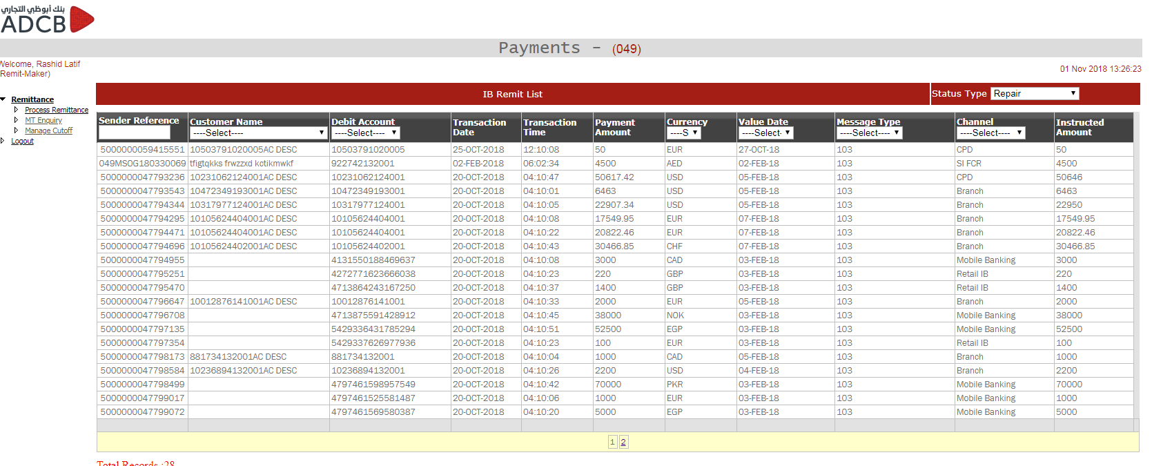

On clicking any transaction, the repair screen will open where user can change the data accordingly and generate swift message. The message is generating by calling swift service “**InqPreviewSwiftMsgEndpoint2**”. Account details and other customer related information is fetched from Golden Gage. We have separate repair screens for MT103, MT 202COV and MT 202 messages. The basic flow of all the messages are defined below with the fetch query.

SELECT a.*,

b.original_pymnt_amnt, b.ERROR_CODE AS errcode,

TO_CHAR (b.swift_msg) AS swift_msg, b.nostro_acc_no,

b.order_cust_name, b.pymnt_aed_rate,

TO_CHAR (b.pymnt_value_date) pymnt_value_date,

b.debit_ccy, b.pymnt_curr, b.pymnt_amnt,

b.debit_acc_no, b.cid, b.remittance_info1, b.remittance_info2,

b.remittance_info3, b.remittance_info4, b.bene_bank_name,

b.customer_type, b.processing_charge_amount,

b.bank_code, b.bank_bic, bene_bank_name,

bene_bank_addr1, bene_bank_addr2, bank_country,

b.intermediary_bank_bic,

TO_CHAR (pymnt_value_date, 'DD-MON-YYYY') valdate,

dealer_ref_no, c.override_rates, b.pymnt_debit_rate,

b.pymnt_debit_amnt, b.pymnt_aed_rate, b.pymnt_aed_amnt,

b.debit_aed_rate, b.debit_aed_amnt, b.bene_bank_name,

b.bene_bank_addr1, b.bene_bank_addr2, b.bank_country,

a.is_cover_present, b.nostro_bank_bic, b.bene_acc_no,

(SELECT channel_desc

FROM payment_txn_in_ch_master

WHERE channel_id = b.receiving_channel_id)

AS channel_desc,

b.bene_acc_no, b.cid, b.idfcatref, b.receiving_channel_id,

b.transaction_type, b.bene_name, b.bank_country_code,

b.debit_acc_no, b.order_cust_name, b.beneficiary_id,

a.pymnt_ccy orig_pymnt_ccy, b.customer_category,

b.profit_centre_desc

FROM uaefts_fcy_txn_adapter a

INNER JOIN

stgg_fcy_outward b

ON a.batch_id = b.batch_id

AND a.txn_ref_no = b.txn_ref_no

AND a.MESSAGE_TYPE = b.MESSAGE_TYPE

AND b.status = 5

INNER JOIN

uaefts_fcy_validations c

ON b.receiving_channel_id = c.receiving_channel_id

WHERE a.batch_id = @BatchId AND a.txn_ref_no = @TxnRefNo

AND b.ERROR_CODE IN

('64', '65', '66', '67', '68', '69', '70', '71', '72', '73', '74', '75', '76', '77', '78', '79', '82', '83', '84', '85', '86', '87', '88', '89', '131', '141')

AND a.MESSAGE_TYPE = @MsgType

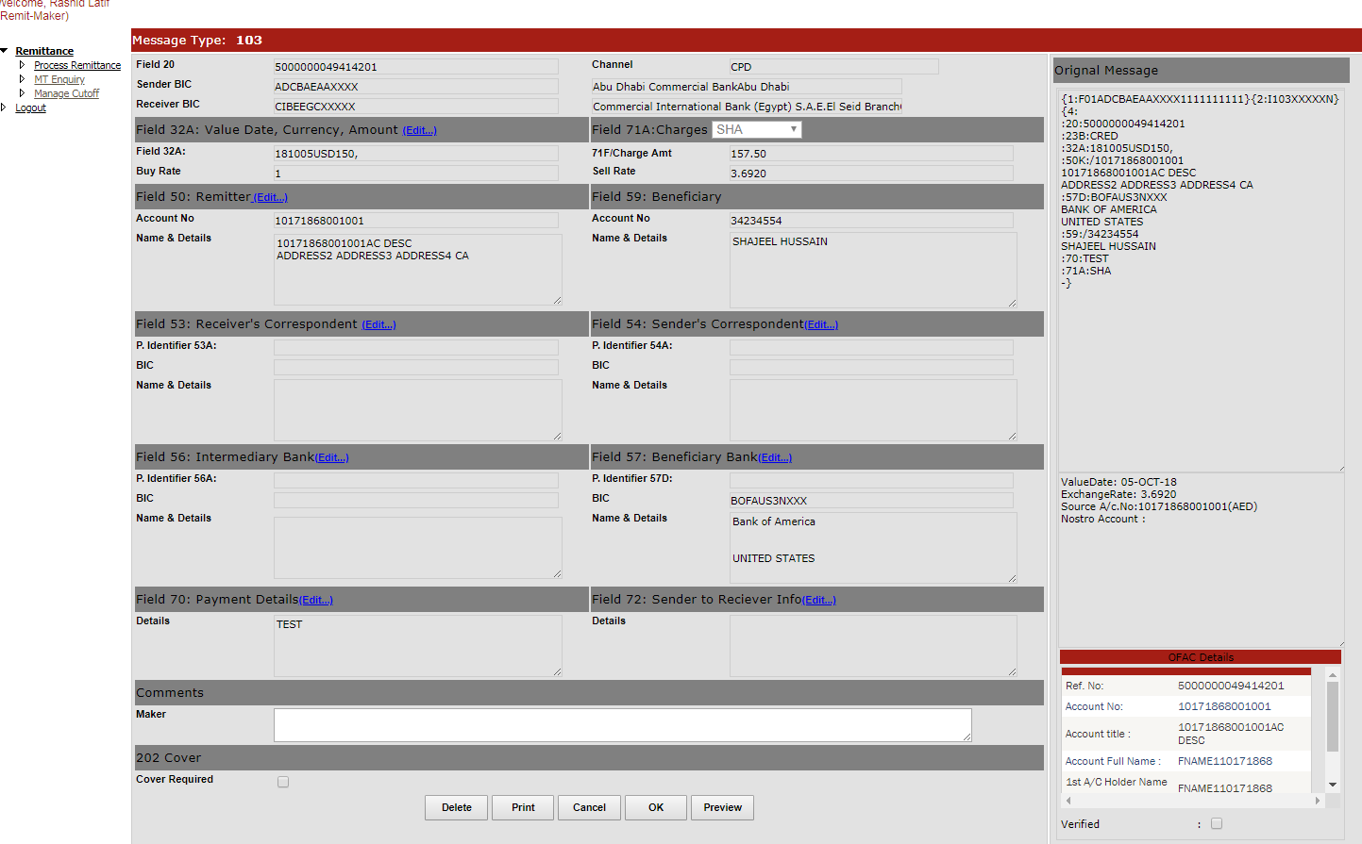

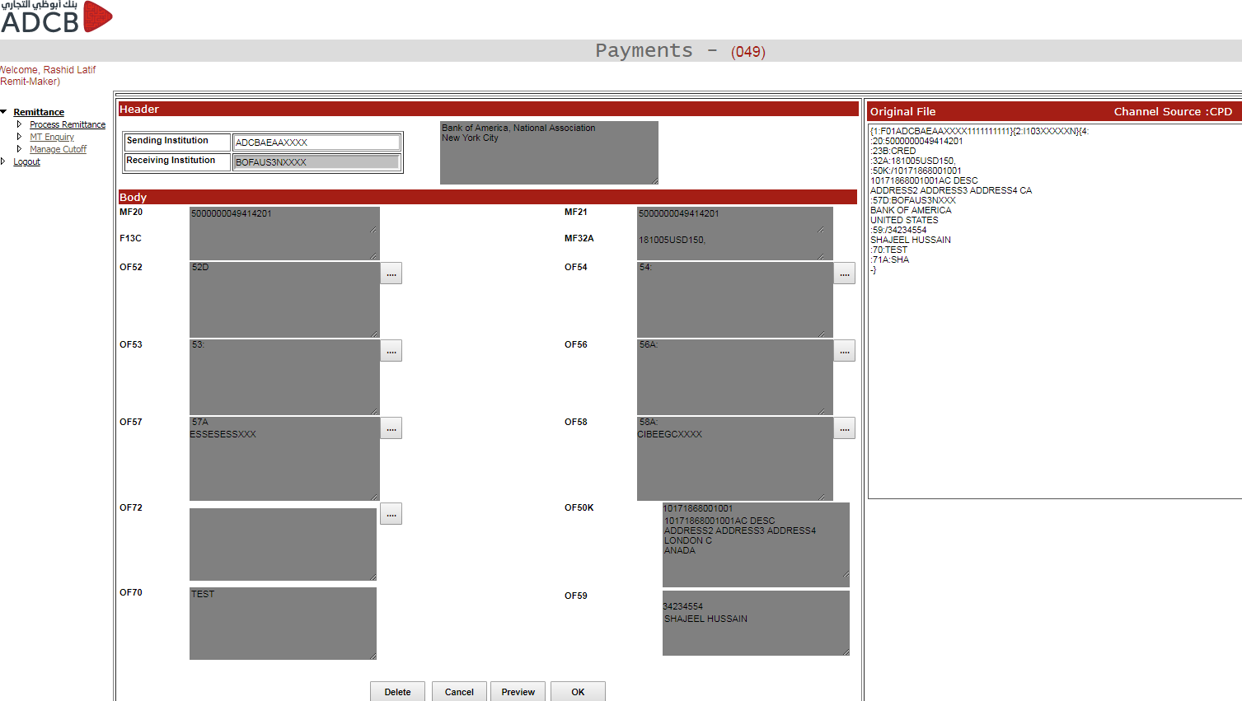

Once the record is saved, the record is inserted in UAEFTS_REMIT_MODIFIED and updated in two tables STGG_FCY_OUTWARD and UAEFTS_FCY_TXN_ADAPTER

Once the maker saves the transaction, it goes to checker where after approving, the transaction goes to payment hub engine for swift file generation. Below is the checker screen.

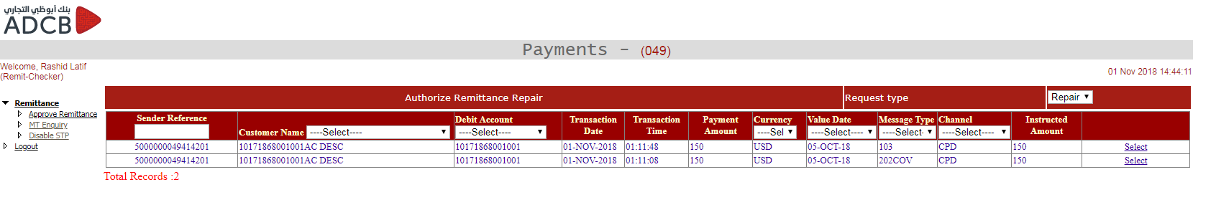

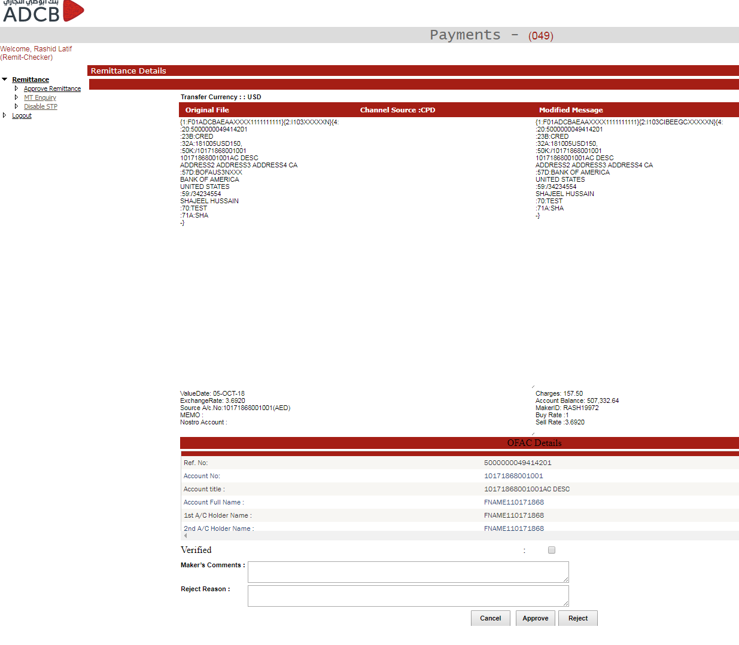

If the transactions are from MIB/RIB/FCR/SIFCR, then the certain fields are saved (AI rules described later in a table) in to AI tables so that if the similar transactions come next time, it goes through STP.

* + 1. **PaymentGateWay-Procash**

Procash will be sending the request to MQ .Webphere listener port will be listening to the messages and one MDB will consume the message.

Once the message is consumed ,the message will be logged in the table

* CMS_PAYMENT_REQUEST

After the insert,the message will be parsed and fields would be stored in java Objects.

MessagesComingtoNormalQueue

1) SIF file processing request

If new Transaction

* Insert into payment_reponse_queue one entry with initial status(0).

The key to search the column is cms_batch_id

* Insert the records into STGG_PAYMENT_FILE_BATCH with unique key as CMS_BATCH_ID
* Validate the header fields in the request
* Validate the XML request using the XSD validation,XSD is stored in the table
* Validate the sif file for total records in the file and total records in the header
* Generate the sif file with content that came in the request in the path mentioned in the SFTP Properties UAEFTS_SIF_LOCAL_DIR
* Call the wps servlet URL for the sif
* Once sif generated update the sif file name in
  + PAYMENT_RESPONSE_QUEUE and status as 5
  + STGG_PAYMENT_FILE_BATCH

If repair transaction

* Update the original SIF transaction with the new CMS_BATCH_ID

Table:-payment_response_queue

Stgg_payment_file_batch

* Call the WPS Servlet URL for the repair

2) PaymentRequest

New Transaction

* Insert into payment_reponse_queue one entry with initial status(0).
* Insert the records into STGG_PAYMENT_FILE_BATCH with unique key as CMS_BATCH_ID
* Insert the details of the transactons into STGG_PAYMENT_FILE_TXN_DTLS
* Validation of the content of the transaction in the header and data
* Xsd validation of the request XML
* Push batches to PHUB for processing
  + Insert into uaefts_batch
  + Insert into uaefts_Remitdtls
  + Insert into uaefts_remitdtlsckr
* Call the PHUB core Processor(Explained in heading PHUB Core processing)

Repair Transaction

* Insert the repair request in the payment_response_queue
* Update the following tables with the new CMS_BATCH_ID
* STGG_PAYMENT_FILE_BATCH
* STGG_PAYMENT_FILE_TXN_DTLS
* PAYMENT_TXN_MT
* Call the servelet URL for the transaction type

MessageComingToPrioritQueue

* Steps are same till you push the transaction to PHUB and create PHUB batch
* Afer PHUB batch check the transaction type and call its respective processor and process the transaction.
* Once the transaction is processed send the response back to the ProCash
  + 1. **PaymentGateWayReportsDownload**

This module will process only 2 reports from CB FTSDD56 and FTSDD57

1. Des will be downloading the file and pushing to the location in PHUB server.
2. Des will be sending message to MQ with file Name and file Type
3. Insert file details into

UAEFTS_INCOMING_FILE_AUDIT with file name and downloaded time

1. Parse the file and store into uaefts_uncnfrmed_credit_rep for FTSDD56
2. Parse the file and store into uaefts_cnfrmed_credit_rep for FTSDD57
   * 1. **PaymentGateWay-SIFCR Extraction**

This module will fetch EFD and EFI transactions from FCUBS,by direct Query.

There a java scheduler which will be running in the configured interval.

Process Flow

* Check the extraction is enabled for the channel

select count(*) COUNT from channel_charges where IS_EXTRACT_REQUIRE='Y' and channel_id=#receivingChannelId#

* Get the extraction query from the extraction.properties.Conenct to FCUBS and run the query
* Parse the result and extract into a java object
* Get debit account no and call the InqCSAcctIBANInfoClient tibco service to check if it’s a jersey transaction.
* If the account currency is AED and beneficiary country is UAE and not a jersery then set the transaction type as EFD ,otherwise the transaction type is EFI
* Insert the details into uaefts_fcrsi_remit
* Insert into UAEFTS_BATCH and get the PHUB batch ID.
* Insert into uaefts_Remitdtls and uaefts_Remitdtlsckr.Update the batch id in uaefts_fcrsi_remit
* Update the transaction in FCUBS as successfully fetched by calling an update query to FCUBS.Update query available in extraction.properties.
* Send Email to configured emails IDS
* Call the payment HUB Core Processing Outgoing for further processing
  + 1. **Payment Gateway – Salary**

This application is used to repair and process the salary (CST) transactions from all the channels. The main validations are done through a package deployed on PHUB database called **“phub_validation”.** Once the transaction comes into phub through custom bulk upload channel or cpd or any other channel, the records are inserted in **UAEFTS_SALARY_TXN_CKR** and then we have two windows services called **UAEFTS_AI_Oracle Incoming and UAEFTS_AI_Oracle Outgoing service** which pulls the data from the table **UAEFTS_SALARY_TXN_CKR** based on the record types (incoming or outgoing). The services then call the stored procedure **phub_validation.validate_record2_outgoing** or **phub_validation.validate_record1_incoming** based on the record type. If any of the validation is failed, the records come in the repair queue of Payment Gateway – Salary application. There are two profiles in salary module. One is Maker and the other one is Checker. Once user logins to maker profile, they can see different links from repair payments to CCM repair queue to enquire any of the transactions.

**Salary Payment Maker – Repair Payments**

on click or Repair Payments, the records are fetched from table UAEFTS_SALARY_TXN_CKR in the grid and once user clicks on any of the transaction the detail is opened. Below is the query to fetch the grid data for salary repair.

SELECT batchid "Batch ID", batchdesc "Batch Desc.", to_number(totrecords) "Total Rec.", acctno "Acct. No.", to_char(openby) "Created By", to_char(openon,'dd-Mon-yyyy hh:mi:ss') "Created At", 'O' FROM UAEFTS_BATCH WHERE batchid IN (

SELECT DISTINCT BATCH_ID batchid FROM UAEFTS_SALARY_TXN_CKR WHERE status = '5' and FETCH IS NULL AND NVL(request,' ') IN ('I','R') AND BATCH_ID > @BATCH_ID

UNION

SELECT batchid "Batch ID", filename "Batch Desc.", to_number(totrecords) "Total Rec.", '241012990' "Acct. No.", to_char(uploadedby) "Created By", to_char(uploadeddate,'dd-Mon-yyyy hh:mi:ss') "Created At", 'I' FROM UAEFTS_INWARD_BATCH WHERE batchid IN (

SELECT DISTINCT BATCH_ID batchid FROM UAEFTS_SALARY_TXN_CKR WHERE status = '5' and FETCH IS NULL AND NVL(request,' ') IN ('I','R') AND BATCH_ID > @BATCH_ID) Order by 1

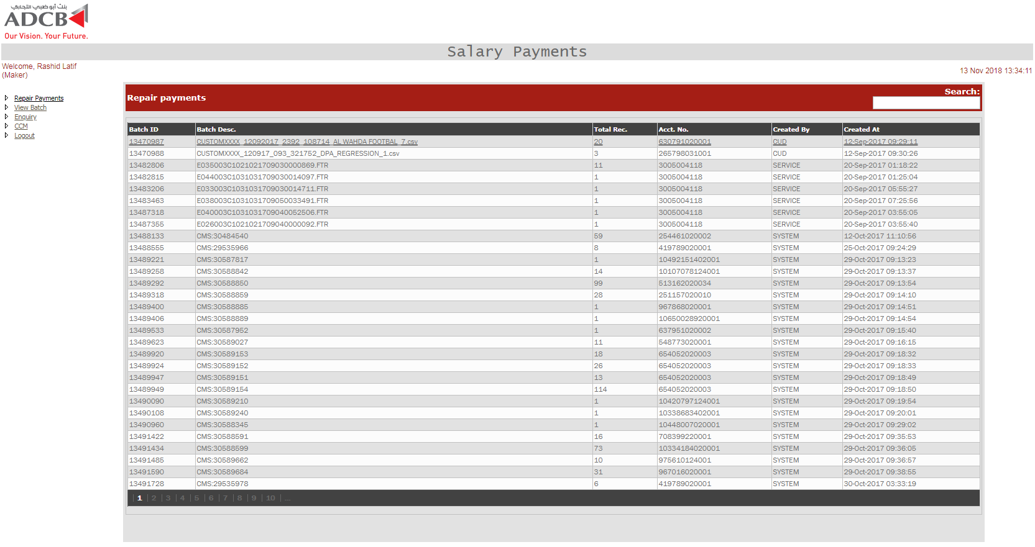

Once the user clicks on any of the batch, all the transactions associated with the same batch are binded to one more grid. The fetch query of the detail grid is below.

SELECT checkerrowid "Transaction Ref. No.", bene_acc_no "Benificiary Acct. No.", bene_name "Benificiary Name",to_char(pymnt_amnt,'999,999,999,999,999,999,999.99') "Transfer Amount", to_char(pymnt_value_date,'dd mon yyyy') "VALUE DATE" , error_code , error_desc "Reject Reason", makerid, checkerid, recstatus

FROM UAEFTS_SALARY_TXN_CKR

WHERE status = '5' and NVL(request,' ') IN ('I','R') AND batch_id = @BatchID

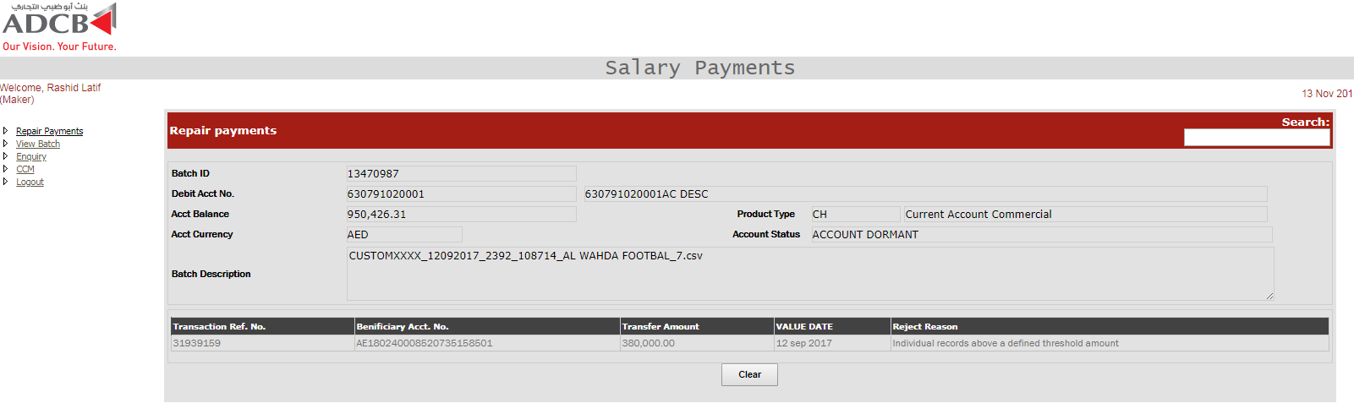

The detail of is show to the user once the user click on the transaction. Based on the error code, user can either update or delete the transaction. The fetch query of the

SELECT * FROM UAEFTS_SALARY_TXN_CKR MT

INNER JOIN UAEFTS_PAYMENT ON

UAEFTS_PAYMENT.paymentcode = MT.transaction_type

LEFT OUTER JOIN UAEFTS_BANK ON

UAEFTS_BANK.bankcode = MT.bene_bank_name

LEFT OUTER JOIN UAEFTS_BRANCH ON

UAEFTS_BRANCH.branchcode = MT.bene_acc_bic

LEFT JOIN UAEFTS_CHARGE ON

MT.charge_to_id = UAEFTS_CHARGE.chargedesc

WHERE MT.txn_ref_no =@TransactionRefNo and MT.batch_id = @BatchID

AND mt.checkerrowid = @TransactionRefNo

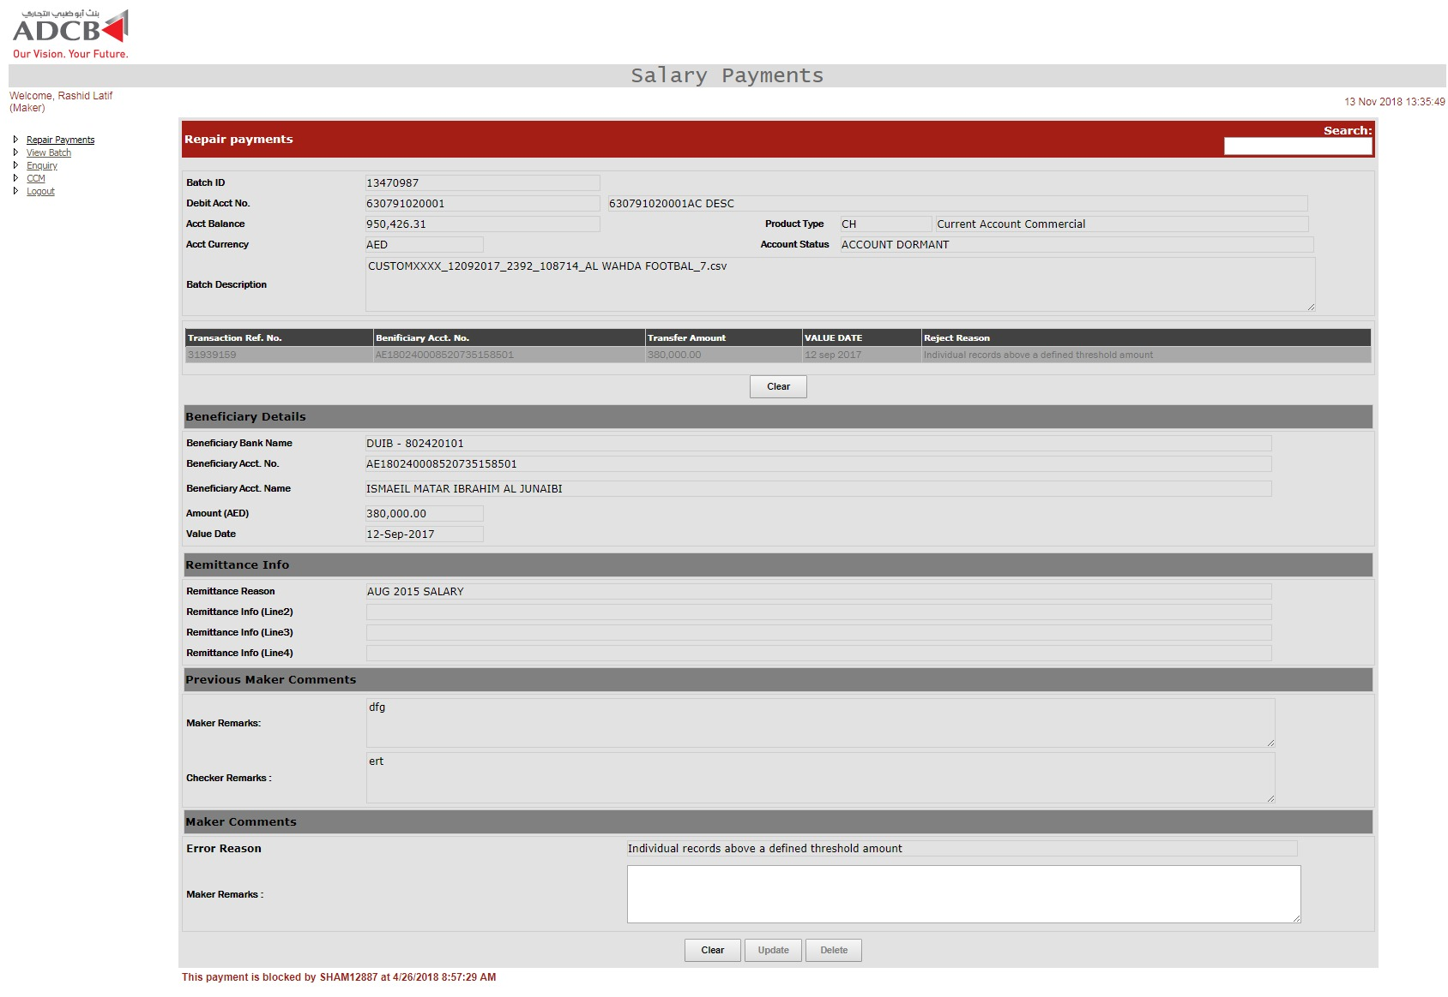

once the user clicks on save or delte, the record is updated in **UAEFTS_SALARY_TXN_CKR** table and one entry is inserted in table **UAEFTS_ARCHIVE_SALARY_TXN_CKR** for audit purpose.

UPDATE UAEFTS_SALARY_TXN_CKR SET

**strA**

makerid = '@UserID',

makerdate = sysdate,

recstatus = NULL,

checkerid = NULL,

checkerdate = NULL,

GEN_CB202 = 'Y/N',

request = 'D/M',

mremarks = '@remarks

WHERE batch_id = @batch_id AND TXN_REF_NO = @txn_ref_no AND checkerrowid = @checkerrowid

AND NVL(request, ' ') in ('I','R') AND status = '5'

Where **strA** is defined based on the error code of that particular transaction.

If errorCode.Trim = "8" Then

If exeedThreshold.Trim.ToString.ToLower = "n" Then

actval = "Y"

Else

actval = "N"

End If

strA = "fraud_filter_flg = '" + actval + "',"

ElseIf errorCode.Trim = "20" Then

strA = "is_salary = '" + exeedThreshold.Trim.ToString + "',"

ElseIf errorCode.Trim = "24" Then

strA = "DUPLICATE_FLG = '" + exeedThreshold.Trim.ToString + "',"

ElseIf errorCode.Trim = "5" Then

strA = " bene_name = '" + bene_name + "'") + ","

ElseIf errorCode.Trim = "13" Or errorCode.Trim = "1" Then

strA = " bene_acc_no = '" + bene_acc_no + "'") + ","

ElseIf errorCode.Trim = "14" Then

strA = " bene_bank_name = '" + bic.Split("|")(0) + "', bene_acc_bic = '" + bic.Split("|")(1) + "', branch_routing_code = '" + bic.Split("|")(1) + "',"

End If

If the channel is incoming (channel id: 13) and error code is one of '6','13','30','108','109','110','111','112','113','114','115','116','117','118','119','126','127','128','129','130' then the generate CB202 checkbox is also enabled and user can generate CB202 message as well.

**Salary Payment Maker – CCM Repair**

For CCM repair queue, below is the query for fetching the CCM records.

SELECT batch_id "Batch ID",

txn_ref_no "Transaction Ref. No.",

pymnt_amnt "Payment Amt.",

TO_CHAR(pymnt_value_date,'dd-Mon-yyyy') "Value Date",

ERROR_CODE "Error Code",

rejection_desc "Error Desc.",

bene_acc_no "Beneficiary Acct. No.",

bene_name "Beneficiary Name",

filename "Batch Description"

FROM payment_txn_mt mt

INNER JOIN uaefts_inward_batch bt ON

bt.batchid = mt.batch_id

LEFT JOIN

uaefts_rejection ct

ON mt.ERROR_CODE = ct.rejection_code

WHERE mt.receiving_channel_id = '13' AND ((status = '18' AND transaction_type = 'CST' AND ERROR_CODE in ('30','12','13','110','126','112','128','113','116','130','117')) OR (status = '32' AND transaction_type = 'CST' AND ERROR_CODE IS NULL ))

AND BATCHID >@BATCHID ORDER BY batch_id DESC

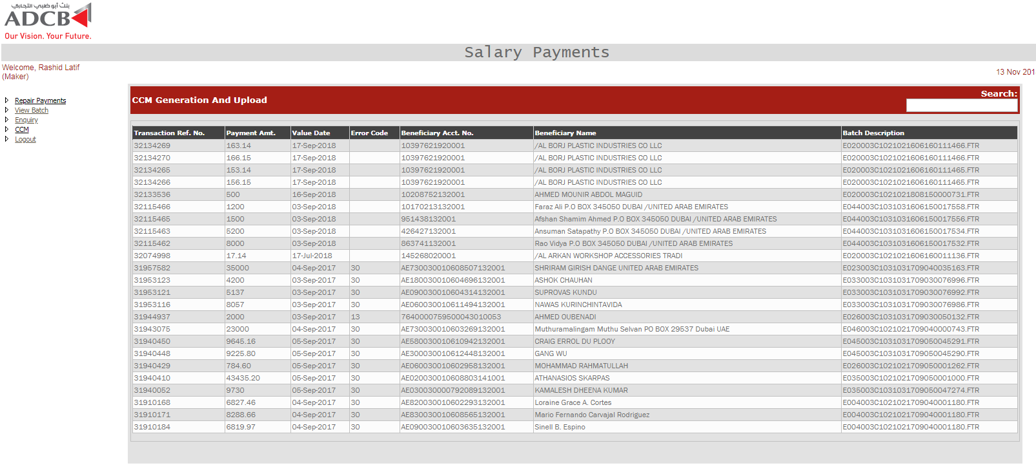

The detais of the batch is fetched with below query.

SELECT * FROM PAYMENT_TXN_MT

INNER JOIN UAEFTS_PAYMENT ON

UAEFTS_PAYMENT.paymentcode = PAYMENT_TXN_MT.transaction_type

INNER JOIN uaefts_fm_txn_dtls ON

PAYMENT_TXN_MT.original_batch_id = uaefts_fm_txn_dtls.batch_id

AND PAYMENT_TXN_MT.original_txn_ref_no = uaefts_fm_txn_dtls.txn_ref_no

LEFT OUTER JOIN UAEFTS_BRANCH ON

UAEFTS_BRANCH.branchcode = PAYMENT_TXN_MT.bene_acc_bic

LEFT JOIN UAEFTS_CHARGE ON

PAYMENT_TXN_MT.charge_to_id = UAEFTS_CHARGE.chargetype

LEFT JOIN uaefts_fm_txn_dtls ON

uaefts_fm_txn_dtls.txn_ref_no = PAYMENT_TXN_MT.original_txn_ref_no

AND uaefts_fm_txn_dtls.BATCH_ID = PAYMENT_TXN_MT.original_batch_id

WHERE PAYMENT_TXN_MT.txn_ref_no =@txn_ref_no and PAYMENT_TXN_MT.batch_id = @batch_id

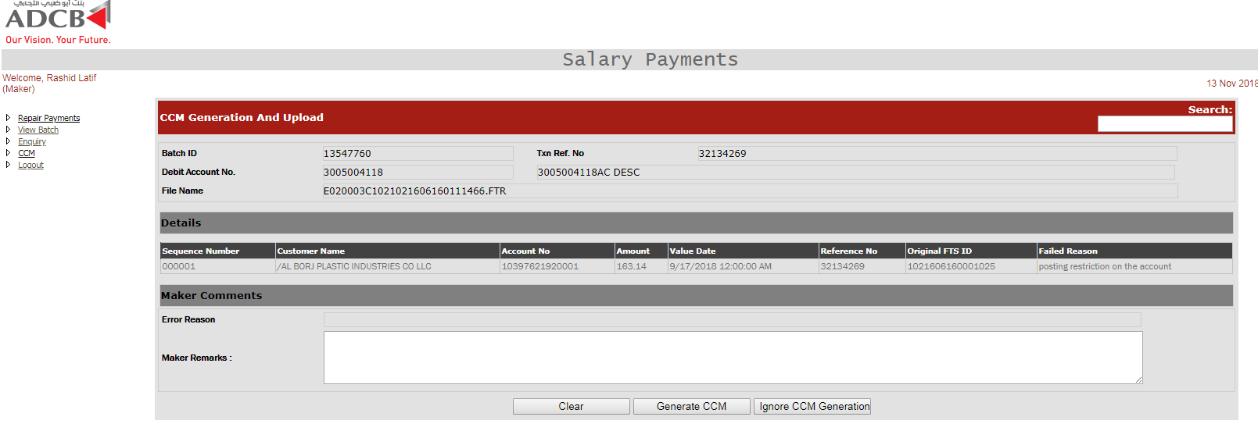

Once the details are fetched, user can either generate the CCM message or ignore the CCM generation. If generate CCM is clicked, one record is inserted in audit table **UAEFTS_ARCHIVE_SALARY_TXN_CKR** and the existing record is updated in **UAEFTS_SALARY_TXN_CKR and and PAYMENT_TXN_MT** tables.

UPDATE UAEFTS_SALARY_TXN_CKR SET

status = '163',

makerid = @user,

makerdate = sysdate,

recstatus = NULL,

checkerid = NULL,

checkerdate = NULL,

request = 'D/M',

mremarks = 'Remarks'

WHERE batch_id = @batch_id AND TXN_REF_NO = @txn_ref_no AND checkerrowid = @checkerrowid

UPDATE PAYMENT_TXN_MT SET status = '163', maker_desc = 'User', maker_date = sysdate, checker_desc = '', checker_date = null ,

status_datetime = systimestamp WHERE txn_ref_no = @txn_ref_no AND batch_id = @batch_id

**Salary Payment Checker – Post Payments**

On this screen, we have all the transactions which are failed for posting due to insufficient fund and which require force debit from user. Below is the query to fetch the records.

SELECT batchid "Batch ID",

batchdesc "Batch Desc.",

TO_NUMBER (totrecords) "Total Rec.",

acctno "Acct. No.",

TO_CHAR (openby) "Created By",

TO_CHAR (openon, 'dd-Mon-yyyy hh:mi:ss') "Created At",

'O'

FROM uaefts_batch

WHERE batchid IN

(SELECT DISTINCT batch_id batchid

FROM uaefts_salary_txn

WHERE batch_id IN

( SELECT a.batch_id batchid

FROM UAEFTS_SALARY_TXN a

WHERE STATUS in (18,12) and batch_id> @maxBatchID

GROUP BY batch_id

HAVING COUNT ( * ) =

(SELECT COUNT ( * )

FROM PAYMENT_TXN_MT

WHERE batch_id =

a.batch_id

AND TRANSACTION_TYPE = 'CST' AND STATUS in (18,139) and batch_id> @maxBatchID

)

)

AND senttoprocess = 'I')

ORDER BY 1 DESC

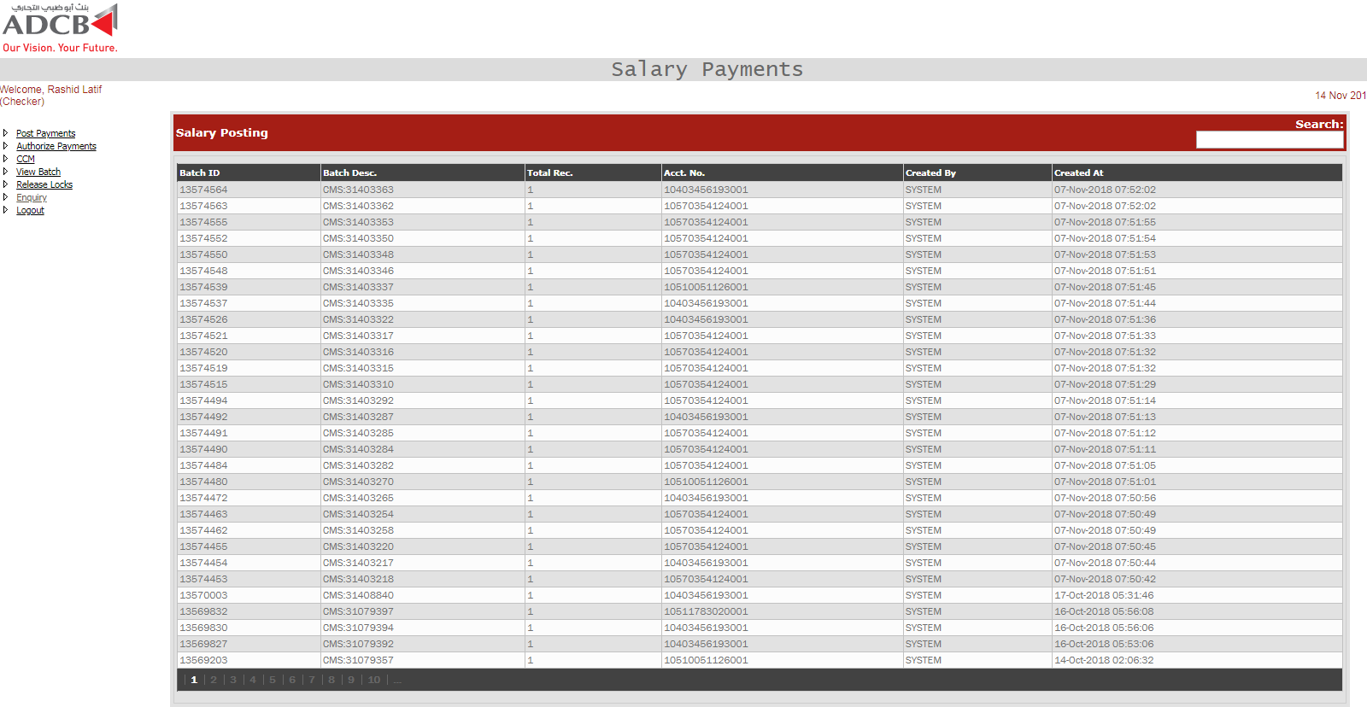

Once the user clicks on any of the batch id, the details of the batch are displayed with all the transaction references. There are three grids that will be loaded for the force debit, one is the records which are pending for authorization, future dated transactions and processed transactions.

The customer details are fetched from MDM golden gate

SELECT MCD.COMP_MIS_1 mis_code, SCCC.customer_type flg_typ_class, SCA.iban_ac_no cod_acct_iban, SC.customer_category flg_cust_typ,

SCA.ac_desc title, SCA.cust_ac_no acctno, SCA.cust_no custid,

fn_fcr_account_stat(SCA.cust_ac_no,SCA.branch_Code,'C') AS acctstatuscode,

fn_fcr_account_stat(SCA.cust_ac_no,SCA.branch_Code,'D') AS acctstatusdesc,

NVL((NVL(sca.acy_avl_bal,'0') + NVL((SELECT dsp_eff_line_amount FROM getm_facility a, getm_liab_cust b, Sttm_facility_Lmcust c Where line_code||line_serial = linked_ref_no And c.cust_ac_no = sca.cust_ac_no And c.branch_code =sca.branch_code And c.CUSTOMER_NO = b.customer_no And b.liab_id = a.liab_id ), '0') - NVL (sca.min_reqd_bal, '0') - NVL (( Select Nvl(Sum(Amount_Due - Amount_Available-amount_paid), 0) From Cstb_Auto_Settle_Block Where Account_No = sca.cust_ac_no And Account_Br = sca.branch_code ),0)), '0') bal,

(TRIM (sc.address_line1)|| ' ' || TRIM (sc.address_line2) || ' ' || TRIM (sc.address_line3) || ' ' || TRIM (sc.address_line4) || ' ' || TRIM (sc.country)) CustomerAdd,

(TRIM (sca.address1)|| ' ' || TRIM (sca.address2) || ' ' || TRIM (sca.address3) || ' ' || TRIM (sca.address4) || ' ' || TRIM (sca.country_code)) address,

SCA.account_class productcode, SCA.ccy currencycode, SCA.ccy currencydesc,

' ' instr, 'CH' productdesc, SAC.DESCRIPTION acproddesc,

(select case when count(1) > 0 Then 'Y' Else 'N' end from sttm_sweep_details where cust_account = SCA.cust_ac_no) sweepin,

'Customer Level : ' || (SELECT cid.user_message FROM cstm_inst_master cim, cstm_inst_detail cid WHERE cid.memo_id = cim.memo_id AND cim.category = 'C' AND cim.record_stat = 'O' AND cim.auth_stat = 'A' AND cid.customer_no = sc.customer_no AND inst_id = (SELECT MAX(inst_id) FROM cstm_inst_master cim, cstm_inst_detail cid WHERE cid.memo_id = cim.memo_id AND cim.category = 'C' AND cim.record_stat = 'O' AND cim.auth_stat = 'A' AND cid.customer_no = sc.customer_no)) || ' Account Level : ' || (SELECT cid.user_message FROM cstm_inst_master cim, cstm_inst_detail cid WHERE cid.memo_id = cim.memo_id AND cim.category = 'A' AND cim.record_stat = 'O' AND cim.auth_stat = 'A' AND cid.customer_no = sca.cust_ac_no AND inst_id = (SELECT MAX(inst_id) FROM cstm_inst_master cim, cstm_inst_detail cid WHERE cid.memo_id = cim.memo_id AND cim.category = 'C' AND cim.record_stat = 'O' AND cim.auth_stat = 'A' AND cid.customer_no = sca.cust_ac_no)) custmemo,

(SELECT cid.display_type FROM cstm_inst_master cim, cstm_inst_detail cid WHERE cid.memo_id = cim.memo_id AND cim.category = 'C' AND cim.record_stat = 'O' AND cim.auth_stat = 'A' AND cid.customer_no = sc.customer_no AND inst_id = (SELECT MAX(inst_id) FROM cstm_inst_master cim, cstm_inst_detail cid WHERE cid.memo_id = cim.memo_id AND cim.category = 'C' AND cim.record_stat = 'O' AND cim.auth_stat = 'A' AND cid.customer_no = sca.cust_ac_no)) memoseverity,

SCA.branch_code BRANCH_CODE, (SELECT branch_name FROM sttm_branch sb WHERE sb.branch_code = sca.branch_code) BRANCH_DESC

FROM sttm_cust_account SCA INNER JOIN sttm_customer SC ON sca.cust_no = sc.customer_no

INNER JOIN sttm_customer_cat SCC ON SCC.cust_cat = sc.customer_category

INNER JOIN sttm_cust_cat_custom SCCC ON SCC.cust_cat = SCCC.cust_cat

INNER JOIN STTM_ACCOUNT_CLASS SAC ON SCA.ACCOUNT_CLASS = SAC.ACCOUNT_CLASS

LEFT OUTER JOIN MITM_CUSTOMER_DEFAULT MCD ON SCA.CUST_NO = MCD.CUSTOMER

LEFT OUTER JOIN SVTM_ADD_ACC_MSG_CUSTOM SAAMC ON SCA.CUST_AC_NO = SAAMC.ACC_NO AND SCA.BRANCH_CODE = SAAMC.BRANCH

LEFT OUTER JOIN sttm_cust_Acc_custom scac ON SCA.CUST_AC_NO = scac.CUST_AC_NO AND SCA.branch_code = scac.branch_code

WHERE (SCA.iban_ac_no ='@Account_No' OR SCA.cust_ac_no='@Account_No')

Transactions Pending Query:

SELECT checkerrowid "Transaction Ref. No.", bene_acc_no "Benificiary Acct. No.",bene_name "Benificiary Name",to_char(pymnt_amnt,'999,999,999,999,999,999.99') "Transfer Amount", to_char(pymnt_value_date,'dd Mon yyyy') "VALUE DATE"

FROM UAEFTS_SALARY_TXN

INNER JOIN uaefts_status ON uaefts_status.statuscode = UAEFTS_SALARY_TXN.status

WHERE TO_DATE(TO_CHAR(pymnt_value_date,'DD-MM-YYYY'), 'DD-MM-YYYY') <= TO_DATE(TO_CHAR(sysdate,'DD-MM-YYYY'), 'DD-MM-YYYY')

AND NVL(senttoprocess,' ') <> 'Y' AND STATUS <> '18' AND batch_id = @BatchID

Future Dated Transction Query:

SELECT checkerrowid "Transaction Ref. No.", bene_acc_no "Benificiary Acct. No.", bene_name "Benificiary Name",to_char(pymnt_amnt,'999,999,999,999,999,999.99') "Transfer Amount",

to_char(pymnt_value_date,'dd Mon yyyy') "VALUE DATE" , statusdesc "Status"

FROM UAEFTS_SALARY_TXN

INNER JOIN uaefts_status ON uaefts_status.statuscode = UAEFTS_SALARY_TXN.status

WHERE TO_DATE(TO_CHAR(pymnt_value_date,'DD-MM-YYYY'), 'DD-MM-YYYY') > TO_DATE(TO_CHAR(sysdate,'DD-MM-YYYY'), 'DD-MM-YYYY')

AND NVL(senttoprocess,' ') <> 'Y' AND STATUS <> '18'

Processed Transaction Query:

SELECT checkerrowid, bene_acc_no "Benificiary Acct. No.",bene_name "Benificiary Name",

to_char(pymnt_amnt,'999,999,999,999,999,999.99') "Transfer Amount",

to_char(pymnt_value_date,'dd Mon yyyy') "VALUE DATE" , statusdesc "Status"

FROM UAEFTS_SALARY_TXN

INNER JOIN uaefts_status ON uaefts_status.statuscode = UAEFTS_SALARY_TXN.status

WHERE NVL(senttoprocess,' ') = 'Y' AND STATUS <> '18'

AND batch_id = @Batch_ID

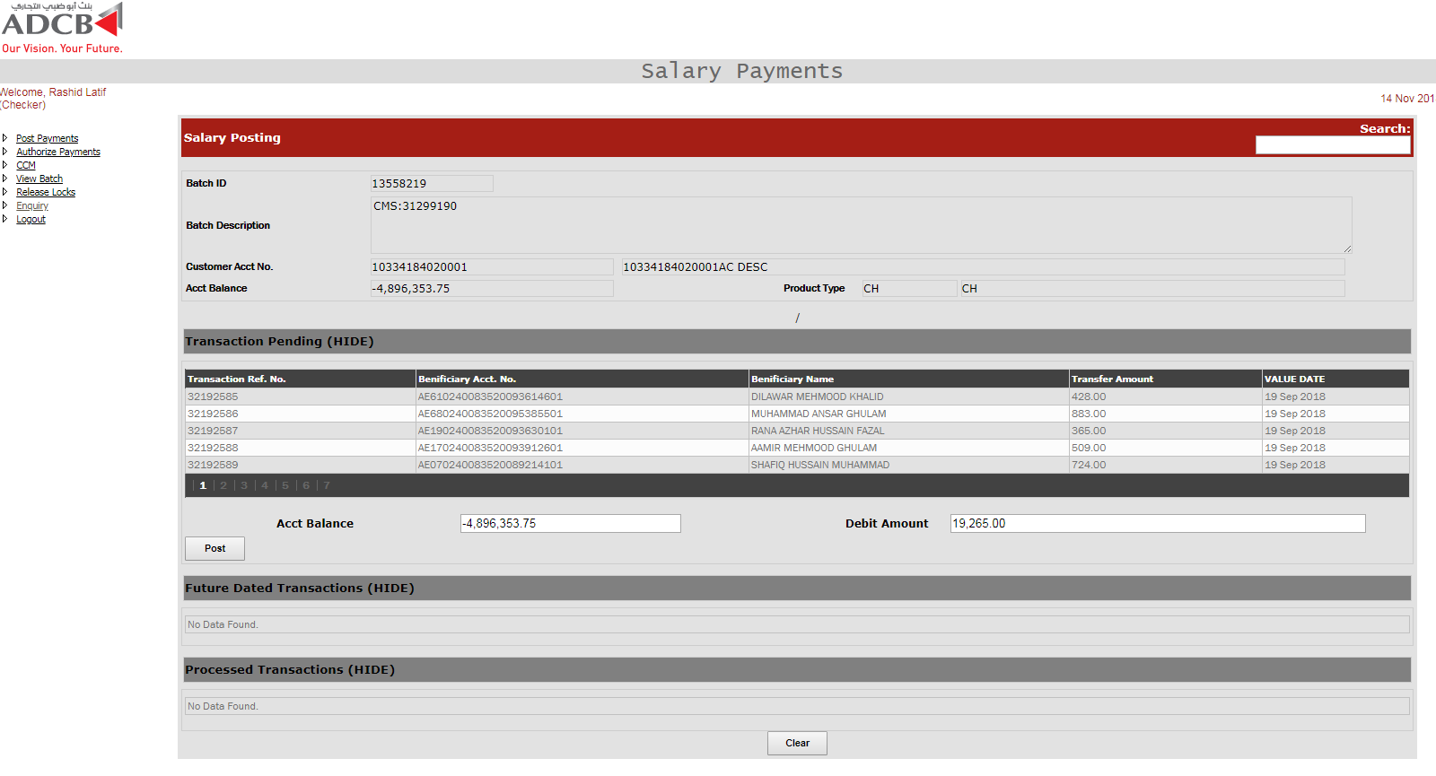

Post button is only enabled for pending transaction grid. Once the user click on the post button, the PAYMENT_TXN_MT and PAYMENT_TXN_MT are update with the below query.

UPDATE UAEFTS_SALARY_TXN SET senttoprocess = 'N' WHERE TXN_REF_IN(@TXNREFNOS)

UPDATE PAYMENT_TXN_MT SET status_datetime = sysdate, status = '4', Force_debit = 'Y', maker_desc = '@USER', maker_date =sysdate, process_datetime = sysdate WHERE TXN_REF_IN(@TXNREFNOS) AND batch_id =@BATCH_id

**Salary Payment Checker – Authorize Payments**

This screen shows all the CST repairded transaction which are pending for approval. Below query is used to fetched the records.

SELECT batch_id "Batch ID", txn_ref_no "Payment Ref. No", blockedby "Blocked By", TO_CHAR(blockedon,'DD Mon yyyy hh:mi:ss') "Blocked On" FROM UAEFTS_SALARY_TXN_CKR WHERE blockedby IS NOT NULL AND batch_id > @Maxbatch_id

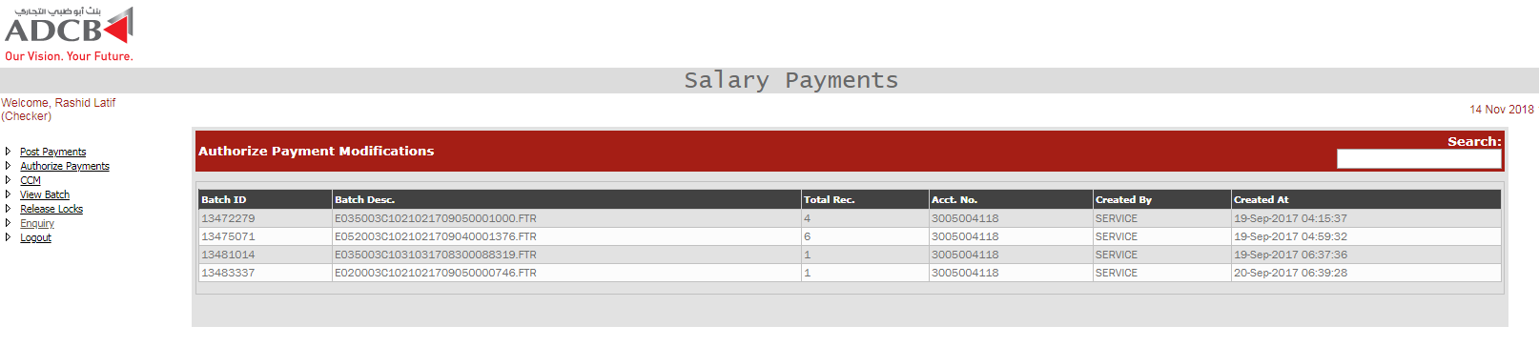

Once the user clicks on the batch, all those transaction which failed validation appears in another grid. Below is the query for fetching the transaction of a particular batch.

SELECT batchid "Batch ID", batchdesc "Batch Desc.",

to_number(totrecords) "Total Rec.", acctno "Acct. No.", to_char(openby) "Created By",

to_char(openon,'dd-Mon-yyyy hh:mi:ss') "Created At" , 'O'

FROM UAEFTS_BATCH

WHERE batchid IN (

SELECT DISTINCT BATCH_ID batchid

FROM UAEFTS_SALARY_TXN_CKR

WHERE STATUS <> '163' AND FETCH IS NULL AND request IN ('M','D') AND BATCH_ID > @maxBatch )

UNION

SELECT batchid "Batch ID", filename "Batch Desc.", to_number(totrecords) "Total Rec.", '241012990' "Acct. No.", to_char(uploadedby) "Created By",

to_char(uploadeddate,'dd-Mon-yyyy hh:mi:ss') "Created At" , 'I'

FROM UAEFTS_INWARD_BATCH

WHERE batchid IN (

SELECT DISTINCT BATCH_ID batchid

FROM UAEFTS_SALARY_TXN_CKR

WHERE STATUS <> '163' AND FETCH IS NULL AND request IN ('M','D') AND BATCH_ID > @maxBatchID) ORDER BY 1

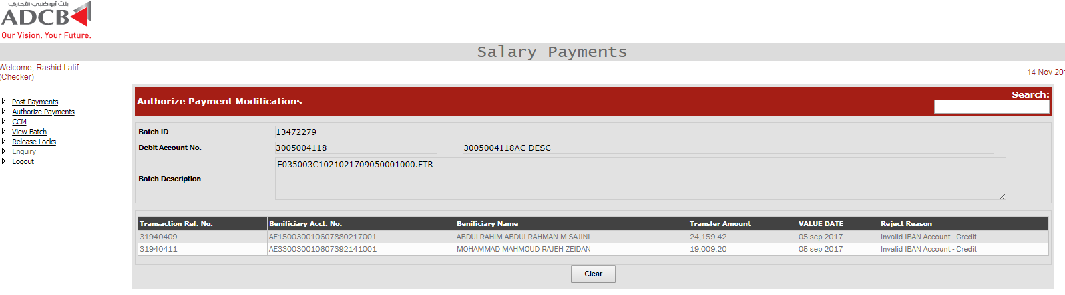

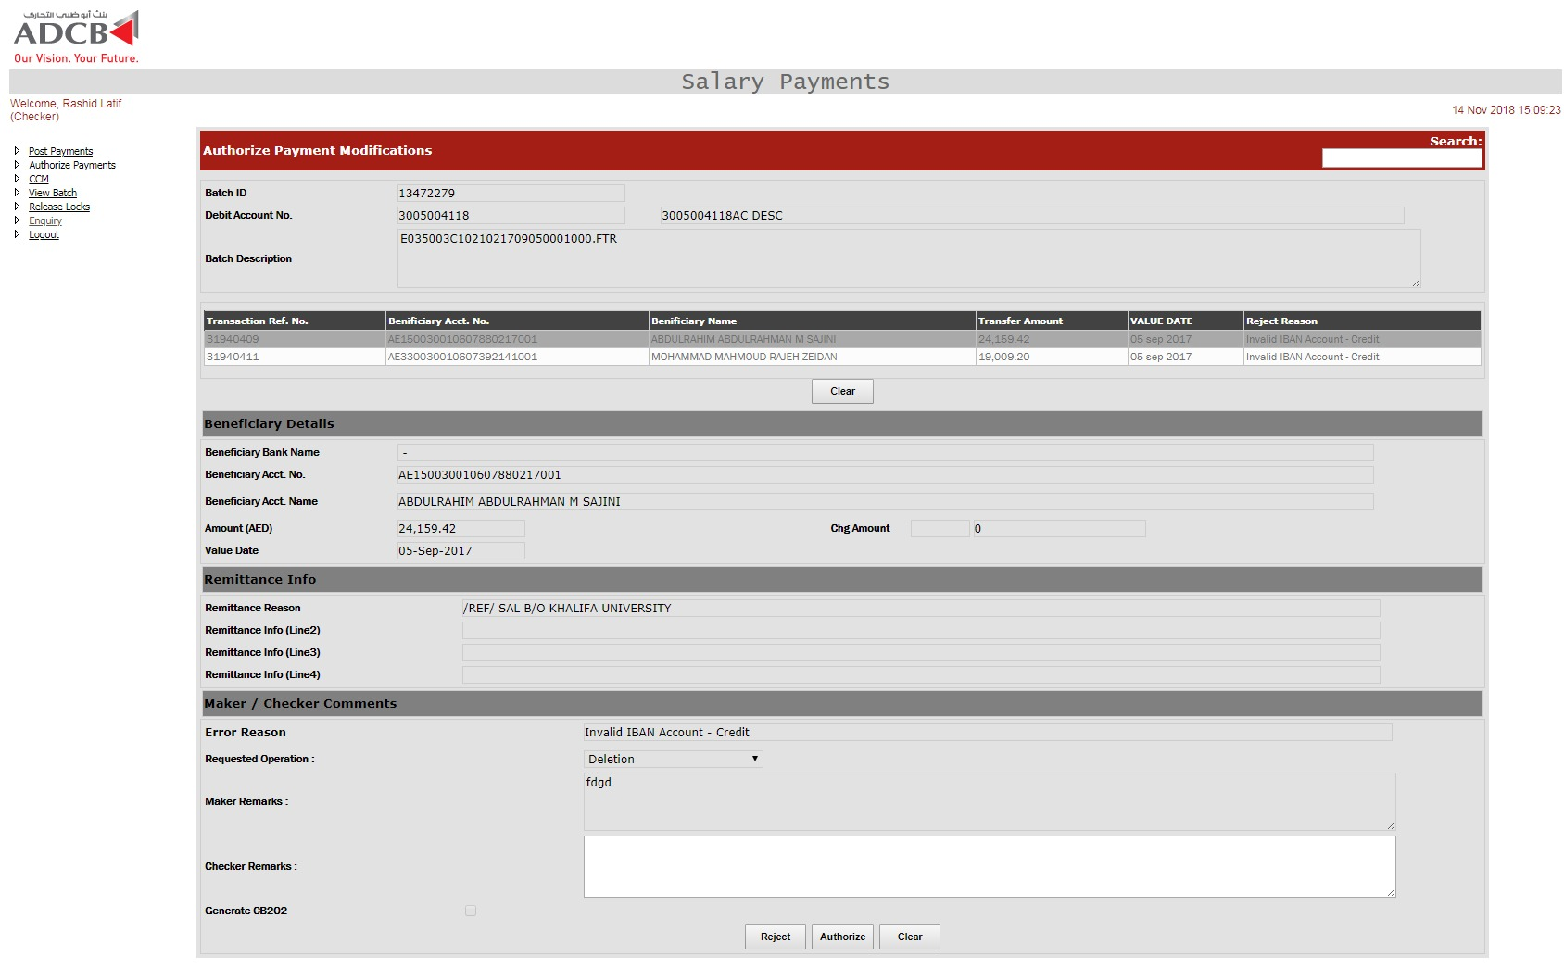

User can either authorize or reject individual transaction. On authorization, the record is inserted in UAEFTS_ARCHIVE_SALARY_TXN_CKR and UAEFTS_SALARY_TXN table while UAEFTS_SALARY_TXN_CKR AND PYAMENT_TXN_MT tables are update. Below are the query based on the reject reason of the transaction.

If user is authorizing the deletion, then below queries are executed in transaction

INSERT INTO UAEFTS_SALARY_TXN

(CHECKERROWID, BATCH_ID, FILE_REF_NO , TXN_REF_NO, PYMNT_AMNT , PYMNT_VALUE_DATE, PYMNT_CURR , EX_RATE , STATUS,

ERROR_CODE , ERROR_DESC, DEBIT_ACC_NO, DEBIT_ACC_BIC, ORDER_CUST_NAME , ORDER_CUST_ADDR1, ORDER_CUST_ADDR2,

ORDER_CUST_ADDR3 , BENE_NAME , BENE_ACC_NO , BENE_ADDR1 , BENE_ADDR2, BENE_ADDR3 , BENE_ACC_BIC , BENE_BANK_NAME ,

BENE_BANK_ADDR1, BENE_BANK_ADDR2, BENE_BANK_ADDR3 , INTERMEDIARY_BANK_NAME , INTERMEDIARY_BANK_ADDRESS_1 ,

INTERMEDIARY_BANK_ADDRESS_2 , INTERMEDIARY_BANK_ADDRESS_3 , REMITTANCE_INFO1 , REMITTANCE_INFO2 ,

REMITTANCE_INFO3 , REMITTANCE_INFO4 , CHARGE_TO_ID , TOTAL_CHARGE_AMOUNT, OTHER_SYSTEM_REF_NO, TRANSACTION_TYPE,

PROCESS_DATETIME , BRANCH_ROUTING_CODE , MAKER_DESC , MAKER_DATE , STATUS_DATETIME , CHECKER_DESC ,

CHECKER_DATE , MIDDLEWARE_REQUEST , MIDDLEWARE_RESPONSE, AUTHORIZE_YN , RECEIVING_CHANNEL_ID , FILE_NAME ,

POSTING_STATUS , PROCESSING_CHANNEL_ID , ORIGINAL_BATCH_ID, ORIGINAL_TXN_REF_NO , RECORD_TYPE , INTERMEDIARY_BANK_BIC, fraud_filter_flg,

org_branch_code, dest_branch_code,DUPLICATE_FLG )

SELECT CHECKERROWID, BATCH_ID, FILE_REF_NO , TXN_REF_NO, PYMNT_AMNT , PYMNT_VALUE_DATE, PYMNT_CURR , EX_RATE , '18',

ERROR_CODE , ERROR_DESC, DEBIT_ACC_NO, DEBIT_ACC_BIC, ORDER_CUST_NAME , ORDER_CUST_ADDR1, ORDER_CUST_ADDR2,

ORDER_CUST_ADDR3 , BENE_NAME , BENE_ACC_NO , BENE_ADDR1 , BENE_ADDR2, BENE_ADDR3 , BENE_ACC_BIC , BENE_BANK_NAME ,

BENE_BANK_ADDR1, BENE_BANK_ADDR2, BENE_BANK_ADDR3 , INTERMEDIARY_BANK_NAME , INTERMEDIARY_BANK_ADDRESS_1 ,

INTERMEDIARY_BANK_ADDRESS_2 , INTERMEDIARY_BANK_ADDRESS_3 , REMITTANCE_INFO1 , REMITTANCE_INFO2 ,

REMITTANCE_INFO3 , REMITTANCE_INFO4 , CHARGE_TO_ID , TOTAL_CHARGE_AMOUNT, OTHER_SYSTEM_REF_NO, TRANSACTION_TYPE,

PROCESS_DATETIME , BRANCH_ROUTING_CODE , MAKER_DESC , MAKER_DATE , STATUS_DATETIME , CHECKER_DESC ,

CHECKER_DATE , MIDDLEWARE_REQUEST , MIDDLEWARE_RESPONSE, AUTHORIZE_YN , RECEIVING_CHANNEL_ID , FILE_NAME ,

POSTING_STATUS , PROCESSING_CHANNEL_ID , ORIGINAL_BATCH_ID, ORIGINAL_TXN_REF_NO , RECORD_TYPE , INTERMEDIARY_BANK_BIC , fraud_filter_flg,

org_branch_code, dest_branch_code,DUPLICATE_FLG

FROM UAEFTS_SALARY_TXN_CKR

WHERE batch_id = @batch_id AND TXN_REF_NO = @txn_ref_no AND checkerrowid = @recordID

UPDATE UAEFTS_SALARY_TXN_CKR

SET status = '18', checkerid = '@USerid', cremarks = 'Remarks',

checkerdate = sysdate, recstatus = 'A', request = 'P'

WHERE batch_id = @batch_id AND TXN_REF_NO = @txn_ref_no AND checkerrowid = @recordID

If Generate CB202 is true then the staus is 173, otherwise the status is 18

UPDATE PAYMENT_TXN_MT

SET STATUS_DATETIME = sysdate, STATUS = '173',

MAKER_DESC = 'Remarks',

MAKER_DATE = @makerDate,

CHECKER_DESC = @userID, CHECKER_DATE = sysdate

WHERE TXN_REF_NO = @txn_ref_no and batch_id = @batch_id

Based on the reject code, one of the below query is executed along with the above ones for the deletion.

If reject code = 13 or 6

UPDATE UAEFTS_FM_TXN_DTLS SET STATUSDATE = SYSDATE, ERROR_CODE = '3', STATUS = '66' WHERE TXN_REF_NO = (SELECT ORIGINAL_TXN_REF_NO FROM PAYMENT_TXN_MT WHERE TXN_REF_NO = @txn_ref_no AND batch_id = @batch_id)

If reject code = 26

UPDATE UAEFTS_FM_TXN_DTLS SET STATUSDATE = SYSDATE, ERROR_CODE = '2', STATUS = '66' WHERE TXN_REF_NO = (SELECT ORIGINAL_TXN_REF_NO FROM PAYMENT_TXN_MT WHERE TXN_REF_NO = @txn_ref_no AND batch_id = @batch_id)

If reject code = 5

UPDATE UAEFTS_FM_TXN_DTLS SET STATUSDATE = SYSDATE, ERROR_CODE = '3', STATUS = '66' WHERE TXN_REF_NO = (SELECT ORIGINAL_TXN_REF_NO FROM PAYMENT_TXN_MT WHERE TXN_REF_NO = @txn_ref_no AND batch_id = @batch_id)

If reject code = 23

UPDATE UAEFTS_FM_TXN_DTLS SET STATUSDATE = SYSDATE, ERROR_CODE = '5', STATUS = '66' WHERE TXN_REF_NO = (SELECT ORIGINAL_TXN_REF_NO FROM PAYMENT_TXN_MT WHERE TXN_REF_NO = @txn_ref_no AND batch_id = @batch_id)

If reject code = 25

UPDATE UAEFTS_FM_TXN_DTLS SET STATUSDATE = SYSDATE, ERROR_CODE = '6', STATUS = '66' WHERE TXN_REF_NO = (SELECT ORIGINAL_TXN_REF_NO FROM PAYMENT_TXN_MT WHERE TXN_REF_NO = @txn_ref_no AND batch_id = @batch_id)

If the transaction is authorize for processing and not for deletion, below are the queries executed based on the error codes of the transactions.

If error code = 5

INSERT INTO UAEFTS_AI_ACCTITLE (ACCNO, OLD_TITLE, NEW_TITLE, MAKERID, MDATE, CHECKERID, CDATE, txn_ref_no)

VALUES (@beneAcctNo, (SELECT BENE_NAME FROM PAYMENT_TXN_MT WHERE txn_ref_no =@txn_ref_no AND batch_id = @batch_id),@beneName,@makerID,@makerDate,@CHECKERID, sysdate,@recordID)

UPDATE PAYMENT_TXN_MT

SET STATUS_DATETIME = sysdate, ERROR_CODE = NULL, ERROR_DESC = NULL,

STATUS = '35', BENE_NAME = @beneName,

MAKER_DESC = 'desc',

MAKER_DATE = @makerDate,

CHECKER_DESC = '@userID',

CHECKER_DATE = SYSDATE

WHERE TXN_REF_NO = @txn_ref_no AND BATCH_ID = @batch_id

UPDATE PAYMENT_TXN_MT

SET STATUS_DATETIME = sysdate,

STATUS = '12',

MAKER_DESC = '@makerid',

MAKER_DATE = @makerDate,

CHECKER_DESC = @CHECKERID,

CHECKER_DATE = SYSDATE

WHERE TXN_REF_NO = @txn_ref_no AND BATCH_ID = @batch_id

INSERT INTO UAEFTS_ARCHIVE_SALARY_TXN_CKR (

CHECKERROWID,BATCH_ID,FILE_REF_NO,TXN_REF_NO,PYMNT_AMNT,PYMNT_VALUE_DATE,PYMNT_CURR,EX_RATE,STATUS,ERROR_CODE,ERROR_DESC,DEBIT_ACC_NO,

DEBIT_ACC_BIC,ORDER_CUST_NAME,ORDER_CUST_ADDR1,ORDER_CUST_ADDR2,

ORDER_CUST_ADDR3,BENE_NAME,BENE_ACC_NO,BENE_ADDR1,BENE_ADDR2,BENE_ADDR3,BENE_ACC_BIC,BENE_BANK_NAME,BENE_BANK_ADDR1,BENE_BANK_ADDR2,BENE_BANK_ADDR3,INTERMEDIARY_BANK_NAME,INTERMEDIARY_BANK_ADDRESS_1,INTERMEDIARY_BANK_ADDRESS_2, INTERMEDIARY_BANK_ADDRESS_3, REMITTANCE_INFO1,

REMITTANCE_INFO2,REMITTANCE_INFO3,REMITTANCE_INFO4,CHARGE_TO_ID,TOTAL_CHARGE_AMOUNT,OTHER_SYSTEM_REF_NO,TRANSACTION_TYPE,PROCESS_DATETIME, BRANCH_ROUTING_CODE,MAKER_DESC,MAKER_DATE,STATUS_DATETIME,CHECKER_DESC,CHECKER_DATE,MIDDLEWARE_REQUEST,MIDDLEWARE_RESPONSE,AUTHORIZE_YN,RECEIVING_CHANNEL_ID,FILE_NAME,POSTING_STATUS,PROCESSING_CHANNEL_ID,ORIGINAL_BATCH_ID,ORIGINAL_TXN_REF_NO,RECORD_TYPE,INTERMEDIARY_BANK_BIC,MAKERID,MREMARKS,MAKERDATE,CHECKERID,CREMARKS,CHECKERDATE,RECSTATUS,BLOCKEDBY,BLOCKEDON,REJECTCODE,REJECTREASON,KSTATUS,FETCH,FORCE_DEBIT,REQUEST,ORG_BRANCH_CODE,DEST_BRANCH_CODE,ISSALARY,DUPLICATE_FLG,CID,IBAN,IBAN_DR )

SELECT

CHECKERROWID,BATCH_ID,FILE_REF_NO,TXN_REF_NO,PYMNT_AMNT,PYMNT_VALUE_DATE,PYMNT_CURR,EX_RATE,STATUS,ERROR_CODE,ERROR_DESC,DEBIT_ACC_NO,

DEBIT_ACC_BIC,ORDER_CUST_NAME,ORDER_CUST_ADDR1,ORDER_CUST_ADDR2,

ORDER_CUST_ADDR3,BENE_NAME,BENE_ACC_NO,BENE_ADDR1,BENE_ADDR2,BENE_ADDR3,BENE_ACC_BIC,BENE_BANK_NAME,BENE_BANK_ADDR1,BENE_BANK_ADDR2,BENE_BANK_ADDR3,INTERMEDIARY_BANK_NAME,INTERMEDIARY_BANK_ADDRESS_1,INTERMEDIARY_BANK_ADDRESS_2,INTERMEDIARY_BANK_ADDRESS_3,REMITTANCE_INFO1,REMITTANCE_INFO2,REMITTANCE_INFO3,REMITTANCE_INFO4,CHARGE_TO_ID,TOTAL_CHARGE_AMOUNT,OTHER_SYSTEM_REF_NO,TRANSACTION_TYPE,PROCESS_DATETIME,BRANCH_ROUTING_CODE,MAKER_DESC,MAKER_DATE,STATUS_DATETIME,CHECKER_DESC, CHECKER_DATE,MIDDLEWARE_REQUEST,MIDDLEWARE_RESPONSE,AUTHORIZE_YN,RECEIVING_CHANNEL_ID,FILE_NAME,POSTING_STATUS,PROCESSING_CHANNEL_ID,ORIGINAL_BATCH_ID,ORIGINAL_TXN_REF_NO,RECORD_TYPE,INTERMEDIARY_BANK_BIC,MAKERID,MREMARKS,MAKERDATE,CHECKERID,CREMARKS,CHECKERDATE,RECSTATUS,BLOCKEDBY,BLOCKEDON,REJECTCODE,REJECTREASON,KSTATUS,FETCH,FORCE_DEBIT,REQUEST,ORG_BRANCH_CODE,DEST_BRANCH_CODE,IS_SALARY,DUPLICATE_FLG,CID,IBAN,IBAN_DR

FROM UAEFTS_SALARY_TXN_CKR

WHERE batch_id AND TXN_REF_NO = @txn_ref_no AND checkerrowid = @recordID

UPDATE UAEFTS_SALARY_TXN_CKR

SET status = '12', checkerid =NULL, cremarks = NULL,checkerdate = NULL,

recstatus = NULL, request = NULL,

error_code = NULL, error_desc = NULL

WHERE batch_id = @batch_id AND TXN_REF_NO = @txn_ref_no AND checkerrowid = @recordID

If error code = 8

UPDATE PAYMENT_TXN_MT

SET STATUS_DATETIME = sysdate, ERROR_CODE = NULL, ERROR_DESC = NULL,

STATUS = '19', FRAUD_FILTER_FLG = @Y/N,

MAKER_DESC = @makerid,MAKER_DATE = @makerDate,

CHECKER_DESC = '@user', CHECKER_DATE = SYSDATE

WHERE batch_id = @batch_id AND TXN_REF_NO = @txn_ref_no

INSERT INTO UAEFTS_ARCHIVE_SALARY_TXN_CKR (

CHECKERROWID,BATCH_ID,FILE_REF_NO,TXN_REF_NO,PYMNT_AMNT,PYMNT_VALUE_DATE,PYMNT_CURR,EX_RATE,STATUS,ERROR_CODE,ERROR_DESC,DEBIT_ACC_NO,

DEBIT_ACC_BIC,ORDER_CUST_NAME,ORDER_CUST_ADDR1,ORDER_CUST_ADDR2,

ORDER_CUST_ADDR3,BENE_NAME,BENE_ACC_NO,BENE_ADDR1,BENE_ADDR2,BENE_ADDR3,BENE_ACC_BIC,BENE_BANK_NAME,BENE_BANK_ADDR1,BENE_BANK_ADDR2,BENE_BANK_ADDR3,INTERMEDIARY_BANK_NAME,INTERMEDIARY_BANK_ADDRESS_1,INTERMEDIARY_BANK_ADDRESS_2, INTERMEDIARY_BANK_ADDRESS_3, REMITTANCE_INFO1,

REMITTANCE_INFO2,REMITTANCE_INFO3,REMITTANCE_INFO4,CHARGE_TO_ID,TOTAL_CHARGE_AMOUNT,OTHER_SYSTEM_REF_NO,TRANSACTION_TYPE,PROCESS_DATETIME, BRANCH_ROUTING_CODE,MAKER_DESC,MAKER_DATE,STATUS_DATETIME,CHECKER_DESC,CHECKER_DATE,MIDDLEWARE_REQUEST,MIDDLEWARE_RESPONSE,AUTHORIZE_YN,RECEIVING_CHANNEL_ID,FILE_NAME,POSTING_STATUS,PROCESSING_CHANNEL_ID,ORIGINAL_BATCH_ID,ORIGINAL_TXN_REF_NO,RECORD_TYPE,INTERMEDIARY_BANK_BIC,MAKERID,MREMARKS,MAKERDATE,CHECKERID,CREMARKS,CHECKERDATE,RECSTATUS,BLOCKEDBY,BLOCKEDON,REJECTCODE,REJECTREASON,KSTATUS,FETCH,FORCE_DEBIT,REQUEST,ORG_BRANCH_CODE,DEST_BRANCH_CODE,ISSALARY,DUPLICATE_FLG,CID,IBAN,IBAN_DR )

SELECT

CHECKERROWID,BATCH_ID,FILE_REF_NO,TXN_REF_NO,PYMNT_AMNT,PYMNT_VALUE_DATE,PYMNT_CURR,EX_RATE,STATUS,ERROR_CODE,ERROR_DESC,DEBIT_ACC_NO,

DEBIT_ACC_BIC,ORDER_CUST_NAME,ORDER_CUST_ADDR1,ORDER_CUST_ADDR2,

ORDER_CUST_ADDR3,BENE_NAME,BENE_ACC_NO,BENE_ADDR1,BENE_ADDR2,BENE_ADDR3,BENE_ACC_BIC,BENE_BANK_NAME,BENE_BANK_ADDR1,BENE_BANK_ADDR2,BENE_BANK_ADDR3,INTERMEDIARY_BANK_NAME,INTERMEDIARY_BANK_ADDRESS_1,INTERMEDIARY_BANK_ADDRESS_2,INTERMEDIARY_BANK_ADDRESS_3,REMITTANCE_INFO1,REMITTANCE_INFO2,REMITTANCE_INFO3,REMITTANCE_INFO4,CHARGE_TO_ID,TOTAL_CHARGE_AMOUNT,OTHER_SYSTEM_REF_NO,TRANSACTION_TYPE,PROCESS_DATETIME,BRANCH_ROUTING_CODE,MAKER_DESC,MAKER_DATE,STATUS_DATETIME,CHECKER_DESC, CHECKER_DATE,MIDDLEWARE_REQUEST,MIDDLEWARE_RESPONSE,AUTHORIZE_YN,RECEIVING_CHANNEL_ID,FILE_NAME,POSTING_STATUS,PROCESSING_CHANNEL_ID,ORIGINAL_BATCH_ID,ORIGINAL_TXN_REF_NO,RECORD_TYPE,INTERMEDIARY_BANK_BIC,MAKERID,MREMARKS,MAKERDATE,CHECKERID,CREMARKS,CHECKERDATE,RECSTATUS,BLOCKEDBY,BLOCKEDON,REJECTCODE,REJECTREASON,KSTATUS,FETCH,FORCE_DEBIT,REQUEST,ORG_BRANCH_CODE,DEST_BRANCH_CODE,IS_SALARY,DUPLICATE_FLG,CID,IBAN,IBAN_DR

FROM UAEFTS_SALARY_TXN_CKR

WHERE batch_id AND TXN_REF_NO = @txn_ref_no AND checkerrowid = @recordID

UPDATE UAEFTS_SALARY_TXN_CKR

SET status = '12', checkerid =NULL, cremarks = NULL,checkerdate = NULL,

recstatus = NULL, request = NULL,

error_code = NULL, error_desc = NULL

WHERE batch_id = @batch_id AND TXN_REF_NO = @txn_ref_no AND checkerrowid = @recordID

If error code = 24

UPDATE PAYMENT_TXN_MT

SET STATUS_DATETIME = sysdate, ERROR_CODE = NULL, ERROR_DESC = NULL,

STATUS = '19', FRAUD_FILTER_FLG = @Y/N,

MAKER_DESC = @makerid,MAKER_DATE = @makerDate,

CHECKER_DESC = '@user', CHECKER_DATE = SYSDATE

WHERE batch_id = @batch_id AND TXN_REF_NO = @txn_ref_no

INSERT INTO UAEFTS_ARCHIVE_SALARY_TXN_CKR (

CHECKERROWID,BATCH_ID,FILE_REF_NO,TXN_REF_NO,PYMNT_AMNT,PYMNT_VALUE_DATE,PYMNT_CURR,EX_RATE,STATUS,ERROR_CODE,ERROR_DESC,DEBIT_ACC_NO,

DEBIT_ACC_BIC,ORDER_CUST_NAME,ORDER_CUST_ADDR1,ORDER_CUST_ADDR2,

ORDER_CUST_ADDR3,BENE_NAME,BENE_ACC_NO,BENE_ADDR1,BENE_ADDR2,BENE_ADDR3,BENE_ACC_BIC,BENE_BANK_NAME,BENE_BANK_ADDR1,BENE_BANK_ADDR2,BENE_BANK_ADDR3,INTERMEDIARY_BANK_NAME,INTERMEDIARY_BANK_ADDRESS_1,INTERMEDIARY_BANK_ADDRESS_2, INTERMEDIARY_BANK_ADDRESS_3, REMITTANCE_INFO1,

REMITTANCE_INFO2,REMITTANCE_INFO3,REMITTANCE_INFO4,CHARGE_TO_ID,TOTAL_CHARGE_AMOUNT,OTHER_SYSTEM_REF_NO,TRANSACTION_TYPE,PROCESS_DATETIME, BRANCH_ROUTING_CODE,MAKER_DESC,MAKER_DATE,STATUS_DATETIME,CHECKER_DESC,CHECKER_DATE,MIDDLEWARE_REQUEST,MIDDLEWARE_RESPONSE,AUTHORIZE_YN,RECEIVING_CHANNEL_ID,FILE_NAME,POSTING_STATUS,PROCESSING_CHANNEL_ID,ORIGINAL_BATCH_ID,ORIGINAL_TXN_REF_NO,RECORD_TYPE,INTERMEDIARY_BANK_BIC,MAKERID,MREMARKS,MAKERDATE,CHECKERID,CREMARKS,CHECKERDATE,RECSTATUS,BLOCKEDBY,BLOCKEDON,REJECTCODE,REJECTREASON,KSTATUS,FETCH,FORCE_DEBIT,REQUEST,ORG_BRANCH_CODE,DEST_BRANCH_CODE,ISSALARY,DUPLICATE_FLG,CID,IBAN,IBAN_DR )

SELECT

CHECKERROWID,BATCH_ID,FILE_REF_NO,TXN_REF_NO,PYMNT_AMNT,PYMNT_VALUE_DATE,PYMNT_CURR,EX_RATE,STATUS,ERROR_CODE,ERROR_DESC,DEBIT_ACC_NO,

DEBIT_ACC_BIC,ORDER_CUST_NAME,ORDER_CUST_ADDR1,ORDER_CUST_ADDR2,

ORDER_CUST_ADDR3,BENE_NAME,BENE_ACC_NO,BENE_ADDR1,BENE_ADDR2,BENE_ADDR3,BENE_ACC_BIC,BENE_BANK_NAME,BENE_BANK_ADDR1,BENE_BANK_ADDR2,BENE_BANK_ADDR3,INTERMEDIARY_BANK_NAME,INTERMEDIARY_BANK_ADDRESS_1,INTERMEDIARY_BANK_ADDRESS_2,INTERMEDIARY_BANK_ADDRESS_3,REMITTANCE_INFO1,REMITTANCE_INFO2,REMITTANCE_INFO3,REMITTANCE_INFO4,CHARGE_TO_ID,TOTAL_CHARGE_AMOUNT,OTHER_SYSTEM_REF_NO,TRANSACTION_TYPE,PROCESS_DATETIME,BRANCH_ROUTING_CODE,MAKER_DESC,MAKER_DATE,STATUS_DATETIME,CHECKER_DESC, CHECKER_DATE,MIDDLEWARE_REQUEST,MIDDLEWARE_RESPONSE,AUTHORIZE_YN,RECEIVING_CHANNEL_ID,FILE_NAME,POSTING_STATUS,PROCESSING_CHANNEL_ID,ORIGINAL_BATCH_ID,ORIGINAL_TXN_REF_NO,RECORD_TYPE,INTERMEDIARY_BANK_BIC,MAKERID,MREMARKS,MAKERDATE,CHECKERID,CREMARKS,CHECKERDATE,RECSTATUS,BLOCKEDBY,BLOCKEDON,REJECTCODE,REJECTREASON,KSTATUS,FETCH,FORCE_DEBIT,REQUEST,ORG_BRANCH_CODE,DEST_BRANCH_CODE,IS_SALARY,DUPLICATE_FLG,CID,IBAN,IBAN_DR

FROM UAEFTS_SALARY_TXN_CKR

WHERE batch_id AND TXN_REF_NO = @txn_ref_no AND checkerrowid = @recordID

If error = 20 and is_salary = N

INSERT INTO UAEFTS_ARCHIVE_SALARY_TXN_CKR (

CHECKERROWID,BATCH_ID,FILE_REF_NO,TXN_REF_NO,PYMNT_AMNT,PYMNT_VALUE_DATE,PYMNT_CURR,EX_RATE,STATUS,ERROR_CODE,ERROR_DESC,DEBIT_ACC_NO,

DEBIT_ACC_BIC,ORDER_CUST_NAME,ORDER_CUST_ADDR1,ORDER_CUST_ADDR2,

ORDER_CUST_ADDR3,BENE_NAME,BENE_ACC_NO,BENE_ADDR1,BENE_ADDR2,BENE_ADDR3,BENE_ACC_BIC,BENE_BANK_NAME,BENE_BANK_ADDR1,BENE_BANK_ADDR2,BENE_BANK_ADDR3,INTERMEDIARY_BANK_NAME,INTERMEDIARY_BANK_ADDRESS_1,INTERMEDIARY_BANK_ADDRESS_2, INTERMEDIARY_BANK_ADDRESS_3, REMITTANCE_INFO1,

REMITTANCE_INFO2,REMITTANCE_INFO3,REMITTANCE_INFO4,CHARGE_TO_ID,TOTAL_CHARGE_AMOUNT,OTHER_SYSTEM_REF_NO,TRANSACTION_TYPE,PROCESS_DATETIME, BRANCH_ROUTING_CODE,MAKER_DESC,MAKER_DATE,STATUS_DATETIME,CHECKER_DESC,CHECKER_DATE,MIDDLEWARE_REQUEST,MIDDLEWARE_RESPONSE,AUTHORIZE_YN,RECEIVING_CHANNEL_ID,FILE_NAME,POSTING_STATUS,PROCESSING_CHANNEL_ID,ORIGINAL_BATCH_ID,ORIGINAL_TXN_REF_NO,RECORD_TYPE,INTERMEDIARY_BANK_BIC,MAKERID,MREMARKS,MAKERDATE,CHECKERID,CREMARKS,CHECKERDATE,RECSTATUS,BLOCKEDBY,BLOCKEDON,REJECTCODE,REJECTREASON,KSTATUS,FETCH,FORCE_DEBIT,REQUEST,ORG_BRANCH_CODE,DEST_BRANCH_CODE,ISSALARY,DUPLICATE_FLG,CID,IBAN,IBAN_DR )

SELECT

CHECKERROWID,BATCH_ID,FILE_REF_NO,TXN_REF_NO,PYMNT_AMNT,PYMNT_VALUE_DATE,PYMNT_CURR,EX_RATE,STATUS,ERROR_CODE,ERROR_DESC,DEBIT_ACC_NO,

DEBIT_ACC_BIC,ORDER_CUST_NAME,ORDER_CUST_ADDR1,ORDER_CUST_ADDR2,

ORDER_CUST_ADDR3,BENE_NAME,BENE_ACC_NO,BENE_ADDR1,BENE_ADDR2,BENE_ADDR3,BENE_ACC_BIC,BENE_BANK_NAME,BENE_BANK_ADDR1,BENE_BANK_ADDR2,BENE_BANK_ADDR3,INTERMEDIARY_BANK_NAME,INTERMEDIARY_BANK_ADDRESS_1,INTERMEDIARY_BANK_ADDRESS_2,INTERMEDIARY_BANK_ADDRESS_3,REMITTANCE_INFO1,REMITTANCE_INFO2,REMITTANCE_INFO3,REMITTANCE_INFO4,CHARGE_TO_ID,TOTAL_CHARGE_AMOUNT,OTHER_SYSTEM_REF_NO,TRANSACTION_TYPE,PROCESS_DATETIME,BRANCH_ROUTING_CODE,MAKER_DESC,MAKER_DATE,STATUS_DATETIME,CHECKER_DESC, CHECKER_DATE,MIDDLEWARE_REQUEST,MIDDLEWARE_RESPONSE,AUTHORIZE_YN,RECEIVING_CHANNEL_ID,FILE_NAME,POSTING_STATUS,PROCESSING_CHANNEL_ID,ORIGINAL_BATCH_ID,ORIGINAL_TXN_REF_NO,RECORD_TYPE,INTERMEDIARY_BANK_BIC,MAKERID,MREMARKS,MAKERDATE,CHECKERID,CREMARKS,CHECKERDATE,RECSTATUS,BLOCKEDBY,BLOCKEDON,REJECTCODE,REJECTREASON,KSTATUS,FETCH,FORCE_DEBIT,REQUEST,ORG_BRANCH_CODE,DEST_BRANCH_CODE,IS_SALARY,DUPLICATE_FLG,CID,IBAN,IBAN_DR

FROM UAEFTS_SALARY_TXN_CKR

WHERE batch_id AND TXN_REF_NO = @txn_ref_no AND checkerrowid = @recordID

UPDATE PAYMENT_TXN_MT

SET STATUS_DATETIME = sysdate, ERROR_CODE = NULL, ERROR_DESC = NULL,

STATUS = '18’, MAKER_DESC = @makerid,

MAKER_DATE = @makerDate, CHECKER_DESC = '@user',

CHECKER_DATE = SYSDATE

WHERE batch_id = @batch_id AND TXN_REF_NO = @txn_ref_no

If error = 20 and is_salary = Y

UPDATE PAYMENT_TXN_MT

SET STATUS_DATETIME = sysdate, ERROR_CODE = NULL, ERROR_DESC = NULL,

STATUS = '42’, MAKER_DESC = @makerid,

MAKER_DATE = @makerDate, CHECKER_DESC = '@user',

CHECKER_DATE = SYSDATE

WHERE batch_id = @batch_id AND TXN_REF_NO = @txn_ref_no

INSERT INTO UAEFTS_ARCHIVE_SALARY_TXN_CKR (

CHECKERROWID,BATCH_ID,FILE_REF_NO,TXN_REF_NO,PYMNT_AMNT,PYMNT_VALUE_DATE,PYMNT_CURR,EX_RATE,STATUS,ERROR_CODE,ERROR_DESC,DEBIT_ACC_NO,

DEBIT_ACC_BIC,ORDER_CUST_NAME,ORDER_CUST_ADDR1,ORDER_CUST_ADDR2,

ORDER_CUST_ADDR3,BENE_NAME,BENE_ACC_NO,BENE_ADDR1,BENE_ADDR2,BENE_ADDR3,BENE_ACC_BIC,BENE_BANK_NAME,BENE_BANK_ADDR1,BENE_BANK_ADDR2,BENE_BANK_ADDR3,INTERMEDIARY_BANK_NAME,INTERMEDIARY_BANK_ADDRESS_1,INTERMEDIARY_BANK_ADDRESS_2, INTERMEDIARY_BANK_ADDRESS_3, REMITTANCE_INFO1,

REMITTANCE_INFO2,REMITTANCE_INFO3,REMITTANCE_INFO4,CHARGE_TO_ID,TOTAL_CHARGE_AMOUNT,OTHER_SYSTEM_REF_NO,TRANSACTION_TYPE,PROCESS_DATETIME, BRANCH_ROUTING_CODE,MAKER_DESC,MAKER_DATE,STATUS_DATETIME,CHECKER_DESC,CHECKER_DATE,MIDDLEWARE_REQUEST,MIDDLEWARE_RESPONSE,AUTHORIZE_YN,RECEIVING_CHANNEL_ID,FILE_NAME,POSTING_STATUS,PROCESSING_CHANNEL_ID,ORIGINAL_BATCH_ID,ORIGINAL_TXN_REF_NO,RECORD_TYPE,INTERMEDIARY_BANK_BIC,MAKERID,MREMARKS,MAKERDATE,CHECKERID,CREMARKS,CHECKERDATE,RECSTATUS,BLOCKEDBY,BLOCKEDON,REJECTCODE,REJECTREASON,KSTATUS,FETCH,FORCE_DEBIT,REQUEST,ORG_BRANCH_CODE,DEST_BRANCH_CODE,ISSALARY,DUPLICATE_FLG,CID,IBAN,IBAN_DR )

SELECT

CHECKERROWID,BATCH_ID,FILE_REF_NO,TXN_REF_NO,PYMNT_AMNT,PYMNT_VALUE_DATE,PYMNT_CURR,EX_RATE,STATUS,ERROR_CODE,ERROR_DESC,DEBIT_ACC_NO,

DEBIT_ACC_BIC,ORDER_CUST_NAME,ORDER_CUST_ADDR1,ORDER_CUST_ADDR2,

ORDER_CUST_ADDR3,BENE_NAME,BENE_ACC_NO,BENE_ADDR1,BENE_ADDR2,BENE_ADDR3,BENE_ACC_BIC,BENE_BANK_NAME,BENE_BANK_ADDR1,BENE_BANK_ADDR2,BENE_BANK_ADDR3,INTERMEDIARY_BANK_NAME,INTERMEDIARY_BANK_ADDRESS_1,INTERMEDIARY_BANK_ADDRESS_2,INTERMEDIARY_BANK_ADDRESS_3,REMITTANCE_INFO1,REMITTANCE_INFO2,REMITTANCE_INFO3,REMITTANCE_INFO4,CHARGE_TO_ID,TOTAL_CHARGE_AMOUNT,OTHER_SYSTEM_REF_NO,TRANSACTION_TYPE,PROCESS_DATETIME,BRANCH_ROUTING_CODE,MAKER_DESC,MAKER_DATE,STATUS_DATETIME,CHECKER_DESC, CHECKER_DATE,MIDDLEWARE_REQUEST,MIDDLEWARE_RESPONSE,AUTHORIZE_YN,RECEIVING_CHANNEL_ID,FILE_NAME,POSTING_STATUS,PROCESSING_CHANNEL_ID,ORIGINAL_BATCH_ID,ORIGINAL_TXN_REF_NO,RECORD_TYPE,INTERMEDIARY_BANK_BIC,MAKERID,MREMARKS,MAKERDATE,CHECKERID,CREMARKS,CHECKERDATE,RECSTATUS,BLOCKEDBY,BLOCKEDON,REJECTCODE,REJECTREASON,KSTATUS,FETCH,FORCE_DEBIT,REQUEST,ORG_BRANCH_CODE,DEST_BRANCH_CODE,IS_SALARY,DUPLICATE_FLG,CID,IBAN,IBAN_DR

FROM UAEFTS_SALARY_TXN_CKR

WHERE batch_id AND TXN_REF_NO = @txn_ref_no AND checkerrowid = @recordID

UPDATE UAEFTS_SALARY_TXN_CKR

SET status = '12', checkerid =NULL, cremarks = NULL,checkerdate = NULL,

recstatus = NULL, request = NULL,

error_code = NULL, error_desc = NULL

WHERE batch_id = @batch_id AND TXN_REF_NO = @txn_ref_no AND checkerrowid = @recordID

If error code in (6,13,108,109,110,111,112,113,114,115,116,117,118,119,126,127,128,129,130)

UPDATE PAYMENT_TXN_MT

SET STATUS_DATETIME = sysdate, ERROR_CODE = NULL, ERROR_DESC = NULL,

STATUS = '173’, MAKER_DESC = @makerid,

MAKER_DATE = @makerDate, CHECKER_DESC = '@user',

CHECKER_DATE = SYSDATE

WHERE batch_id = @batch_id AND TXN_REF_NO = @txn_ref_no

INSERT INTO UAEFTS_ARCHIVE_SALARY_TXN_CKR (

CHECKERROWID,BATCH_ID,FILE_REF_NO,TXN_REF_NO,PYMNT_AMNT,PYMNT_VALUE_DATE,PYMNT_CURR,EX_RATE,STATUS,ERROR_CODE,ERROR_DESC,DEBIT_ACC_NO,

DEBIT_ACC_BIC,ORDER_CUST_NAME,ORDER_CUST_ADDR1,ORDER_CUST_ADDR2,

ORDER_CUST_ADDR3,BENE_NAME,BENE_ACC_NO,BENE_ADDR1,BENE_ADDR2,BENE_ADDR3,BENE_ACC_BIC,BENE_BANK_NAME,BENE_BANK_ADDR1,BENE_BANK_ADDR2,BENE_BANK_ADDR3,INTERMEDIARY_BANK_NAME,INTERMEDIARY_BANK_ADDRESS_1,INTERMEDIARY_BANK_ADDRESS_2, INTERMEDIARY_BANK_ADDRESS_3, REMITTANCE_INFO1,

REMITTANCE_INFO2,REMITTANCE_INFO3,REMITTANCE_INFO4,CHARGE_TO_ID,TOTAL_CHARGE_AMOUNT,OTHER_SYSTEM_REF_NO,TRANSACTION_TYPE,PROCESS_DATETIME, BRANCH_ROUTING_CODE,MAKER_DESC,MAKER_DATE,STATUS_DATETIME,CHECKER_DESC,CHECKER_DATE,MIDDLEWARE_REQUEST,MIDDLEWARE_RESPONSE,AUTHORIZE_YN,RECEIVING_CHANNEL_ID,FILE_NAME,POSTING_STATUS,PROCESSING_CHANNEL_ID,ORIGINAL_BATCH_ID,ORIGINAL_TXN_REF_NO,RECORD_TYPE,INTERMEDIARY_BANK_BIC,MAKERID,MREMARKS,MAKERDATE,CHECKERID,CREMARKS,CHECKERDATE,RECSTATUS,BLOCKEDBY,BLOCKEDON,REJECTCODE,REJECTREASON,KSTATUS,FETCH,FORCE_DEBIT,REQUEST,ORG_BRANCH_CODE,DEST_BRANCH_CODE,ISSALARY,DUPLICATE_FLG,CID,IBAN,IBAN_DR )

SELECT

CHECKERROWID,BATCH_ID,FILE_REF_NO,TXN_REF_NO,PYMNT_AMNT,PYMNT_VALUE_DATE,PYMNT_CURR,EX_RATE,STATUS,ERROR_CODE,ERROR_DESC,DEBIT_ACC_NO,

DEBIT_ACC_BIC,ORDER_CUST_NAME,ORDER_CUST_ADDR1,ORDER_CUST_ADDR2,

ORDER_CUST_ADDR3,BENE_NAME,BENE_ACC_NO,BENE_ADDR1,BENE_ADDR2,BENE_ADDR3,BENE_ACC_BIC,BENE_BANK_NAME,BENE_BANK_ADDR1,BENE_BANK_ADDR2,BENE_BANK_ADDR3,INTERMEDIARY_BANK_NAME,INTERMEDIARY_BANK_ADDRESS_1,INTERMEDIARY_BANK_ADDRESS_2,INTERMEDIARY_BANK_ADDRESS_3,REMITTANCE_INFO1,REMITTANCE_INFO2,REMITTANCE_INFO3,REMITTANCE_INFO4,CHARGE_TO_ID,TOTAL_CHARGE_AMOUNT,OTHER_SYSTEM_REF_NO,TRANSACTION_TYPE,PROCESS_DATETIME,BRANCH_ROUTING_CODE,MAKER_DESC,MAKER_DATE,STATUS_DATETIME,CHECKER_DESC, CHECKER_DATE,MIDDLEWARE_REQUEST,MIDDLEWARE_RESPONSE,AUTHORIZE_YN,RECEIVING_CHANNEL_ID,FILE_NAME,POSTING_STATUS,PROCESSING_CHANNEL_ID,ORIGINAL_BATCH_ID,ORIGINAL_TXN_REF_NO,RECORD_TYPE,INTERMEDIARY_BANK_BIC,MAKERID,MREMARKS,MAKERDATE,CHECKERID,CREMARKS,CHECKERDATE,RECSTATUS,BLOCKEDBY,BLOCKEDON,REJECTCODE,REJECTREASON,KSTATUS,FETCH,FORCE_DEBIT,REQUEST,ORG_BRANCH_CODE,DEST_BRANCH_CODE,IS_SALARY,DUPLICATE_FLG,CID,IBAN,IBAN_DR

FROM UAEFTS_SALARY_TXN_CKR

WHERE batch_id AND TXN_REF_NO = @txn_ref_no AND checkerrowid = @recordID

**Salary Payment Checker – CCM**

All pending CCM requests from maker will come in this screen, below is the query for fetching the records.

SELECT batch_id "Batch ID",

txn_ref_no "Transaction Ref. No.",

pymnt_amnt "Payment Amt.",

TO_CHAR(pymnt_value_date,'dd-Mon-yyyy') "Value Date",

ERROR_CODE "Error Code",

rejection_desc "Error Desc.",

bene_acc_no "Beneficiary Acct. No.",

bene_name "Beneficiary Name",

filename "Batch Description"

FROM uaefts_salary_txn_ckr mt

INNER JOIN uaefts_inward_batch bt ON

bt.batchid = mt.batch_id

LEFT JOIN

uaefts_rejection ct

ON mt.ERROR_CODE = ct.rejection_code

WHERE mt.receiving_channel_id = '13' AND request in ('M','D') AND status = '163' AND transaction_type = 'CST' AND (ERROR_CODE in ('30','12','13','110','126','112','128','113','116','130','117') or ERROR_CODE is NULL)

AND BATCHID >@maxBatchID ORDER BY batch_id DESC

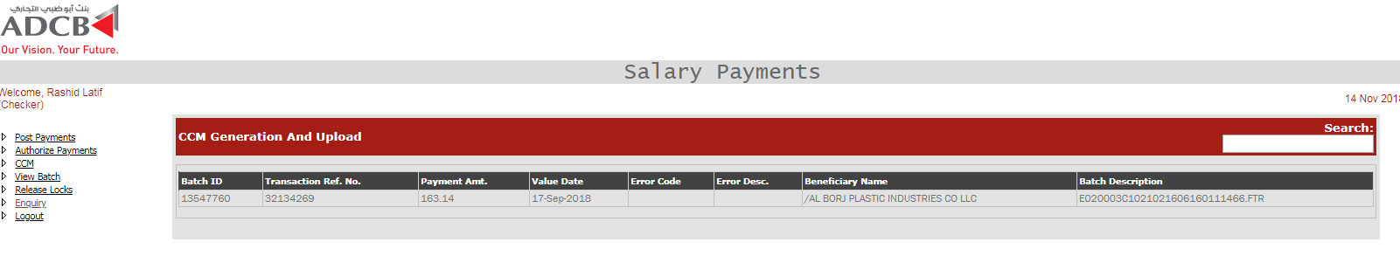

Once the user clicks on the record, details are shown and below query is fired to fetched the records.

SELECT * FROM UAEFTS_SALARY_TXN_CKR MT

INNER JOIN UAEFTS_PAYMENT ON

UAEFTS_PAYMENT.paymentcode = MT.transaction_type

LEFT OUTER JOIN UAEFTS_BANK ON

UAEFTS_BANK.bankcode = MT.bene_bank_name

LEFT OUTER JOIN UAEFTS_BRANCH ON

UAEFTS_BRANCH.branchcode = MT.bene_acc_bic

LEFT JOIN UAEFTS_CHARGE ON

MT.charge_to_id = UAEFTS_CHARGE.chargedesc

WHERE MT.txn_ref_no =@txn_ref_no and MT.batch_id = @batch_id

AND mt.checkerrowid = @recordID

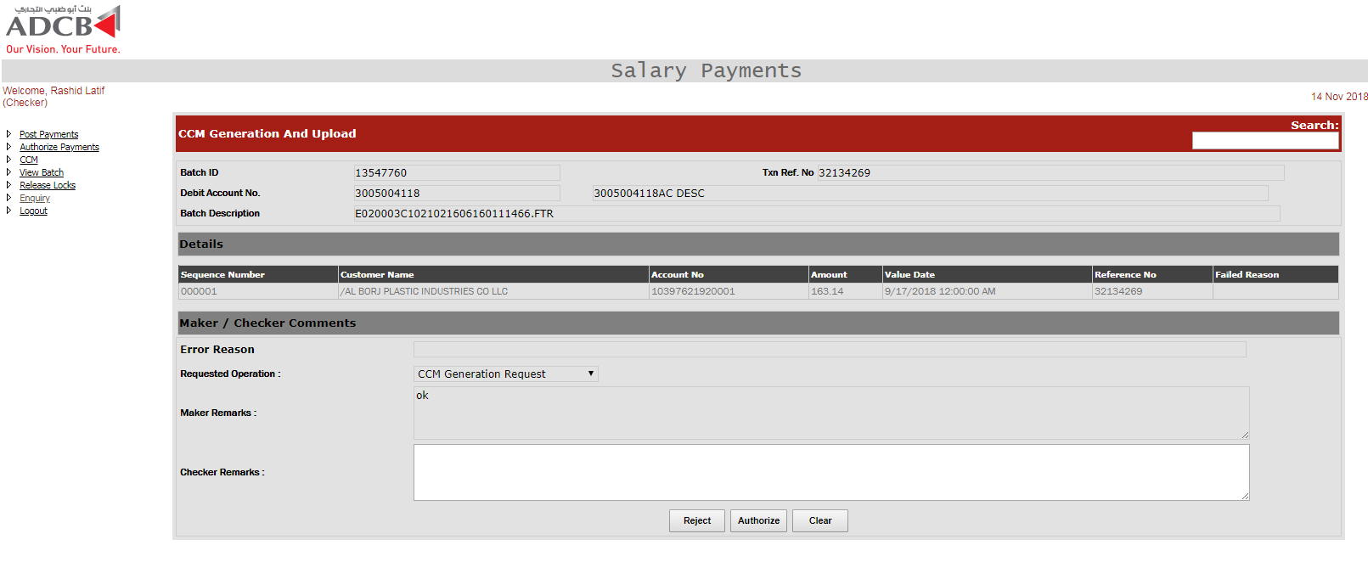

Once the records are authorized, below queries are fired as a single transaction.

INSERT INTO UAEFTS_ARCHIVE_SALARY_TXN_CKR (

CHECKERROWID,BATCH_ID,FILE_REF_NO,TXN_REF_NO,PYMNT_AMNT,PYMNT_VALUE_DATE,PYMNT_CURR,EX_RATE,STATUS,ERROR_CODE,ERROR_DESC,DEBIT_ACC_NO,

DEBIT_ACC_BIC,ORDER_CUST_NAME,ORDER_CUST_ADDR1,ORDER_CUST_ADDR2,

ORDER_CUST_ADDR3,BENE_NAME,BENE_ACC_NO,BENE_ADDR1,BENE_ADDR2,BENE_ADDR3,BENE_ACC_BIC,BENE_BANK_NAME,BENE_BANK_ADDR1,BENE_BANK_ADDR2,BENE_BANK_ADDR3,INTERMEDIARY_BANK_NAME,INTERMEDIARY_BANK_ADDRESS_1,INTERMEDIARY_BANK_ADDRESS_2, INTERMEDIARY_BANK_ADDRESS_3, REMITTANCE_INFO1,

REMITTANCE_INFO2,REMITTANCE_INFO3,REMITTANCE_INFO4,CHARGE_TO_ID,TOTAL_CHARGE_AMOUNT,OTHER_SYSTEM_REF_NO,TRANSACTION_TYPE,PROCESS_DATETIME, BRANCH_ROUTING_CODE,MAKER_DESC,MAKER_DATE,STATUS_DATETIME,CHECKER_DESC,CHECKER_DATE,MIDDLEWARE_REQUEST,MIDDLEWARE_RESPONSE,AUTHORIZE_YN,RECEIVING_CHANNEL_ID,FILE_NAME,POSTING_STATUS,PROCESSING_CHANNEL_ID,ORIGINAL_BATCH_ID,ORIGINAL_TXN_REF_NO,RECORD_TYPE,INTERMEDIARY_BANK_BIC,MAKERID,MREMARKS,MAKERDATE,CHECKERID,CREMARKS,CHECKERDATE,RECSTATUS,BLOCKEDBY,BLOCKEDON,REJECTCODE,REJECTREASON,KSTATUS,FETCH,FORCE_DEBIT,REQUEST,ORG_BRANCH_CODE,DEST_BRANCH_CODE,ISSALARY,DUPLICATE_FLG,CID,IBAN,IBAN_DR )

SELECT

CHECKERROWID,BATCH_ID,FILE_REF_NO,TXN_REF_NO,PYMNT_AMNT,PYMNT_VALUE_DATE,PYMNT_CURR,EX_RATE,STATUS,ERROR_CODE,ERROR_DESC,DEBIT_ACC_NO,

DEBIT_ACC_BIC,ORDER_CUST_NAME,ORDER_CUST_ADDR1,ORDER_CUST_ADDR2,

ORDER_CUST_ADDR3,BENE_NAME,BENE_ACC_NO,BENE_ADDR1,BENE_ADDR2,BENE_ADDR3,BENE_ACC_BIC,BENE_BANK_NAME,BENE_BANK_ADDR1,BENE_BANK_ADDR2,BENE_BANK_ADDR3,INTERMEDIARY_BANK_NAME,INTERMEDIARY_BANK_ADDRESS_1,INTERMEDIARY_BANK_ADDRESS_2,INTERMEDIARY_BANK_ADDRESS_3,REMITTANCE_INFO1,REMITTANCE_INFO2,REMITTANCE_INFO3,REMITTANCE_INFO4,CHARGE_TO_ID,TOTAL_CHARGE_AMOUNT,OTHER_SYSTEM_REF_NO,TRANSACTION_TYPE,PROCESS_DATETIME,BRANCH_ROUTING_CODE,MAKER_DESC,MAKER_DATE,STATUS_DATETIME,CHECKER_DESC, CHECKER_DATE,MIDDLEWARE_REQUEST,MIDDLEWARE_RESPONSE,AUTHORIZE_YN,RECEIVING_CHANNEL_ID,FILE_NAME,POSTING_STATUS,PROCESSING_CHANNEL_ID,ORIGINAL_BATCH_ID,ORIGINAL_TXN_REF_NO,RECORD_TYPE,INTERMEDIARY_BANK_BIC,MAKERID,MREMARKS,MAKERDATE,CHECKERID,CREMARKS,CHECKERDATE,RECSTATUS,BLOCKEDBY,BLOCKEDON,REJECTCODE,REJECTREASON,KSTATUS,FETCH,FORCE_DEBIT,REQUEST,ORG_BRANCH_CODE,DEST_BRANCH_CODE,IS_SALARY,DUPLICATE_FLG,CID,IBAN,IBAN_DR

FROM UAEFTS_SALARY_TXN_CKR

WHERE batch_id AND TXN_REF_NO = @txn_ref_no AND checkerrowid = @recordID

If the record is for deletion, the status will be 164, else 165

UPDATE PAYMENT_TXN_MT

SET STATUS_DATETIME = sysdate, ERROR_CODE = NULL, ERROR_DESC = NULL,

STATUS = '165', MAKER_DESC = @makerid,MAKER_DATE = @makerDate,

CHECKER_DESC = '@user', CHECKER_DATE = SYSDATE

WHERE batch_id = @batch_id AND TXN_REF_NO = @txn_ref_no

UPDATE UAEFTS_SALARY_TXN_CKR

SET status = '165', checkerid =@checkerID, cremarks = @remarks,checkerdate = sysdate, recstatus = ‘A’, request = ‘P’,

WHERE batch_id = @batch_id AND TXN_REF_NO = @txn_ref_no AND checkerrowid = @recordID

* + 1. **Utility Bill Settlement System**
    2. **Multi Corridor Remittance System**
    3. **Corporate IB**
    4. **Supplier Management System (ARIBA)**
    5. **Wages Protection System (WPS)**
  1. **Assumptions & Dependencies**
  2. **Utilized Third Party Components**

We use Chilkat for SFTP purposes.

* 1. **Third Party Consumers**

1. **Data Design**
   1. **ER Diagram**



* 1. **Persistent Static Data – Master Tables**

**Backend Maintainance Tables**

|  |
| --- |
| UAEFTS_TRASACTION_TYPE |
| UAEFTS_CUSTOMERTYPE |
| UAEFTS_CHARGE_PARAMS |
| UAEFTS_CUSTOMER_TYPE |
| UAEFTS_MSGTYPE |
| UAEFTS_OUT_FILE_STATUS_MASTER |
| CHANNEL_CHARGES |
| UAEFTS_202_TXN_CODE |
| UAEFTS_REJECTION |
| UAEFTS_STATUS |
| UAEFTS_VALIDATION |
| UAEFTS_GL_IBAN |
| UAEFTS_ARIBA_FCC_GEFU_DTL |
| UAEFTS_ARIBA_FCC_GEFU_MST |
| PARAM_MASTER |
| UAEFTS_DES_SVRDTLS |
| UAEFTS_INWARD_EXCEPTION |
| UAEFTS_OUT_STATUS_MASTER |
| UAEFTS_FILE_TYPE_MASTER |
| UAEFTS_REMITTER_BANK |
| CMS_PHUB_ERROR_MASTER |
| UAEFTS_OFFSHORE_BRANCHES |
| UAEFTS_BLOCKED_BRANCHES |
| UAEFTS_MENU3 |
| UAEFTS_MENU_SAL3 |
| UAEFTS_MSG_TYPE |
| UAEFTS_BRANCH_SCREEN_CNTRL |
| UAEFTS_CC_BIN |
| UAEFTS_ESB_STAGGING_STATUS |
| UAEFTS_EFI_BANK |
| UAEFTS_FCY_WATCH_LIST |
| UAEFTS_FCY_VALIDATIONS |
| UAEFTS_COUNTRY_CURRENCY_LIST |
| PAYMENT_TXN_IN_CH_MASTER |
| PAYMENT_TXN_SYS_PARAM |
| PAYMENT_TXN_SYS_PARAM_HT |
| UAEFTS_BANK |
| UAEFTS_BRANCH |
| UAEFTS_PAYMENT |
| UAEFTS_CURRENCY_PRECISION |
| UAEFTS_CREDIT_ACCT_STATUS |
| UAEFTS_DEBIT_ACCT_STATUS |
| UAEFTS_CHARGE |
| UAEFTS_CURRENCY |
| UAEFTS_ADAPTER_DATA |
| UAEFTS_NOSTRO_VOSTRO_ACCOUNT |
| UAEFTS_FCY_SPECIAL_CHARACTERS |
| UAEFT_BANK_BIC_MAP |
| UAEFTS_ALLOWED_CHARACTER |
| UAEFTS_EFI_VALUE_DATE |
| UAEFTS_CID_CONSOLIDATION |
| UAEFTS_VOSTRO_MAINTAINANCE |
| UAEFTS_INTER_VOSTRO_ACC_MAP |
| UAEFTS_SENDERS_DATA_MAP |
| UAEFTS_TRANSACTION_MNEMONIC |
| UAEFTS_REPAIRABLE_CODES |
| DEBIT_SUSPENSE_CHANNEL |
| CONFIG_TABLE |
| UAEFTS_DES_FILEMAPPING |
| UAEFTS_DES_FILEDTLS |
| UAEFTS_FCY_AI_STATUS |

**Frontend Maker Checker Tables**

|  |
| --- |
| **Table Name** |
| CID_FRAUD_EXEMPTION |
| UAEFTS_OUT_PROCESSING_CHARGES |
| UAEFTS_OUT_CB_CHARGES |
| UAEFTS_IN_CB_CHARGES |
| UAEFTS_OUT_PROC_CHARGES_B |
| CID_FRAUD_EXEMPTION_DETAILS |
| UAEFTS_EFD_CHARGE_MAINTENANCE |
| UAEFTS_FCY_CHARGE_MAINTENANCE |
| UAEFTS_FCY_CHARGE_MAINT_TEMP |
| UAEFTS_CST_EFD_CHARGE_MAINT |
| UAEFTS_CST_IFT_CHARGE_MAINT |
| IFST_COUNTRY |
| UAEFTS_DES_FILEMAPPINGGDTLS |
| UAEFTS_REMITDTLS_TEMPLATE |
| UAEFTS_FCY_ROUTING_RULES |
| BILL_FILETYPE |
| BILL_ALERT_TYPE |
| BILL_ALERT_MODE |
| BILL_ALERT_MODE_MAPPING |
| UAEFTS_FRAUD_QUEUE_RULE |
| UAEFTS_FRAUD_QUEUE_RULE_TMP |
| UAEFTS_CUTOFF_THRESHOLD_CONFIG |
| UAEFTS_AUDIT_CHANNELS |

**FCR Tables in PHUB for ETL**

|  |
| --- |
| **Table Name** |
| DIM_PRODUCT |
| BA_CCY_CODE |
| CH_ACCT_MAST |
| CH_ACCT_IBAN_XREF |
| BA_VW_MIS_CLASS_CODE_XREF |
| CI_CUST_TYPES |

**Al Manac Tables**

|  |
| --- |
| **Table Name** |
| ACCUITY_GPSUB_TGT |
| ACCUITY_GPSUB_FAIL |
| ACCUITY_GPOFF_TGT |
| ACCUITY_GPOFF_FAIL |
| ACCUITY_GPLOC_TGT |
| ACCUITY_GPLOC_FAIL |
| ACCUITY_GPCOR_TGT |
| ACCUITY_GPCOR_FAIL |
| ACCUITY_GPCOD_TGT |
| ACCUITY_GPCOD_FAIL |
| ACCUITY_GPCNT_TGT |
| ACCUITY_GPCNT_FAIL |
| ACCUITY_GPATT_TGT |
| ACCUITY_GPATT_FAIL |
| ACCUITY_GPATT_TGT_HIST |
| ACCUITY_GPCNT_TGT_HIST |
| ACCUITY_GPCOD_TGT_HIST |
| ACCUITY_GPCOR_TGT_HIST |
| ACCUITY_GPOFF_TGT_HIST |
| ACCUITY_GPSUB_TGT_HIST |
| ACCUITY_GPLOC_TGT_HIST |

* 1. **Transient Dynamic Data**
     1. **FCR / FCRSI Tables**

|  |
| --- |
| **Table Name** |
| UAEFTS_FCRSI_REMIT |

* + 1. **Pelican**

|  |
| --- |
| **Table Name** |
| UAEFTS_PELICAN_TRANSFERDTLS |

* + 1. **Ariba**

|  |
| --- |
| **Table Name** |
| UAEFTS_ARIBA_ACCOUNTING_EXPORT |
| UAEFTS_ARIBA_DETAIL_EXPORT |
| UAEFTS_ARIBA_HEADER_EXPORT |
| UAEFTS_ARIBA_BANK_EXPORT |

* + - 1. **Bill Desk**

|  |
| --- |
| **Table Name** |
| BILL_FILE |
| BILL_FILE_HT |

* + - 1. **Mobile Banking / LMS**

|  |
| --- |
| **Table Name** |
| ESB_PAYMENT_REQUEST |
| STGG_ESB_APPROVAL_AUDIT |
| STGG_ESB_PAYMENT_BATCH |
| STGG_ESB_PAYMENT_BATCH_HT |
| STGG_ESB_PAYMENT_TXN_DTLS |
| STGG_ESB_PAYMENT_TXN_DTLS_HT |
| UAEFTS_ESB_VALIDATION_FAILURE |

* + - 1. **Retail IB**

|  |
| --- |
| **Table Name** |
| UAEFTS_IB_REMIT |

* + - 1. **Custom Bulk Upload**

|  |
| --- |
| **Table Name** |
| UAEFTS_FILE_MAKER |

* + - 1. **UAEFTS Incoming**

|  |
| --- |
| **Table Name** |
| UAEFTS_INWARD_BATCH |
| UAEFTS_INWARD_BATCH_RECORD |
| UAEFTS_INWARD_BATCHCHK |

* + - 1. **Incoming Financial Messages**

|  |
| --- |
| **Table Name** |
| UAEFTS_FM_TXN_DTLS |
| UAEFTS_FM_BATCH_TB_HISTORY |
| UAEFTS_FM_TXN_DTLS_HT |
| UAEFTS_DUP_FM_TXN_DTLS |
| UAEFTS_FM_BATCH_TB |
| UAEFTS_DUP_FM_BATCH_TB |
| UAEFTS_INCOMING_FILE_AUDIT |
| UAEFTS_WPS_RECON |

* + - 1. **PHUB Procash Response**

|  |
| --- |
| **Table Name** |
| PAYMENT_RESPONSE |
| PAYMENT_RESPONSE_QUEUE |
| PAYMENT_RESPONSE_XML |

* + - 1. **Incoming Non Financial Messages**

|  |
| --- |
| **Table Name** |
| UAEFTS30_NFM_92_HISTORY |
| UAEFTS30_NFM_92 |
| UAEFTS30_NFM_95 |
| UAEFTS30_NFM_95_96_HISTORY |
| UAEFTS30_NFM_99 |
| UAEFTS30_NFM_95_96 |
| UAEFTS30_NFM_99_HISTORY |
| UAEFTS30_NONFUNC_95 |

* + - 1. **All Outgoing**

|  |
| --- |
| **Table Name** |
| UAEFTS_REMITDTLS |
| UAEFTS_REMITDTLSCKR |
| UAEFTS_BATCH |
| UAEFTS_ARCHIVE_BATCH |
| UAEFTS_ARCHIVE_REMITDTLSCKR |
| UAEFTS_DEL_REMITDTLSCKR |
| UAEFTS_DEL_BATCH |

* + - 1. **Procash**

|  |
| --- |
| **Table Name** |
| STGG_PAYMENT_FILE_BATCH |
| STGG_PAYMENT_FILE_TXN_DTLS |
| CMS_PAYMENT_REQUEST |
| STGG_PAYMENT_FILE_BATCH_HIST |

* + 1. **EFD – CB Responses**

|  |
| --- |
| **Table Name** |
| UAEFTS_OUTGOING_FILE_DTLS |
| UAEFTS_OUTGOING_FILE_DTLS_HT |
| UAEFTS_202_FILE_AUDIT |

* + 1. **Processing and Repair Tables**
    2. **Corona**

|  |
| --- |
| **Table Name** |
| UAEFTS_FM_IN_CORONA |
| UAEFTS_FM_OUT_CORONA |
| UAEFTS_ENQ_IN_CORONA |
| UAEFTS_ENQ_SWIFT_CORONA |

* + 1. **Salary AI Procedure**

|  |
| --- |
| **Table Name** |
| UAEFTS_SALARY_TXN |
| UAEFTS_SALARY_TXN_CKR |
| UAEFTS_ARCHIVE_SALARY_TXN_CKR |

* + 1. **NAK Repair (Appzone)**

|  |
| --- |
| **Table Name** |
| UAEFTS_NACK_CB202 |
| UAEFTS_NACK_CB2C2 |
| UAEFTS_NACK_CB103 |

* + 1. **Paymenthub Core**

|  |
| --- |
| **Table Name** |
| PAYMENT_TXN_MT |
| PAYMENT_TXN_HT |
| PAYMENT_TXN_BILLING_TB |

* + 1. **Fast Pay Repair (Appzone)**

|  |
| --- |
| **Table Name** |
| UAEFTS_REMIT_MODIFIED |

* + 1. **Payment Hub Generec Repair (Appzone)**

|  |
| --- |
| **Table Name** |
| PAYMENT_TXN_MT_REPAIRCKR |

* + 1. **CCM Generation**

|  |
| --- |
| **Table Name** |
| UAEFTS_CCM_FILE |
| UAEFTS_CCM_FILE_HT |

* + 1. **Fast Pay**

|  |
| --- |
| **Table Name** |
| STGG_FCY_OUTWARD_HT |
| STGG_FCY_OUTWARD |
| UAEFTS_FCY_TXN_ADAPTER |

* + 1. **Bill Desk**

|  |
| --- |
| **Table Name** |
| BILL_SUMMARY |
| BILL_ALERT |
| BILL_RECONCILE |
| BILL_REFUND |
| BILL_REFUND_HT |

* + 1. **Random Fraud Repair (Appzone)**

|  |
| --- |
| **Table Name** |
| UAEFTS_FRAUD_RANDOM |
| UAEFTS_FRAUD_RANDOM_AUDIT |
| UAEFTS_FRAUD_STP |
| UAEFTS_FRAUD_STP_HT |
| UAEFTS_FRAUD_QUEUE_RULE_ARCH |
| UAEFTS_RANDOM_FRAUD_Q_RULE_TMP |

* + 1. **Utility Bill Payment**

|  |
| --- |
| **Table Name** |
| uaefts_utility_vendor_temp |
| uaefts_utility_vendor_maint |
| uaefts_util_succ_fail_dtl |
| utility_bill_payments |

* + 1. **AI Tables**

|  |
| --- |
| **Table Name** |
| UAEFTS_FCY_AI_SIFCR_DATA_HT |
| UAEFTS_FCY_AI_SIFCR_DATA |
| UAEFTS_FCY_AI_BENEF_DATA |
| UAEFTS_FCY_AI_BENEF_DATA_HT |

* + 1. **Account Title / Account No AI**

|  |
| --- |
| **Table Name** |
| UAEFTS_AI_ACCNO |
| UAEFTS_AI_ACCTITLE |

* + 1. **Report Tables**

|  |
| --- |
| **Table Name** |
| UAEFTS_CNFRMED_CREDIT_REP |
| UAEFTS_UNCNFRMED_CREDIT_REP |
| UAEFTS_RECON_CNM_REPORTDUMP |
| UAEFTS_RECON_DCM_REPORTDUMP |

* + 1. **Logging Tables**

|  |
| --- |
| **Table Name** |
| UAEFTS_BICLOOKUP_REQ_RES |
| PAYMENT_TXN_AUDIT_TRIAL |
| UAEFTS_REMIT_ESB_SRVLOGS |
| LOG_EFD_CHARGE_REQ |
| LOG_EFI_CHARGE_REQ |
| LOG_CST_IFT_CHARGE_REQ |
| LOG_CST_EFD_CHARGE_REQ |
| UAEFTS_FX_RATE_REQ_RES |
| UAEFTS_FILE_AUDIT_ARCHIVE |
| UAEFTS_FILE_AUDIT |
| UAEFTS_ACC_DTLS_REQ_RES |
| UAEFTS_BENEID_STATUS_REQ_RES_2 |
| PHUB_RATE_REQ_RESP |
| FCR_GEFUBATCHSEQ |
| FCR_GEFUCODRECNO |
| UAEFTS_ACK_ADVICE |
| BILL_MIDDLEWARE_REQ_RES |
| FILE_AUDIT |
| PHUB_CORONA_JOB_AUDIT |
| PHUB_CORONA_FILE_AUDIT |
| UAEFTS_SALARY_TXN_CKR_HIST |
| CST_VALIDATE_LOG |
| UAEFTS_CST_CHRG_POST_DTLS |
| UAEFTS_CST_CHRG_POST_DTLS_HT |
| UAEFTS_CST_PROCESSED_BATCH |
| SALARY_CARD_DTLS |
| UAEFTS_FCY_ACK_FILE_AUDIT |
| UAEFTS_SWIFT_MESSAGE_REQUEST |
| PHUB_CST_ETL |
| UAEFTS_MUREX_FILE_LOG |
| STGG_DES_MDB_DTLS |
| UAEFTS_ACK_FILE_AUDIT |
| UAEFTS_CONSOLIDATED_POSTING |
| PAYMENT_TXN_CHRG_TB |

**TODO-**Description of the tables against each

* 1. **External Interface Data**

There is certain data which is not present in Payment hub and for which we need to fetch it using Golden Gate, TIBCO and webservices. Below are the TIBCO and web services being used in frontend.

**Web Services**

SMS Webservice:

Being used to call for authentication and authorization of particular user

https://appzoneuat.adcbappsdr.local:88/smsmodule/service.asmx

Corporate BIC Validate Service

This service is called to validate BIC for coorporates.

https://appzoneuat.adcbappsdr.local:88/SwiftValidations/ValidateBic.asmx

BIC Code Service

To validate BIC

https://appzoneuat.adcbappsdr.local:88/biccode/service.asmx

**TIBCO Services**

Retail Rate Server

Called to fetch rates against currency for retail customers

http://10.146.163.100:5509/Services/EnterpriseServicesInquiry/Investment/Service/InqFxRate.serviceagent/InqFxRatePortTypeEndpoint0

Corporate Rate Server

Called to fetch ratest for corporate customers

http://10.146.163.71:5509/Services/EnterpriseServicesInquiry/Investment/Service/InqFxRate.serviceagent/InqFxRatePortTypeEndpoint0

Swift Message preview

http://10.146.163.71:5521/Services/InqPreviewSwiftMsg/Service/InqPreviewSwiftMsg_wsdl-service2.serviceagent/InqPreviewSwiftMsgEndpoint2

Nostro Vostro Lookup

http://10.146.163.71:5521/Services/InqVostroLookup/Service/InqVostroLookup.serviceagent/InqVostroLookupPortTypeEndpoint0

Vasco Varification for Token

http://10.146.163.100:5528/Services/EnterpriseServicesMaintenance/ENTMaintenanceServices/Service/ModVASCOProfile.serviceagent/ModVASCOProfilePortTypeEndpoint0

Email SMS service

http://10.146.163.100:6502/Services/EnterpriseServicesMaintenance/NonCard/Service/AddSendSMSEmail.serviceagent/AddSendSMSEmailPortTypeEndpoint1

Account IBAN Info

http://10.146.163.71:5502/Services/EnterpriseServicesInquiry/Accounts/Service/InqCSAcctIBANInfo.serviceagent/InqCSAcctIBANInfoPortTypeEndpoint0

Exchange Rate CB

http://10.146.163.71:5509/Services/EnterpriseServicesInquiry/Investment/Service/InqExchangeRateCB_wsdl-service0.serviceagent/InqExchangeRateCBPortTypeEndpoint0

Account Basic Info

http://10.146.163.71:5502/Services/EnterpriseServicesInquiry/Accounts/Service/InqCSAcctBasicInfo.serviceagent/InqCSAcctBasicInfoPortTypeEndpoint1

Customer Personal Detail service

http://10.146.163.71:5501/Services/EnterpriseServicesInquiry/Customer/Service/InqCustPersonalDtl.serviceagent/InqCustPersonalDtlPortTypeEndpoint1

Account Summary Service

http://10.146.163.71:5511/Services/TradeFinanceServices/Service/InqCSAcctSummary.serviceagent/InqCSAcctSummaryPortTypeEndpoint1

Customer Signature Service

http://10.146.163.71:5510/Services/EnterpriseServicesInquiry/Customer/Service/InqCustSignatureInfo.serviceagent/InqCustSignatureInfoPortTypeEndpoint1

Account Operational Detail Service

http://10.146.163.71:5502/Services/EnterpriseServicesInquiry/Accounts/Service/InqCSAcctOperationDtl.serviceagent/InqCSAcctOperationDtlPortTypeEndpoint1

Customer Banking Relational Profile Service

http://10.146.163.71:5509/Services/EnterpriseServicesInquiry/Customer/Service/InqCustBankingRelProfile.serviceagent/InqCustBankingRelProfilePortTypeEndpoint1

Account Balance Service

http://10.146.163.71:5511/Services/TradeFinanceServices/Service/InqCSAcctBalance.serviceagent/InqCSAcctBalancePortTypeEndpoint1

1. **User Interface Design**
   1. **User Interface Design Overview**

**Profile: De – Maker**

Landing page.

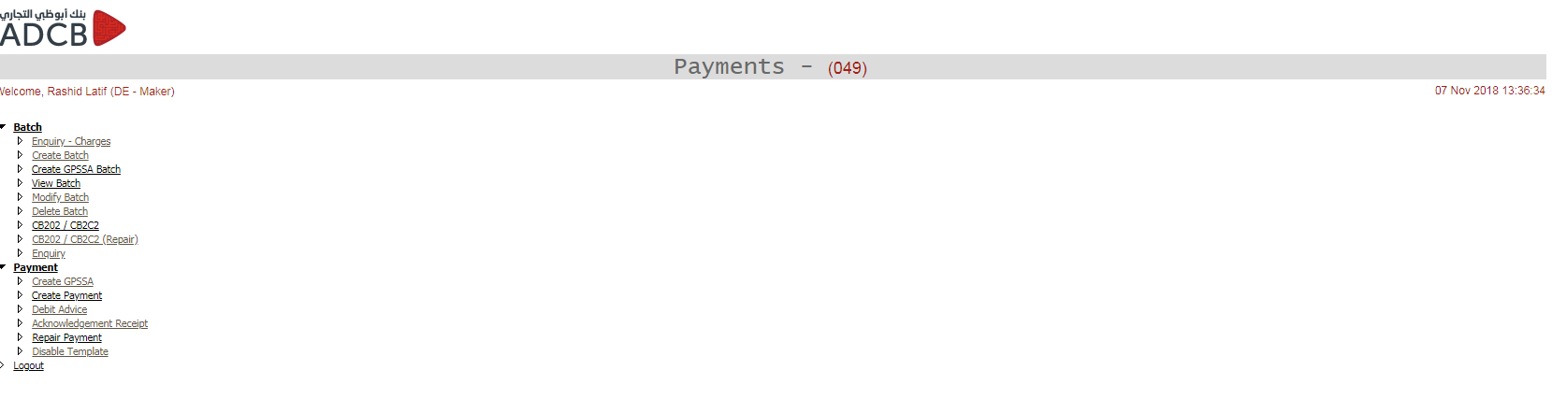

**De – Maker: Enquiry Charges**

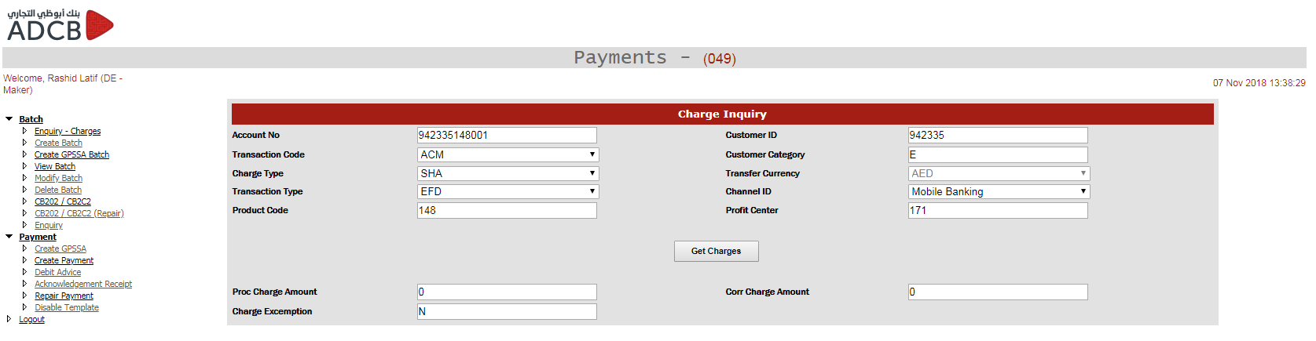

**De – Maker: Create Batch**

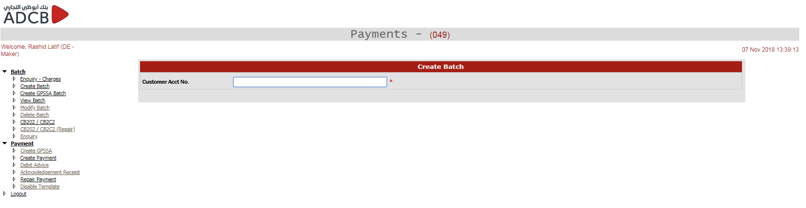

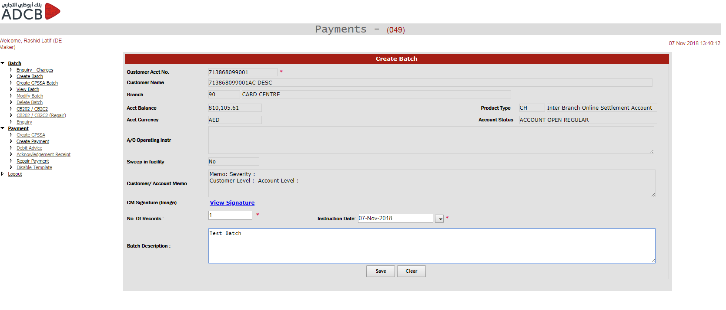

**De – Maker: Create Payment**

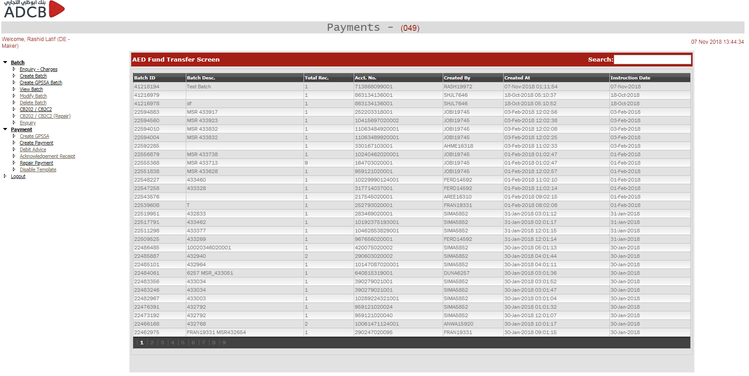

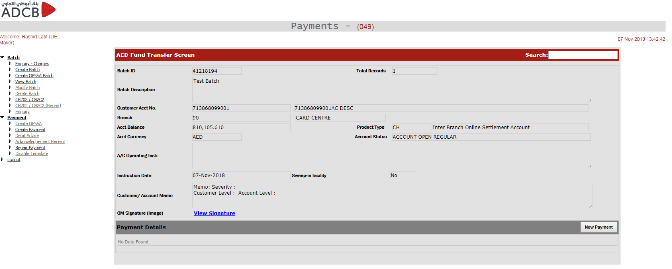

Create Payment - IFT

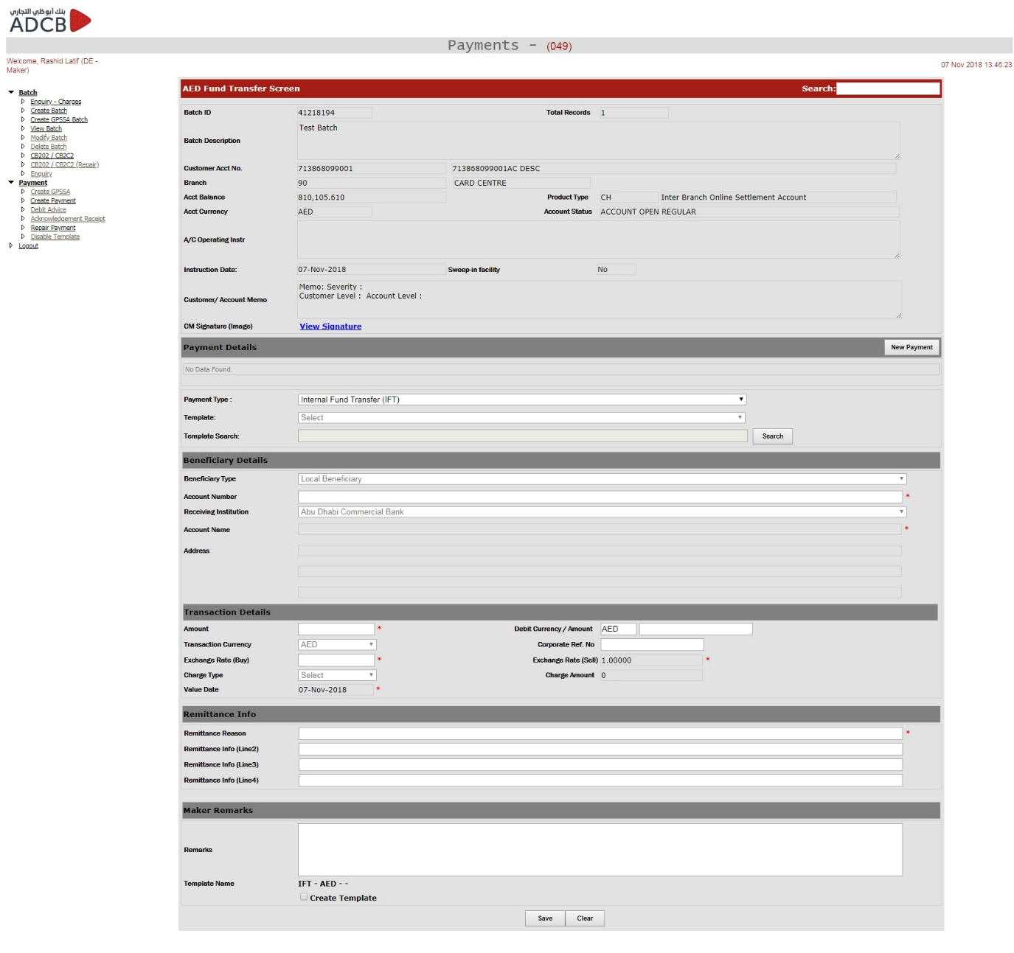

Create Payment - EFD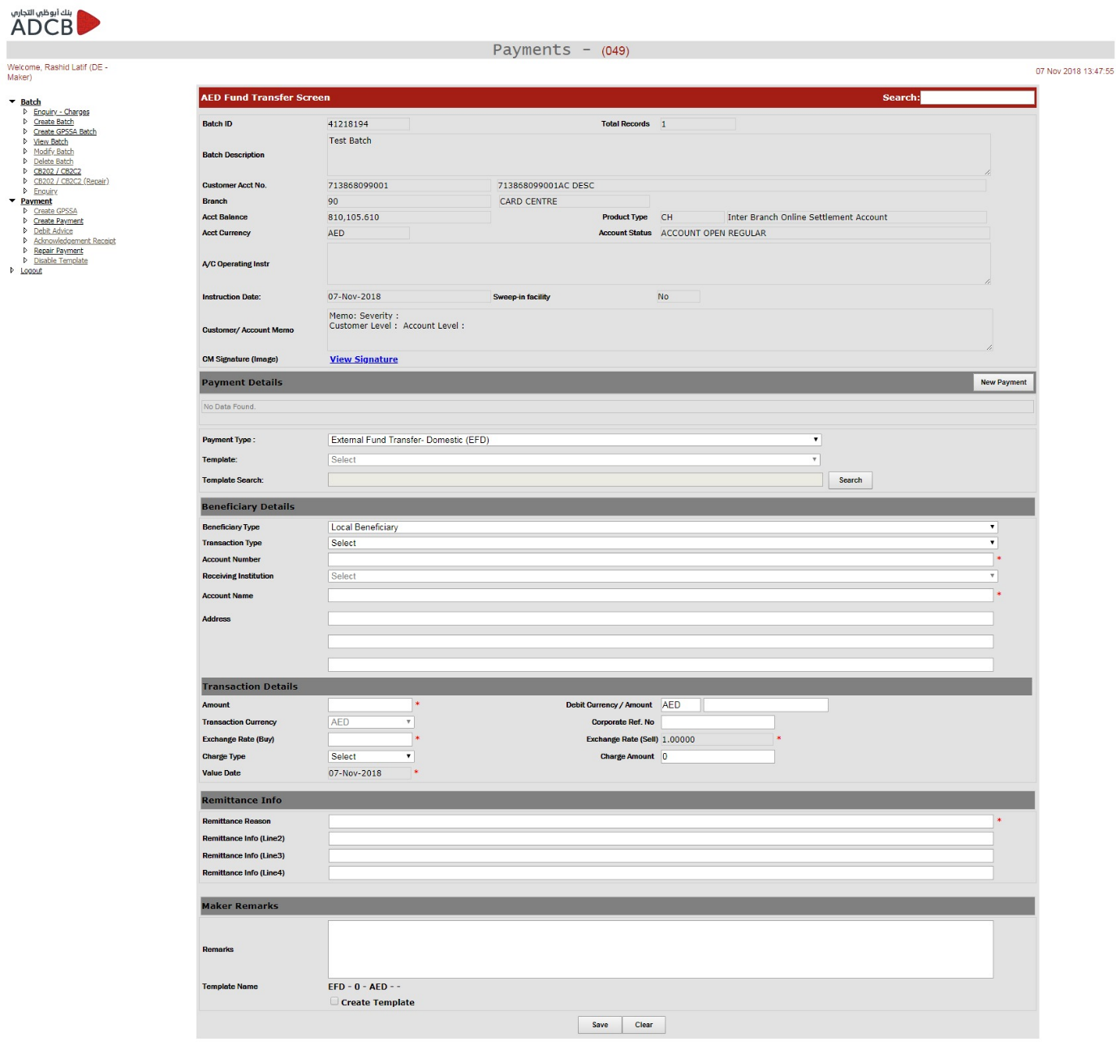

Create Payment - EFI

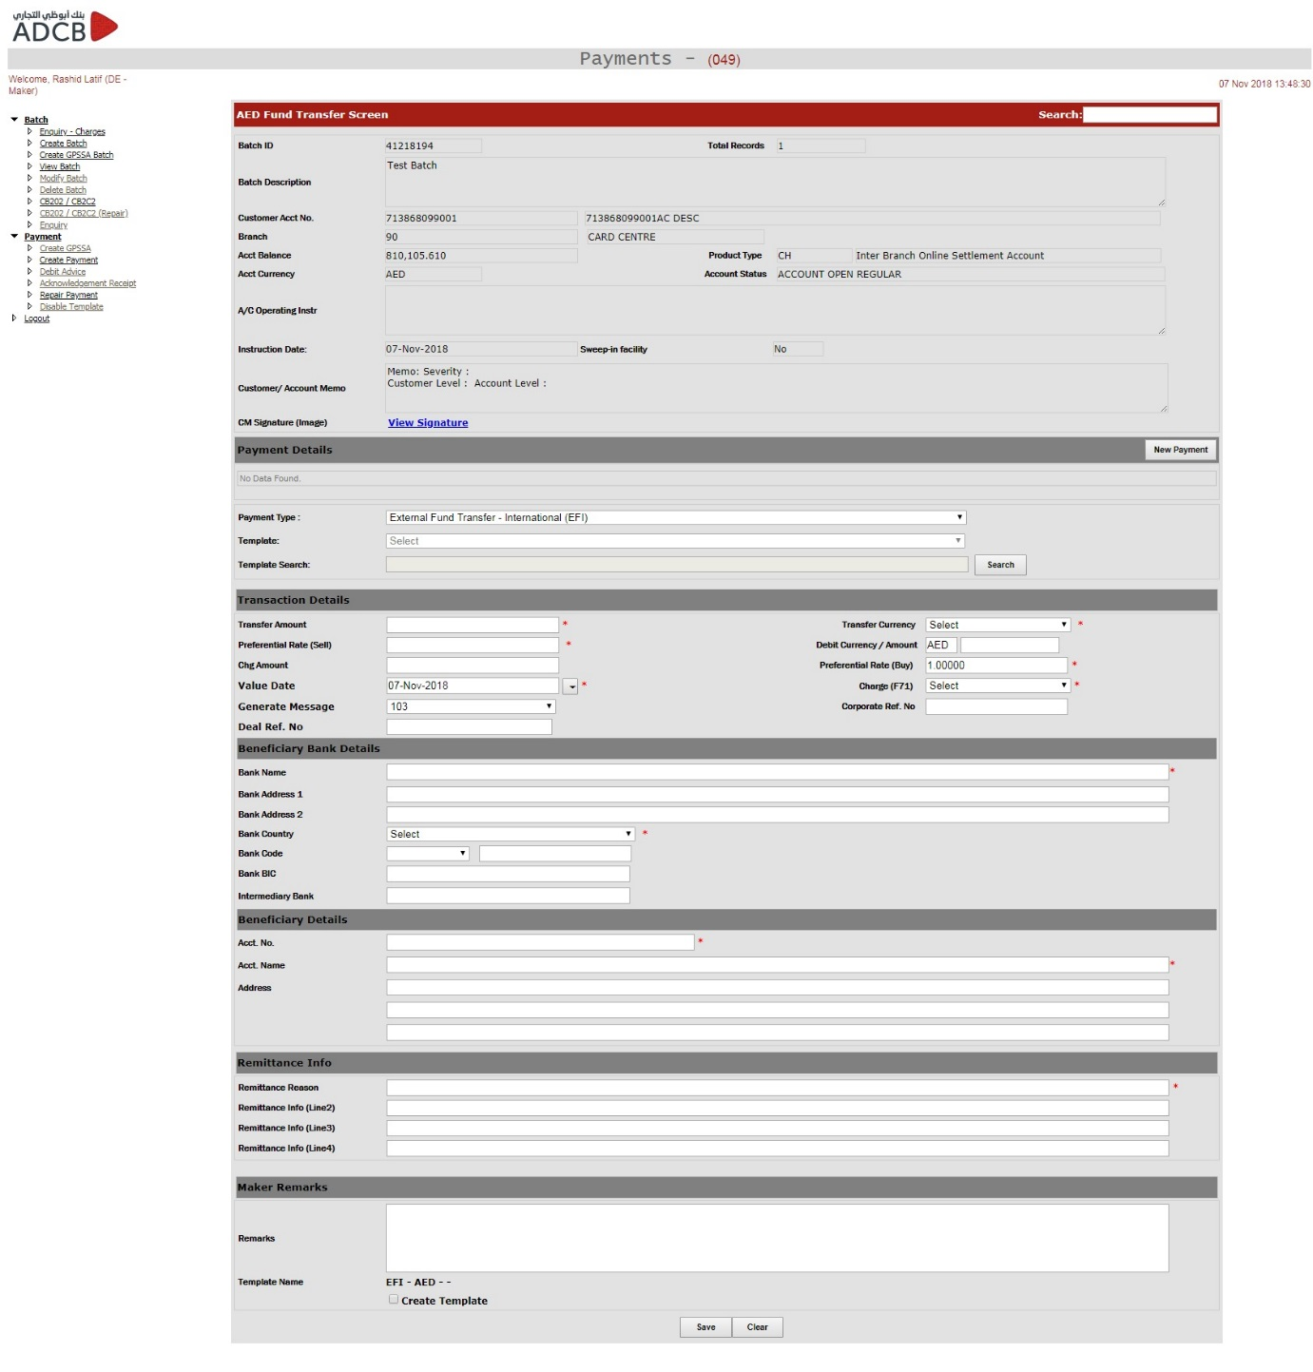

Create Payment - CST

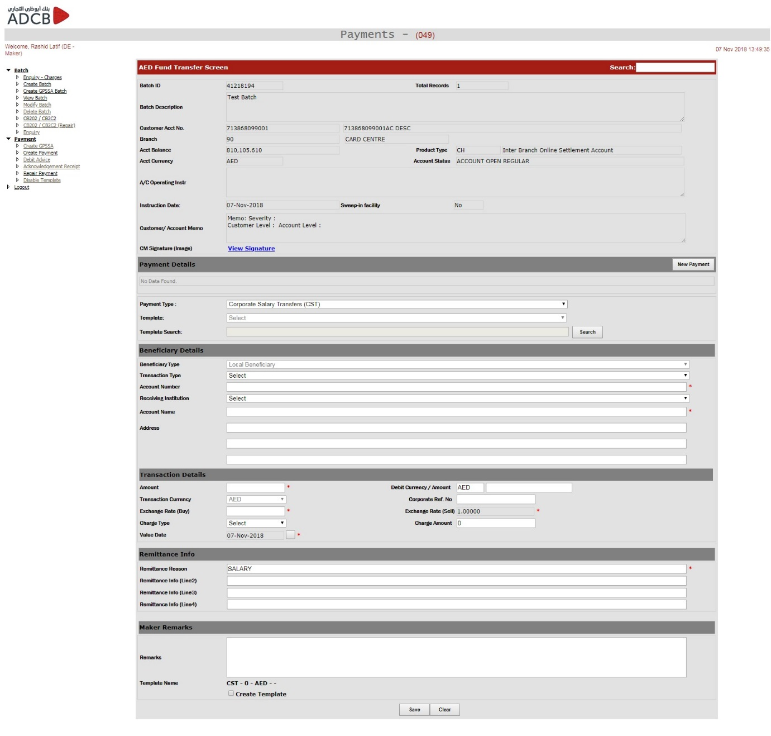

**De – Maker: Create GPSSA Batch**

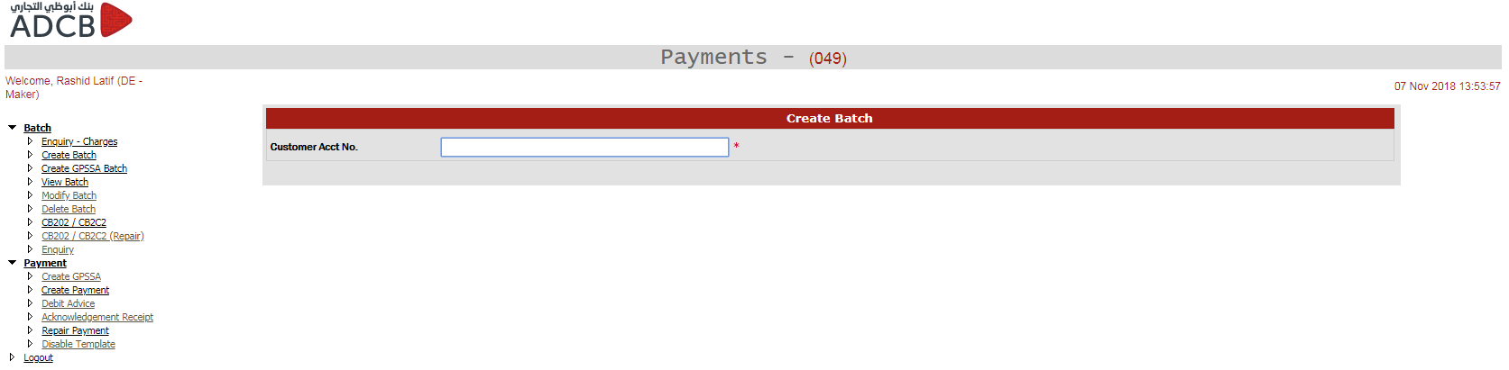

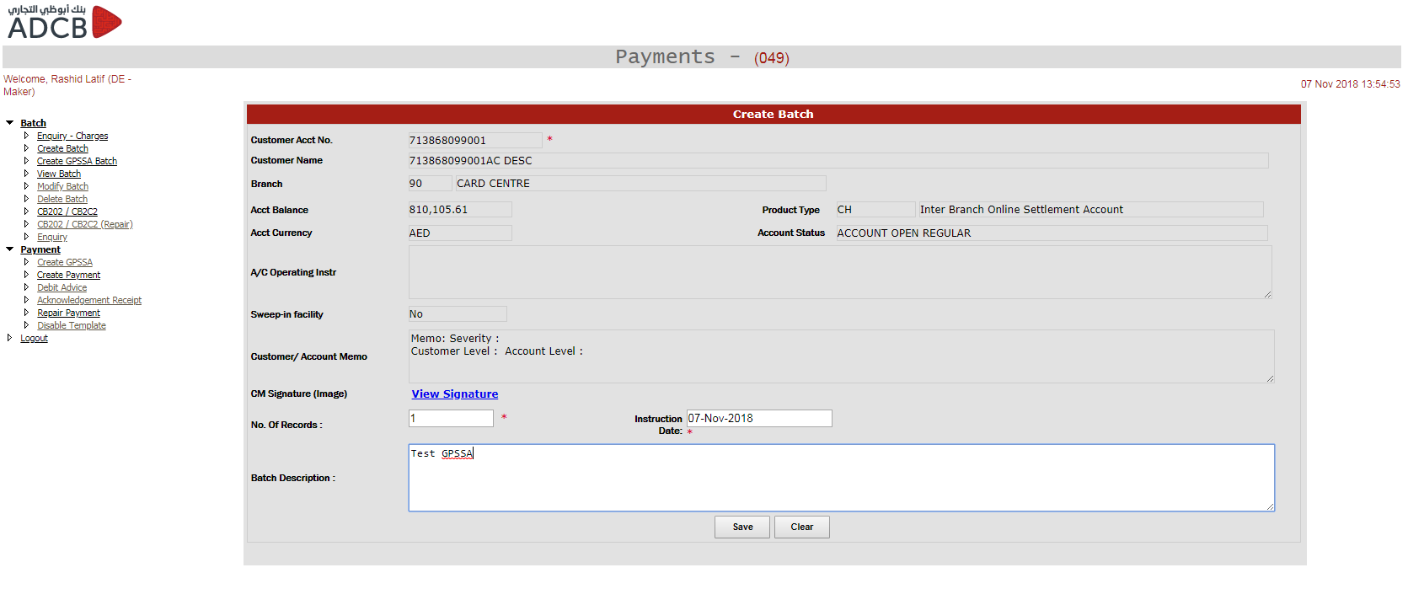

**De – Maker: Create GPSSA**

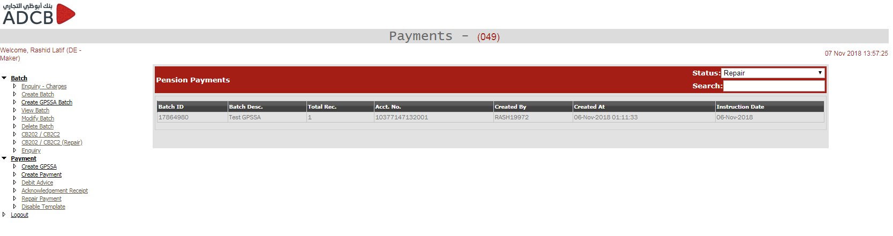

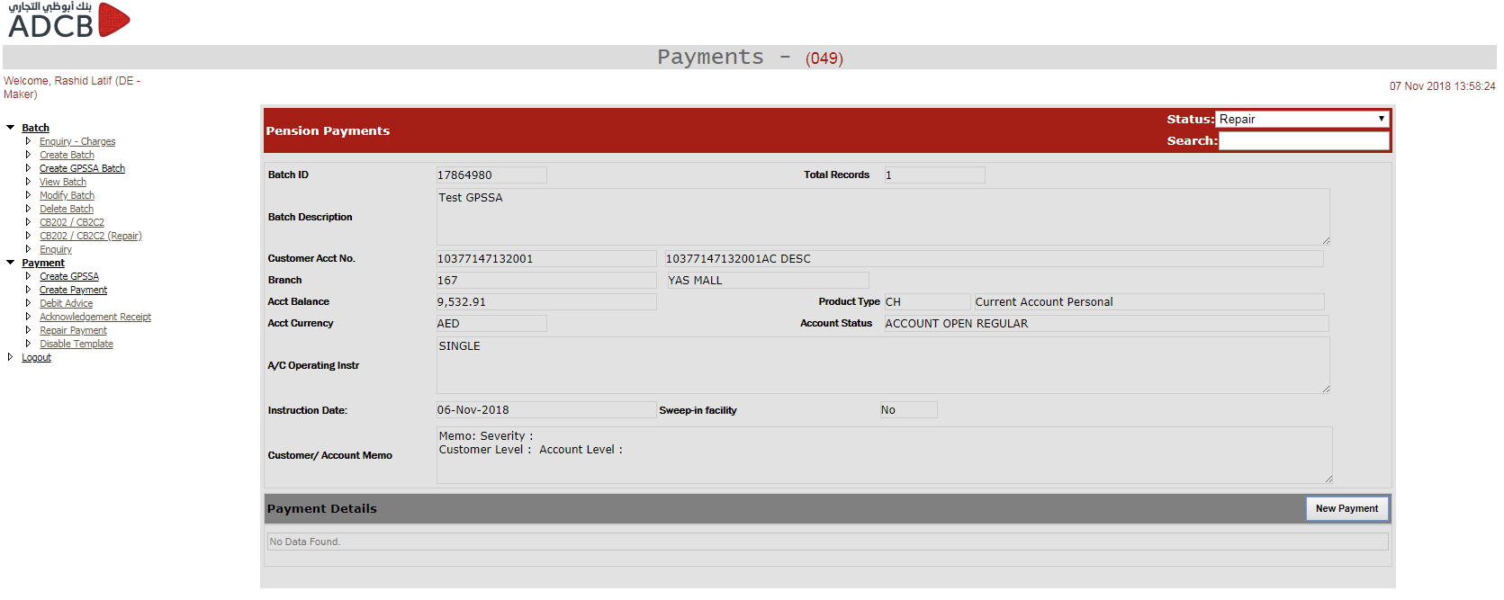

Create GPSSA – Normal Contribution GPSSA

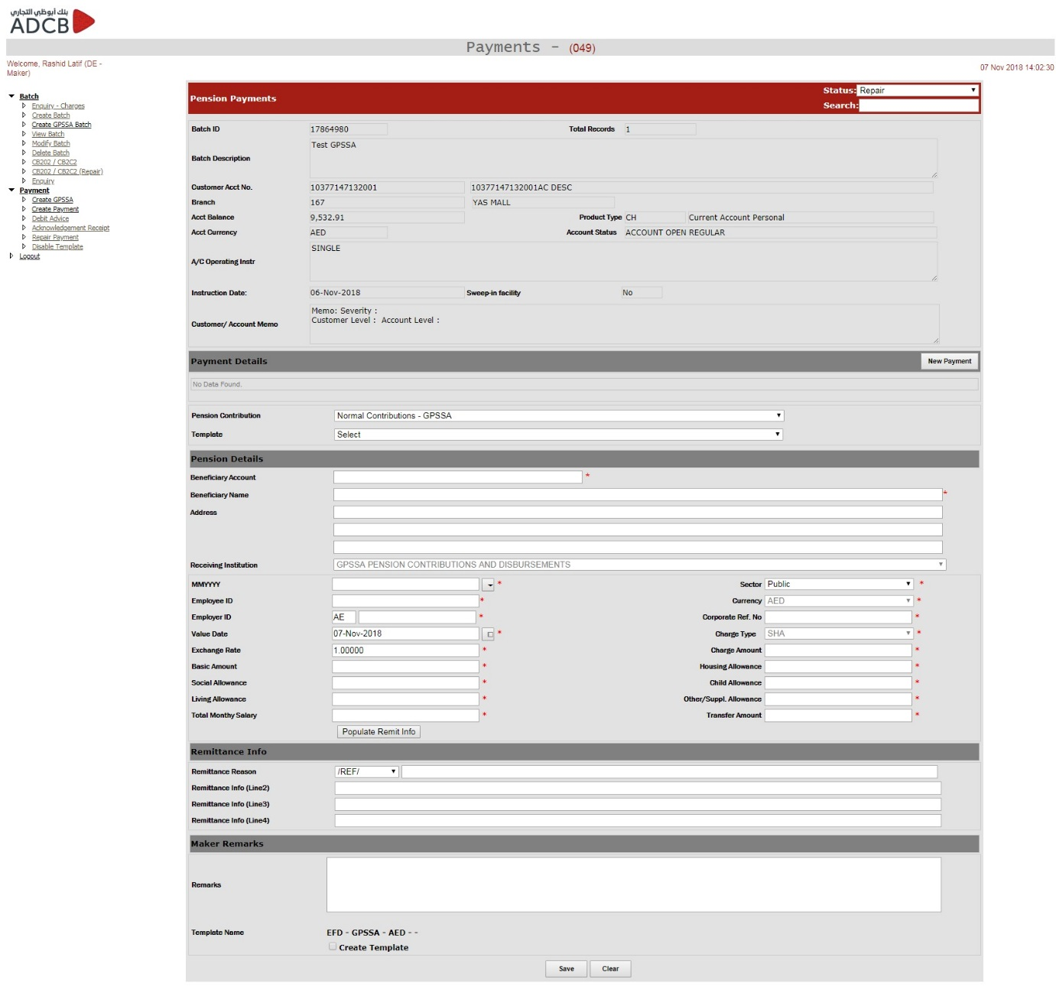

Create GPSSA – (Adjustments – ADJST, New Employees First Contribution – GPNEW, Last Contribution – GPEOS, Retro Payments – GPRET, Temporary Stoppage of Contribution – GPTSP, Resumption After Temporary Stoppage – GPRSM)

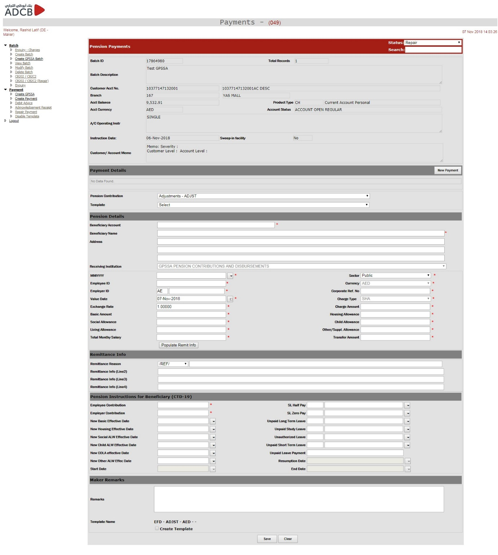

**De – Maker: View Batch**

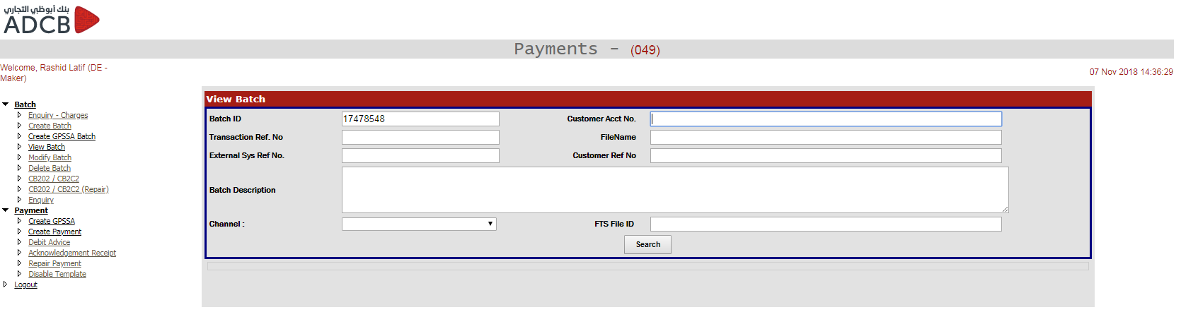

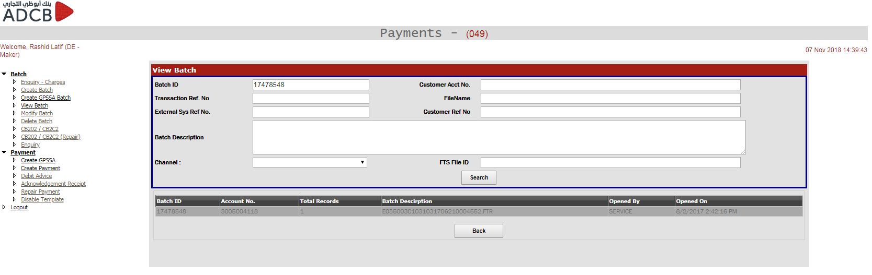

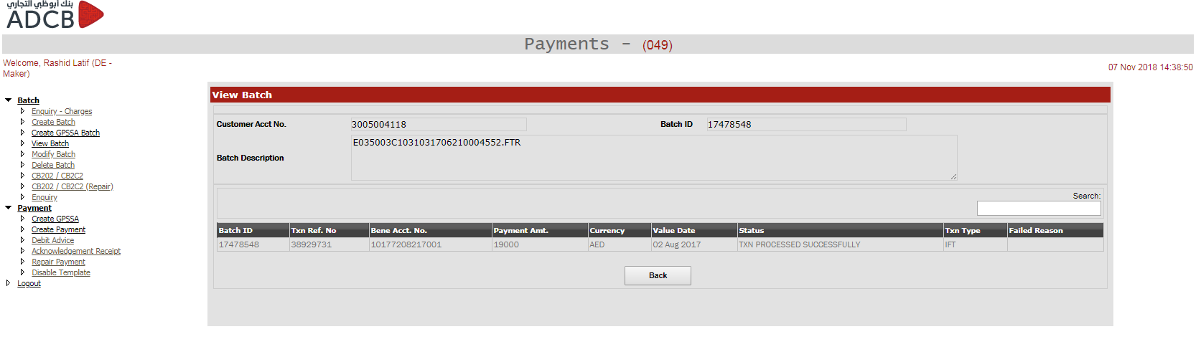

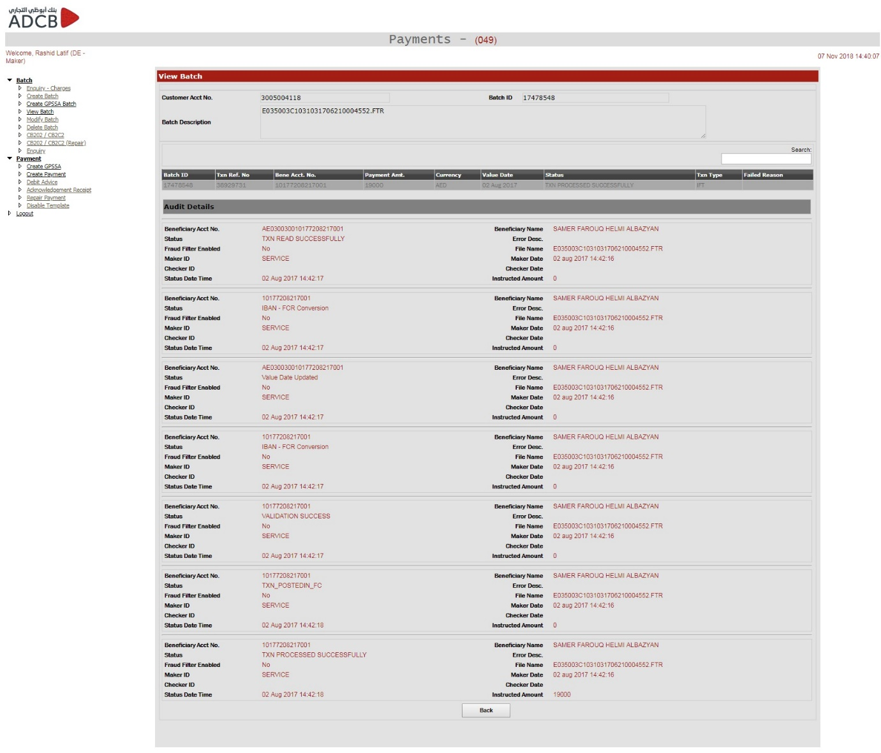

**De – Maker: Modify Batch**

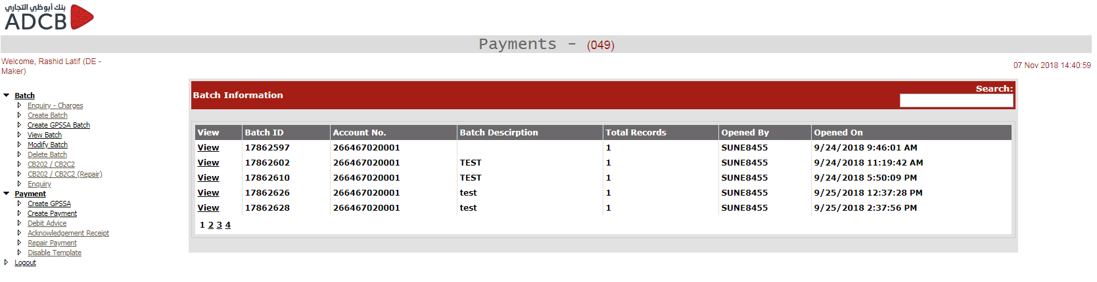

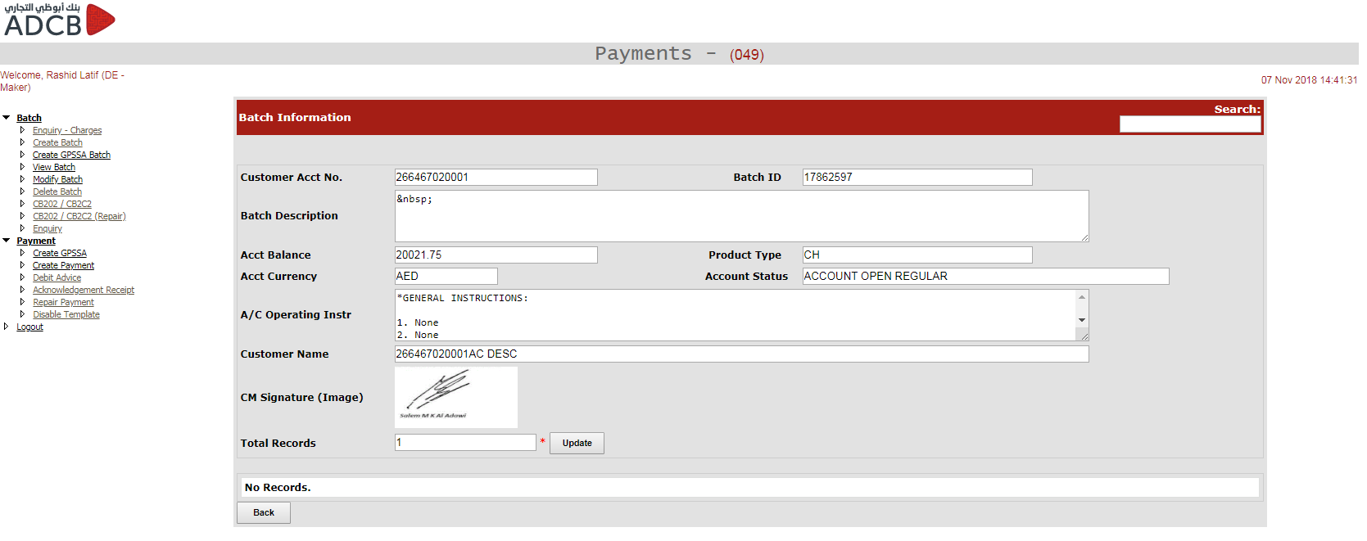

**De – Maker: Delete Batch**

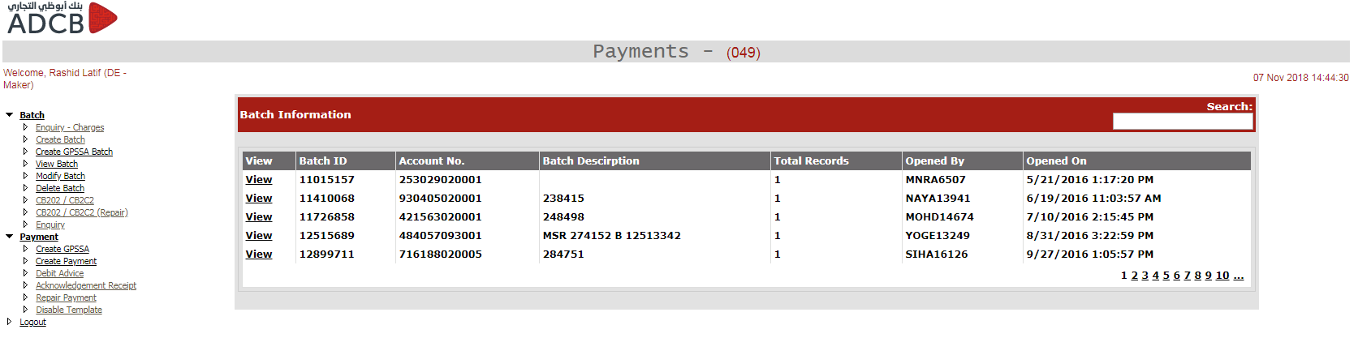

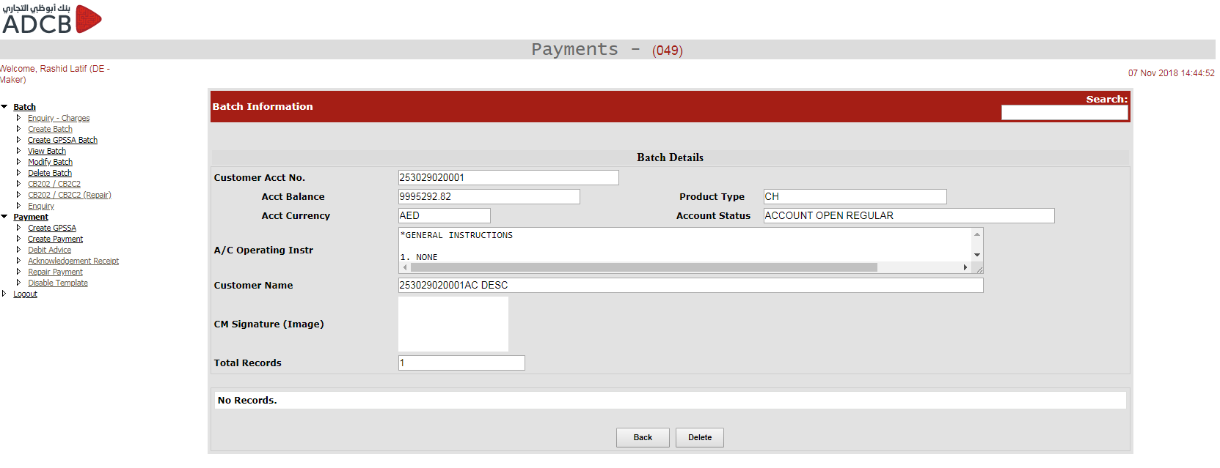

**De – Maker: CB202 / CB2C2**

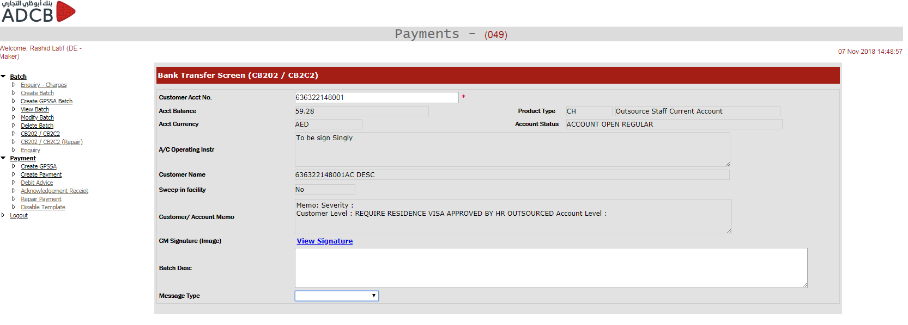

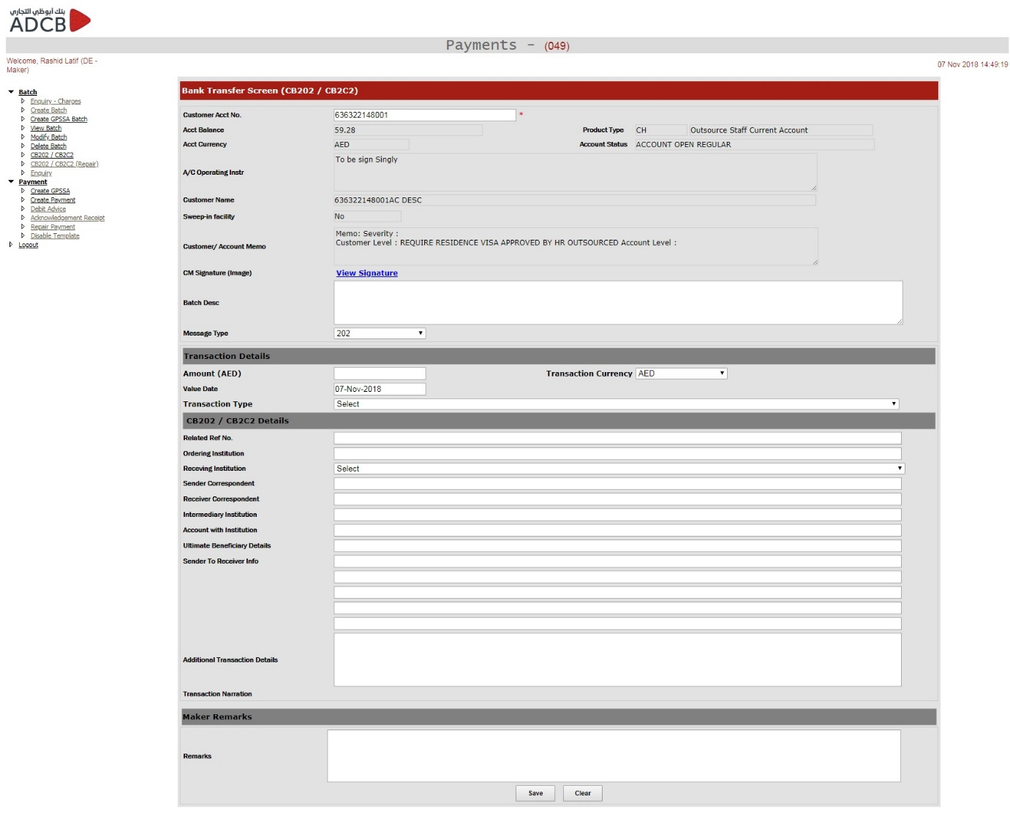

De – Maker: CB202 / CB2C2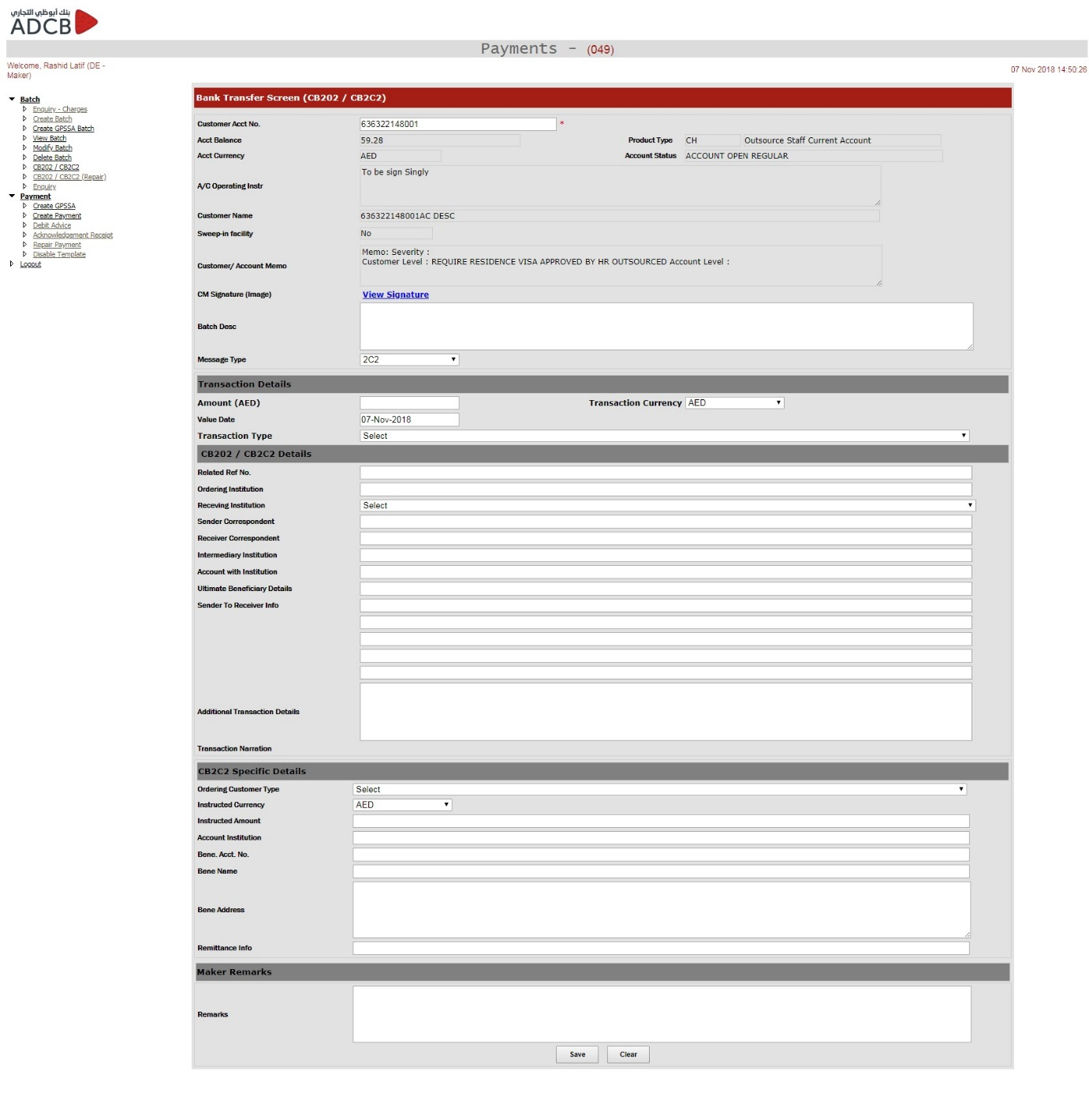

**De – Maker: CB202 / CB2C2 (Repair)**

**De – Maker: Enquiry**

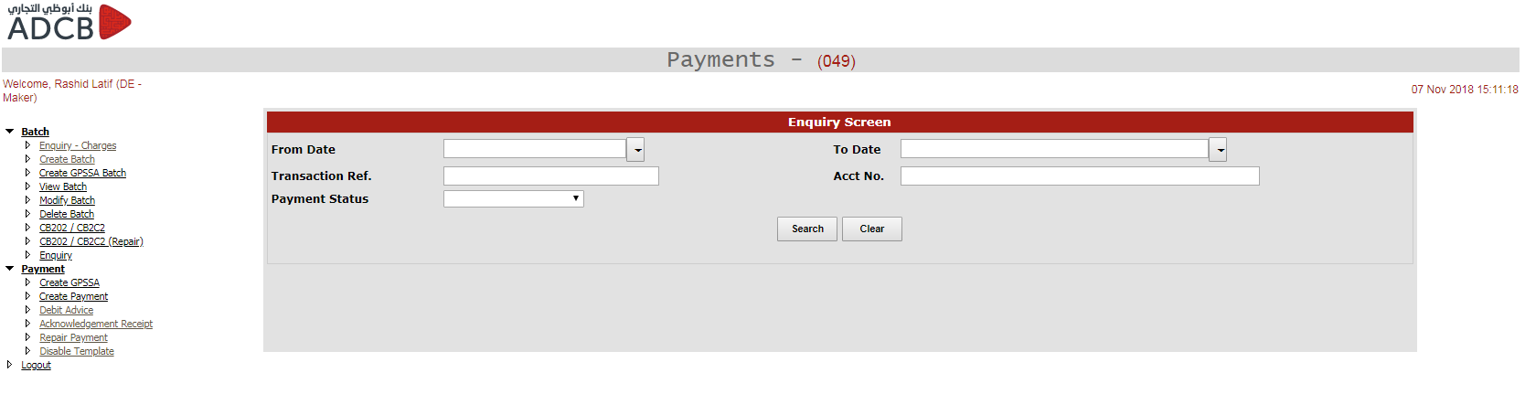

**De – Maker: Debit Advice**

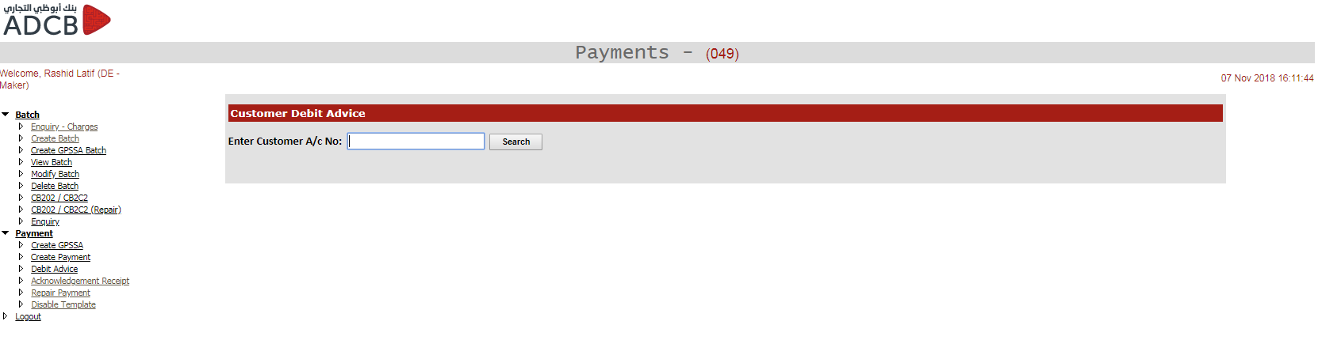

**De – Maker: Disable Templates**

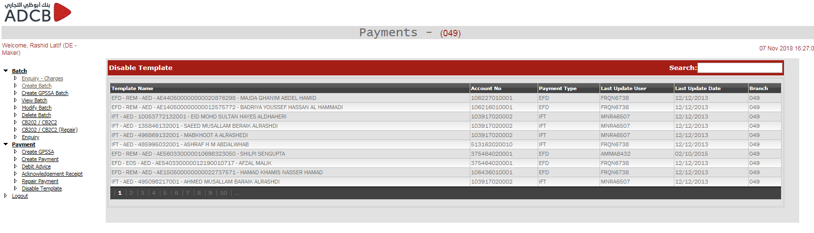

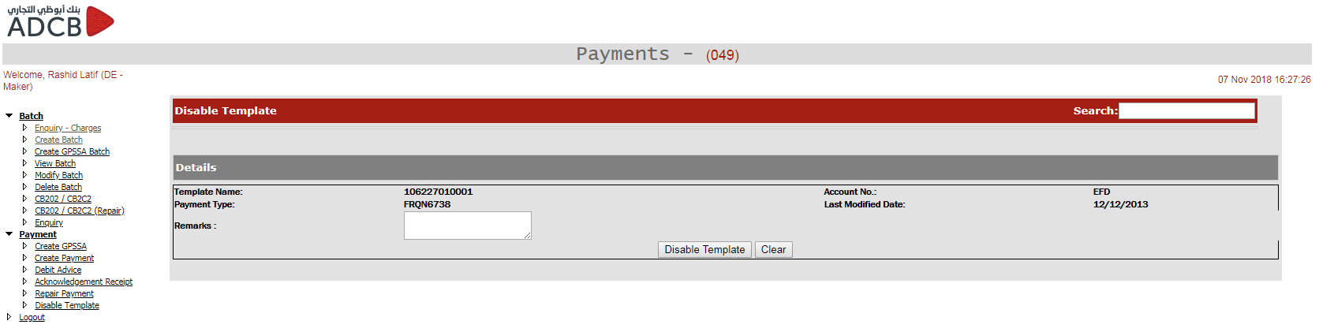

**De – Maker: Repair Payments**

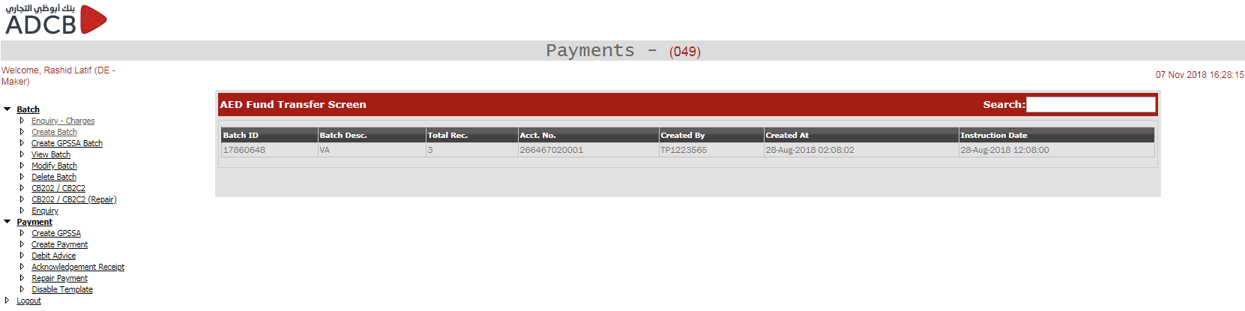

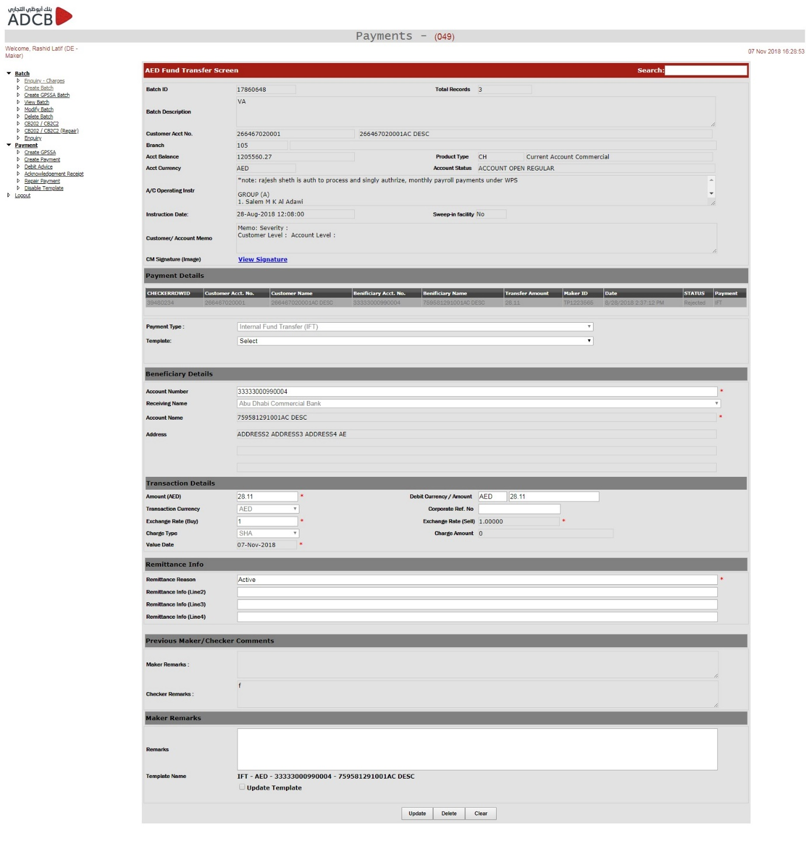

**De – Maker: Acknowledgement Receipt**

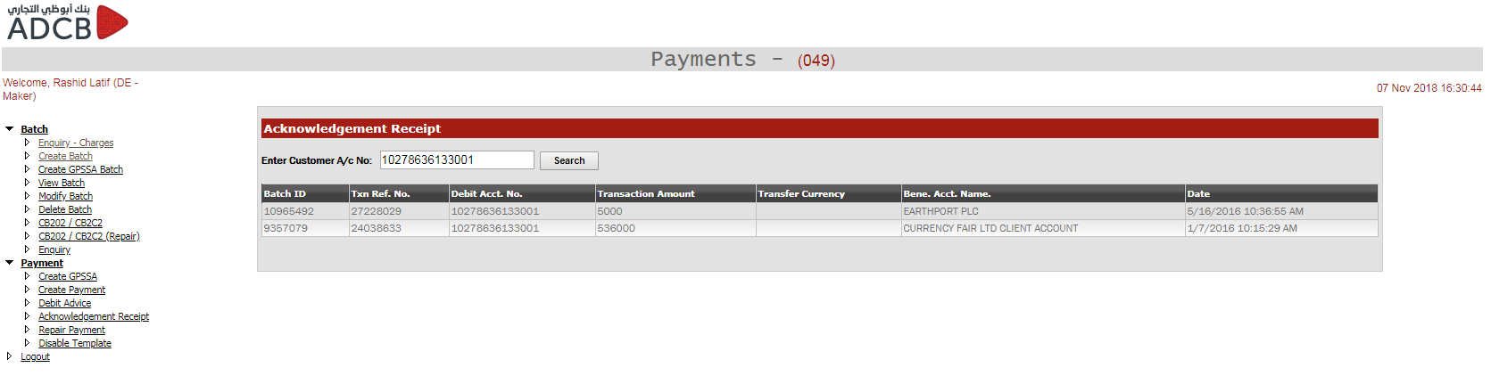

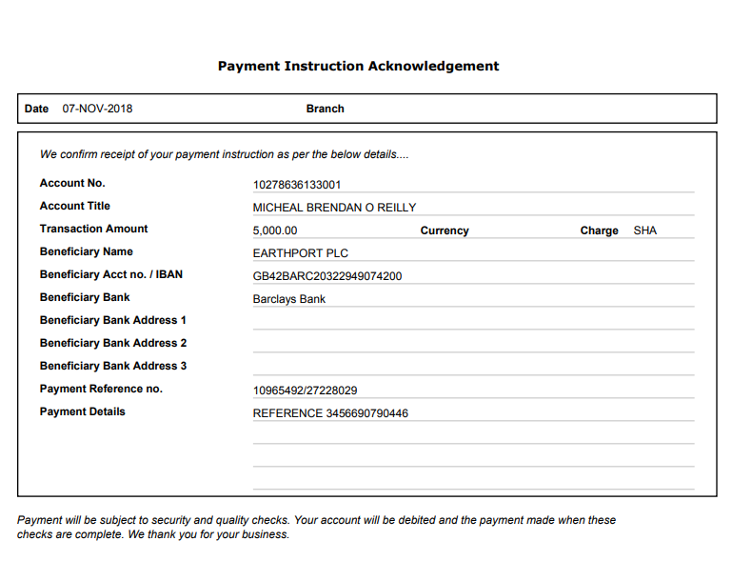

**Profile: De – Checker**

**De – Checker: CB202/CB2C2**

To be inserted

**De – Checker: Authorize Payment**

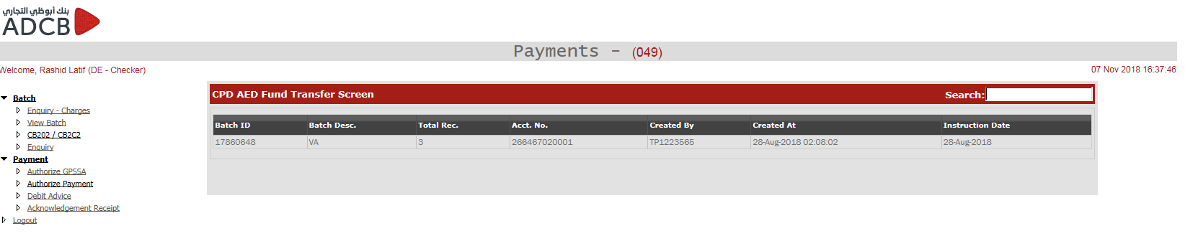

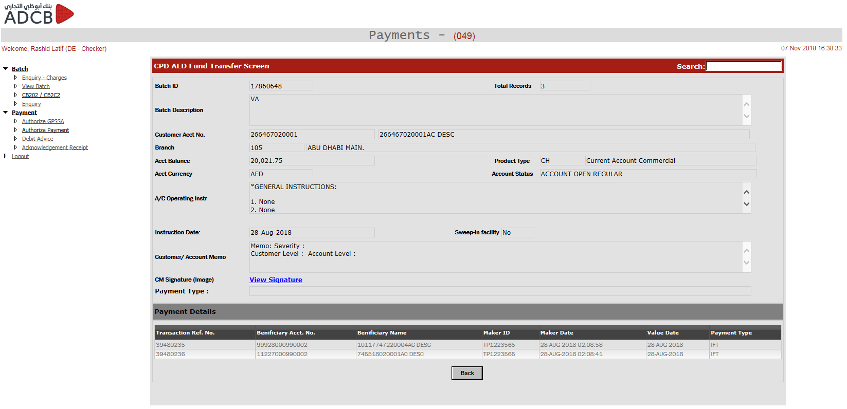

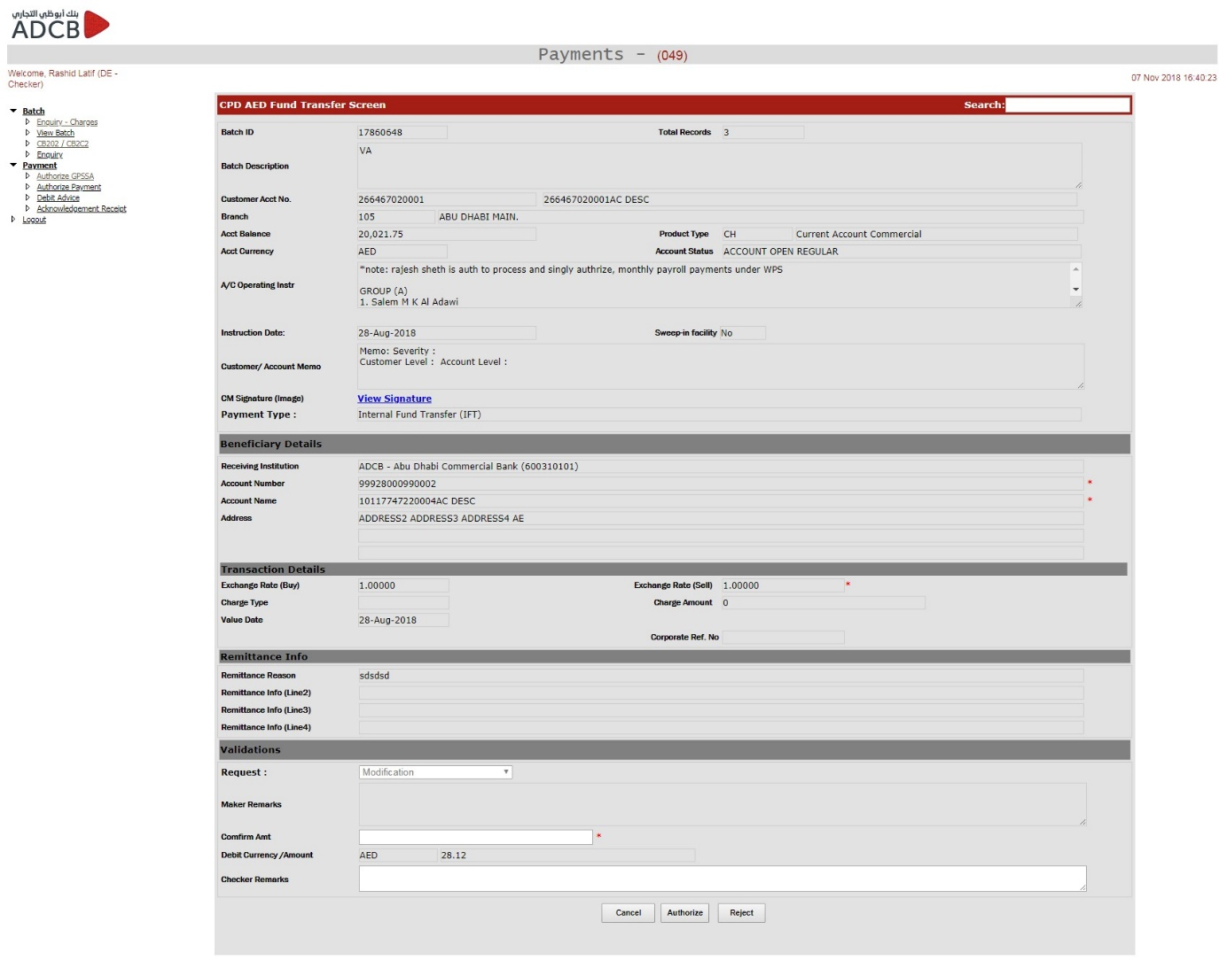

**Profile: Rep – Maker**

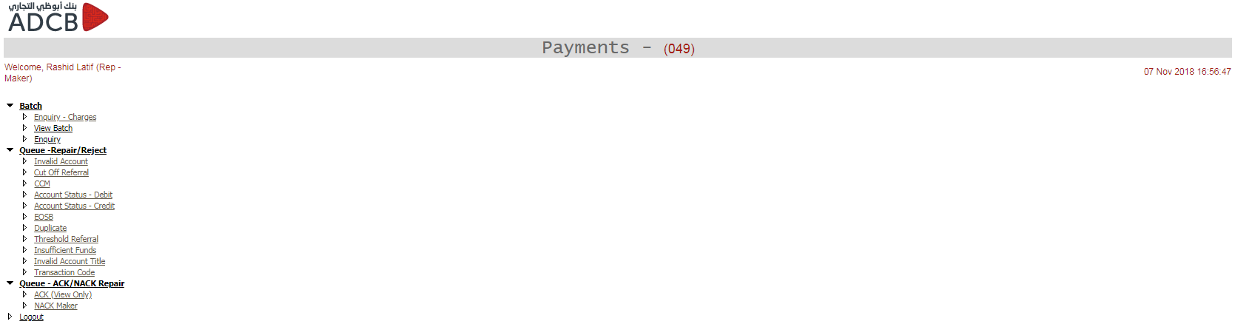

**Rep – Maker: Invalid Account**

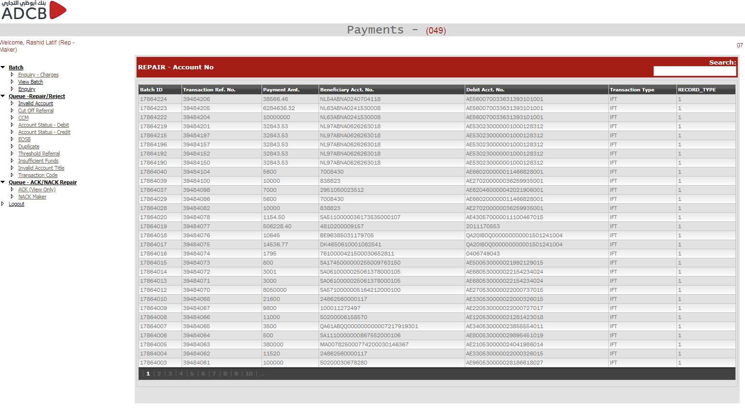

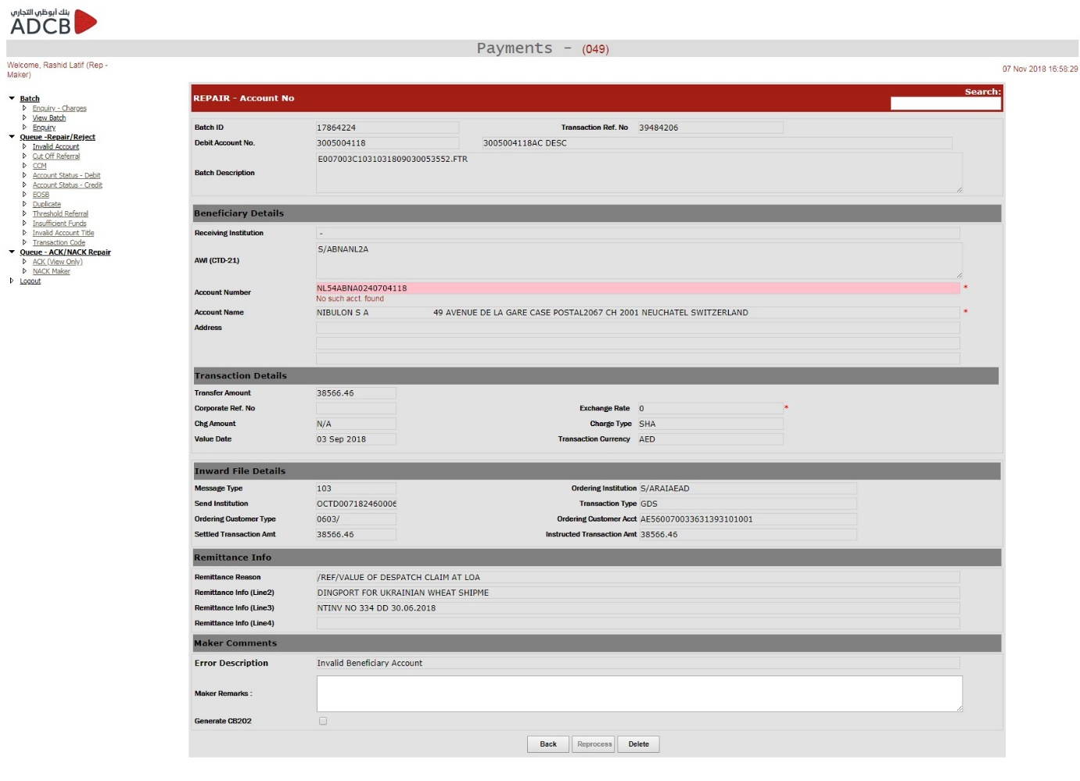

We have similar repair screen for all the other repairs including:

* Cut off Referral
* Account Status – Debit
* Account Status – Credit
* Duplicate
* Threshold Referral
* Insufficient Fund
* Invalid Account Title
* Transaction Code

Repair conditions have already been defined and can be found in Annexure F

**Upload Maker – Inward UAEFTS**

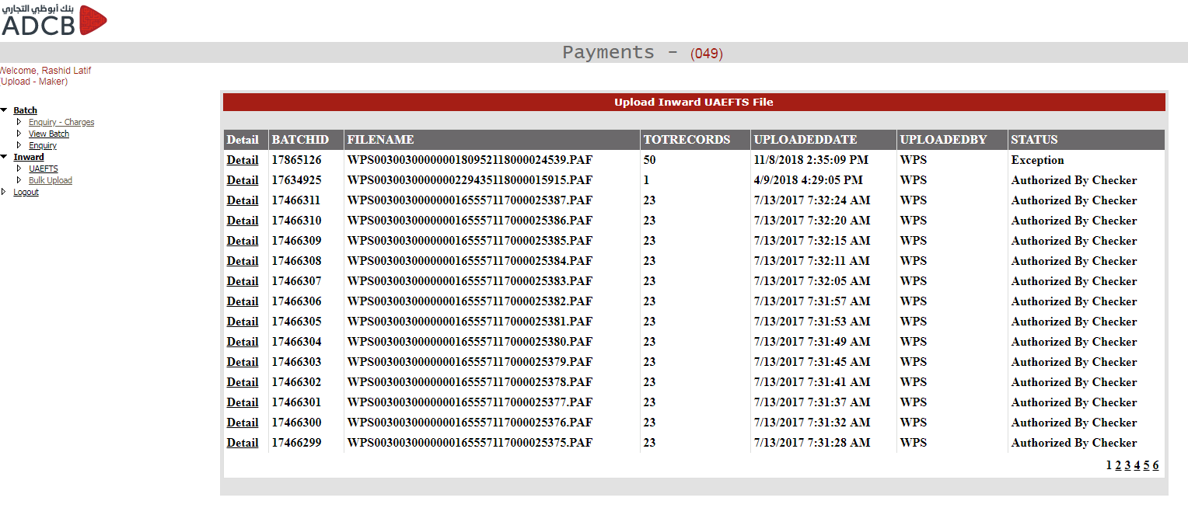

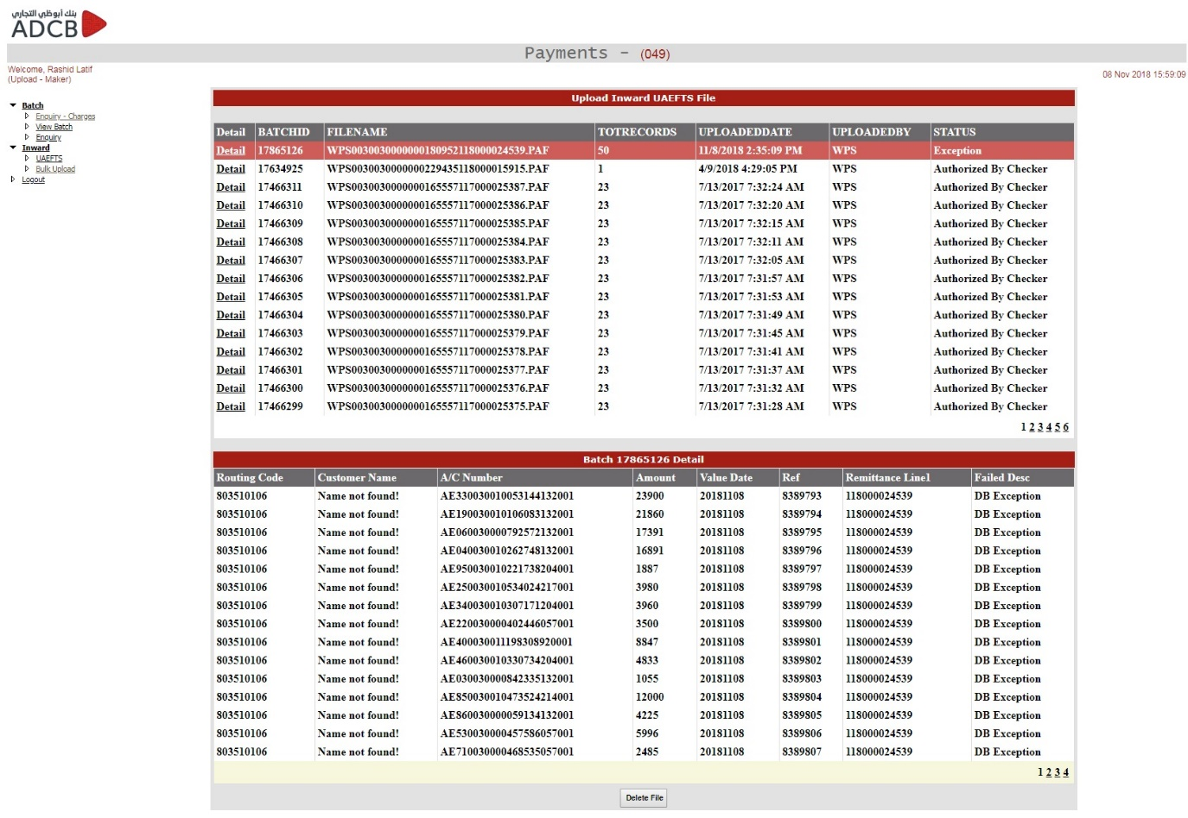

**Upload Maker – Bulk Upload**

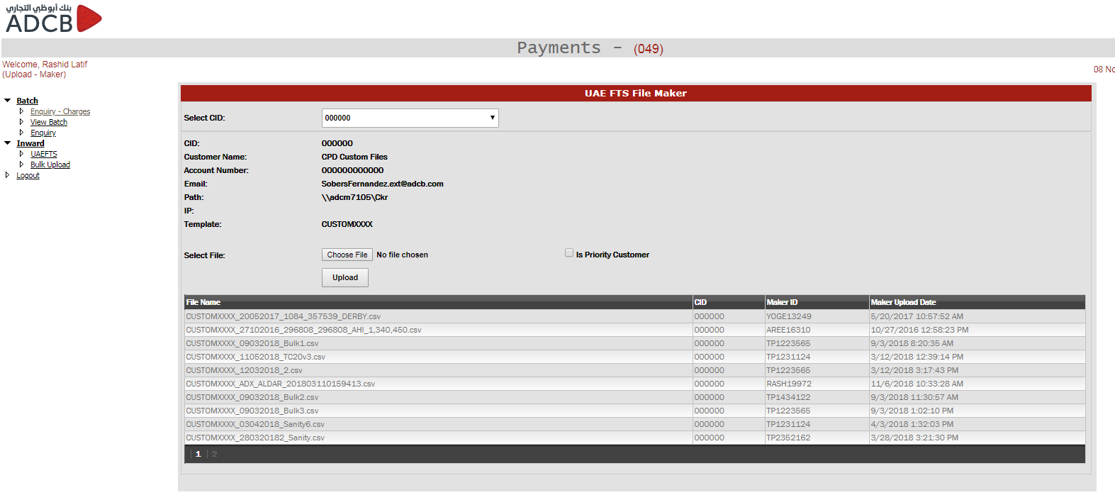

**Upload Checker – Bulk Upload**

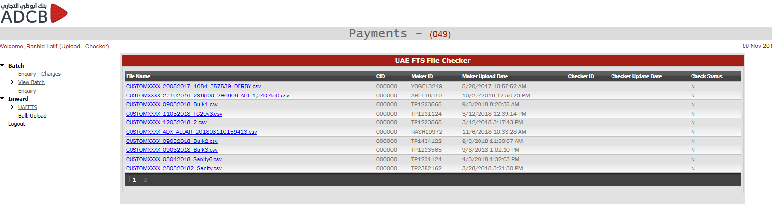

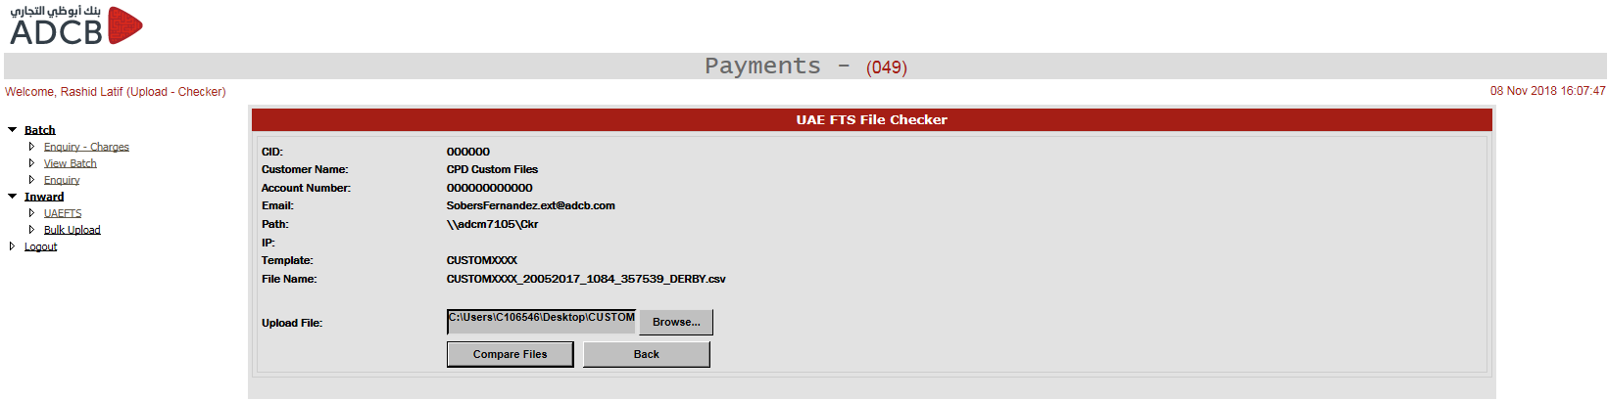

**Parameter Maker – Branch Config**

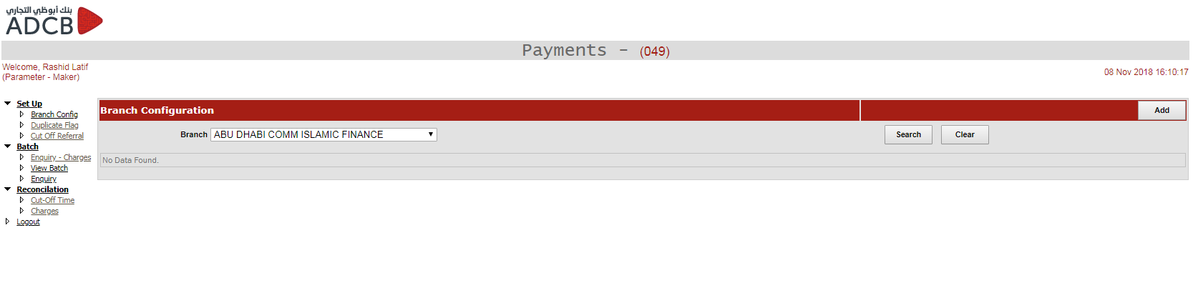

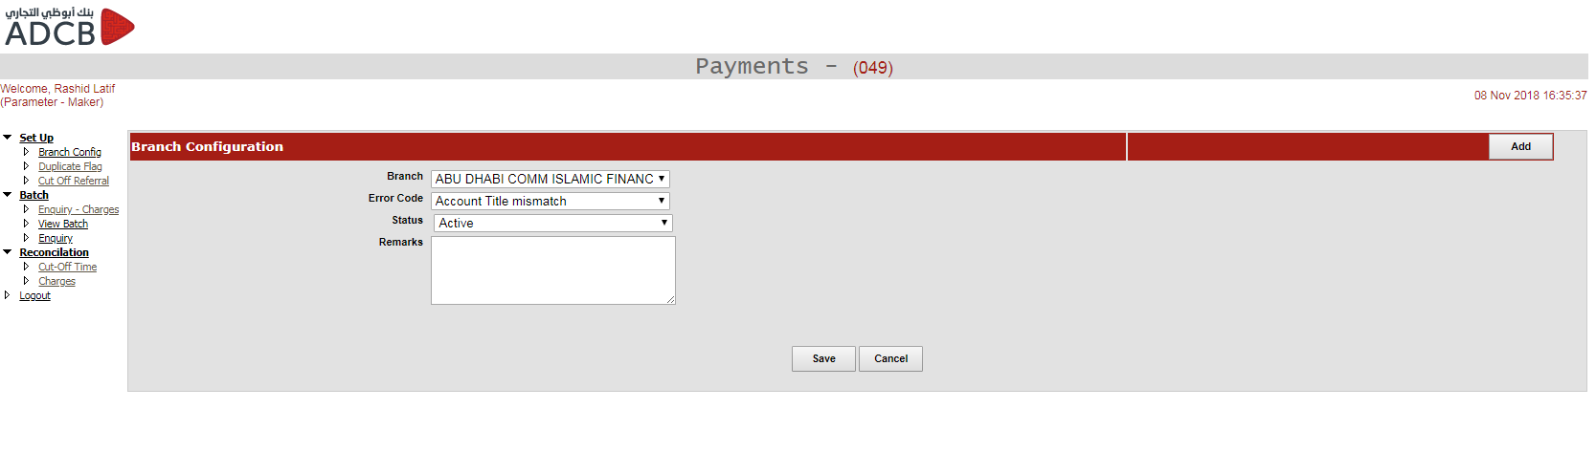

We can individually mark each branch so that the users from that branch can have the repair screen for Account Title Mismatch repair, Insufficient Funds repair and NACK repair.

**Parameter Checker – Branch Config**

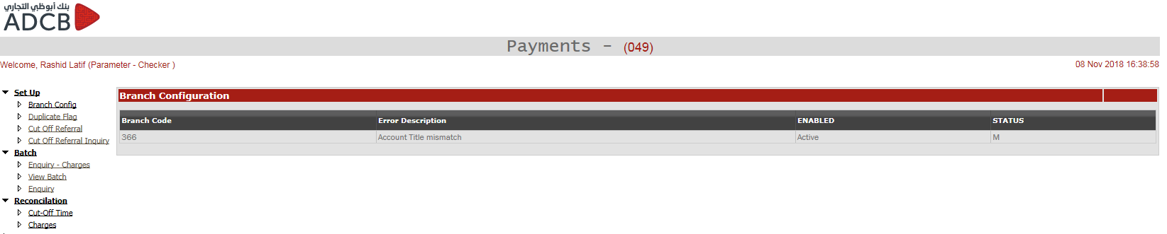

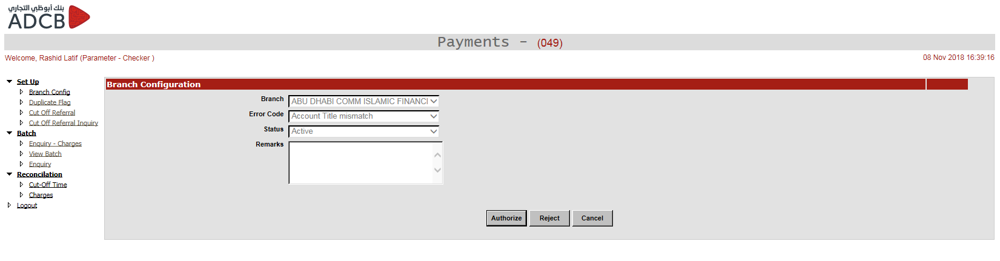

**Parameter Maker – Duplicate**

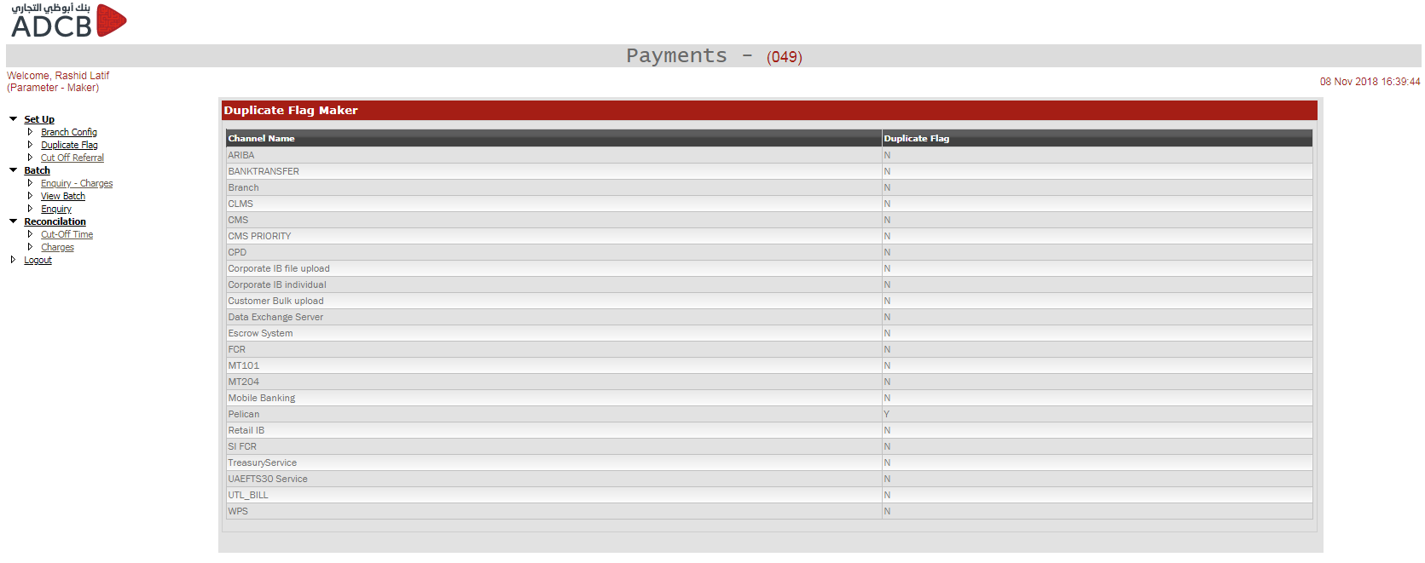

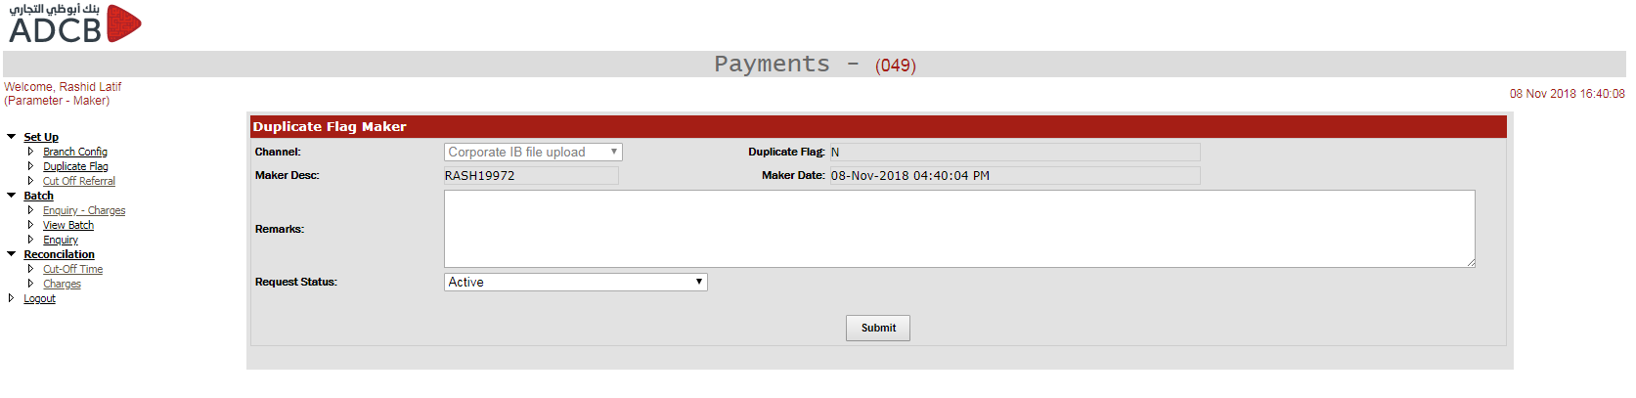

**Parameter Checker – Duplicate**

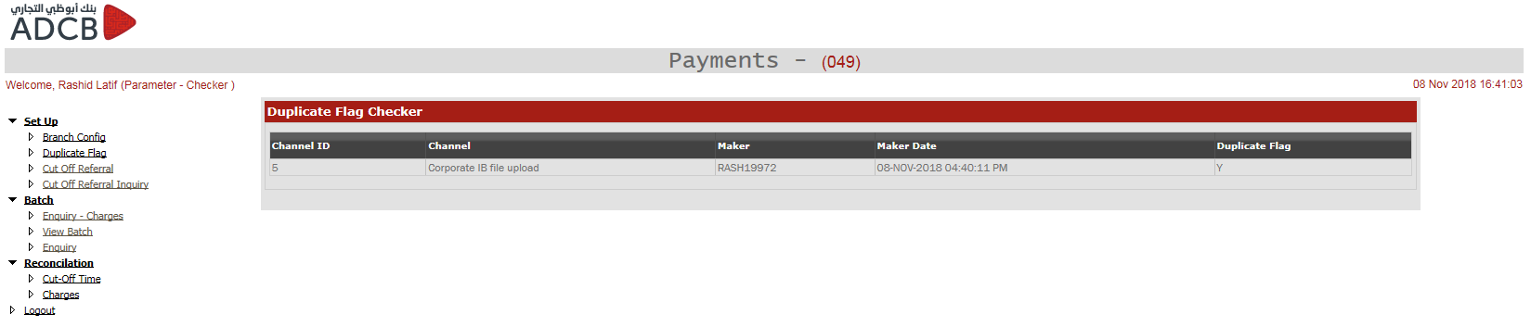

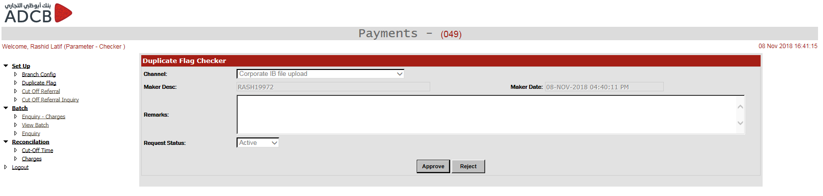

**Parameter Maker – Cut Off Referral**

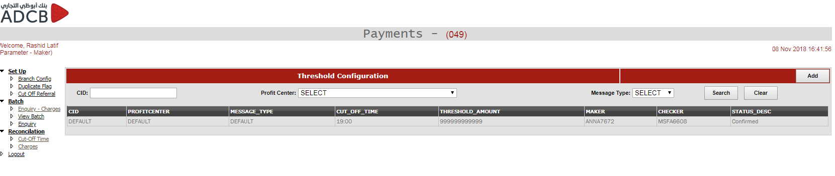

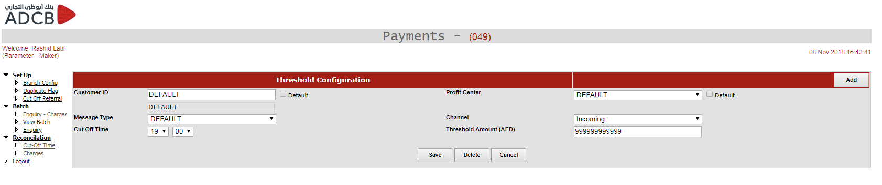

**Parameter Checker – Cut Off Referral**

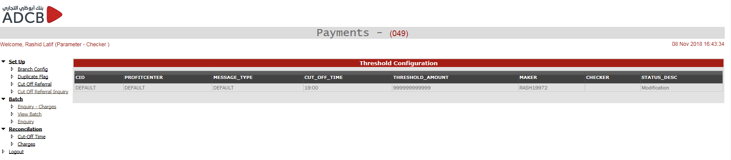

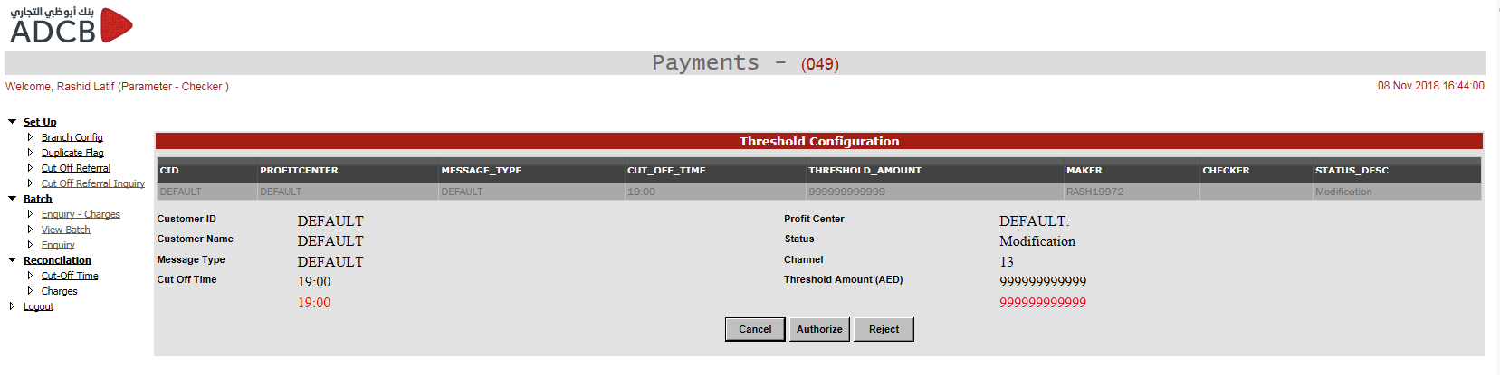

**Parameter Maker – Cut off Time**

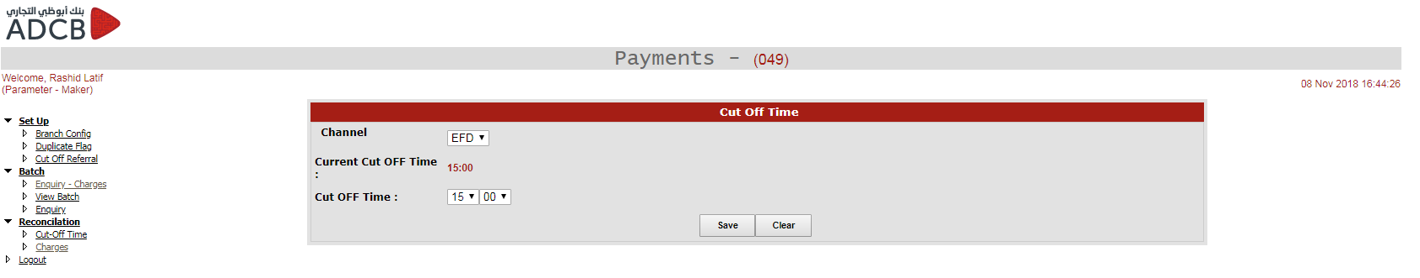

**Parameter Checker – Cut Off Time**

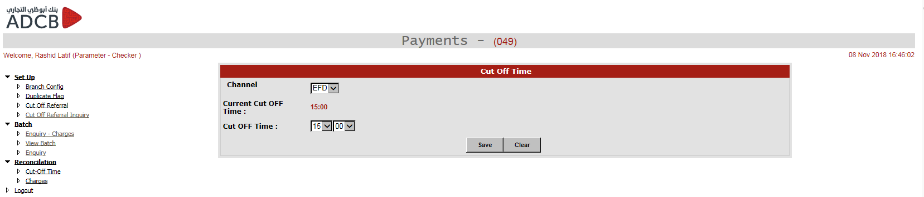

**Parameter Maker – Charges**

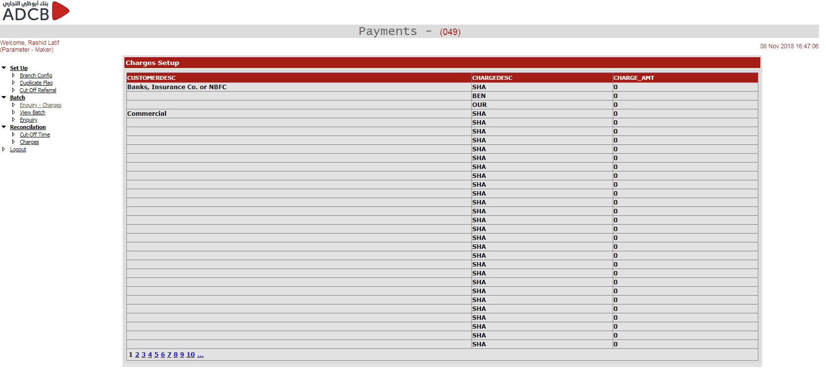

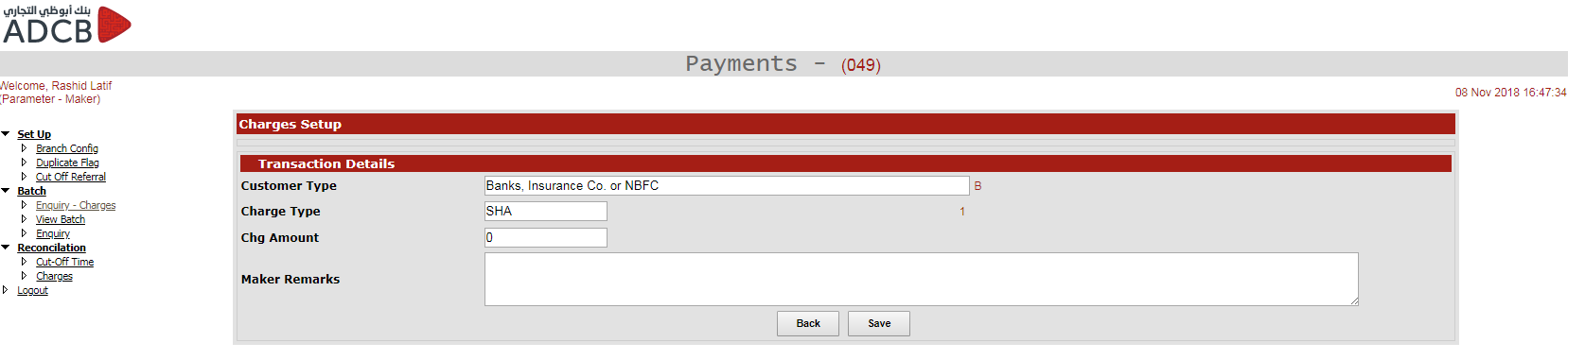

**Remit Maker – Process Remittance**

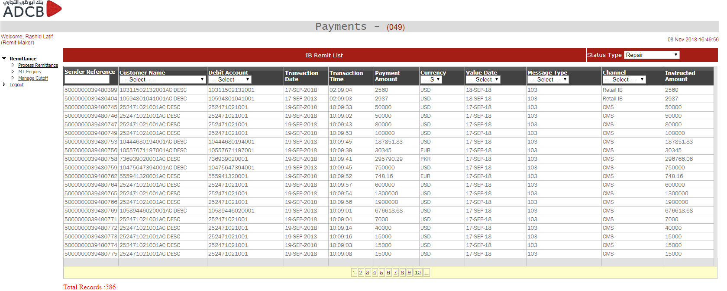

**MT103 Maker Screen**

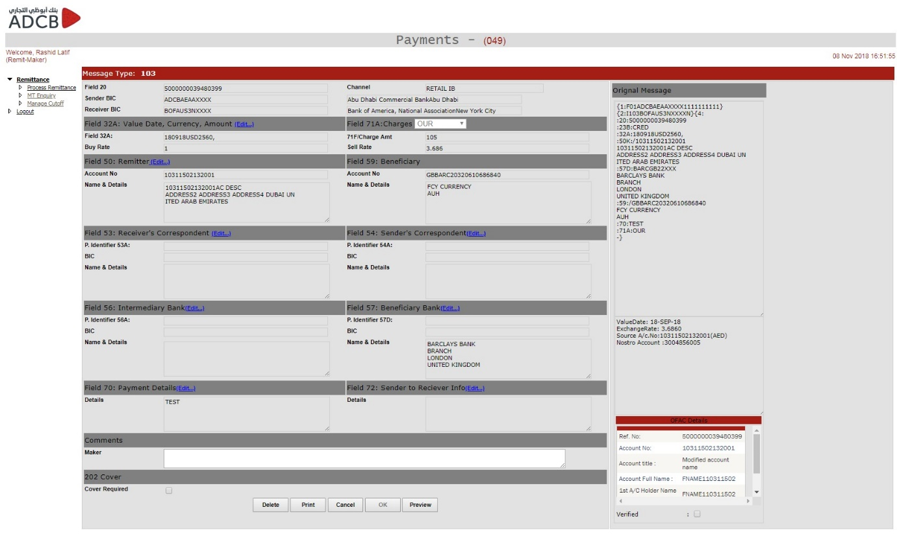

**MT202 Cover Maker Screen**

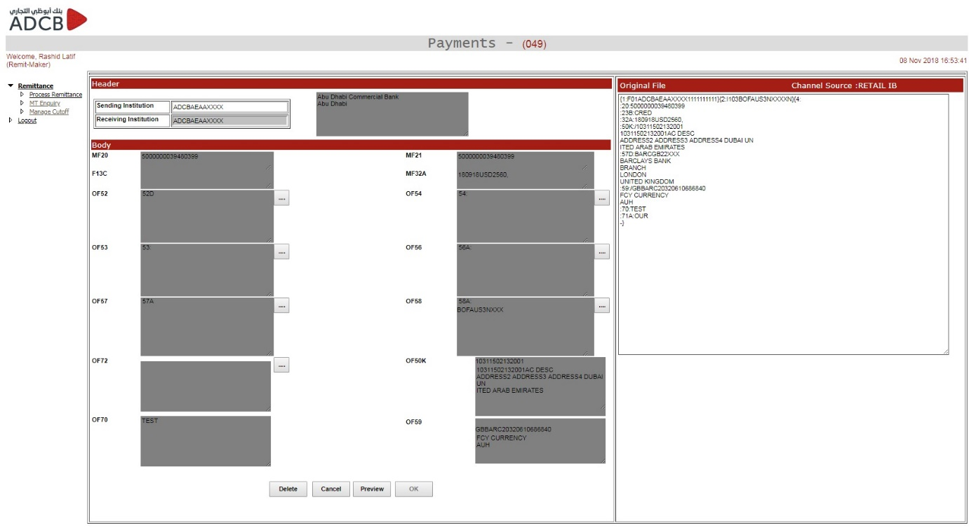

**MT202 Message Maker**

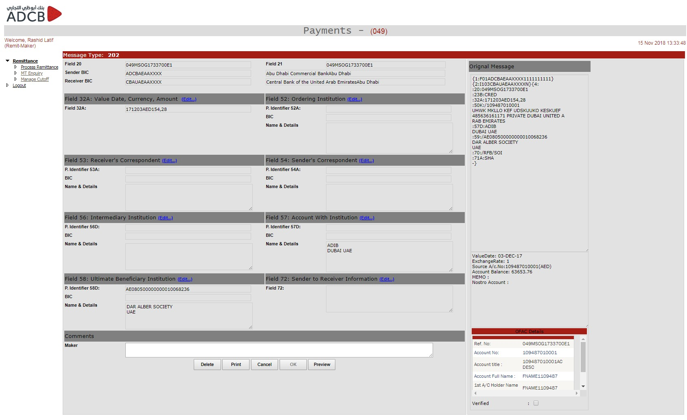

**Remit Maker – MT Enquiry**

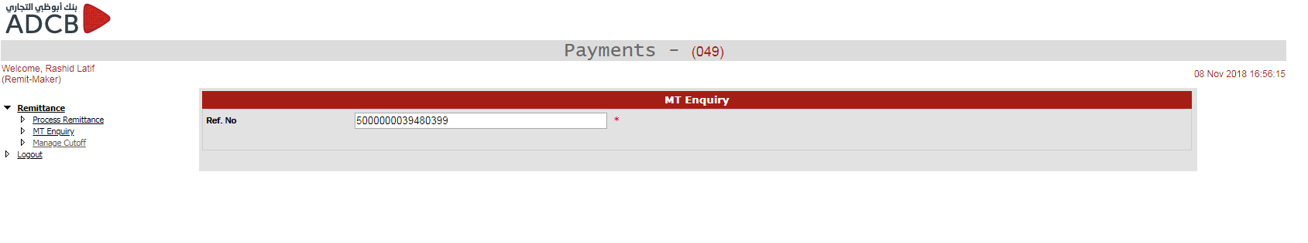

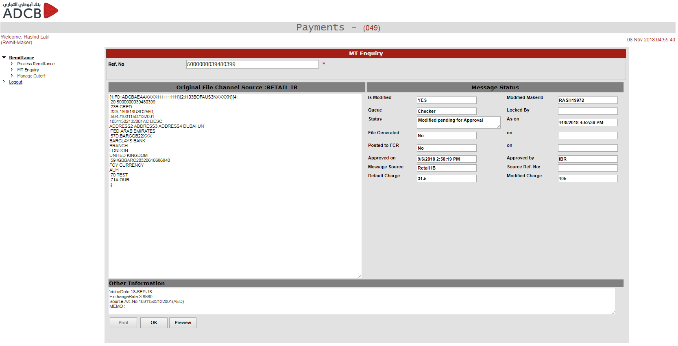

**Remit Maker – Manage Cut Off**

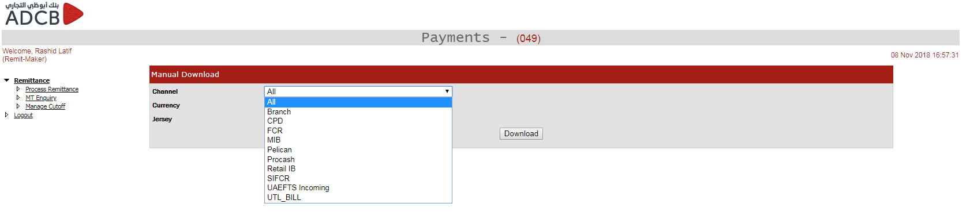

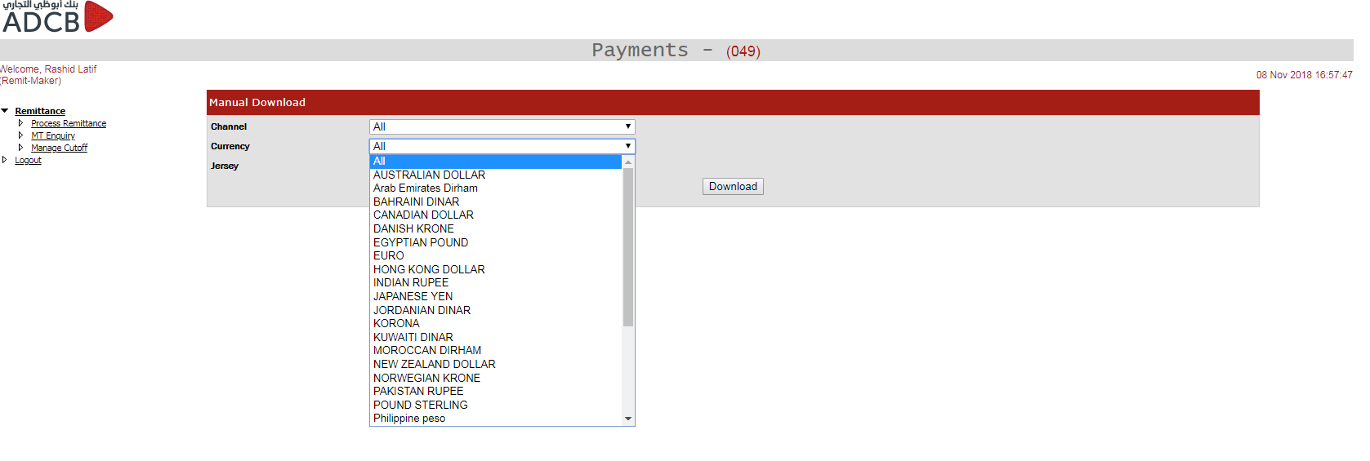

**Remit Checker – Approve Remittance**

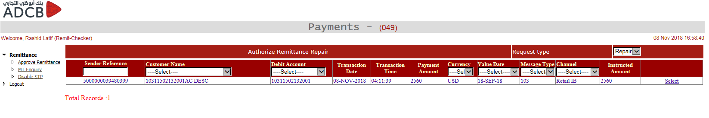

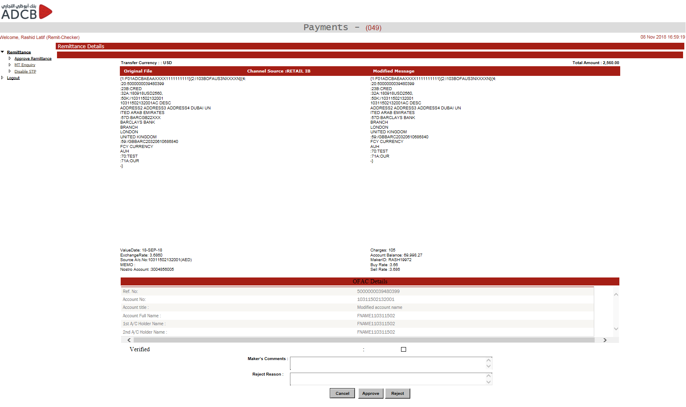

**Remit Checker – Disable STP**

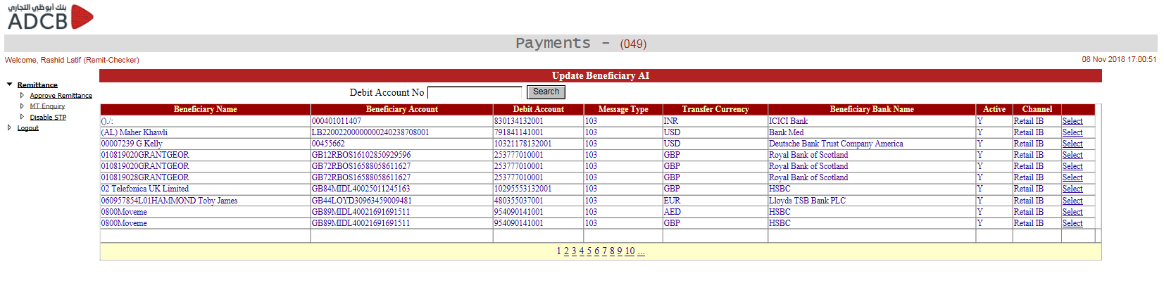

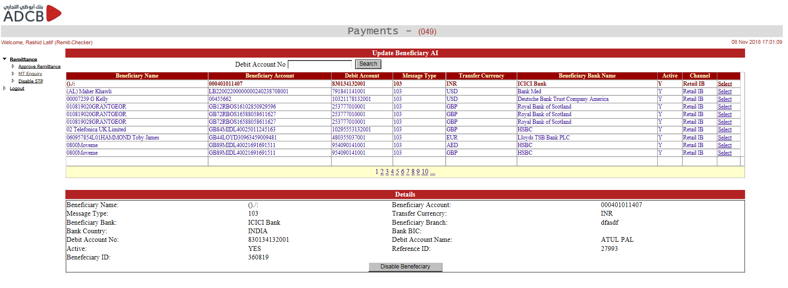

**Salary Payment Maker – CCM Repair Queue**





**Salary Payment Maker – Repair Queue**







**Salary Payment Checker – Authorize Payment**

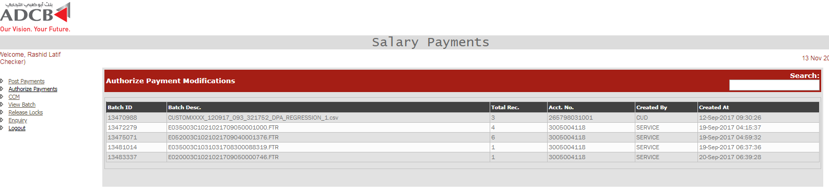

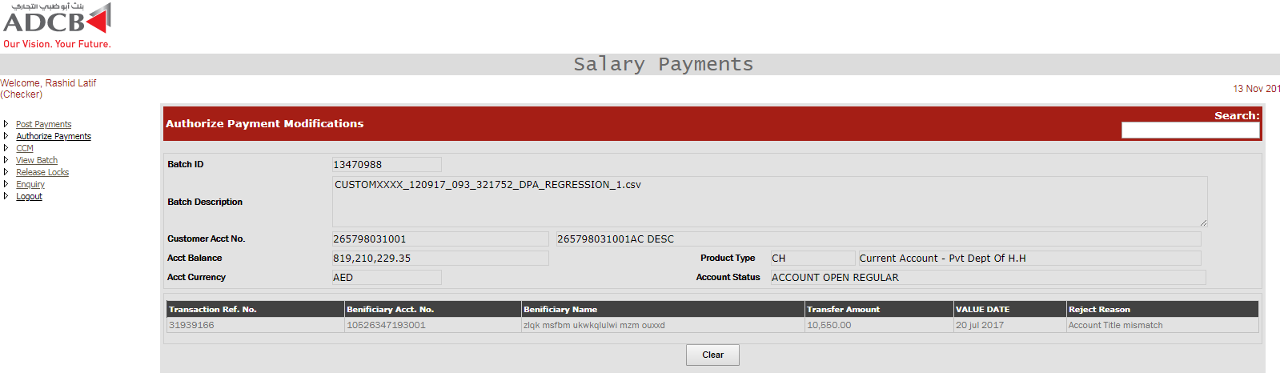

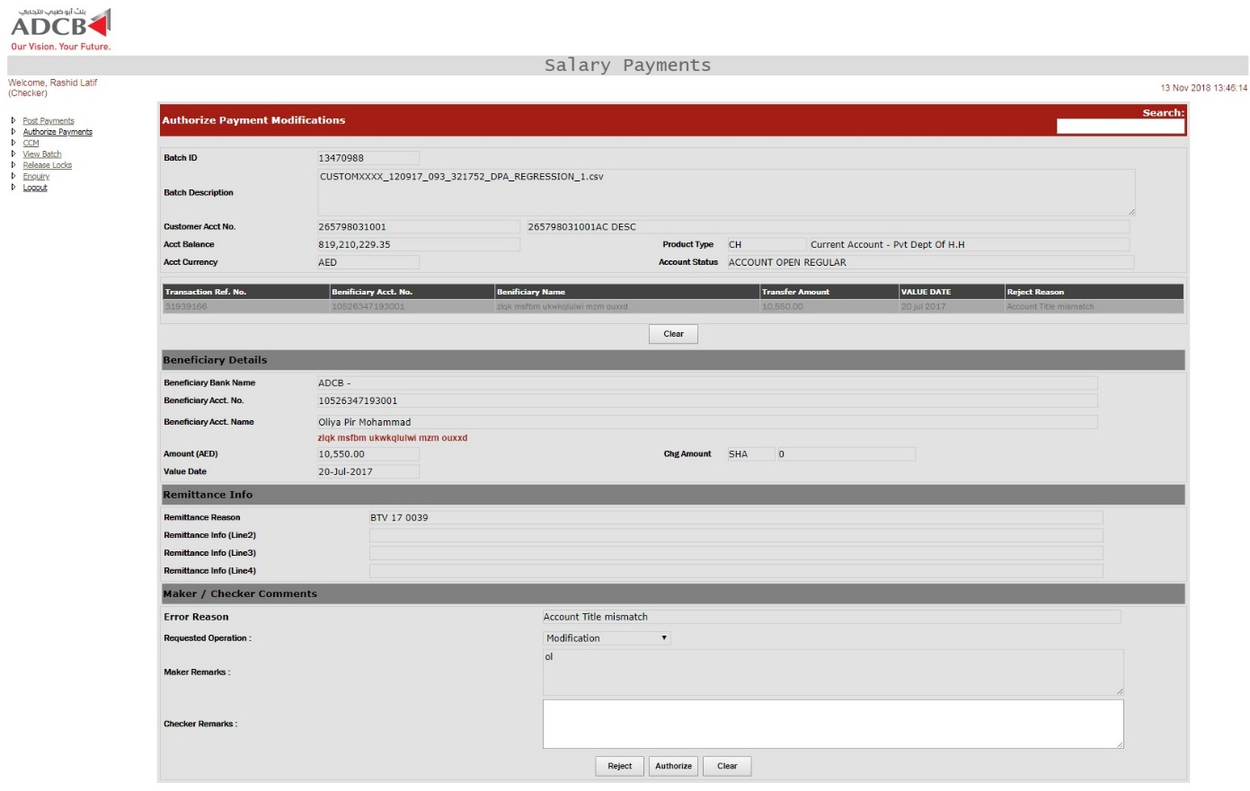

**Salary Payment Checker – CCM Repair**

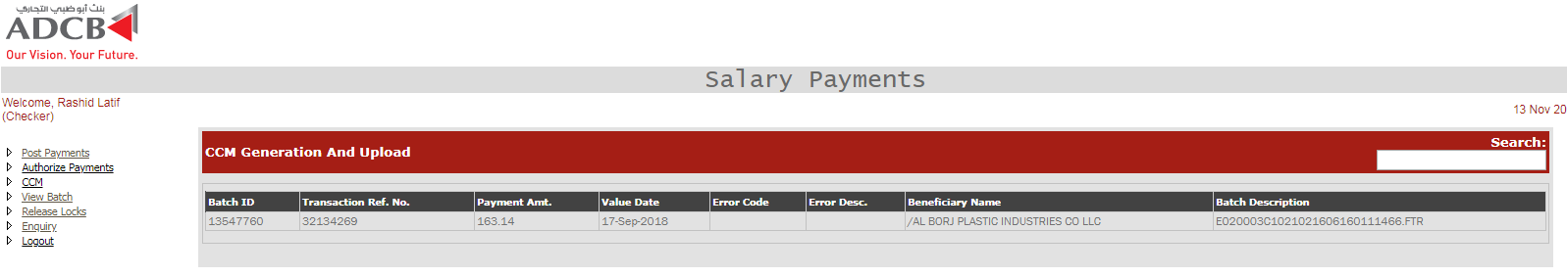

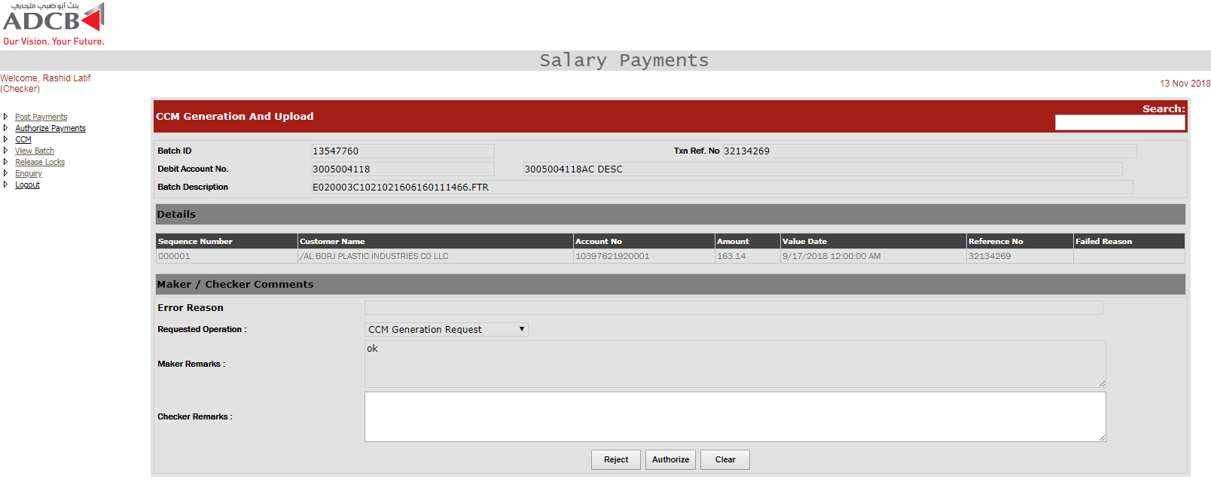

**Salary Payment Checker – Post Payment**

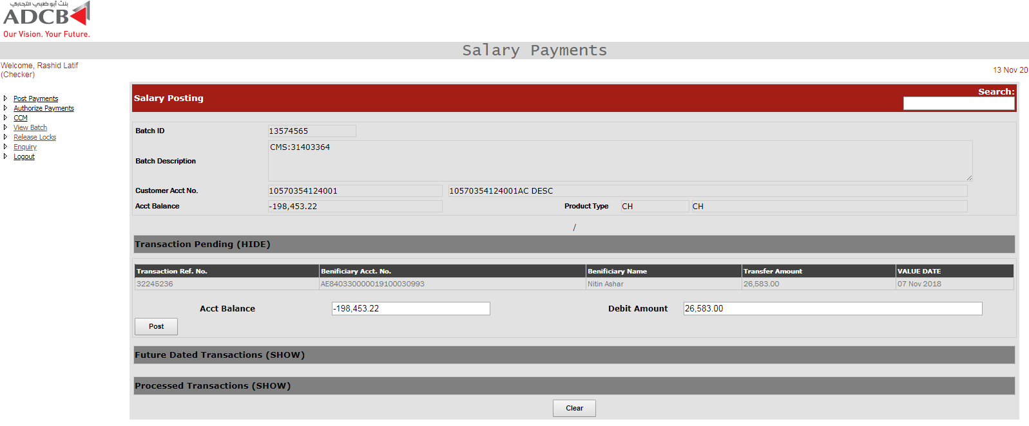 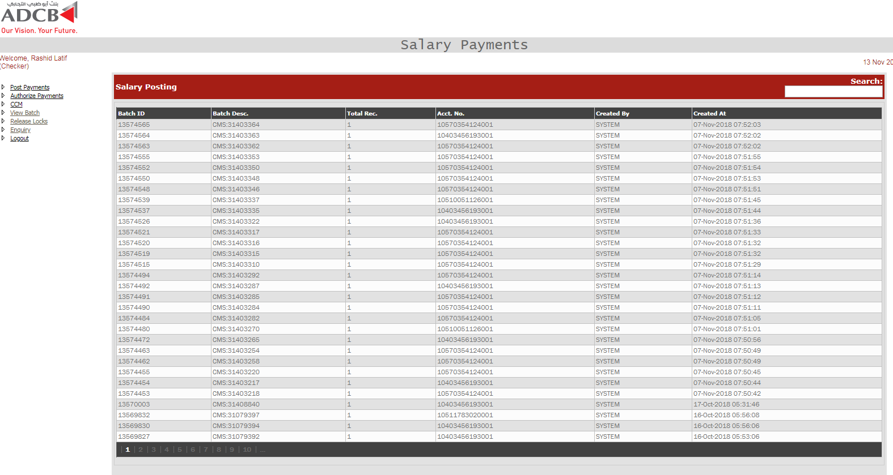

**Salary Payment Checker – Release Lock**

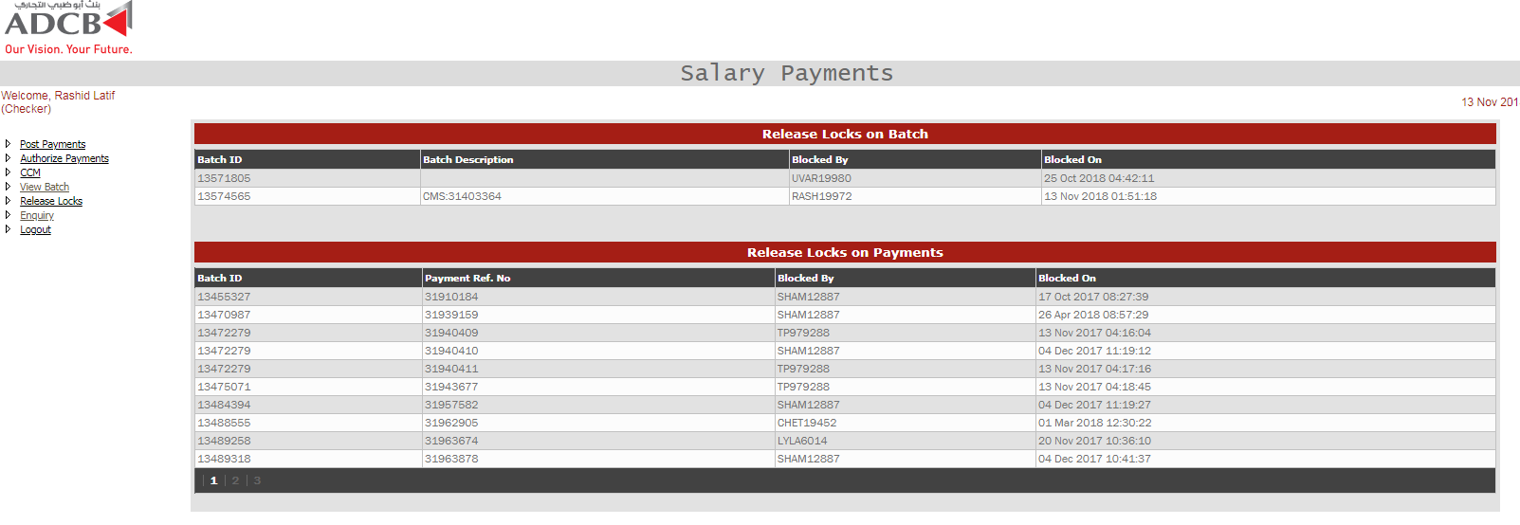

**Salary Payment – View Batch**

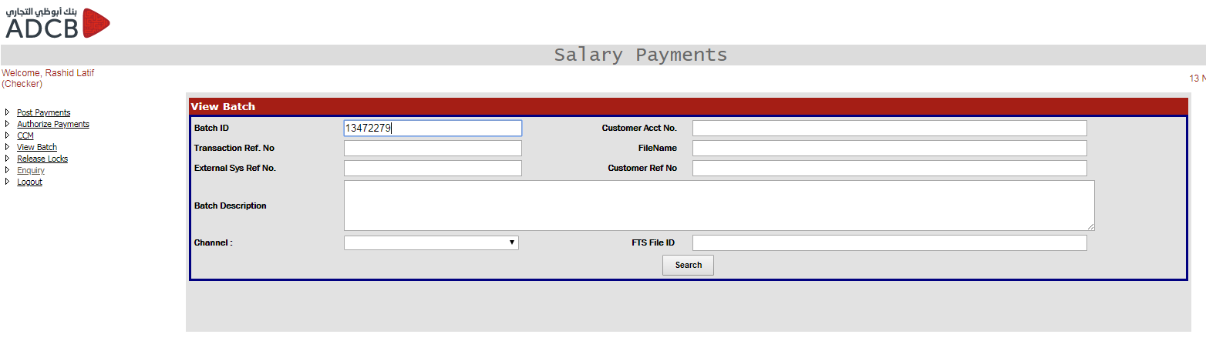

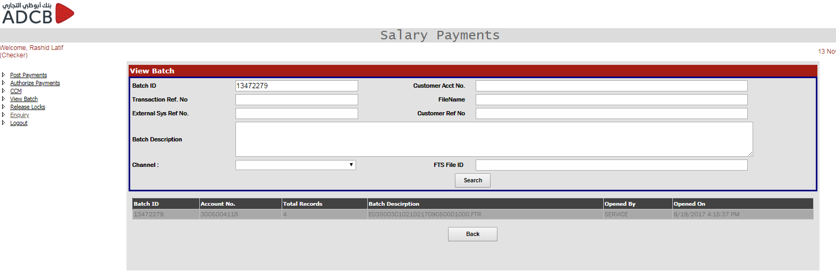

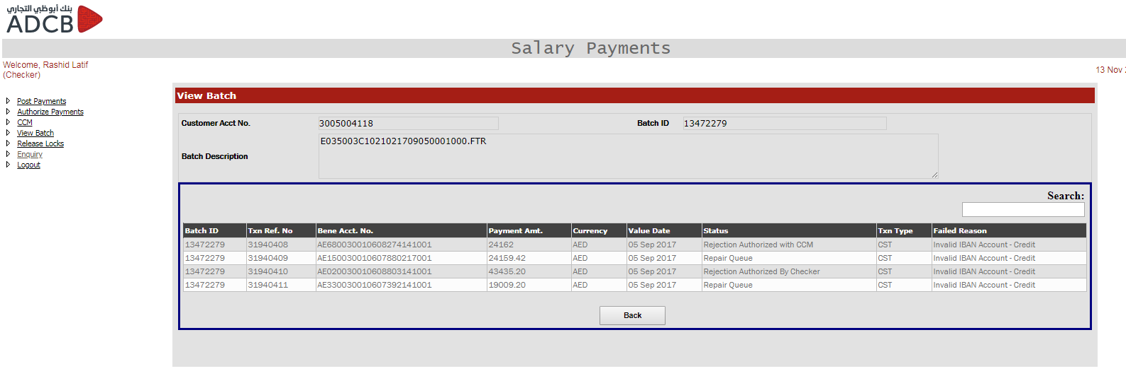

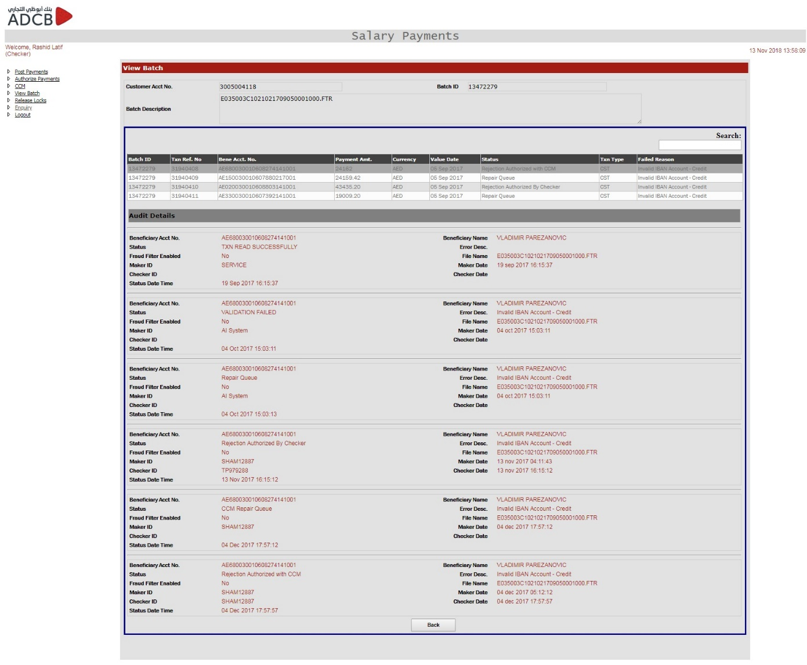

* 1. **User Interface Navigation Hierarchy**

NA.

1. **Other Details**

NA.

1. **References**

NA.

1. **Glossary**

Definitions, Acronyms, Abbreviations

|  |  |
| --- | --- |
| **Term** | **Acronyms** |
| FCR | FlexCube Retail |
| CPD | Central Processing Department |
| ITD | Information Technology Department / Institution Transfer Details |
| UAEFTS | UAE Funds Transfer System |
| CSV | Comma-separated Values |
| CB | Central Bank of UAE |
| EOSB | End of Service Benefit |
| GEFU | Generic File Upload |
| DCM | Debit Confirmation Message |
| CNM | Credit Notification Message |
| CRLF | Carriage-Return and Line-feed |
| CTD | Customer Transfer Details |
| ITC | Institution Transfer Control record |
| CTC | Customer Transfer Control record |
| SSL VPN | Secure Sockets Layer Virtual Private Network |
| IB | Internet Banking |
| DES | Data Exchange Server |
| FCC | FlexCube Corporate |
| IBAN | International Bank Account Number |
| SME | Small Medium Enterprise |
| SFTP | Secure File Transfer Protocol |
| STP | Straight Through Processing |
| OFAC | Office for Foreign Assets Control |
| FATF | Financial Action Task Force |

1. **Appendices**

NA.

1. **Annexures**

**Annexure A: Messages outbound from UAEFTS**

| **Sr.No** | **CBMSGID** | **Description** |
| --- | --- | --- |
| 01 | CB202 | Single Institutional Transfer Message |
| 02 | CB2C2 | COVER General Institutional Transfer Message |
| 03 | CB203 | Multiple Institutional Transfer Message |
| 04 | CB103 | Single Customer Credit Transfer |
| 05 | CB102 | Multiple Customer Credit Transfer |
| 06 | CB192 | Request for refund of funds pertaining to a previously transmitted and accepted CB103 or any one of the individual instruction from a CB102. For a CB102, as many number of CB192’s must be generated as there were instructions in the CB102. |
| 07 | CB292 | Request for refund of funds pertaining to a previously transmitted and accepted CB202 or any one of the individual instruction from a CB203. For a CB203, as many number of CB292’s must be generated as there were instructions in the CB203. |
| 08 | CB190 | Advice of charges debited |
| 09 | CB195 | Query relating to a previously transmitted CB1XX. |
| 10 | CB295 | Query relating to a previously transmitted CB2XX. |
| 11 | CB196 | Response to a CB195 |
| 12 | CB296 | Response to a CB295 |
| 13 | CB199 | Free Format message relating to previously transmitted CB1XX. |
| 14 | CB299 | Free Format message relating to previously transmitted CB2XX. |
| 15 | CB999 | Free Format message relating to previously transmitted CB9XX message. |
| 16 | CB900 | Debit Confirmation Message |
| 17 | CB910 | Credit Notification Message |
| 18 | CB941 | Balance Report for request lodged using the UAEFTS TEP |
| 19 | CB950 | Statement Message for request lodged using the UAEFTS TEP |
| 20 | CB002 | WPS Funding Account Transfer Request |
| 21 | CBACK | Positive Acknowledgement |
| 22 | CBNAK | Negative Acknowledgement |

**Annexure B: Messages inbound to UAEFTS**

| **S. No.** | **CBMSGID** | **Description** | **SWIFT MT** |
| --- | --- | --- | --- |
| 01 | CB202 | Single Institutional Transfer Message | MT202 |
| 02 | CB2C2 | COVER General Institutional Transfer Message | MT202 COV |
| 03 | CB203 | Multiple Institutional Transfer Message | MT203 |
| 04 | CB103 | Single Customer Credit Transfer | MT103 |
| 05 | CB102 | Multiple Customer Credit Transfer | MT102 |
| 06 | CB192 | Request for refund of funds pertaining to a previously transmitted and accepted CB103 or any one of the individual instruction from a CB102. For a CB102, as many number of CB192’s must be generated as there were instructions in the CB102. | MT192 |
| 07 | CB292 | Request for refund of funds pertaining to a previously transmitted and accepted CB202 or any one of the individual instruction from a CB203. For a CB203, as many number of CB292’s must be generated as there were instructions in the CB203. | MT292 |
| 08 | CB191 | For a previously transmitted and accepted CB103 or any one of the individual instruction from a CB102 where the charges for the transaction were indicated as “OUR”. For a CB102, as many number of CB191’s must be generated as there were instructions in the CB102 where the charges for the transaction were indicated as “OUR”. | MT191 |
| 09 | CB195 | Query relating to a previously transmitted CB1XX. | MT195 |
| 10 | CB295 | Query relating to a previously transmitted CB2XX. | MT295 |
| 11 | CB196 | Response to a CB195 | MT196 |
| 12 | CB296 | Response to a CB295 | MT296 |
| 13 | CB199 | Free Format message relating to previously transmitted CB1XX. | MT199 |
| 14 | CB299 | Free Format message relating to previously transmitted CB2XX message. | MT299 |
| 15 | CB999 | Free Format message relating to previously transmitted CB9XX message. | MT999 |
| 16 | CB001 | WPS Funding Account Transfers | N/A |
| 17 | CB002 | WPS Funding Account Transfer Request | N/A |
| 18 | CB003 | WPS Funding Account Transfer Fulfillment | N/A |
| 19 | CB004 | WPS Settlement Account Transfer | N/A |

**Annexure C: Transaction Types:**

|  |  |
| --- | --- |
| **Transaction Type** | **Description** |
| ACM | Agency Commission |
| AES | Advance payment against EOS |
| AFA | Receipts or payments from personal residents bank account or deposits abroad |
| AFL | Receipts or payments from personal n-resident bank account in the UAE |
| ALW | Allowance |
| ATS | Air transport |
| BON | Bonus |
| CBP | Cross Border Payments |
| CCP | Corporate Card Payment |
| CEA | Equity for the establishment of new company from residents abroad equity of merger or acquisition of companies abroad from residents and articipation to capital increase of related company abroad |
| CEL | Equity for the establishment of new company in the UAE from nresidents equity of merger or acquisition of companies in the UAE from n-residents participation to capital increase of related companies |
| CHC | Charitable Contributions |
| CIN | Commercial Investments |
| COM | Commission |
| COP | Compensation |
| CRP | Credit Card Payment |
| DCP | Debit Card Payments |
| DIF | Debt instruments intragroup loans securities deposits foreign |
| DIL | Debt instruments intragroup loans securities deposits in the UAE |
| DIV | Dividend Payouts |
| DLA | Purchases and sales of foreign debt securities more than a year in t related companies |
| DLL | Purchases and sales of securities issued by residents more than a year in t related companies |
| DOE | Dividends on equity not intra group |
| DSA | Purchases and sales of foreign debt securities less than a year in t related companies |
| DSL | Purchases and sales of securities issued by residents less than a year in t related companies |
| EDU | Educational Support |
| EMI | Equated Monthly Installments |
| EOS | End of Service / Final Settlement |
| FAM | Family Support |
| FDA | Financial derivatives foreign |
| FDL | Financial derivatives in the UAE |
| FIA | Investment fund shares foreign |
| FIL | Investment fund shares in the UAE |
| FIS | Financial services |
| FSA | Equity other than investment fund shares in t related companies abroad |
| FSL | Equity other than investment fund shares in t related companies in the UAE |
| GDS | Goods Bought or Sold |
| GMS | Processing repair and maintenance services on goods |
| GOS | Government goods and services embassies etc |
| GRI | Government related income taxes tariffs capital transfers etc |
| IFS | Information services |
| IGD | Intra group dividends |
| IGT | INTER GROUP TRANSFER |
| IID | Intra group interest on debt |
| INS | Insurance services |
| IOD | Income on deposits |
| IOL | Income on loans |
| IPC | Charges for the use of intellectual property royalties |
| IPO | IPO Subscriptions |
| IRP | INTEREST RATE SWAP PAYMENTS |
| IRW | INTERST RATE UNWIND PAYMENTS |
| ISH | Income on investment funds shares |
| ISL | Interest on securities more than a year |
| ISS | Interest on securities less than a year |
| ITS | Computer services |
| LAS | Leave Salary |
| LEA | Leasing abroad |
| LEL | Leasing in the UAE |
| LIP | Loan Interest Payments |
| LLA | Loans- Drawings or Repayments on loans extended to n-residents - long term |
| LLL | Loans-Drawings or Repayments on foreign loans extended to residents- long term |
| LNC | Loan Charges |
| LND | Loan Disbursements |
| MCR | Monetary Claim Reimbursements Medical Insurance or Auto Insurance etc. |
| MIS | Miscellaneous |
| MIS | Miscellaneous |
| MIS | Miscellaneous |
| MIS | Miscellaneous |
| MWI | MOBILE WALLET CASH IN |
| MWO | MOBILE WALLET CASH OUT |
| MWP | MOBILE WALLET PAYMENTS |
| OAT | OWN ACCOUNT TRNSFER |
| OTS | Other modes of transport |
| OVT | Overtime |
| PEN | Pension |
| PIN | Personal Investments |
| PIP | Profits on Islamic products |
| PMS | Professional and management consulting services |
| POR | Refunds/Reversals on IPO subscriptions |
| POS | POS Merchant Settlement |
| POS | POS Merchant Settlement |
| PPA | Purchase of real estate abroad from residents |
| PPL | Purchase of real estate in the UAE from n-residents |
| PRP | PROFIT RATE SWAP PAYMENTS |
| PRR | Profits or rents on real estate |
| PRS | Personal cultural audio visual and recreational services |
| PRW | PROFIT RATE UNWIND PAYMENTS |
| RDS | Research and development services |
| REM | Remittance |
| RFS | Repos on foreign securities |
| RLS | Repos on securities issued by residents |
| RNT | Rent Payments |
| SAA | Salary Advance |
| SAL | Salary |
| SCO | Construction |
| SLA | Loans- Drawings or Repayments on loans extended to n-residents - short term |
| SLL | Loans -Drawings or Repayments on foreign loans extended to residents -short term |
| STO | Standing Order |
| STR | Travel |
| STS | Sea transport |
| SVI | STORED VALUE CARD CASH?IN |
| SVO | STORED VALUE CARD CASH?OUT |
| SVP | STORED VALUE CARD PAYMENTS |
| TCP | Trade credits and advances payable |
| TCR | Trade credits and advances receivable |
| TCS | Telecommunication services |
| TKT | Tickets |
| TOF | Transfer of funds between persons Normal and Juridical |
| TTS | Technical trade -related and other business services |
| UTL | Utility Bill Payments |

**Annexure D: Swift Messages Specifications**

|  |  |  |  |  |  |
| --- | --- | --- | --- | --- | --- |
| **MT103 Details (Serial - MT103 only)** | | | | | |
| **Field** | **Description** | **Option** | **Contents** | **Type** | **Mapping** |
| Senr | Sending Bank |  | 11!c | M | Default as "ADCBAEAA" |
| Recvr | Receiving Bank |  | 11!c | M | Nostro Bank BIC applied through the Nostro Vostro Maintenance Table |
| 20 | Sender's Reference |  | 16!c | M | ADCB unique generated transaction reference number |
| 23B | Bank Operation Code |  | 4!c | M | Default as "CRED" |
| 26T | Transaction Type Code |  |  | O | Not required |
| 32A | Value Date / Currency / Interbank Settled Amount |  | 6!n3!a15d | M | Default to T+2 ; T+0 will be as a selected request ; Currency and Amount reference to frontend input |
| 33B | Currency / Instructed Amount |  | 3!a15d | O | Not required |
| 36 | Exchange rate |  | 12d | O | Not required |
| 50 | Ordering Customer | K | [/34x] (Account) 4X35!c (Name & Address) | M | Obtained from FCR reference to debit account on mailing address |
| 52 | Ordering Institution | A | 11!c | O | Not required |
| 53 | Sender's Correspondent | A | 11!c | C | Not required |
| 54 | Receiver's Correspondent | A | 11!c | C | Not required |
| 56 | Intermediary Institution | A | [/34x] (Account) 11!c | O |  |
| 57 | Account With Institution | A / D | [/34x] (Account) 11!c ; [/34x] (Account / Bank Code) 4X35!c | O | Beneficiary Bank Details Input |
| 59 | Beneficiary Details |  | /34 digits 4 lines 35 digits each | M | Ultimate Beneficiary Input |
| 70 | Remittance Information |  | 4X35 | O | Remittance Information Input |
| 71A | Details of Charges |  | 3!a (SHA/OUR/BEN) | M | Details of Charges Input |
| 71F | Sender's Charges |  |  | C | No mapping |
| 72 | Sender to Receiver |  | 6X35 /ACC/ // |  | No mapping |

|  |  |  |  |  |  |  |  |  |  |
| --- | --- | --- | --- | --- | --- | --- | --- | --- | --- |
| **MT202 (Financial to Financial - MT202 only)** | | | | | | | | | |
| **Field** | **Description** | | **Option** | | **Contents** | **Type** | | **Remarks** | |
| Senr | Sending Bank | |  | | 11!c | M | | Default as "ADCBAEAA" | |
| Recvr | Receiving Bank | |  | | 11!c | M | | Nostro Bank BIC applied through the Nostro Vostro Maintenance Table | |
| 20 | Transaction Reference Number | |  | | 16!c | M | | ADCB unique generated transaction reference number | |
| 21 | Related Reference Number | |  | | 16!c | M | | Default as "NONREF" | |
| 32A | Value Date , Currency , Amount | |  | | 6!n3!a15d | M | | Default to T+2 ; T+0 will be as a selected request ; Currency and Amount reference to frontend input | |
| 52a | Ordering Institution | | A | | 11!c | O | | Default as "ADCBAEAA" | |
| 53 | Sender's Correspondent | | A | | 11!c | O | | No mapping | |
| 54 | Receiver's Correspondent | | A | | 11!c | O | | No mapping | |
| 56 | Intermediary Institution | | A/D | | D : [/34x] (Account) 4X35!c (Name & Address) A : [/34x] (Account) 11!c | O | | No mapping | |
| 57 | Account With Institution | | A/D | | D : [/34x] (Account) 4X35!c (Name & Address) A : [/34x] (Account) 11!c | O | | Populated based from Fld 58 contents against SSI or Frontend Input | |
| 58 | Ultimate Beneficiary Institution | | A/D | | D : [/34x] (Account) 4X35!c (Name & Address) A : [/34x] (Account) 11!c | O | | Ultimate Beneficiary Bank Details Input from frontend | |
| 72 | Sender to Receiver Information | |  | | 6X35 (4X35) | O | | Payment Details Entered from Frontend :  Line 1 : “/REC/” + Frontend Input  Line 2 : “//” + Frontend Input  Line 3 : “//” + Frontend Input  Line 4 : “//” + Frontend Input | |
| **MT202 (Cover Payments against Customer Credit Instruction- MT202COV only)** | | | | | | | | | | |
| **Field** | **Description** | **Option** | | **Contents** | | | **Type** | | **Remarks** | |
| Senr | Sending Bank |  | | 11!c | | | M | | Default as "ADCBAEAA" | |
| Recvr | Receiving Bank |  | | 11!c | | | M | | Nostro Bank BIC applied through the Nostro Vostro Maintenance Table | |
| 20 | Transaction Reference Number |  | | 16!c | | | M | | ADCB unique generated transaction reference number | |
| 21 | Related Reference Number |  | | 16!c | | | M | | MT103 Generated Ref (MT103 Field 20) | |
| 32A | Value Date , Currency , Amount |  | | 6!n3!a15d | | | M | | Default to T+2 ; T+0 will be as a selected request ; Currency and Amount reference to frontend input | |
| 52a | Ordering Institution | A | | 11!c | | | O | | Default as "ADCBAEAA" | |
| 53 | Sender's Correspondent | A | | 11!c | | | O | | No mapping | |
| 54 | Receiver's Correspondent | A | | 11!c | | | O | |  | |
| 56 | Intermediary Institution | A/D | | D : [/34x] (Account) 4X35!c (Name & address) A : [/34x] (Account)11!c | | | O | | No mapping | |
| 57 | Account With Institution | A/D | | D : [/34x] (Account) 4X35!c (Name & Address) A : [/34x] (Account) 11!c | | | O | | Populated based from MT103 Fld 57 contents against SSI or Frontend Input | |
| 58 | Ultimate Beneficiary Institution | A/D | | D : [/34x] (Account) 4X35!c (Name & Address) A : [/34x] (Account)11!c | | | O | | Beneficiary Bank Details Input | |
| 72 | Sender to Receiver Information |  | | 6X35 | | | O | | No mapping | |
| **Underlying Customer Credit Details (MT103 Details)** | |  | |  | | |  | |  | |
| 50 | Ordering Customer | K | |  | | | M | | Obtained from FCR reference to debit account on mailing address | |
| 52 | Ordering Institution | A / D | | [/34x] (Account) 11!c ; [/34x] (Account / Bank Code)4X35!c | | | O | | No mapping | |
| 56 | Intermediary Institution | A / D | | [/34x] (Account) 11!c ; [/34x] (Account / Bank Code) 4X35!c | | | O | | No mapping | |
| 57 | Account With Institution | A / D | | [/34x] (Account) 11!c ; [/34x] (Account / Bank Code) 4X35!c | | | O | | No mapping | |
| 59 | Beneficiary Customer |  | | [/34x] | | | M | | Ultimate Beneficiary Input | |
| 70 | Remittance Information |  | | 4X35!c | | | O | | Remittance Information Input | |
| 72 | Sender to Receiver Information |  | | 6X35!c | | | O | | No mapping | |
| 33B | Currency/Instructed Amount |  | | 3!a15d | | | O | | No mapping | |

|  |  |  |  |  |  |
| --- | --- | --- | --- | --- | --- |
| **MT103 Details (Customer Credit with Cover - MT103 with MT202COV )** | | | | | |
| **Field** | **Description** | **Option** | **Contents** | **Type** | **Mapping** |
| Senr | Sending Bank |  | 11!c | M | Default as "ADCBAEAA" |
| Recvr | Receiving Bank |  | 11!c | M | Beneficiary Bank Details Input |
| 20 | Sender's Reference |  | 16!c | M | ADCB unique generated transaction reference number |
| 23B | Bank Operation Code |  | 4!c | M | Default as "CRED" |
| 26T | Transaction Type Code |  |  | O | Not required |
| 32A | Value Date / Currency / Interbank Settled Amount |  | 6!n3!a15d | M | Default to T+2 ; T+0 will be as a selected request ; Currency and Amount reference to frontend input |
| 33B | Currency / Instructed Amount |  | 3!a15d | O | No mapping |
| 36 | Exchange rate |  | 12d | O | No mapping |
| 50 | Ordering Customer | K | [/34x] (Account) 4X35!c (Name & Address) | M | Obtained from FCR reference to debit account on mailing address |
| 52 | Ordering Institution | A | 11!c | O | No mapping |
| 53 | Sender's Correspondent | A | 11!c | C | Nostro Bank BIC applied through the Nostro Vostro Maintenance Table |
| 54 | Receiver's Correspondent | A | 11!c | C | Populated based from MT103 Fld 57 contents against SSI or Frontend Input |
| 56 | Intermediary Institution | A | [/34x] (Account)11!c | O | No mapping |
| 57 | Account With Institution | A / D | [/34x] (Account) 11!c ;[/34x] (Account / Bank Code)4X35!c | O | No mapping |
| 59 | Beneficiary Details |  | /34 digits 4 lines 35 digits each | M | Ultimate Beneficiary Input |
| 70 | Remittance Information |  | 4X35 | O | Remittance Information Input |
| 71A | Details of Charges |  | 3!a (SHA/OUR/BEN) | M | Details of Charges Input |
| 71F | Sender's Charges |  |  | C | No mapping |
| 72 | Sender to Receiver |  | 6X35/ACC// |  | No mapping |

**Annexure E: Posting Entries for Jersey**

|  |  |  |  |  |
| --- | --- | --- | --- | --- |
| **Ref** | **Posting Entries** | **Narrations** | **Mnemonic Code** | **Remarks** |
| A | - Dr CB Nostro   - Cr Vostro Account | - Dr Narration : FTS ID_PHUB Trx Ref  - Cr Narration : CTC-03 for CB103 or CTD-20 for CB102_PHUB Trx Ref |  | - Dr narration as per existing incoming UAEFTS transaction |
| B | - Dr Customer (CASA)  - Cr Vostro Account | - Dr Narration : O/W TRF PHUB Trx Ref  - Cr Narration : Fast Pay Field 20 Reference |  | - Debit narration as per existing outgoing transfer in production   - Credit narration similar to production with credit account referred from Vostro instead of CB Nostro |
| C | - Dr FCR Transit Account  - Cr Vostro Account | - Dr Narration : FCR Outward Reference No (Field 20)  - Cr Narration : Fast Pay Field 20 Reference |  | - Credit narration as per field 20 population or PHUB EFD reference number |
| D | - Dr IB Suspense Account  - Cr Vostro Account | - Dr Narration : O/W_PHUB Trx Ref_IB Sys Ref  - Cr Narration : Fast Pay Field 20 Reference |  | - Debit narration as per existing in production  - Credit narration similar to production with credit account referred from Vostro instead of CB Nostro |

**Annexure F: Repair Codes and Screen Names with Processing Scenarios**

|  |  |  |
| --- | --- | --- |
| **Repair Queue** | **Error Code** | **Reprocessing Possible** |
| **Account Status Credit Repair** | '108','109','110','111','112','113','114','115','116','117','118','119','126','127','128','129','130' | **select COD_Acct_status from uaefts_debit_acct_status where flag='P' and error_code=@error_Code** |
| **Account Status Debit Repair** | '95','96','98','99','100','157','102','103','104','105','106','150','94','97','106','123','124','125' | **select COD_Acct_status from uaefts_credit_acct_status where flag='P' and error_code=@error_code** |
| **Invalid Account Repair** | 6','13' | **N** |
| **Insufficient Funds Repair** | '16' | **Y** |
| **Account Title Repair** | '5' | **Y** |
| **Duplicate Repair** | '24' | **Y** |
| **Fraud Repair** | '8','132' | **Y** |
| **Transaction Code Repair** | '209','210' | **Y** |
| **Consolidated Debit Repair** | 16' and TXN_CONSOLIDATION_FLG = 'Y' (For Consolidation repair, the query is different) | **Y** |

**Annexure G:**

|  |  |  |  |  |
| --- | --- | --- | --- | --- |
| **Field** | **Field Name** | **UAEFTS_REMITDTLS / UAEFTS_REMITDTLS CKR Column names** | **Payment Txn Mt Column names** | **Sample Values** |
| **Message 202** | | | | |
| **CB202 (ITD)** | | | | |
| ITD1 | Record Type | No mapping | No Mapping. Hard Coded Value | Default ITD |
| ITD2 | Message Type | No mapping | No Mapping | Default I202N |
| ITD3 | Sequence number | No mapping | No mapping | Default 000001 |
| ITD4 | Sending Institution Ref no. | BATCHID/CHECKERROWID | batch_id/txn_ref_no | 843817/4491846 |
| ITD5 | Related ref No. | related_ref_no | related_ref_no | IF EMPTY then NONREF |
| ITD6 | Value Date | VALDATE | VALDATE | 20120902(Format yyyyMMdd) |
| ITD7 | Currency | CURRENCY | PYMNT_CURR | AED |
| ITD8 | Transfer Amount | AMT | PYMNT_AMNT | 46666 |
| ITD9 | Ordering Institution | ORDERING_INSTITUTION | ordering_institution | If EMPTY then ADCBAEAA |
| ITD10 | Intermediatry Institution | INTERMEDIARYBANK | INTERMEDIARY_BANK_NAME | No value available as of now |
| ITD11 | Account with Institution | acct_with_institution | acct_with_institution | SCBLAEAD |
| ITD12 | Receiving Institution | beneficiarybnkid | BRANCH_ROUTING_CODE | 504420120 |
| ITD13 | Transaction Type | TRANSACTION_CODE | TRANSACTION_CODE | /805(Need to Append /) |
| ITD14 | Additional transaction related details | add_txn_detail | add_txn_detail | 0001013003101112005904837 |
| ITD15 | P2P1 Information | p2p1_info | p2p1_info | ADCB COLLECTION CHEQUE |
| ITD16 | P2P2 Information | p2p2_info | p2p2_info | 0001013003101112005904837 |
| ITD17 | P2P3 Information | p2p3_info | p2p3_info | OB20120829100767 |
| ITD18 | P2P4 Information | p2p4_info | p2p4_info | No value available as of now |
| ITD19 | P2P5 Information | p2p5_info | p2p5_info | No value available as of now |
| ITD20 | Sender's Correspondent | senders_corresp | senders_corresp | No value available as of now |
| ITD21 | Receiver's Correspondent | receivers_corresp | receivers_corresp | No value available as of now |
| ITD22 | Ultimate Beneficiary Details | ultimate_bene_details | ultimate_bene_details | SCBLAEAD |
| ITD23 | P2P6 Information | No mapping | No mapping | EMPTY |
| ITD24 | Reserved | No mapping | No mapping | EMPTY |
| ITD25 | Reserved | No mapping | No mapping | EMPTY |
| ITD26 | Reserved | No mapping | No mapping | EMPTY |
| ITD27 | Reserved | No mapping | No mapping | EMPTY |
| ITD28 | Reserved | No mapping | No mapping | EMPTY |
| ITD29 | Reserved | No mapping | No mapping | EMPTY |
| ITD30 | Future use | No mapping | No mapping | Default UAEFTS |
|  | **CB202 (ITC)** | | |  |
| ITC1 | Record Type | No Mapping | No Mapping | Default ITC |
| ITC2 | Sending Institution Identifier | sending_institute_identifier | sending_institute_identifier | If EMPTY then ADCBAEAA |
| ITC3 | Sending Institution Reference | BATCHID/CHECKERROWID | batch_id/txn_ref_no | 843817/4491846 |
| ITC4 | Bank Operation Code | No Mapping | No Mapping | EMPTY |
| ITC5 | Value Date | VALDATE | VALDATE | 20120902(Format yyyyMMdd) |
| ITC6 | Currency Code | CURRENCY | PYMNT_CURR | AED |
| ITC7 | Total Value | AMT | PYMNT_AMNT | 46666 |
| ITC8 | Reserved | No Mapping | No Mapping | EMPTY |
| ITC9 | Reserved | No Mapping | No Mapping | EMPTY |
| ITC10 | Reserved | No Mapping | No Mapping | EMPTY |
| ITC11 | Sender to Receiver Info | No Mapping | No Mapping | EMPTY |
| ITC12 | Reserved | No Mapping | No Mapping | EMPTY |
| ITC13 | Reserved | No Mapping | No Mapping | EMPTY |
| ITC14 | Reserved | No Mapping | No Mapping | EMPTY |
| ITC15 | Reserved | No Mapping | No Mapping | EMPTY |
| ITC16 | Reserved | No Mapping | No Mapping | EMPTY |
| ITC17 | Reserved | No Mapping | No Mapping | EMPTY |
| ITC18 | Reserved | No Mapping | No Mapping | EMPTY |
| ITC19 | Reserved | No Mapping | No Mapping | EMPTY |
| ITC20 | Reserved | No Mapping | No Mapping | EMPTY |
| ITC21 | Reserved | No Mapping | No Mapping | EMPTY |
| ITC22 | Reserved | No Mapping | No Mapping | EMPTY |
| ITC23 | Narrative 1 | No Mapping | No Mapping | EMPTY |
| ITC24 | Narrative 2 | No Mapping | No Mapping | EMPTY |
| ITC25 | Narrative 3 | No Mapping | No Mapping | EMPTY |
| ITC26 | Narrative 4 | No Mapping | No Mapping | EMPTY |
| ITC27 | UAEFTS Ref Number | No Mapping | No Mapping | EMPTY |
| ITC28 | Received File Name | No Mapping | No Mapping | EMPTY |
| ITC29 | Generated File Name | No Mapping | No Mapping | EMPTY |
| ITC30 | Future Use | No Mapping | No Mapping | Default UAEFTS |
| **Message 103** | | | | |
| **CB103 (CTD)** | | | | |
| CTD1 | Record Type | No Mapping | No Mapping | Default CTD |
| CTD2 | Message Type | No mapping | No Mapping | I103N |
| CTD3 | Sequence Number | No mapping | No mapping | 0000001(Sequence) |
| CTD4 | Beneficiary Institution Identifier | beneficiarybnkid | BRANCH_ROUTING_CODE | 303220101 |
| CTD5 | Transaction Type Code | TRANSACTION_CODE | TRANSACTION_CODE | REM |
| CTD6 | Value Date | VALDATE | PYMNT_VALUE_DATE | 20120902(Format yyyyMMdd) |
| CTD7 | Currency Code | CURRENCY | PYMNT_CURR | AED |
| CTD8 | Settled Transaction Amount | AMT | PYMNT_AMNT | 15000 |
| CTD9 | Instructed Amount | AMT | PYMNT_AMNT | 15000 |
| CTD10 | Ordering Customer Type | ORDERING_CUST_CODE | ORDERING_CUST_CODE | 1100/(Append /) |
| CTD11 | Ordering Customer Account | acctno | DEBIT_ACC_NO | 647465032001 |
| CTD12 | Ordering Customer Name & Address | custname/ custaddress | ORDER_CUST_NAME / ORDER_CUST_ADDR1 / ORDER_CUST_ADDR2 / ORDER_CUST_ADDR3 | SUSHMA SUDHAKAR SHETTY PO BOX 131808 SALES DEPT ABU DHABI UNITED ARAB EMIRATES |
| CTD13 | Ordering institution | ordering_institution | ordering_institution | If EMPTY then ADCBAEAA |
| CTD14 | Beneficiary Account With Receiving Participant | BENE_ACC_NO | BENE_ACC_NO | /AE880320060602118333401(Append /) |
| CTD15 | Beneficiary Account Name & Address | benificiaryacctname,benificiaryaddress | BENE_NAME /BENE_ADDR1 /BENE_ADDR2 /BENE_ADDR3 | No value available as of now |
| CTD16 | Remittance Information | info1 | REMITTANCE_INFO1 | HUSBANDS ACCOUNT |
| CTD17 | Details of Charges | chargef71 | CHARGE_TO_ID.Then join it with UAEFTS_CHARGE | BEN |
| CTD18 | Sender Charges | sender_charge | sender_charge | No value available as of now |
| CTD19 | Special Instructions for Beneficiary Bank | special_inst_for_bene_bank | special_inst_for_bene_bank | No value available as of now |
| CTD20 | Sending Institution Reference for this Individual transaction | BATCHID/CHECKERROWID | batch_id/txn_ref_no | 841408/44487194 |
| CTD21 | Account with Institution | acct_with_institution | acct_with_institution | No value available as of now |
| CTD22 | Instructed Currency | instructed_currency | instructed_currency | EMPTY(as of now it is empty) |
| CTD23 | Exchange Rate | No Mapping | No Mapping | EMPTY |
| CTD24 | Sender's Correspondent | No Mapping | No Mapping | EMPTY |
| CTD25 | Receiver's Correspondent | No Mapping | No Mapping | EMPTY |
| CTD26 | Reserved | No Mapping | No Mapping | EMPTY |
| CTD27 | Reserved | No Mapping | No Mapping | EMPTY |
| CTD28 | Reserved | No Mapping | No Mapping | EMPTY |
| CTD29 | Reserved | No Mapping | No Mapping | EMPTY |
| CTD30 | Future use | No Mapping | No Mapping | Default UAEFTS |
| **CB103 (CTC)** | | | | |
| CTC1 | Record Type | No Mapping | No Mapping | Default CTC |
| CTC2 | Sending Institution Identifier | sending_institute_identifier | sending_institute_identifier | If EMPTY then ADCBAEAA |
| CTC3 | Sending Institution Reference | BATCHID/CHECKERROWID | batch_id/txn_ref_no | 841408/44487194 |
| CTC4 | Bank Operation Code | bank_operation_code | bank_operation_code | Default UAEFTSRB |
| CTC5 | Value Date | VALDATE | VALDATE | 20120902(Format yyyyMMdd) |
| CTC6 | Currency Code | CURRENCY | PYMNT_CURR | AED |
| CTC7 | Total Value | AMT | PYMNT_AMNT | 46666 |
| CTC8 | Reserved | No Mapping | No Mapping | EMPTY |
| CTC9 | Reserved | No Mapping | No Mapping | EMPTY |
| CTC10 | Reserved | No Mapping | No Mapping | EMPTY |
| CTC11 | Reserved | No Mapping | No Mapping | EMPTY |
| CTC12 | P2P Information 1 | p2p_info1 | p2p_info1 | As of now EMPTY |
| CTC13 | Reserved | No Mapping | No Mapping | EMPTY |
| CTC14 | Reserved | No Mapping | No Mapping | EMPTY |
| CTC15 | Reserved | No Mapping | No Mapping | EMPTY |
| CTC16 | Reserved | No Mapping | No Mapping | EMPTY |
| CTC17 | Reserved | No Mapping | No Mapping | EMPTY |
| CTC18 | Reserved | No Mapping | No Mapping | EMPTY |
| CTC19 | Reserved | No Mapping | No Mapping | EMPTY |
| CTC20 | Reserved | No Mapping | No Mapping | EMPTY |
| CTC21 | Reserved | No Mapping | No Mapping | EMPTY |
| CTC22 | Reserved | No Mapping | No Mapping | EMPTY |
| CTC23 | Narrative 1 | No Mapping | No Mapping | EMPTY |
| CTC24 | Narrative 2 | No Mapping | No Mapping | EMPTY |
| CTC25 | Narrative 3 | No Mapping | No Mapping | EMPTY |
| CTC26 | Narrative 4 | No Mapping | No Mapping | EMPTY |
| CTC27 | UAEFTS Ref Number | No Mapping | No Mapping | EMPTY |
| CTC28 | Received File Name | No Mapping | No Mapping | EMPTY |
| CTC29 | Generated File Name | No Mapping | No Mapping | EMPTY |
| CTC30 | Future Use | No Mapping | No Mapping | Default UAEFTS |
| **Message 2C2** | | | | |
| **CB2C2 (CID)** | | | | |
| CID1 | Recored Type | No Mapping | No Mapping | Default CID |
| CID2 | Message Type Identifier | No Mapping | No Mapping | Default I2C2N |
| CID3 | Sequence Number | No Mapping | No Mapping | Default 000001 |
| CID4 | Sending Institution Reference | BATCHID/CHECKERROWID | batch_id/txn_ref_no | 841408/44487194 |
| CID5 | Related ref Number | related_ref_no | related_ref_no | IF EMPTY then NONREF |
| CID6 | Value Date | VALDATE | PYMNT_VALUE_DATE | 20120902(Format yyyyMMdd) |
| CID7 | Currency Code | CURRENCY | PYMNT_CURR | AED |
| CID8 | Transaction Amount | AMT | PYMNT_AMNT | 15000 |
| CID9 | Ordering institution | ordering_institution | ordering_institution | If EMPTY then ADCBAEAA |
| CID10 | Intermidiatry | intermediarybank | INTERMEDIARY_BANK_NAME |  |
| CID11 | Account with Institution | acct_with_institution | acct_with_institution | SCBLAEAD |
| CID12 | Message Receiving Institution Identifier | beneficiarybnkid | BRANCH_ROUTING_CODE | 303220101 |
| CID13 | Sender's Correspondent | senders_corresp | senders_corresp | No value available as of now |
| CID14 | Receiver's Correspondent | receivers_corresp | receivers_corresp | No value available as of now |
| CID15 | Ultimate Beneficiary Details | ultimate_bene_details | ultimate_bene_details | SCBLAEAD |
| CID16 | Reserved | No Mapping | No Mapping | EMPTY |
| CID17 | Transaction Type Code | TRANSACTION_CODE | TRANSACTION_CODE | Default CBP |
| CID18 | Ordering Customer Type | ORDERING_CUST_CODE | ORDERING_CUST_CODE | 1100/(Append /) |
| CID19 | Ordering Customer Account | acctno | DEBIT_ACC_NO | 647465032001 |
| CID20 | Ordering Customer Name & Address | custname/ custaddress | ORDER_CUST_NAME / ORDER_CUST_ADDR1 / ORDER_CUST_ADDR2 / ORDER_CUST_ADDR3 | SUSHMA SUDHAKAR SHETTY PO BOX 131808 SALES DEPT ABU DHABI UNITED ARAB EMIRATES |
| CID21 | Ordering Institution | ordering_institution | ordering_institution | No value available as of now |
| CID22 | Intermidiatry Institution | intermediarybank | INTERMEDIARY_BANK_NAME | No value available as of now |
| CID23 | Account with Institution | acct_with_institution | acct_with_institution | No value available as of now |
| CID24 | Beneficiary Account With Receiving Participant | BENE_ACC_NO | BENE_ACC_NO | /AE880320060602118333401(Append /) |
| CID25 | Beneficiary Account Name & Address | benificiaryacctname/benificiaryaddress | BENE_NAME /BENE_ADDR1 /BENE_ADDR2 /BENE_ADDR3 | No value available as of now |
| CID26 | Remittance Information | info1 | REMITTANCE_INFO1 | AAAA |
| CID27 | C2B Information | c2b_info | c2b_info | As of now EMPTY |
| CID28 | Underlying Customer Credit Instructed Amount | instructed_transaction_amount | instructed_transaction_amount | 0 |
| CID29 | Underlying Customer Credit Instructed Acurrency | instructed_transaction_amount | instructed_currency | If same as payment currency then EMPTY |
| CID30 | Future Use | No Mapping | No Mapping | Default UAEFTS |
| **CB2C2 (CIC)** | | | | |
| CIC1 | Record Type | No Mapping | No Mapping | Default CTC |
| CIC2 | Sending Institution Identifier | sending_institute_identifier | sending_institute_identifier | If EMPTY then ADCBAEAA |
| CIC3 | Sending Institution Reference | BATCHID/CHECKERROWID | batch_id/txn_ref_no | 841408/44487194 |
| CIC4 | Bank Operation Code | bank_operation_code | bank_operation_code | Default UAEFTSRB |
| CIC5 | Value Date | VALDATE | VALDATE | 20120902(Format yyyyMMdd) |
| CIC6 | Currency Code | CURRENCY | PYMNT_CURR | AED |
| CIC7 | Total Value | AMT | PYMNT_AMNT | 46666 |
| CIC8 | Reserved | No Mapping | No Mapping | EMPTY |
| CIC9 | Reserved | No Mapping | No Mapping | EMPTY |
| CIC10 | Reserved | No Mapping | No Mapping | EMPTY |
| CIC11 | Reserved | No Mapping | No Mapping | EMPTY |
| CIC12 | Reserved | No Mapping | No Mapping | EMPTY |
| CIC13 | Transaction Type | No Mapping | TRANSACTION_CODE | Append / to transaction code |
| CIC14 | Additional transaction related details | add_txn_detail | add_txn_details | No value available as of now |
| CIC15 | P2P1 Information | p2p1_info | p2p1_info | No value available as of now |
| CIC16 | P2P2 Information | p2p2_info | p2p2_info | No value available as of now |
| CIC17 | P2P3 Information | p2p3_info | p2p3_info | No value available as of now |
| CIC18 | P2P4 Information | p2p4_info | p2p4_info | No value available as of now |
| CIC19 | P2P5 Information | p2p5_info | p2p5_info | No value available as of now |
| CIC20 | Reserved | No Mapping | No Mapping | EMPTY |
| CIC21 | Reserved | No Mapping | No Mapping | EMPTY |
| CIC22 | Reserved | No Mapping | No Mapping | EMPTY |
| CIC23 | Narrative 1 | No Mapping | No Mapping | EMPTY |
| CIC24 | Narrative 2 | No Mapping | No Mapping | EMPTY |
| CIC25 | Narrative 3 | No Mapping | No Mapping | EMPTY |
| CIC26 | Narrative 4 | No Mapping | No Mapping | EMPTY |
| ITC27 | UAEFTS Ref Number | No Mapping | No Mapping | EMPTY |
| ITC28 | Received File Name | No Mapping | No Mapping | EMPTY |
| ITC29 | Generated File Name | No Mapping | No Mapping | EMPTY |
| ITC30 | Future use | No Mapping | No Mapping | Default UAEFTS |

**Annexure H: Frontend Links and their respective pages**

|  |  |
| --- | --- |
| **Link Title** | **Page Location** |
| Create Batch | [https://localhost/CPD/Web/CreateBatch.aspx](https://appzoneuat.adcbappsdr.local/CPD/Web/CreateBatch.aspx) |
| Create Payment | https://localhost/CPD/Web/fadsfxfafsdm/zcvcxcxfaarweqfasdfx.aspx |
| Create GPSSA Batch | https://localhost/CPD/Web/CreateGPSSABatch.aspx |
| Debit Advice | https://localhost/CPD/Web/DebitAdvprint.aspx |
| CB202/CB2C2 | [https://localhost/CPD/Web/fadsfxfafsdm/xadfszaexdafeqazdfds.aspx](https://appzoneuat.adcbappsdr.local/CPD_LiveRep/Web/fadsfxfafsdm/xadfszaexdafeqazdfds.aspx) |
| CB202/CB2C2 (Repair) | https://localhost/CPD/Web/RepairCB.aspx |
| Repair Payments | https://localhost/CPD/Web/CPDREJECTIONS.ASPX |
| Acknowledgment Receipt | https://localhost/CPD/Web/AdviceGen.aspx |
| Disable Templates | https://localhost/CPD/Web/fadsfxfafsdm/DisableTemplate.aspx |
| Authorize Payment | [https://localhost/CPD/Web/CPDChecker.aspx](https://appzoneuat.adcbappsdr.local/CPD_LiveRep/Web/CPDChecker.aspx) |
| Authoize GPSSA | https://localhost/CPD/Web/GPSSAChecker.aspx |
| Invalid Account Repair Maker | https://localhost/CPD/Web/fadsfxfafsdm/dfjxnmbvnsafwersxz.aspx |
| Cutt off Referral Repair Maker | https://localhost/CPD/Web/fadsfxfafsdm/CutOffReferral.aspx |
| CCM Repair Maker | https://localhost/CPD/Web/fadsfxfafsdm/xejdfjxnmbvnsafwersxz.aspx |
| Account Status - Debit Repair Maker | https://localhost/CPD/Web/fadsfxfafsdm/AcctStatusRepairDebit.aspx |
| Account Status - Credit Repair Maker | https://localhost/CPD/Web/fadsfxfafsdm/AcctStatusRepairCredit.aspx |
| Duplicate Repair Maker | https://localhost/CPD/Web/fadsfxfafsdm/fdanbsdaftcxcwarsx.aspx |
| Threshold Referral Repair Maker | https://localhost/CPD/Web/fadsfxfafsdm/ThresholdReferral.aspx |
| Insufficient Funds Repair Maker | https://localhost/CPD/Web/fadsfxfafsdm/xcnafoiiuczqwqexzd.aspx |
| Invalid Account Title Repair Maker | https://localhost/CPD/Web/fadsfxfafsdm/fasdjxoiubvxsgdfsdfvx.aspx |
| Tranasaction Code Repair Maker | https://localhost/CPD/Web/fadsfxfafsdm/TransactionCodeRepair.aspx |
| Ack (View Only) Maker | https://localhost/CPD/Web/CBAckMaker.aspx |
| NACK Repair Maker | https://localhost/CPD/Web/CBNackMaker.aspx |
| Invalid Account Repair Checker | https://localhost/CPD/Web/xzcxffasdfde/xadfsdweersfzd.aspx |
| Cutt off Referral Repair Checker | https://localhost/CPD/Web/xzcxffasdfde/CutOffReferral.aspx |
| CCM Repair Checker | https://localhost/CPD/Web/xzcxffasdfde/adxddfsdweersfzd.aspx |
| Account Status - Debit Repair Checker | https://localhost/CPD/Web/xzcxffasdfde/AcctStatusRepairDebitChkr.aspx |
| Account Status - Credit Repair Checker | https://localhost/CPD/Web/xzcxffasdfde/AcctStatusRepairCreditChkr.aspx |
| Duplicate Repair Checker | https://localhost/CPD/Web/xzcxffasdfde/fdagfdhqerezx.aspx |
| Threshold Referral Repair Checker | https://localhost/CPD/Web/xzcxffasdfde/ThresholdReferral.aspx |
| Insufficient Funds Repair Checker | https://localhost/CPD/Web/xzcxffasdfde/ygxfgsdgrwszdfs.aspx |
| Invalid Account Title Repair Checker | https://localhost/CPD/Web/xzcxffasdfde/dfewriuywerefsdfz.aspx |
| Tranasaction Code Repair Checker | https://localhost/CPD/Web/xzcxffasdfde/TransactionCodeRepairCkr.aspx |
| NACK Repair Checker | https://localhost/CPD/Web/CBNackChecker.aspx |
| FRD - Maker | https://localhost/CPD/Web/fadsfxfafsdm/fdasfdsffwerwehhds.aspx |
| FRD - Checker | https://localhost/CPD/Web/xzcxffasdfde/xfeawrewqzfxfdfdf.aspx |
| Upload Maker - Inward | https://localhost/CPD/Web/InwardUAEFTS.aspx |
| Upload Maker - Bulk Upload | https://localhost/CPD/Web/Uaeftsmaker.aspx |
| Upload Checker - Inward | https://localhost/CPD/Web/InwardUAEFTSCHK.aspx |
| Upload Checker - Bulk Upload | https://localhost/CPD/Web/Uaeftschecker.aspx |
| Enquiry CPD - ACK (View Only) | https://localhost/CPD/Web/CBAckMaker.aspx |
| Treasury Maker - CB202/CB2C2 | https://localhost/CPD/Web/fadsfxfafsdm/xadfszaexdafeqazdfds.aspx |
| TreasuryMaker - CB202/CB2C2 (Repair) | https://localhost/CPD/Web/RepairCB.aspx |
| Treasury Maker - Murex File Process/Repair | [https://localhost/CPD/Web/MurexMaker.aspx](https://appzoneuat.adcbappsdr.local/CPD_LiveRep/Web/MurexMaker.aspx) |
| Treasury Checker - CB202/CB2C2 | https://localhost/CPD/Web/CBCkr.aspx |
| Treasury Checker - CB202 MX | https://localhost/CPD/Web/CBCkr_ND.aspx |
| Parameter Maker - Branch Config | https://localhost/CPD/Web/fadsfxfafsdm/RepairScreenConfig.aspx |
| Parameter Maker - Duplicate Flag | https://localhost/CPD/Web/fadsfxfafsdm/DuplicateFlagMaker.aspx |
| Parameter Maker - Cutt off Referral | https://localhost/CPD/Web/fadsfxfafsdm/ThresholdParam.aspx |
| Parameter Maker - Cutt off Time | https://localhost/CPD/Web/CutOffNWTime.aspx |
| Parameter Maker - Charges | https://localhost/CPD/Web/ChargesSetup.aspx |
| Parameter Checker - Branch Config | https://localhost/CPD/Web/xzcxffasdfde/RepairScreenConfigCkr.aspx |
| Parameter Checker - Duplicate Flag | https://localhost/CPD/Web/xzcxffasdfde/DuplicateFlagChecker.aspx |
| Parameter Checker - Cutt off Referral | https://localhost/CPD/Web/xzcxffasdfde/ThresholdParam.aspx |
| Parameter Checker - Cutt off Time | https://localhost/CPD/Web/CutOffNWTime.aspx |
| Consolidated Debit Rep Maker - Invalid Account | https://localhost/CPD/Web/fadsfxfafsdm/dfjxnmbvnsafwersxz.aspx |
| Consolidated Debit Rep Maker - Invalid Account Title | https://localhost/CPD/Web/fadsfxfafsdm/fasdjxoiubvxsgdfsdfvx.aspx |
| Consolidated Debit Rep Maker - Duplicate | https://localhost/CPD/Web/fadsfxfafsdm/fdanbsdaftcxcwarsx.aspx |
| Consolidated Debit Rep Maker - Insufficient Funds | https://localhost/CPD/Web/fadsfxfafsdm/xcnafoiiuczqwqexzdcons.aspx |
| Consolidated Debit Rep Maker - Account Status Credit | https://localhost/CPD/Web/fadsfxfafsdm/AcctStatusRepairCredit.aspx |
| Consolidated Debit Rep Maker - Account Status - Debit | https://localhost/CPD/Web/fadsfxfafsdm/AcctStatusRepairDebit.aspx |
| Consolidated Debit Rep Checker - Invalid Account | https://localhost/CPD/Web/xzcxffasdfde/xadfsdweersfzd.aspx |
| Consolidated Debit Rep Checker - Invalid Account Title | https://localhost/CPD/Web/xzcxffasdfde/dfewriuywerefsdfz.aspx |
| Consolidated Debit Rep Checker - Duplicate | https://localhost/CPD/Web/xzcxffasdfde/fdagfdhqerezx.aspx |
| Consolidated Debit Rep Checker - Insufficient Funds | https://localhost/CPD/Web/xzcxffasdfde/ygxfgsdgrwszdfscons.aspx |
| Consolidated Debit Rep Checker - Account Status Credit | https://localhost/CPD/Web/xzcxffasdfde/AcctStatusRepairCreditChkr.aspx |
| Consolidated Debit Rep Checker - Account Status - Debit | https://localhost/CPD/Web/xzcxffasdfde/AcctStatusRepairDebitChkr.aspx |
| Remit Maker - Process Remittance | https://localhost/CPD/Web/Remittance/IBRemit.aspx |
| Remit Maker - Process Remittance - (For MT103 Msg) | [https://localhost/CPD/Web/Remittance/EditIBRemit.aspx](https://appzoneuat.adcbappsdr.local/CPD_LiveRep/Web/Remittance/EditIBRemit.aspx) |
| Remit Maker - Process Remittance (For MT202 Msg) | [https://localhost/CPD/Web/Remittance/MT202.aspx](https://appzoneuat.adcbappsdr.local/CPD_LiveRep/Web/Remittance/MT202.aspx) |
| Remit Maker - Process Remittance (For MT202Cov Msg) | [https://localhost/CPD/Web/Remittance/MT202COV.aspx](https://appzoneuat.adcbappsdr.local/CPD_LiveRep/Web/Remittance/MT202COV.aspx) |
| Remit Maker - MT Enquiry | https://localhost/CPD/Web/Remittance/IBMessagesEnquiry.aspx |
| Remit Maker - Manage Cuttoff | https://localhost/CPD/Web/Remittance/ExtendCutoff.aspx |
| Remit Checker - Approve Remittance | http://adcm7108/CPD/Web/Remittance/RemitChecker.aspx |
| Remit Checker - Disable STP | http://adcm7108/CPD/Web/Remittance/RemitBenefAIUpdate.aspx |